Here are a few sample pages, so you can see what the Kenya Reptile Atlas species accounts will look like. Please note; these are not complete, they are just drafts!

Red Spitting Cobra Swila Nyekundu Naja pallida 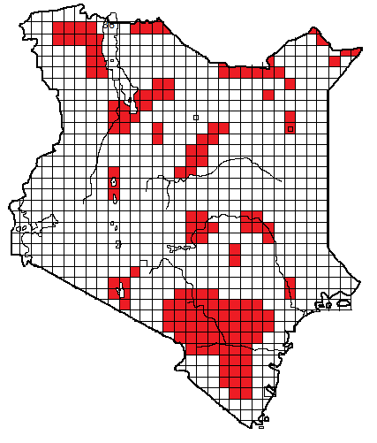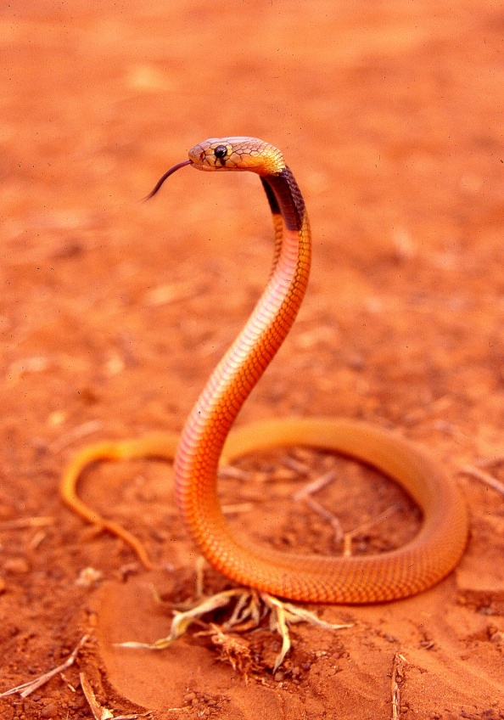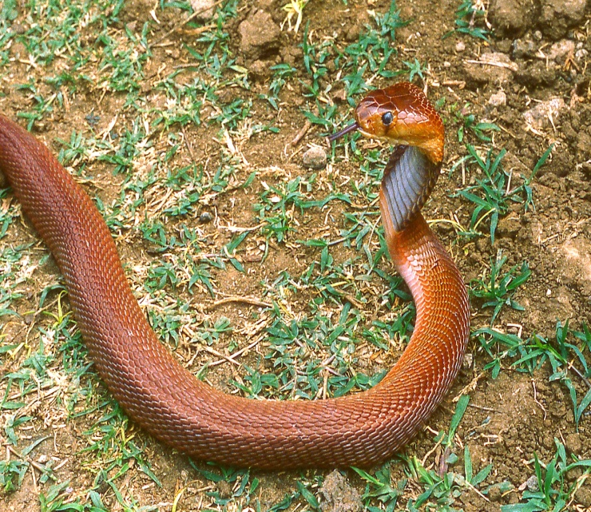
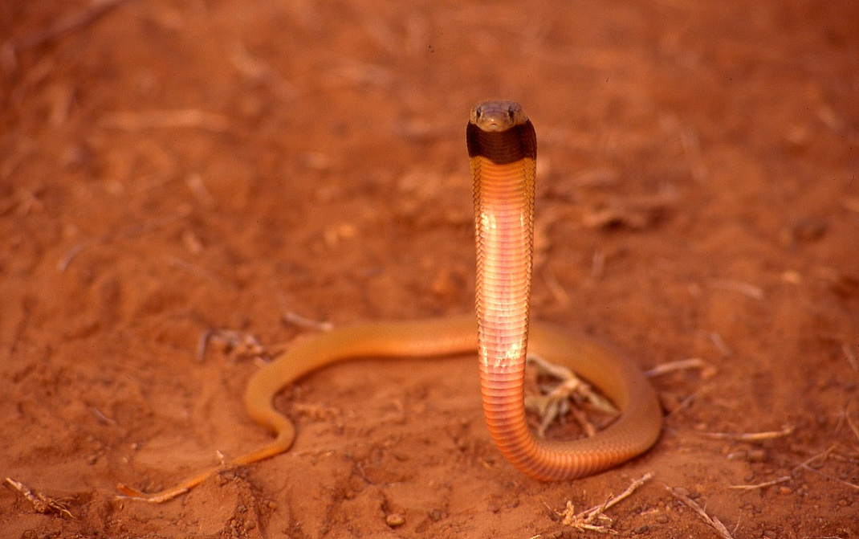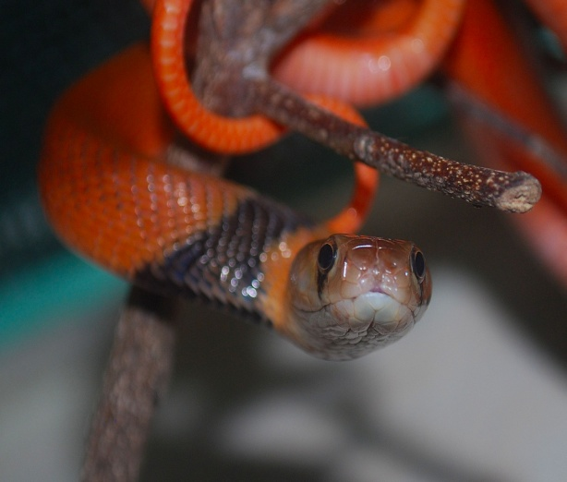
Local Names: Kiko kitune, Kikokya nguku (KiKamba), Kipgineroi (Kalenjin), Kirugwa (KiTharaka), Mas Gadut (Somali)
Identification: A fairly large, slim snake, maximum size about 1.5 m, hatchlings 20 cm, adults usually 70 cm to about 1.2 m.
Distribution: Dry savanna and semi-desert, from sea level to about 1 300 m altitude. Probably occurs virtually through northern and eastern Kenya, but few records from the far eastern side near the Somali border. Recorded from a number of Kenyan towns, including Garissa, Isiolo, Kakuma, Kibwezi, Lodwar, Mandera, Mtito Andei, Mwingi, Voi, Wajir, Wamba. Not found at altitude, so absent from most of southwest Kenya.
Natural History: Adults nocturnal, juveniles sometimes diurnal. Hides in termite hills, in holes, under ground cover. Eats a range of vertebrates, particularly frogs.
Conservation Significance: Not evaluated, but its huge distribution within dry and agriculturally unusable land in Kenya, Somalia and Ethiopia means it is unlikely to be threatened in conservation terms. Occurs within the following Kenyan sanctuaries: Amboseli National Park, Buffalo Springs National Reserve, Losai National Reserve, Malka Murri National Park, Rahole National Reserve, Tsavo National Park (East and West), Samburu National Reserve, Shaba National Reserve,
Medical Significance: Highly venomous, front-fanged elapid snake. Not aggressive, but can spit venom, which causes intense pain if it lands in the eyes; first aid treatment consists of prolonged gentle irrigation of the affected eye(s) with large quantities of water followed by treatment with antibiotic eye ointment.
Symptoms following a bite include immediate pain, vomiting, swelling and occasionally necrosis of the skin and subcutaneous tissues. The venom may be produced in large quantities; neurotoxicity is usually absent. Fatalities are rare, but bites should be treated as emergencies and victims should be seen by a doctor.

Rhombic Night Adder Moma ya Usiku Causus rhombeatus
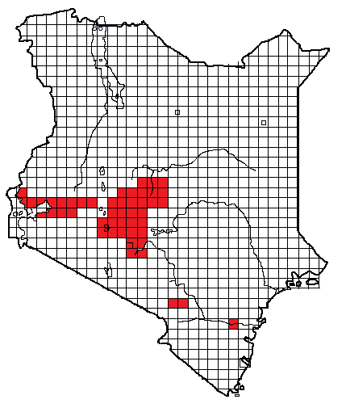
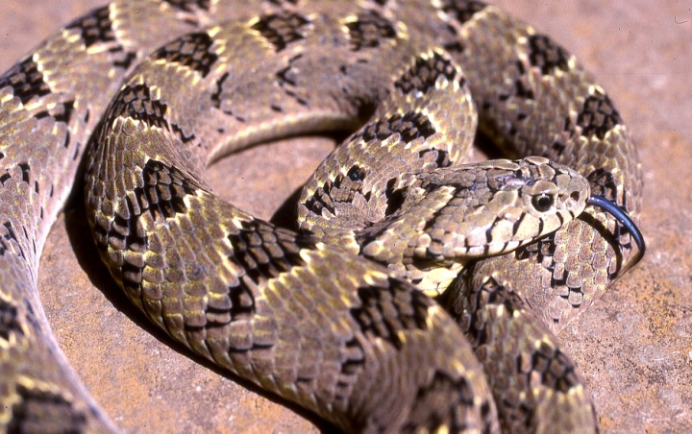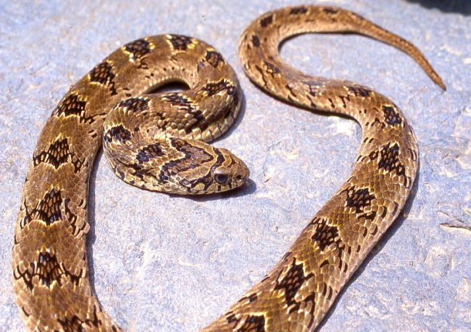
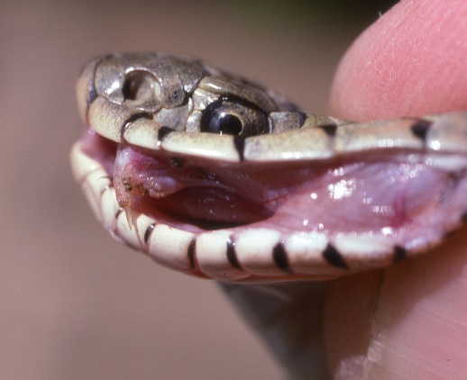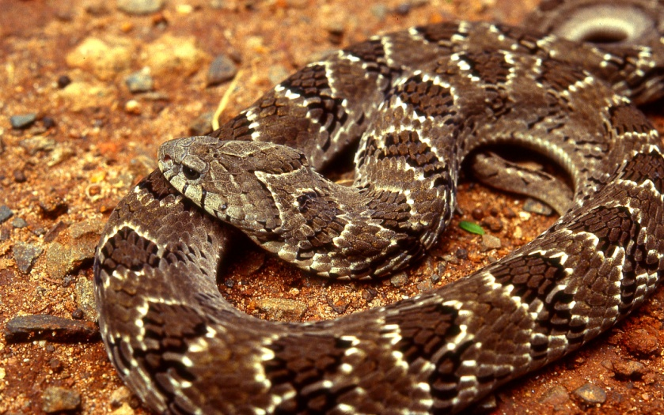
Local Names: None known.
Identification: A small, fairly stout snake, hatchlings 13-16 cm, maximum about 90 cm, average 50-75 cm. Usually brown or grey with a dark V-shape on head and brown, white-bordered blotches on backs.
Distribution: Found in well-watered savanna and grassland of high central and western Kenya, from Nairobi north and west, around Mt Kenya and the Nyambeni Hills, west to Kisumu. Isolated records from the Chyulu Hills and Jilore Forest. Recorded from a number of Kenyan towns including Athi River, Chemilil, Embu, Kahawa, Kiambu, Kisumu, Meru, Muranga, Nairobi, Naivasha, Ruiru, Thika, Tigania.
Natural History: Active by day and night, despite its name. Usually seen in the rainy season. When disturbed, it hisses and puffs loudly and inflates its body. Eats frogs. Hides in holes or under ground cover.
Conservation Significance: Not evaluated, but its huge distribution across eastern and southern Africa means it is unlikely to be threatened in conservation terms. Occurs within the following Kenyan sanctuaries: Hell’s Gate National Park, Meru National Park, Nairobi National Park, Ol Donyo Sabuk National Park.
Medical Significance: Bites from this venomous little adder are quite common, and its assertive behaviour often causes victims to think it is very dangerous, but no definite fatalities are recorded in Kenya. The venom usually causes local pain and swelling, sometimes with fever and some slight local necrosis. No serum is available and polyvalent serum should NOT be injected, bites should be treated conservatively by monitoring for 24 hours (especially in the case of children), analgesics, elevation in the case of swelling.

Jackson’s Chameleon Kinyonga wa Pembe Tatu Chamaeleo (Trioceros) jacksonii
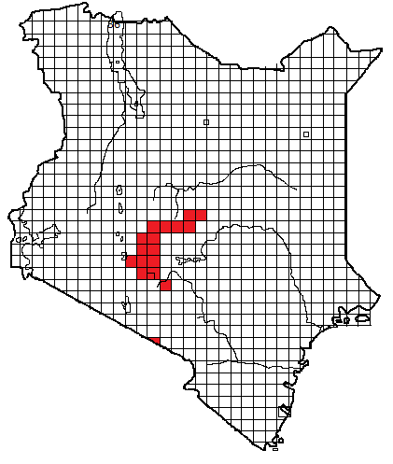
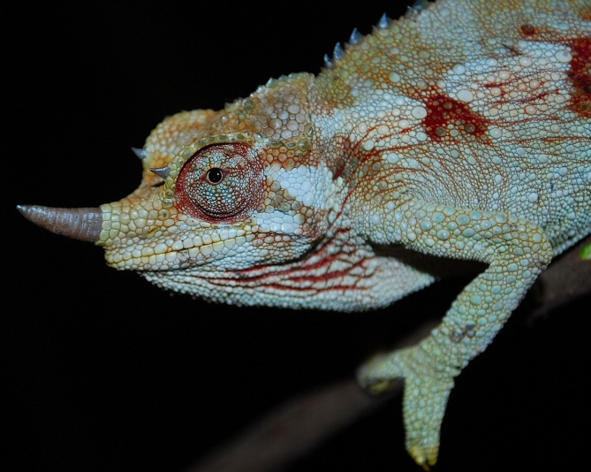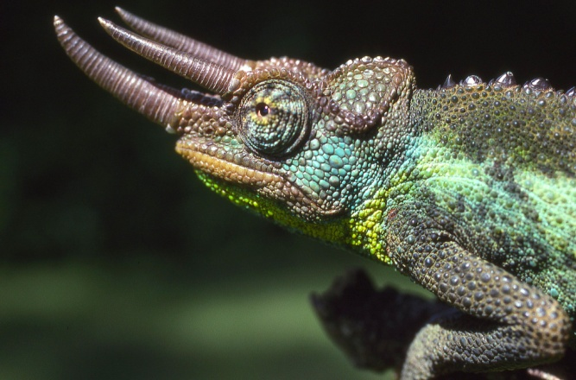
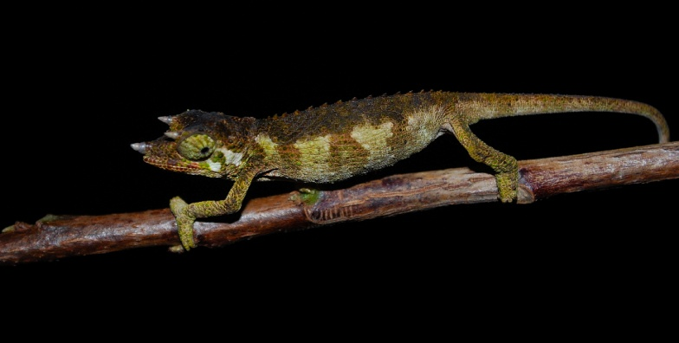
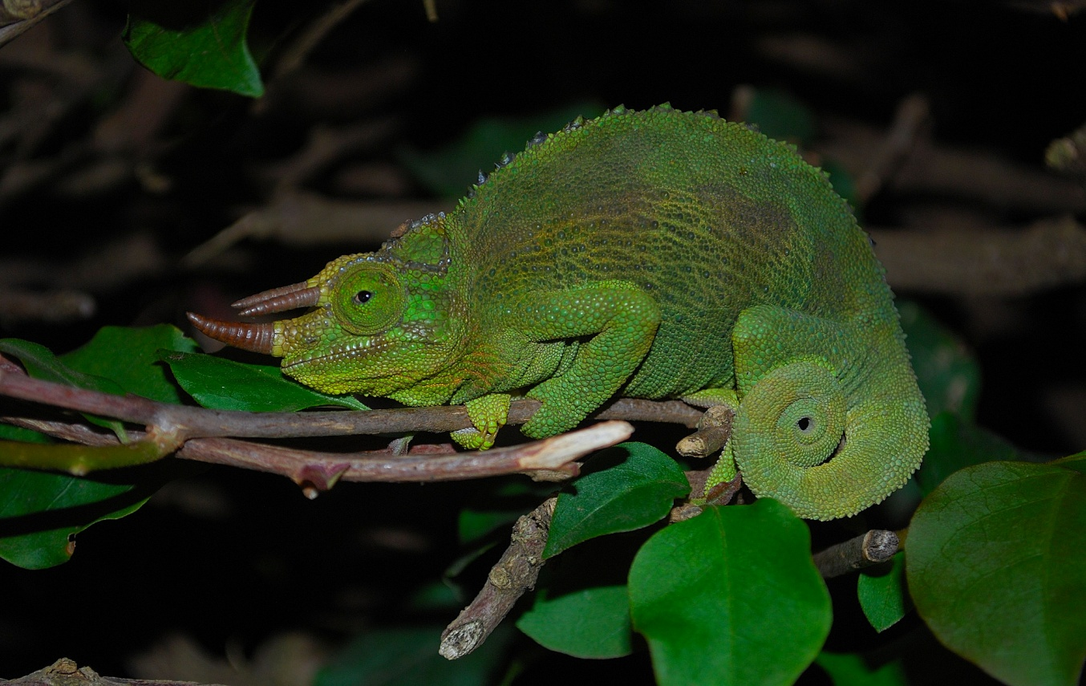 Th
Top left; adult female, top right and above; adult male, middle juvenile male,
Local Names: Kimbu (Kikuyu)
Identification: A fairly large chameleon, up to 30 cm total length, average 15-25 cm, males have three horns, females usually have one large horn and two or no small horns. Usually some green on the body, some females black and white.
Distribution: Mid-altitude forest, woodland and farmland between 1 400 to 2300m, east of the Gregory Rift Valley in Kenya. Found from Nairobi northwards to the forests around Mt Kenya and the southern and eastern flanks of the Aberdares. Recorded from a number of Kenyan towns including Chogoria, Chuka, Embu, Meru, Muranga, Nairobi, Naro Moru and Sagana; isolated records from Ol Donyo Orok (near Namanga) and Machakos.
Natural History: Active by day in trees, bushes and hedges. Territorial, males fight with their horns and bite. Eat insects. Live bearers, between 7 and 52 young.
Conservation Significance: Not evaluated, but fairly widespread and adapts to agriculture, so probably not threatened. Occurs within the following Kenyan sanctuaries: Aberdares National Park, Mt Kenya National Park, Nairobi National Park. Virtually endemic to Kenya, a subspecies occurs on Mt Meru in Tanzania.
Medical Significance: All chameleons are totally harmless, but often feared for superstitious reasons; someone who has been touched by a chameleon may exhibit symptoms of shock.

