The Kenya Reptile Atlas
A free, downloadable atlas of Kenya’s reptiles. This is a free source of regularly updated information on Kenya’s Reptiles. Authors: Stephen Spawls, Beryl Bwong, Patrick Malonza, Vincent Muchai, Victor Wasonga
Obtainable under ‘downloads’ at Kenyareptileatlas.com
This project is funded by the Rufford Foundation under the auspices of the National Museums of Kenya; Department of Herpetology.

The Kenya Reptile Atlas offers you pictures of Kenya’s reptiles, distribution maps by quarter-degree-square and a description of the species
Click on any of the titles listed under the downloads tab to download for free. The various families/groups will be added as the accounts are completed.
If you have any observations of Kenya’s reptiles, any distribution records, or any other data, or any digital pictures, we would like to receive them! Send them to Kenyareptileatlas@gmail.com
If you live or travel in Kenya, and find any dead reptiles, please preserve them and take them to the Herpetology Section, National Museum, Museum Hill, Nairobi.
The team thanks those who kindly commented upon the text or loaned us pictures; including Philipp Wagner, Chege Wa Kariuki, John Whitfield, Dave Bygott, Tomas Mazuch, Daniel Hollands, Reto Kuster, Olivier Hamerlynck, Susie Mitchell, Callan Cohen, Maggie Mahan, Mike McLaren, Dieter Runkel, Andre Van Hecke, Alex Burmann, Myles Hagen and Tony Allport. All uncredited photos by Stephen Spawls.
Agamas
The agamas are a family of old world lizards, known from Australasia (where they are called dragons), Asia, southern Europe and Africa. Around 450 species are known, with roughly 75 in Africa. Kenya has 11 species at present, five of which are widespread in the country (an introduced species has been observed in Mombasa). Agamas are diurnal, alert and fast moving. They have large heads, obvious ear openings, prominent eyes with moveable eyelids, and thin necks. Their bodies are flattened, with strong well-developed clawed limbs. The tail can be shed but reluctantly; in one West African species the broken tail becomes club-shaped at the end and is used in male combat, in others a double tail may grow. Agamas have small and irregular head scales, (not plates) their body scales are overlapping and keeled, and are sometimes in spiny clusters on the head and back. The bigger species often inhabit rocks and trees, where they can hide in cracks and holes. These large species tend to live in structured colonies with a big dominant male who perches and basks in a prominent, highly visible position. Such males will not tolerate rival males in their territory, and will drive away approaching males or their own male offspring when they mature. The smaller species often live in pairs or small colonies on open ground, sheltering in holes to which they dash when threatened. When displaying to a female or rival males, the male agama bobs his head and upper torso up and down in a distinctive manner. Agamas can change colour dramatically; the colours shown depend on sex and position in both space and the hierarchy. In parts of Kenya, agamas are feared, usually because they are wrongly believed to be venomous (no venomous lizards occur in Africa). Agamas feed largely on arthropods, they are fond of ants and termites and some may eat plant material, especially flowers. They lay eggs. It seems that female may be able to hold onto a clutch for some time; when rain falls she rapidly digs a hole in the wet sand or soil and deposits her eggs. Gravid females of some species develop vivid red flank or dorsal patches; it is suggested that this tells males the female is not receptive. The taxonomy of African agamas has been problematic. A major revision of the group by Scott Moody, as a doctoral thesis, was not published and hence sporadically used. However, recent and ongoing work by the German herpetologist Philipp Wagner has greatly clarified the situation. Two genera of agamas occur in Kenya, Acanthocercus, large agamas lacking an enlarged occipital scale in the middle of the head (right hand picture below), and Agama, (left hand picture below) which have an occipital scale.
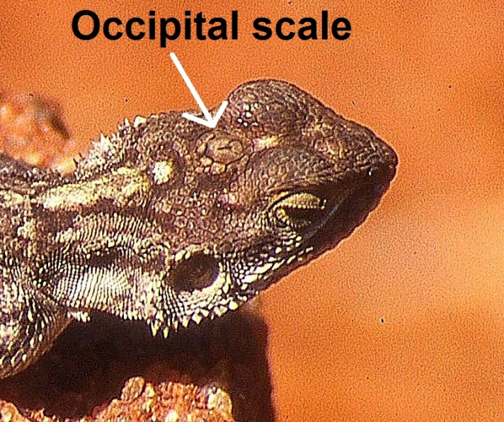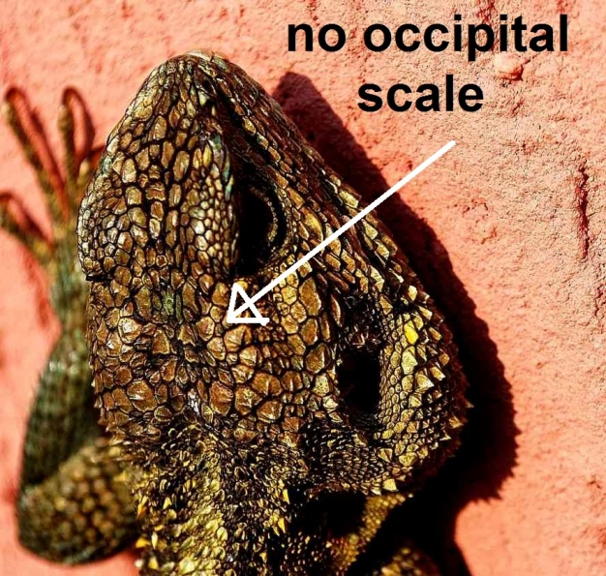
Local Names: Local names of agamas tend to be generic, those we are aware of are balabala (Swahili), kigurumuki (Kikuyu), Ikanza or Ing’ala (Kamba), obongo (DhoLuo), chepenetiet (Kalenjin), daukwo (Turkana), omekwa (Maasai).

Eritrean Rock Agama Acanthocercus annectans
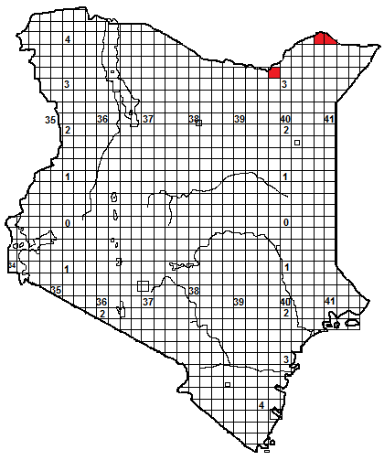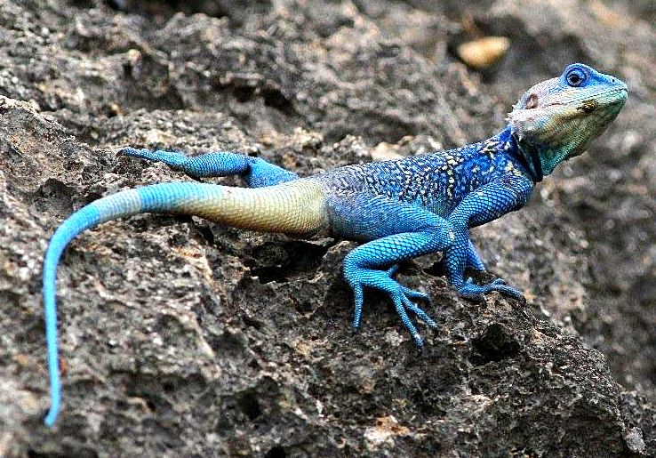

Identification: A big agama, relatively slender, with a large head with a few spiny scales below and behind the angle of the jaw. Scales are mostly small and of similar size, but there are a few enlarged scales along the spine and at the base of the tail, and some back scales are spiny. Colour: usually a mixture of browns and greys, but both sexes may show a distinctive pale vertebral line. Displaying males blue above, speckled with yellow, may show blue and green on the head, females have a banded tail and ocelli on the back. Maximum size about 34 cm, the tail roughly twice the length of the body, average size 15-25 cm.
Distribution: Centred on eastern Ethiopia, Eritrea and northern Somalia; in Kenya only known from Dandu and Malka Murri in the northeast, between altitudes of 700 to 1500m, but widespread through eastern Ethiopia to Eritrea. Lives on rocky hills in dry and moist savanna. but will utilise buildings.
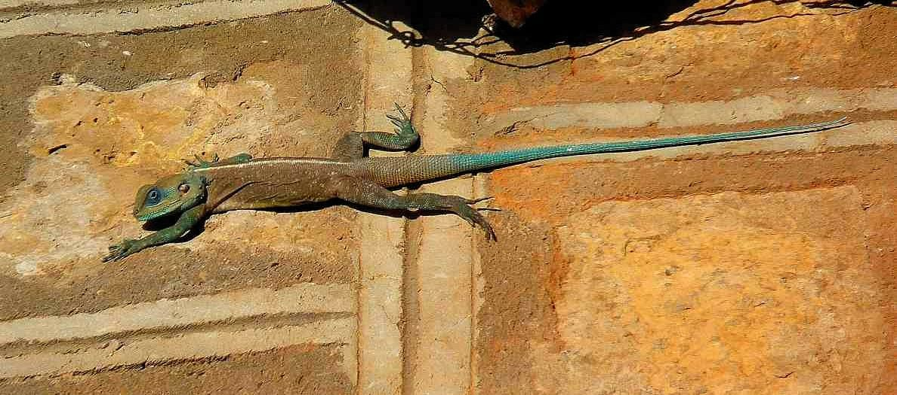
Natural History: Poorly known. A fast moving alert species, lives in structured colonies with a dominant male. Lays eggs but no details known. Diet mostly arthropods.
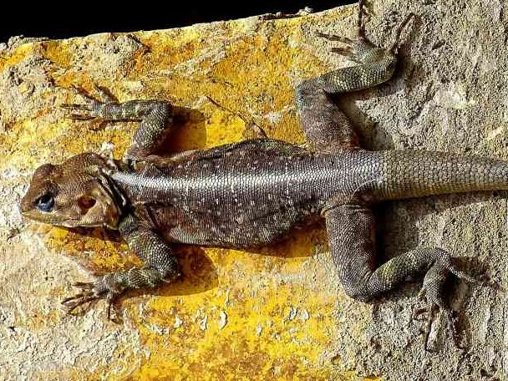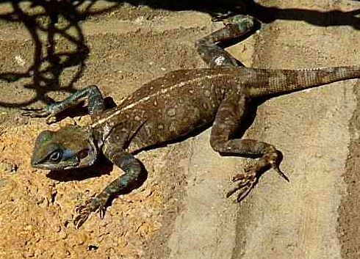
Illustrations: Top Somaliland male, © Callan Cohen, middle and bottom right Eritrea male and female © Philipp Wagner, bottom left southern Ethiopia male © Tomas Mazuch.

Blue-headed Tree Agama Acanthocercus atricollis
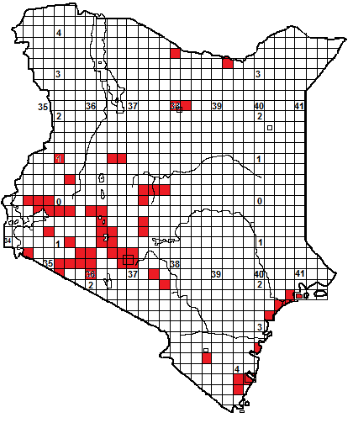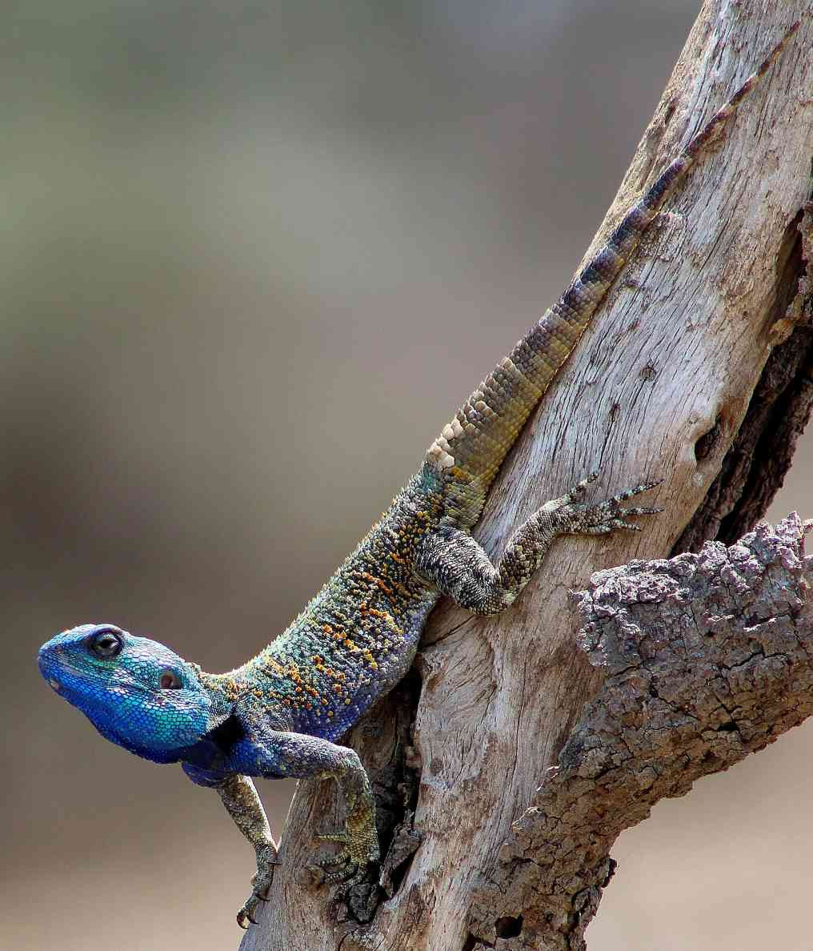
Identification: A big stocky tree agama, with a large muscular head, spiny scales on the head (below and behind the jaw) and back, the tail looks like a pine cone. Displaying males have a vivid blue or turquoise head, the back is blue or green, speckled, those from the west have the tail yellow at the base and blue at the tip. Females are grey-brown or black, with diffuse darker cross bars and often a row of pale lozenges along the spine. All have a narrow black neck band, although this may be hard to see in displaying males. Maximum size about 37 cm in males, females about 25 cm, hatchlings around 8 cm. The tail is about twice the length of the body.
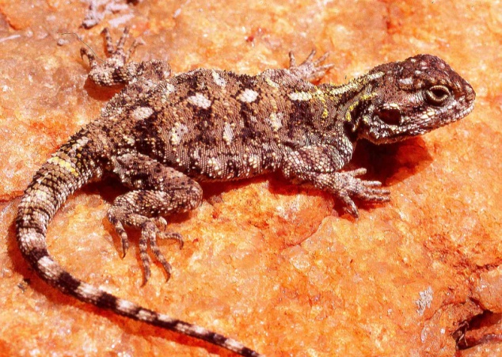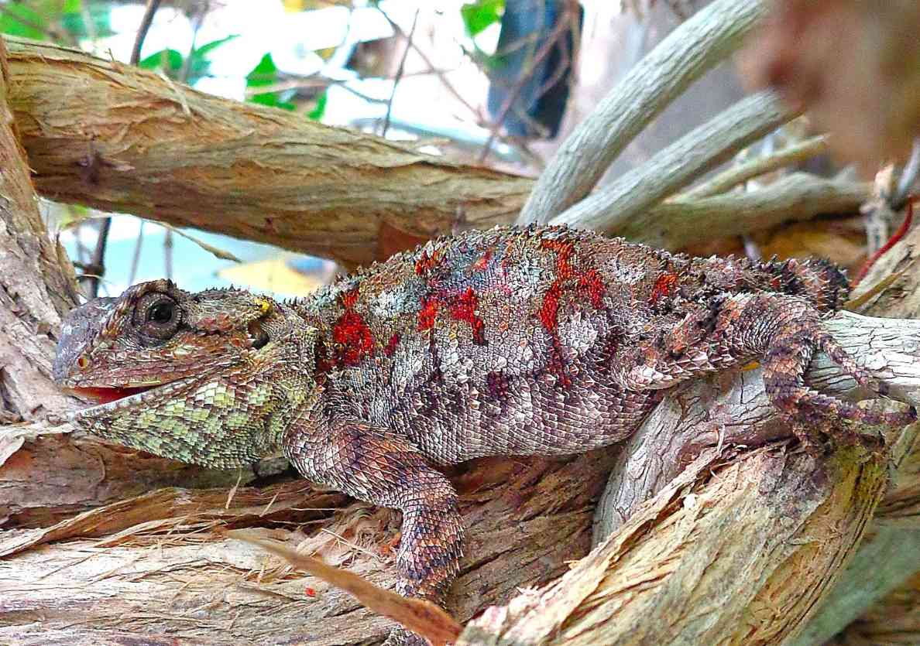
Distribution: Widespread in the highlands of southwest Kenya, from Machakos and Nairobi north round Mt Kenya and northwest to Maralal, west to the Mara and the lakeshore. In this area most common between 1 300 and 2 000 m, but may extend to 2 400m. A few records from isolated hills in the north (Marsabit, Huri Hills, Moyale). Also on the coast, from the Shimba Hills north to the mainland opposite Lamu. Usually on timber in savanna, woodland or forest clearings, (sometimes on the ground) and is tolerant of urbanisation, found in the wooded suburbs of Nairobi, Kisumu, Kitale, Eldoret etc, where it may utilise buildings and rocks
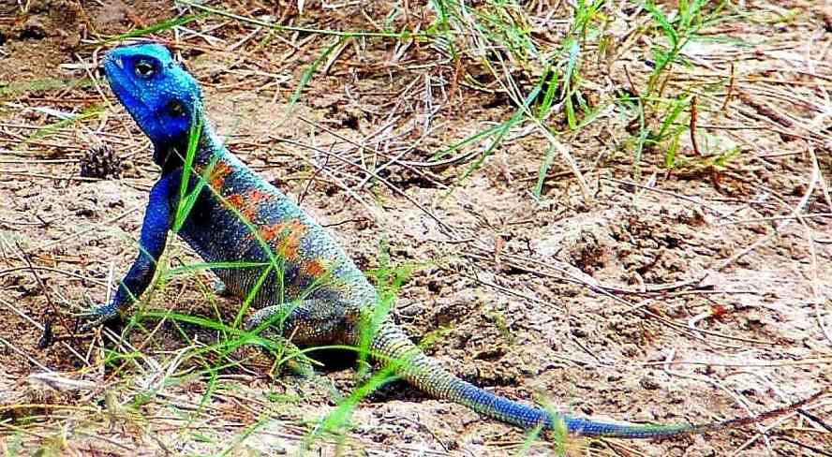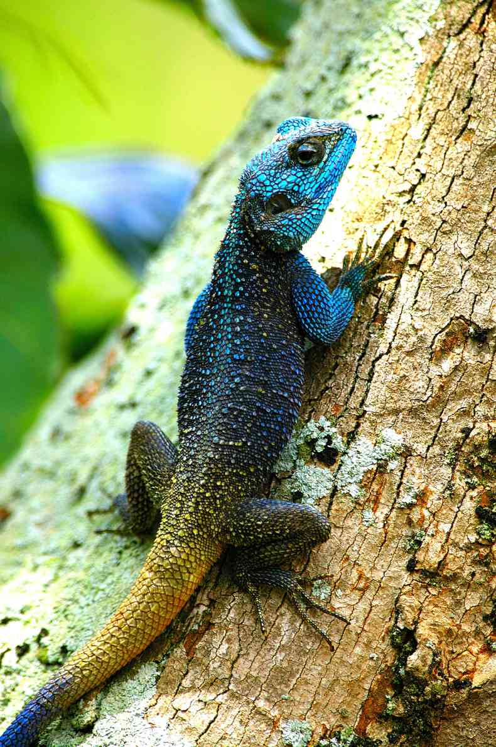
Natural History: Diurnal and arboreal, based around big trees, sometimes on rocks or termite hills. They will descend to hunt. In areas of low acacia savanna, they will hunt on the ground and take refuge in thorny tangles or bird nests. Strongly territorial, they live in structured colonies dominated by a big male, who defends his territory against other males. In urban areas they become tolerant of humans. They have a hard powerful bite; they can draw blood, and are erroneously believed to be venomous. Four to fifteen eggs are laid. They eat arthropods and are fond of ants.
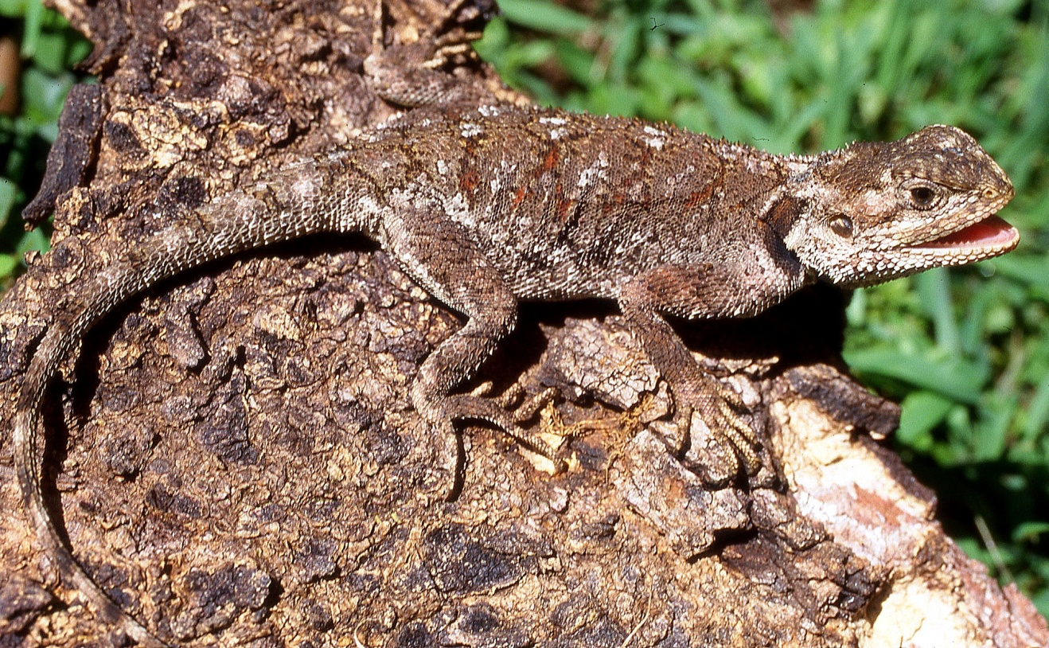
Taxonomic Notes: A 1957 paper by Klausewitz indicated that several subspecies; including gregorii, and minutus, which might in the future be elevated to full species, occur in Kenya. Recent work by Philipp Wagner and Tomas Mazuch indicate that the species Acanthocercus cyanogaster, originally believed to occur in Kenya, is probably confined to the Horn of Africa and Kenyan records of this form are probably mis-identified A. atricollis. The range of Acanthocercus atricollis and the red-headed rock agama (Agama lionotus) appear to be mutually exclusive in Kenyahwe
Illustrations:, Top Ngorongoro male, © Daniel Hollands, upper middle left, Keekorok juvenile, upper middle right Kiserian gravid female © John Whitfield, lower middle left (A atricollis gregorii) Kipini male © Oliver Hamerlynck, lower middle right Kitale male, © Chege Wa Kariuki, bottom female Naivasha.
Tropical Spiny Agama Agama armata
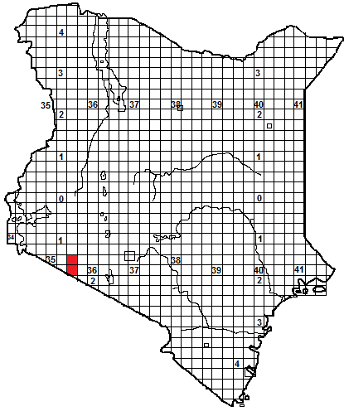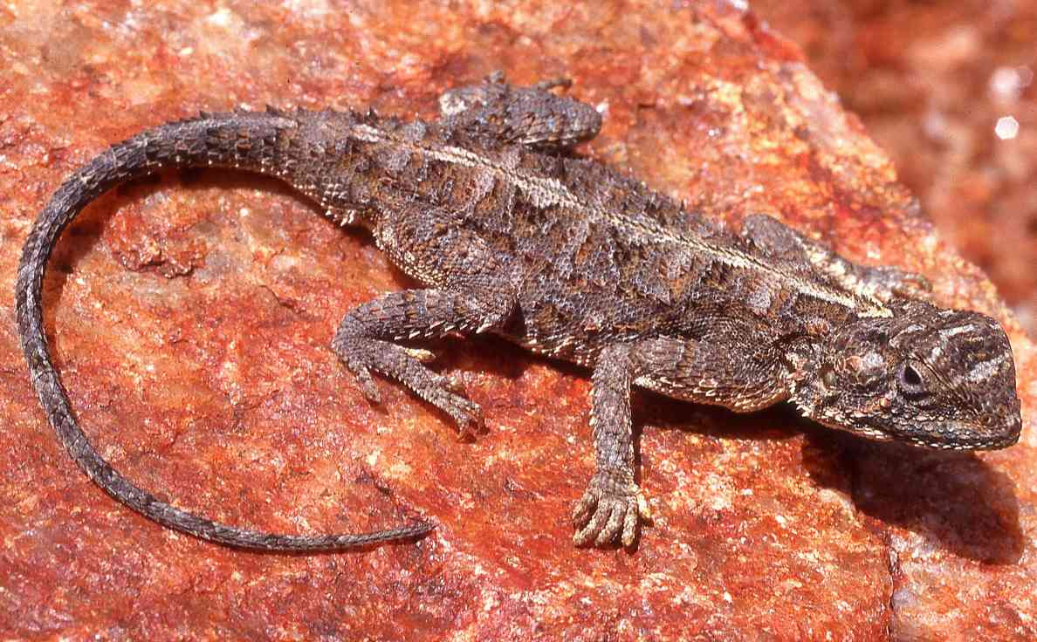
Identification: A small ground-dwelling agama. The body is squat and flattened. The tail is just over half the length although regenerated tails tend to be very thin and short. The small size, rows of spiny scales along the flanks and double- vertebral line are good field characters. The colour is grey, brown or rufous, with a pale vertebral line and light cross bars. Displaying males have various shades of blue and green on the head. Maximum size about 22 average 15-20 cm, hatchling size unknown but probably around 5-6 cm.
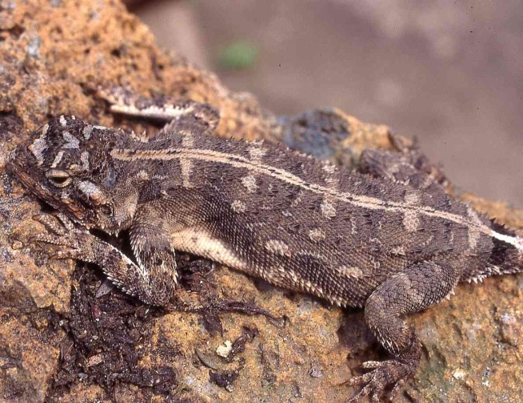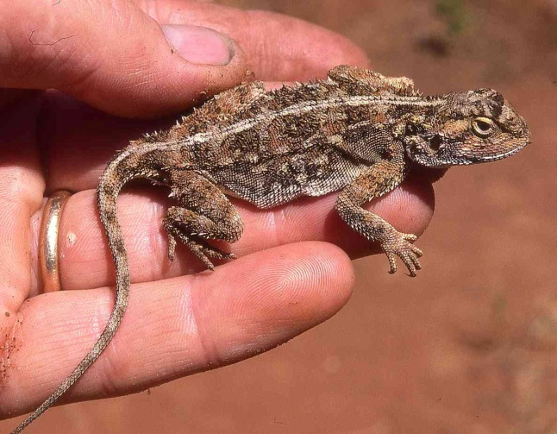
Distribution: In Kenya, known only from the mid-altitude savanna of the Mara area, from the southern Loita Plains and Siana Plains south through Tanzania to southern Africa.
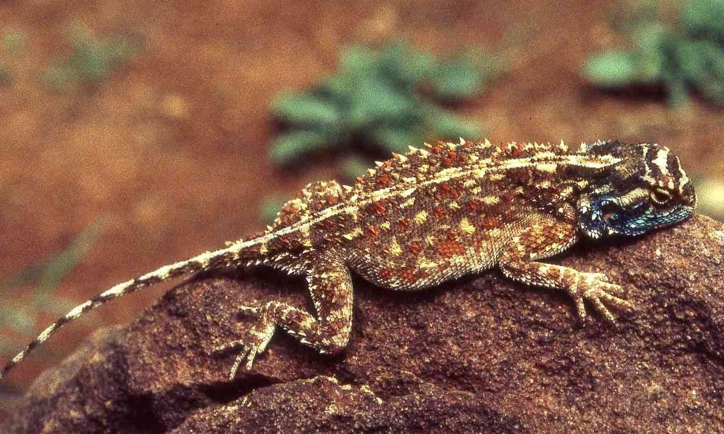
Natural History: Diurnal and terrestrial; usually living in holes on open plains but may live on small outcrops and sheet rock, provided it is not steeply tilted. If approached, they may run or (if they think they are undetected) freeze. Sometimes they bask in a curious way, hanging by a limb, or just a claw, from a flimsy twig. Nine to sixteen eggs are laid. They eat arthropods and are fond of ants.
Illustrations: Top Loita Plains, middle left Dodoma, middle right captive, bottom displaying male N. Zambia © Mike McLaren.
Elmenteita Rock Agama Agama caudospinosa
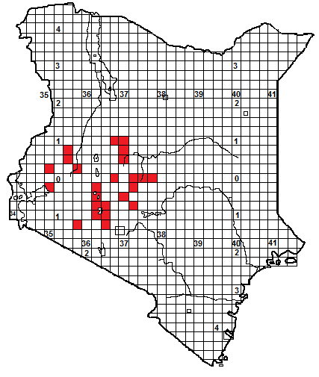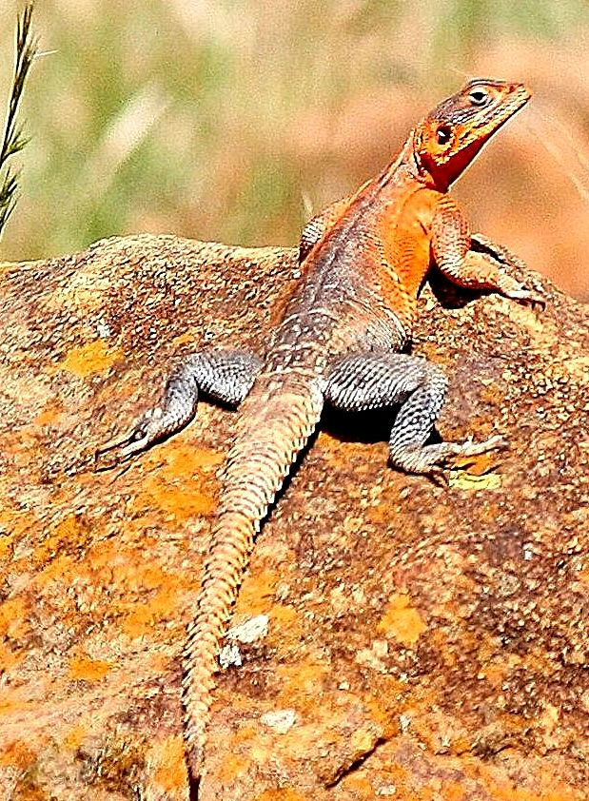
Identification: A huge, flat, secretive rock-dwelling agama. Adult males have a thick tail, which is very broad at the base and about 60% of total length. The dorsal scales are largely smooth. Colour quite variable, the upper torso of displaying males is often some shade of orange or rufous, the lower back and limbs mottled blue, sometimes with pale cross bars. The females may be rufous, brown or grey, with a vertebral line of pale subrectangular blotches. Maximum size about 45 cm (the biggest Kenyan agama by far), average 20-35 cm, hatchling size unknown.
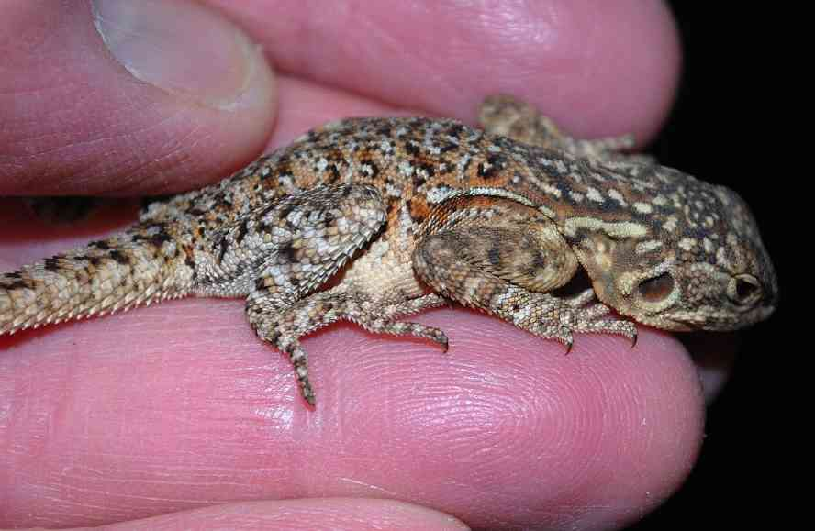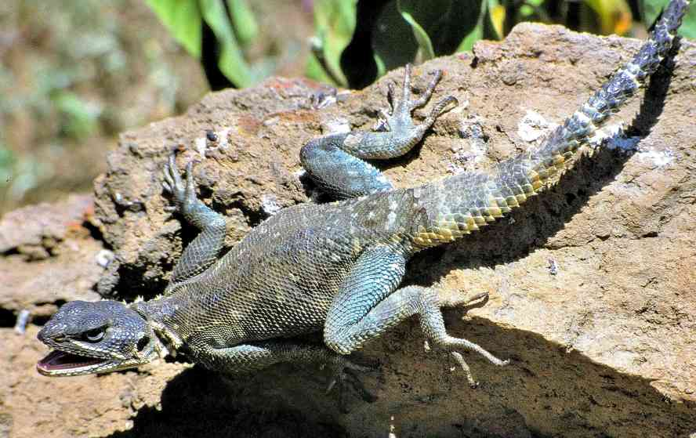
Distribution: Endemic to Kenya, in grassland, savanna and light woodland of the central Rift valley and associated high country, usually at altitudes of 1 700 m and above. Occurs from the Kedong Valley northwards, through the high central rift valley, northeast along the western flank of Mt Kenya to near Meru, also known from the Loita Plains, the western wall of the Kerio Valley and the eastern Uasin Gishu plateau; found in Hell’s Gate National Park and Lake Nakuru National Park.
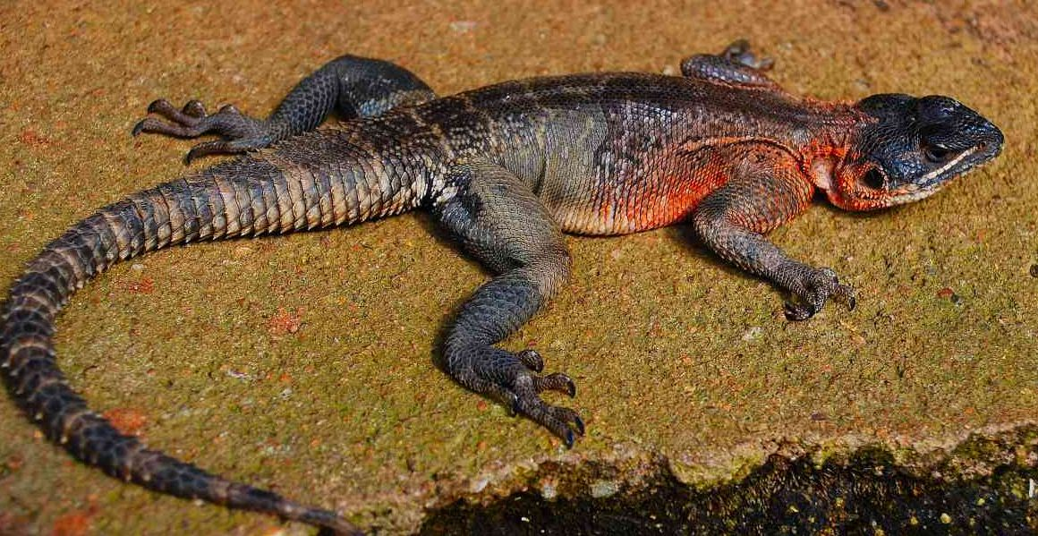
Natural History: Diurnal and terrestrial; living in fissures on sheet rock, outcrops, rocky cliffs and hills. They will live in areas with very little exposed rock, e.g. on the Uasin Gishu plateau, provided there are a few rock cracks in which to hide and small rocks to bask on. Although they live in a densely populated area of Kenya, little is known of their habits. They are shy and very fast moving, and move away unobtrusively, if further approached they run. These agamas are common in both Hells’ Gate and Lake Nakuru National Parks, but visitors rarely see them. They lay eggs, although no clutch details known, juveniles were observed in Laikipia in December. They eat insects and other arthropods.
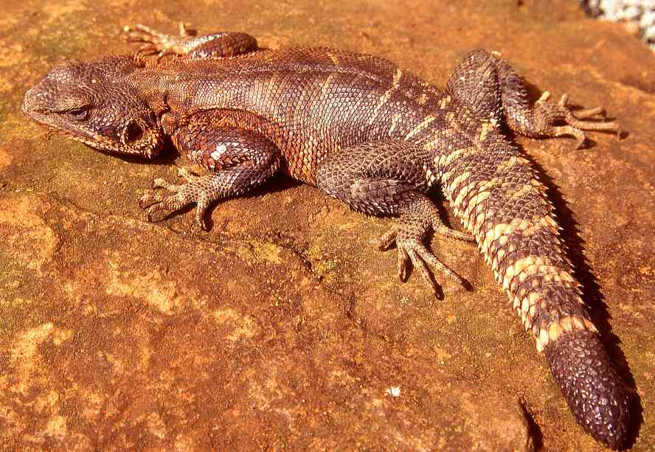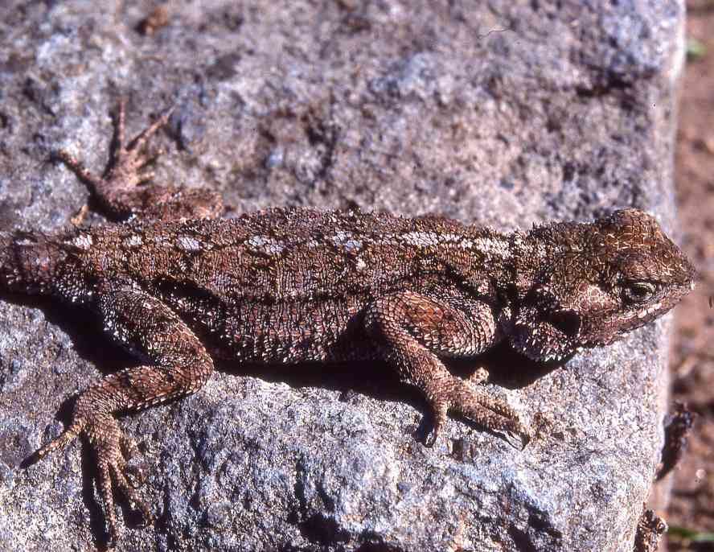
Taxonomic Note: In 2010, Philipp Wagner described a new subspecies, Agama caudospinosa spawlsi; the new form occurs north of the equator; from the western foothills of Mt Kenya clockwise around the mountain to Meru, and also on the western wall of the Kerio Valley. It differs from the nominate subspecies in colour, the males have a deep orange chest and unspotted neck, the females have their tail banded grey-black and white.
Illustrations: Top Laikipia male, © Chege Wa Kariuki, upper middle left Laikipia juvenile, upper middle right Hell’s Gate male, lower middle Laikipia male, bottom left Iten, Kerio Valley, male, bottom right Nakuru female.
Malaba Rock Agama/Brian Finch’s Agama Agama finchi 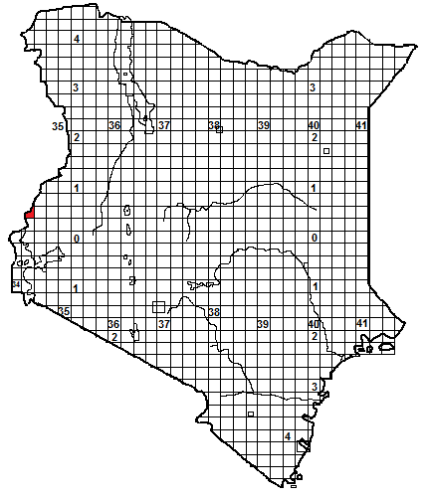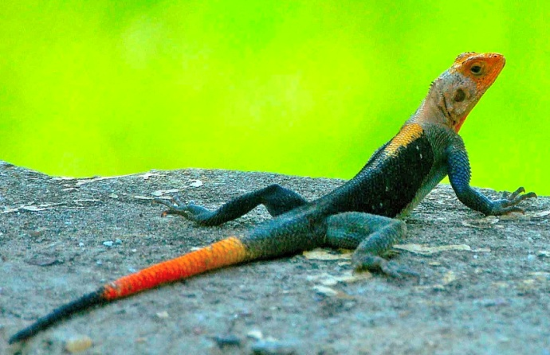
Identification: A small rock-dwelling agama. The displaying males have a red, orange or yellow head, blue—black body and orange and blue tail, females light or dark brown, with yellow or red flank markings and green spots on the head. Maximum size about 25 cm, hatchling size unknown.
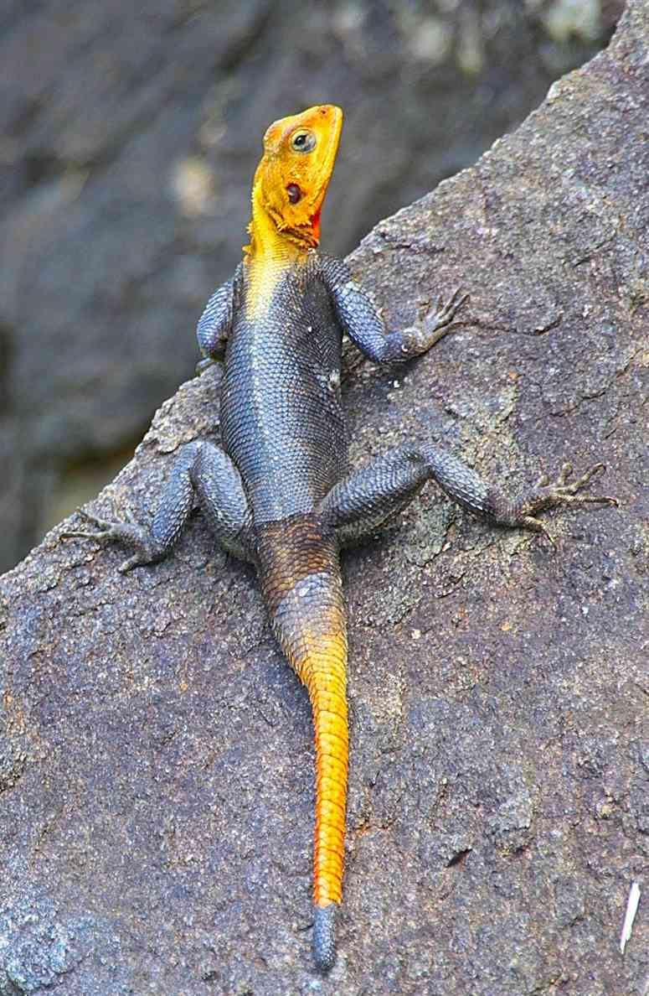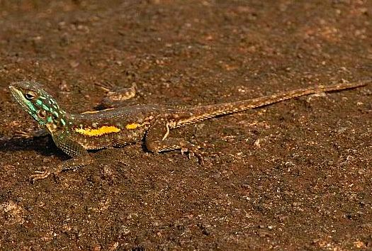
Distribution: Originally described from rock outcrops in savanna on the Malaba –Busia road, on Kenya’s western border, southwest of Mt Elgon, this is the only Kenya record to date, but it has subsequently been recorded from localities in northern Uganda, southwest Ethiopia and eastern Congo.
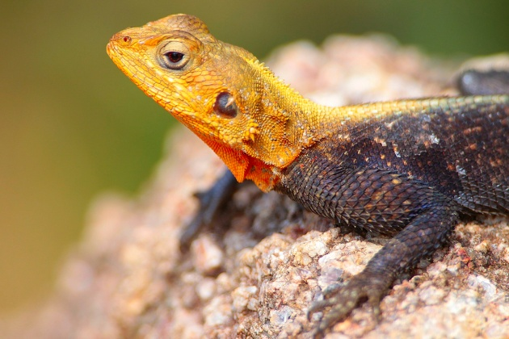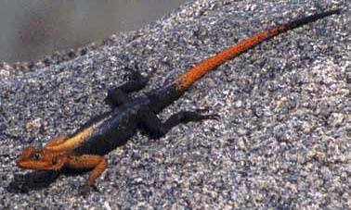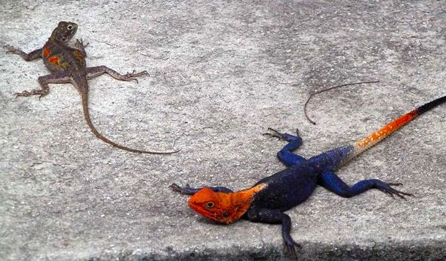
Natural History: Poorly known. Diurnal and terrestrial; living on rocky hills and outcrops in Kenya and on trees and buildings elsewhere; Finch mentions they were relatively abundant and not nervous on the outcrop near Malaba They lay eggs, although no clutch details known, diet probably insects and other arthropods.
Illustrations: Top Murchison Falls male © Chege Wa Kariuki, upper middle left and lower middle left Moroto Uganda,male, © Steve Russell, upper middle right eastern Congo female © Reto Kuster, lower middle right Malaba male © Philipp Wagner, bottom male and female Gambela, Ethiopia, © Dieter Runkel.

Hulbert’s Agama/Ngong Agama Agama hulbertorum
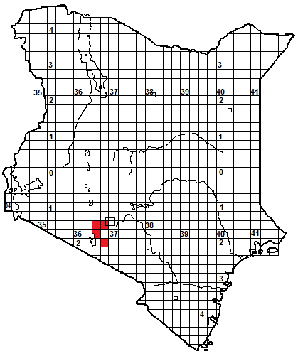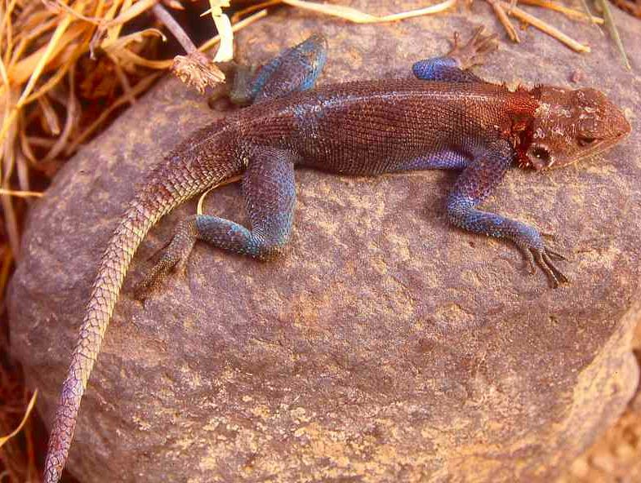
Identification: A small rock-dwelling agama, recently described by Philipp Wagner, from southern Kenya. The displaying males have a rufous head, rufous brown or blue back, a pale vertebral stripe and a banded tail; the throat is orange, the underside blue fading to white towards the tail. In females the head is brown to rufous with pale spots, the back a mixture of grey and brown with diffuse dark cross bars. Maximum size about 23 cm, hatchling size unknown.
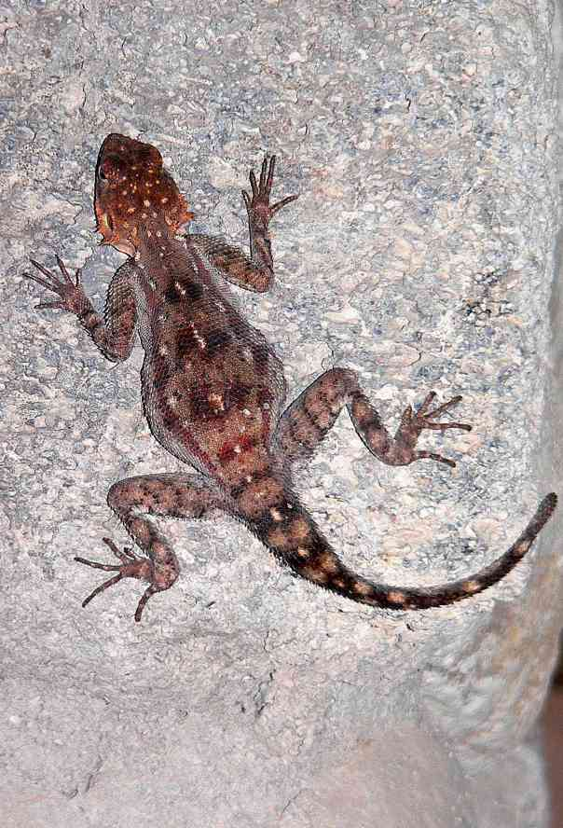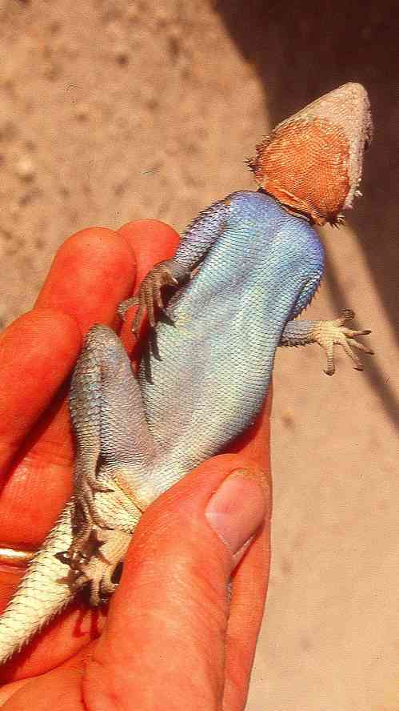
Distribution: At present endemic to Kenya, although its distribution close to the border means it might occur in northern Tanzania. Known from dry savanna west of Kajiado at Elangata Wuas and also the southern Ngong Hills and southern rift valley, from just west of Corner Baridi south and west to at least as far as Olorgesaille; these habitats range from 1 800 down to 1 200m.
Natural History: Poorly known. Diurnal and terrestrial; living on rocky hills and outcrops, also on the walls of buildings. Specimens at Olorgesaille were not nervous, allowing close approach. They are fairly abundant on rock outcrops along the Magadi road southwest of the Ngong Hills. Like other red-headed agamas, they live in colonies with a dominant male who displays at a prominent place. They lay eggs, although no clutch details known; diet probably insects and other arthropods.
Illustrations: top Olorgesaille male, bottom left Olorgesaile female © Daniel Hollands, bottom right Olorgesaille male.

Kakamega Agama Agama kaimosae
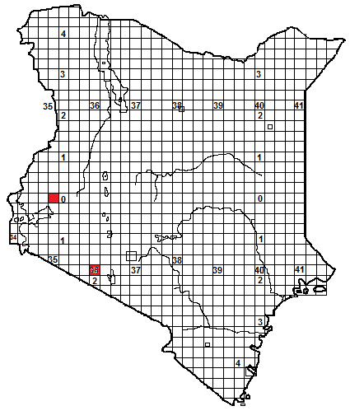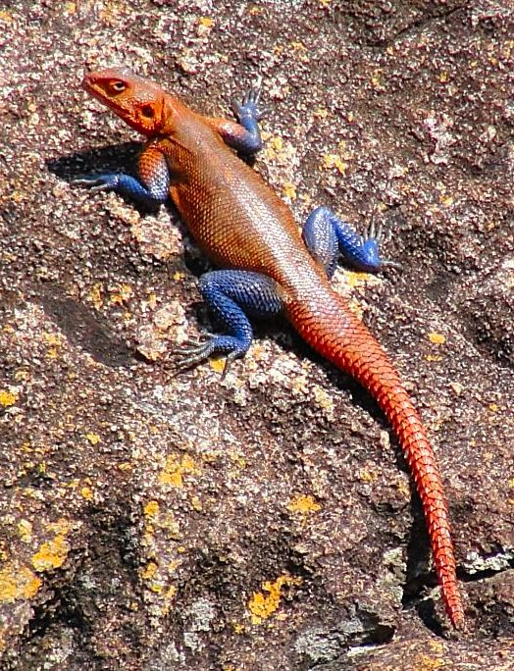

Identification: A large rock-dwelling agama from west of the rift valley in Kenya. The displaying males have a pink or orange head and back, and blue limbs. The life colour of an adult female has not been described, but they appear brown, with poorly defined darker cross bars and yellow scales on the sides of the tail base. Maximum size about 30 cm, hatchling size unknown.
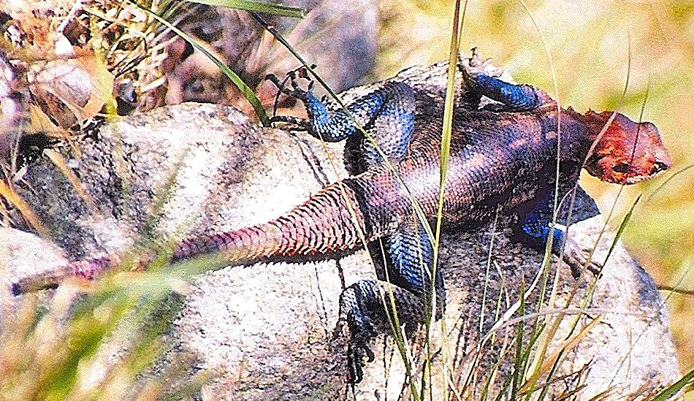
Distribution: In Kenya, known from the Kakamega area, from Kaimosi, Ngoromosi and the South Nandi Forest, and from the Loita Hills; probably occurs in the intervening country; also found in northwest Tanzania.
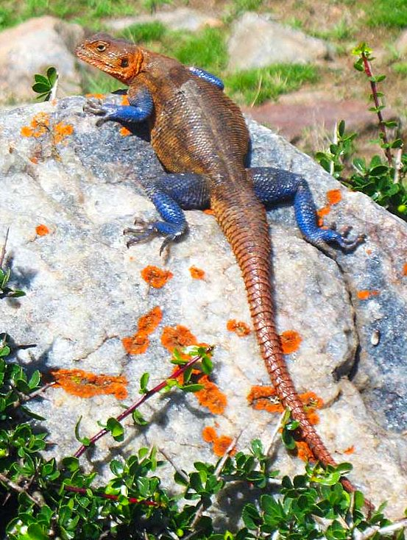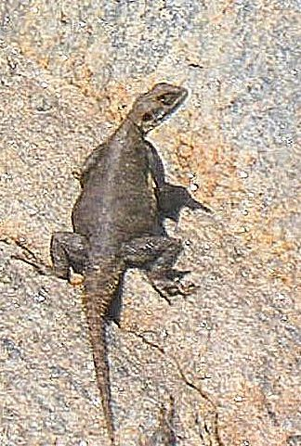
Natural History: Poorly known. Diurnal and terrestrial; living on rocky hills and outcrops. Like other large agamas, they live in colonies with a dominant male who displays at a prominent place. They appear to live in sympatry with the Mwanza flat-headed agama in part of their range. They lay eggs, although no clutch details known; diet probably insects and other arthropods.
Taxonomic Note: Originally described as a subspecies of Agama agama, and then lumped with Agama caudospinosa; recent work by Philipp Wagner indicates that this agama is a full species.
Illustrations; Top North Nandi Forest male © Patrick Malonza, middle Ngoromosi male © Alex Burmann, bottom Serengeti male and female, © David Bygott.
Red-headed Rock Agama Agama lionotus
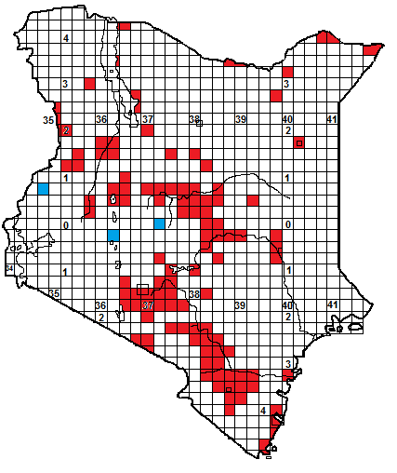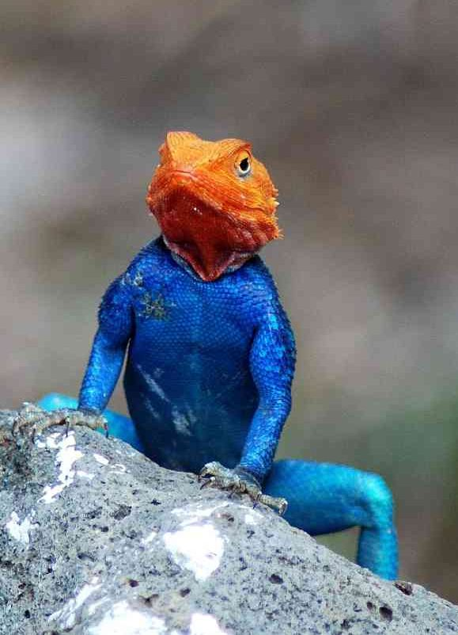
Identification: A large rock-dwelling agama, widespread in the savanna and semi-desert. The displaying males have an orange head and nape, dark blue body, and lighter blue limbs; the tail is usually banded white and blue. Females are brown, with dark crossbars and green spots on the head. Inactive males, or those not holding territory have rufous, brown or pale heads; such pale-headed males appear to be tolerated in a dominant male’s territory. Gravid females develop vivid red flank patches where the hind limbs touch the body. Maximum male size about 35 cm, average 20-30 cm, hatchlings 8-10 cm.
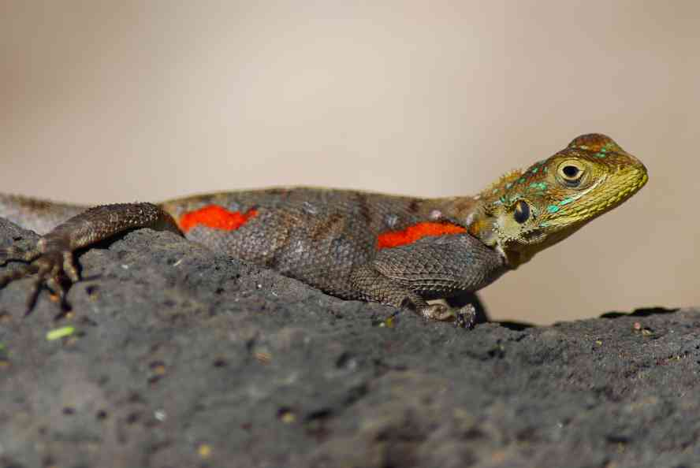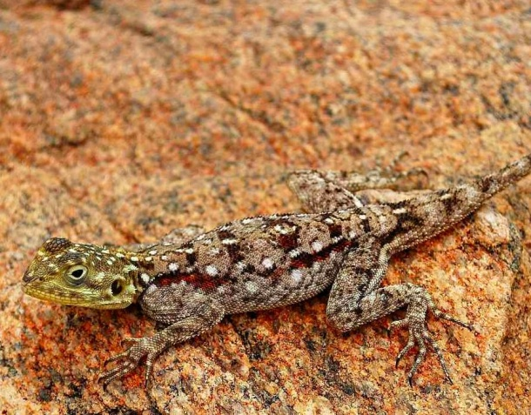
Distribution: Probably Kenya’s most widespread lizard, occurs widely in the savanna and semi-desert of the north and east, and sporadically on the coast, from sea level to 2 200m, although most common below 1 400m altitude. Absent from areas without big trees or rock outcrops, and hence records scattered in the flat country. In general, absent from places where Agama mwanzae, Agama caudospinosa or Acanthocercus atricollis occur (although A. atricollis and this species are sympatric in the southeastern corner of Nairobi National Park).
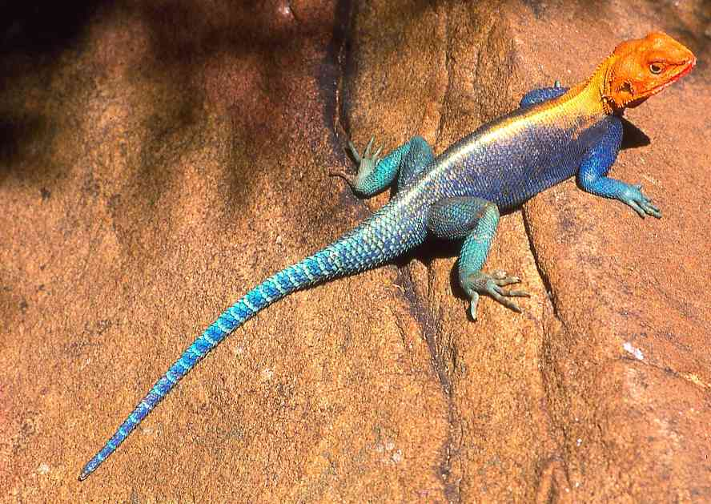
Natural History: Diurnal and terrestrial; living on rocks, big trees, and buildings and walls. Large colonies may form on suitable buildings or fissured rock with many hiding places. Rarely on open sandy ground, unless there are big broken termite mounds. A territorial species, a colony consists of a dominant male, a group of females and juveniles. The male basks in an exposed spot, bobbing his head and body up and down. Rival males are attacked, by biting and using the tail as a whip. These agamas can run extremely fast and jump 50 cm or more. Five to nine eggs are laid, usually at the start of the rainy season, in Ethiopia clutches took 50-60 days to hatch. They eat insects and other arthropods and also plant material, including grass, flowers and fruit.
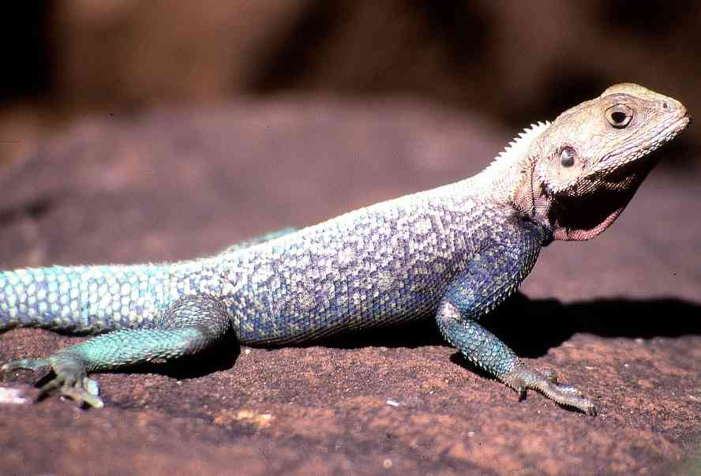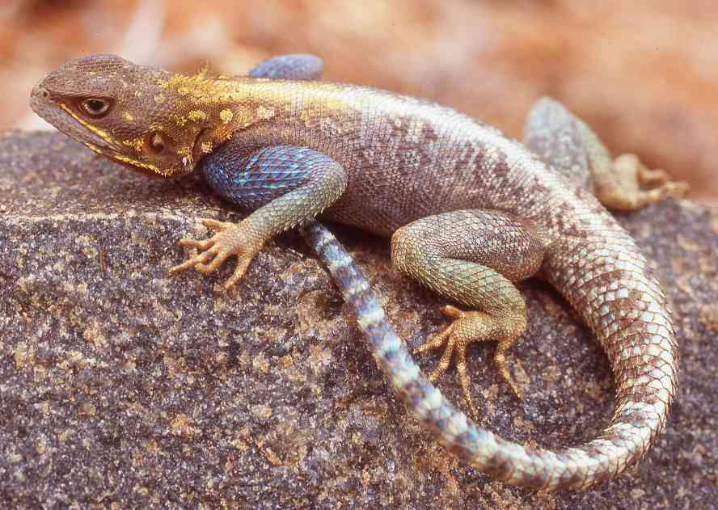

Taxonomic Note: The subspecies A. lionotus elgonis, with a dark patch at the base of the throat, but otherwise identical in appearance, was described from southwest Mt Elgon, and is also known from Lake Nakuru and Laikipia; shown by blue squares on the map. It might prove to be a high-altitude variant.
Illustrations: Top Mzima Springs male, upper middle left Mzima Springs gravid female, upper middle right Voi female, lower middle Ngulia Hills male, bottom left Ngulia Hills non-territorial male, bottom right Yatta Plateau non-territorial male.
Mwanza Flat-headed Agama Agama mwanzae
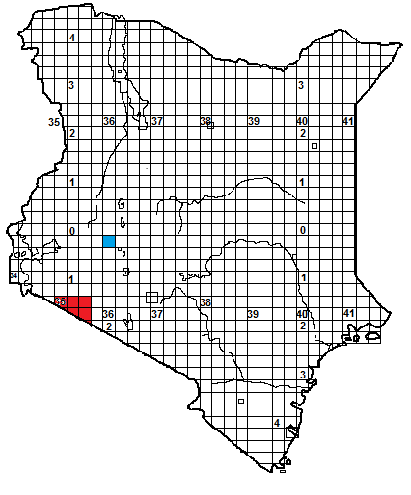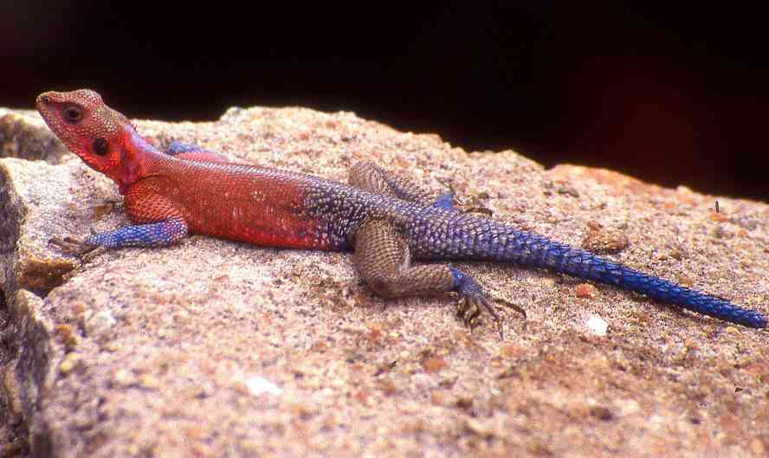
Identification: A big rock-dwelling agama, found in the Mara area. The displaying males have a pink or orange back (more orange towards the west), with a violet or blue-white vertebral line, the front limbs and lower back are mottled blue-white, the rear limbs green or blue. In non-displaying or dormant males the dorsal surface goes grey. Females are mottled brown, with an irregular vertebral line of light patches, the sides of the tail are yellow. Maximum male size about 35 cm, average 20-30 cm, hatchling size unknown but probably around 8-10 cm, tail around 60% of total length.
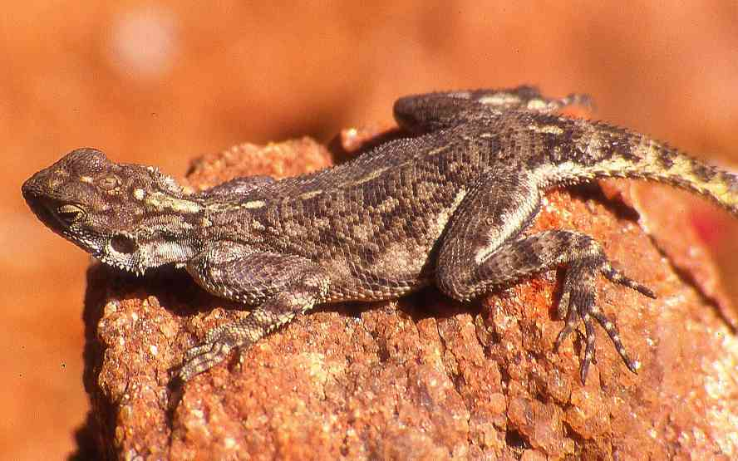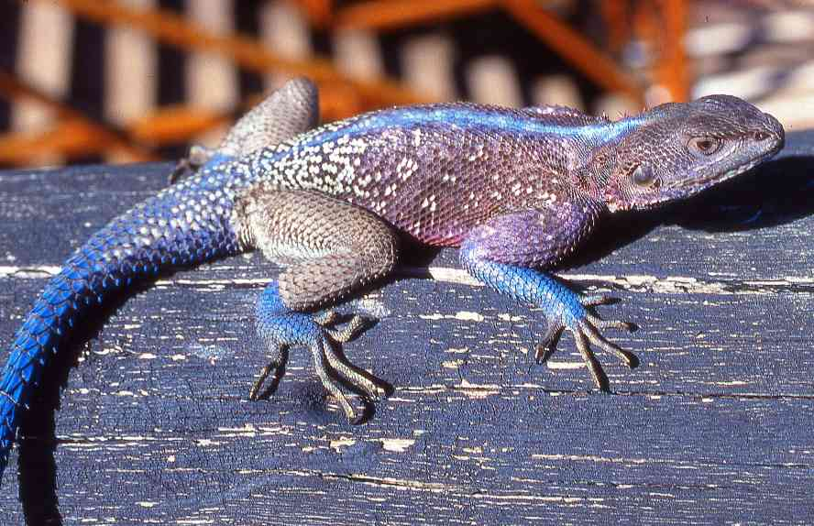
Distribution: In Kenya, known only from the Mara area, from the western Loita Plains and Siana Plains westwards to the Soit Ololol escarpment, then south through the Serengeti and northwest Tanzania to Rwanda, in mid- altitude savanna and grassland, from 1000 to about 2 200 m. A curious isolated population is reported from Mogotio, northwest of Lake Nakuru, shown in blue on the map, although no museum specimens have been collected. 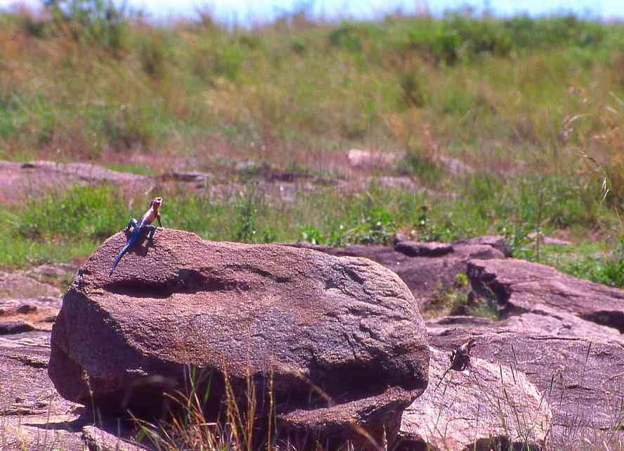 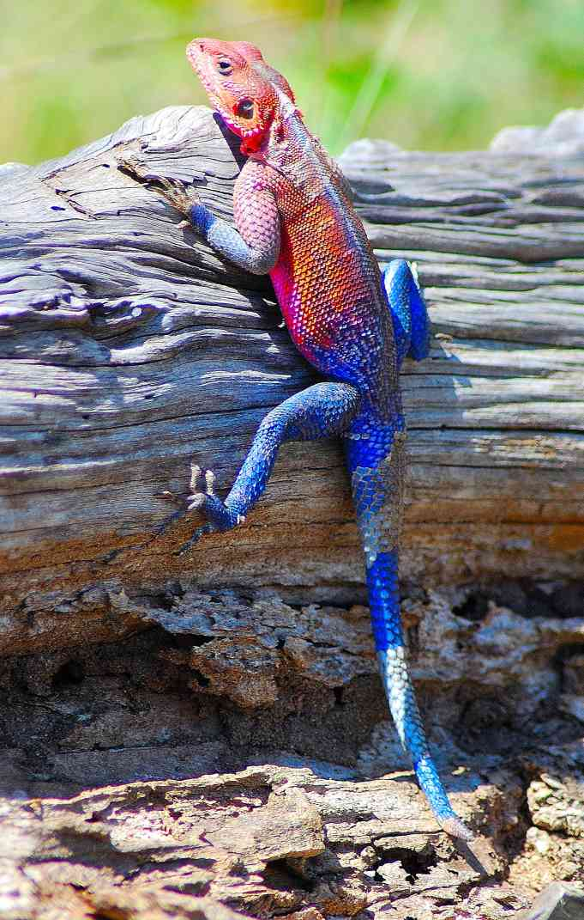
Natural History: Diurnal and terrestrial; living on big boulders, outcrops, rocky hills and cliffs, even on small patches of sheet rock provided there are cracks in which they can hide. They will live on stone buildings and walls, but are often nervous around humans. A fast-moving territorial species, a colony consists of a dominant male, a group of females and juveniles. The male basks in an exposed spot, bobbing his head and body up and down, to warn off rival males; occasional fights occur. They lay eggs. They eat insects and other arthropods and also plant material, including flowers and fruit.
Illustrations: Top Leganishu Hill male, middle left and right Leganishu Hill female and male, bottom left Keekorok, bottom right Mara bridge.
Somali Painted Agama Agama persimilis
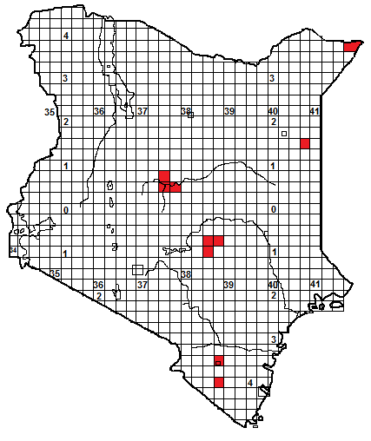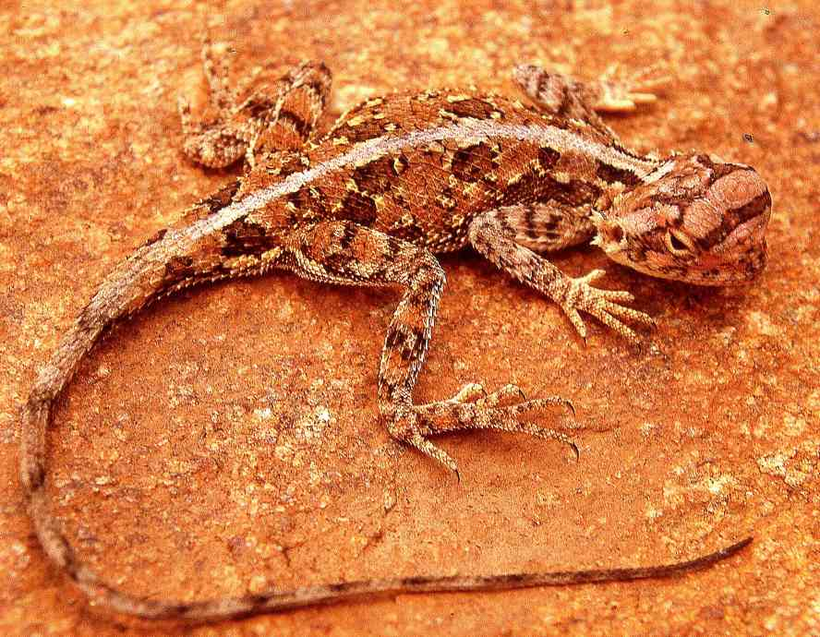

Identification: A small ground- dwelling agama, with a large curiously –shaped foreshortened head and a distinct broad pale vertebral stripe. Usually some shade of rufous or brown, with sub-circular patches on either side of the spine, and rounded blotches on the flanks. Maximum male size about 16 cm, average 10-14 cm, hatchling size unknown but probably around 5-6 cm, tail around 65% of total length. Appearance rather similar to the next species, Rüppell’s agama, but in Kenya the Somali painted agama has a broader vertebral stripe and the head spines never obscure the earhole, as shown in the picture below.
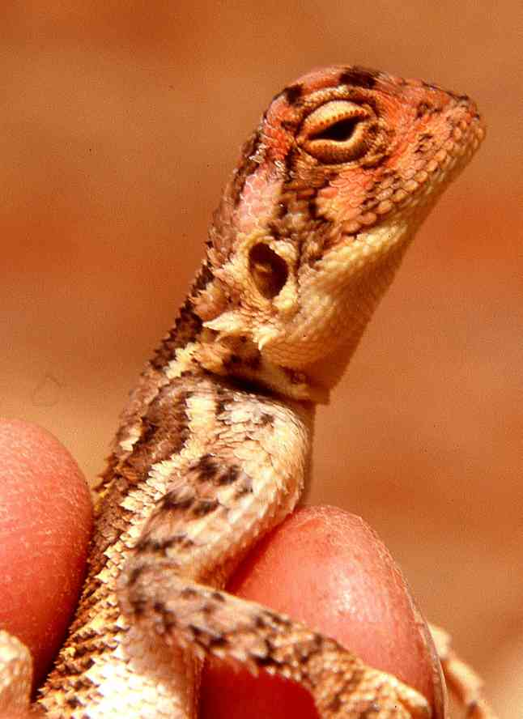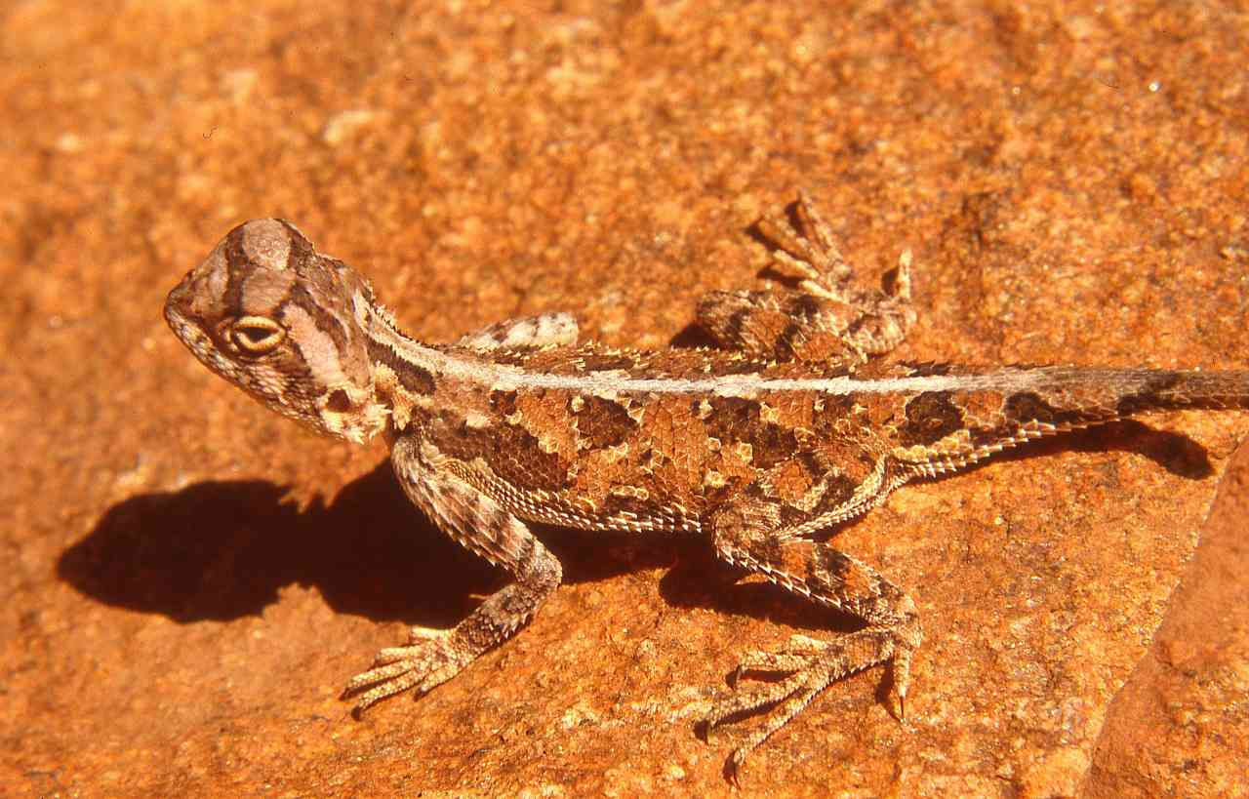
Distribution: In Kenya, known only from a handful of records in the semi-desert and dry savanna, all east of the rift valley. Known localities include Rukanga Ranch and Voi, a cluster of records east of Mwingi in Ukambani, Samburu National Reserve and its environs, Wajir Bor and Mandera. Probably occurs in the intervening areas but in places it is curiously secretive; for example only a single specimen was found during two months of continuous collecting in Mandera.
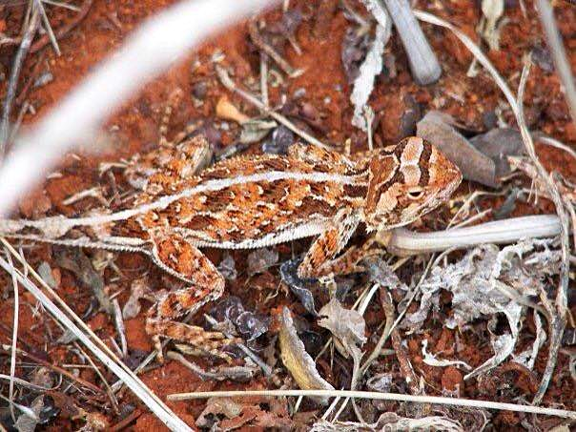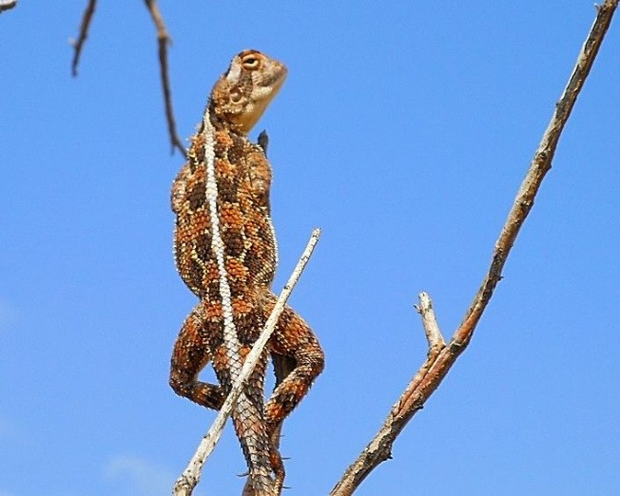
Natural History: Diurnal and terrestrial, they live in open country, usually in holes under shady bushes, although the Mandera specimen was hiding in a rotten log. They venture out to hunt, but dash back into cover if threatened. Active during the day, even during the hottest hours. ln Samburu two individuals were observed in the same hole, possibly a true pair. Individuals have been observed basking in the same curious fashion as Agama armata, hanging by a claw from a flimsy branch, as shown above right. They lay eggs, a gravid female was collected in August in Somalia. Diet insects and other arthropods.
Illustrations: top three Sopa Lodge, Samburu, bottom left Rukanga Ranch © Maggie Mahan, bottom right Sasaab, Samburu, © Tony Allport.
Ruppell’s Agama Agama ruppelli
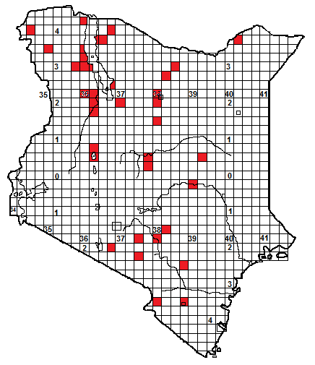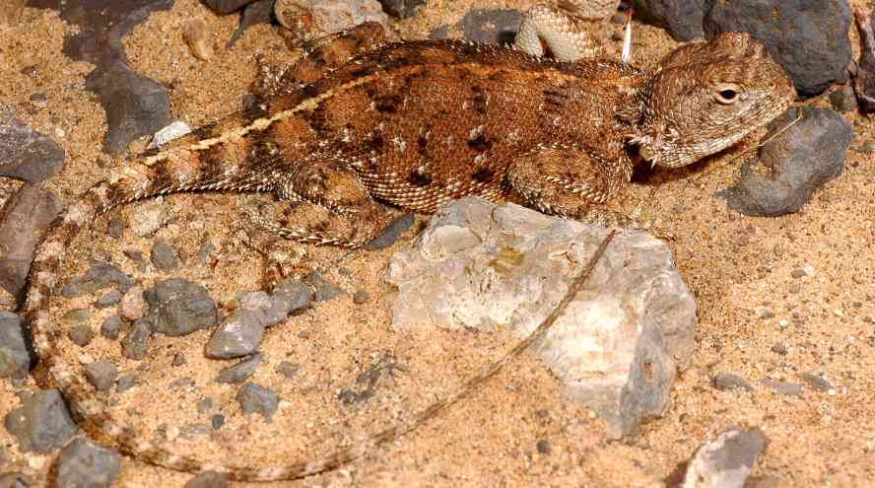
Identification: A small ground- dwelling agama, usually with a thin pale vertebral stripe and a banded tail. Most are some shade of mottled brown or grey, with diffuse darker cross bars, but occasional individuals are virtually patternless. Displaying males said to show green and blue on the head, and gravid females develop green heads and red cross bars. Maximum male size about 25 cm but usually smaller, average 15-20 cm, hatchling size unknown but probably around 6-8 cm, tail around 60% of total length. Rather similar to the Somali painted agama. However, Rüppell’s agama has a narrow vertebral stripe where present, and, as shown in the bottom RH picture, the spines sometimes obscure the ear hole.
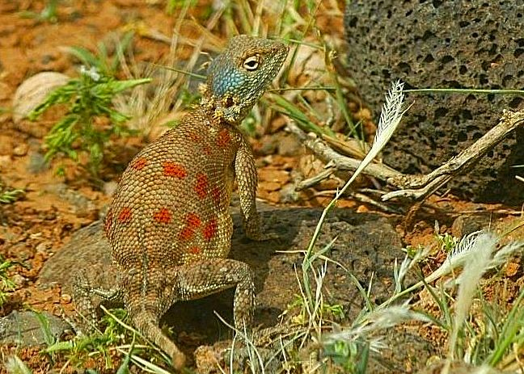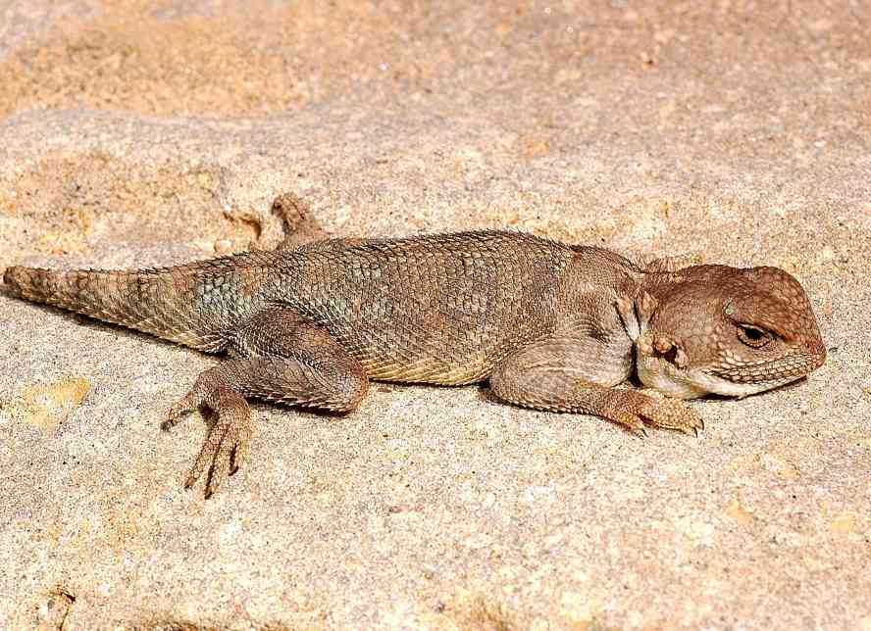
Distribution: Dry savanna and semi-desert of the north and east, known from Murka and Voi northwards through Ukambani and Tsavo (and also Elangata Wuas), records from the north sporadic, although probably more widespread than indicated, due to undercollecting. Usually at altitudes below 1 500m.
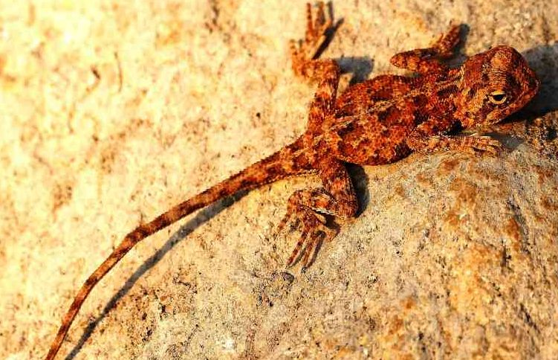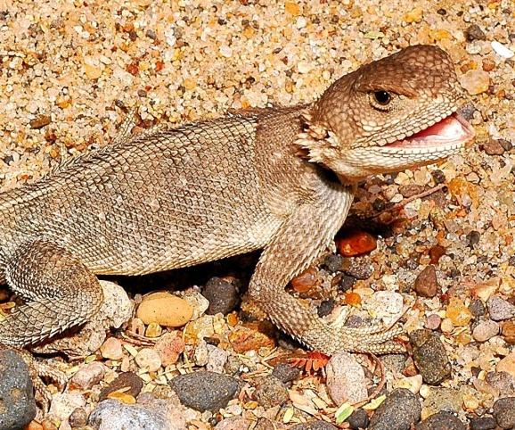
Natural History: Diurnal and terrestrial, they live in open country, both on the ground and in rocky areas, although on rock faces they seem to avoid areas where the bigger brightly coloured agamas live. They take shelter in holes, rock fissures and under ground cover. They venture out to hunt, but dash back into cover if threatened. Active during the day, even during the hottest hours. They lay eggs, but no breeding details known. A gravid female was observed near Isiolo in March. Diet insects and other arthropods.
Taxonomic Note: There are three known subspecies, which might turn out to be full evolutionary species; Those from northern Kenya are A. rüppelli occidentalis, those from south of the equator are A. r. septentrionalis.
Illustrations: Top Lake Turkana © Eduardo Razzetti, middle left Isiolo gravid female © Suzie Mitchell, middle right and bottom right Lake Turkana, © Robert Sindaco, and bottom left Baringo © Andre Van Hecke.

Introduced Species: In 2007, Martin Sandera and Zuzana Starostova observed one specimen (possibly two) of an Asian agama, the Garden Lizard, Calotes versicolor, at Mombasa railway station (see illustration below, male left, female right, Maldivian specimens) This agama is widespread in southern Asia and has been introduced at a number of places, including the Seychelles. It has the potential to cause problems, including the displacement of indigenous species, and its distribution on Mombasa should be monitored.
