Some of Kenya’s common reptiles
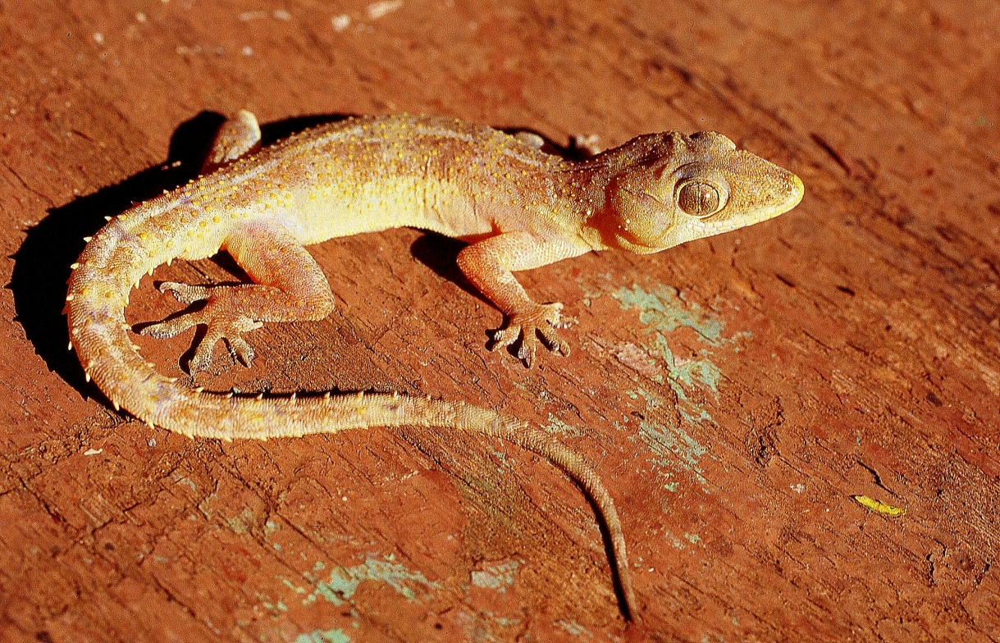
Tropical house gecko, mjusi ya usiku, Hemidactylus mabouia. Widespread in the southern half of Kenya. Active at night.
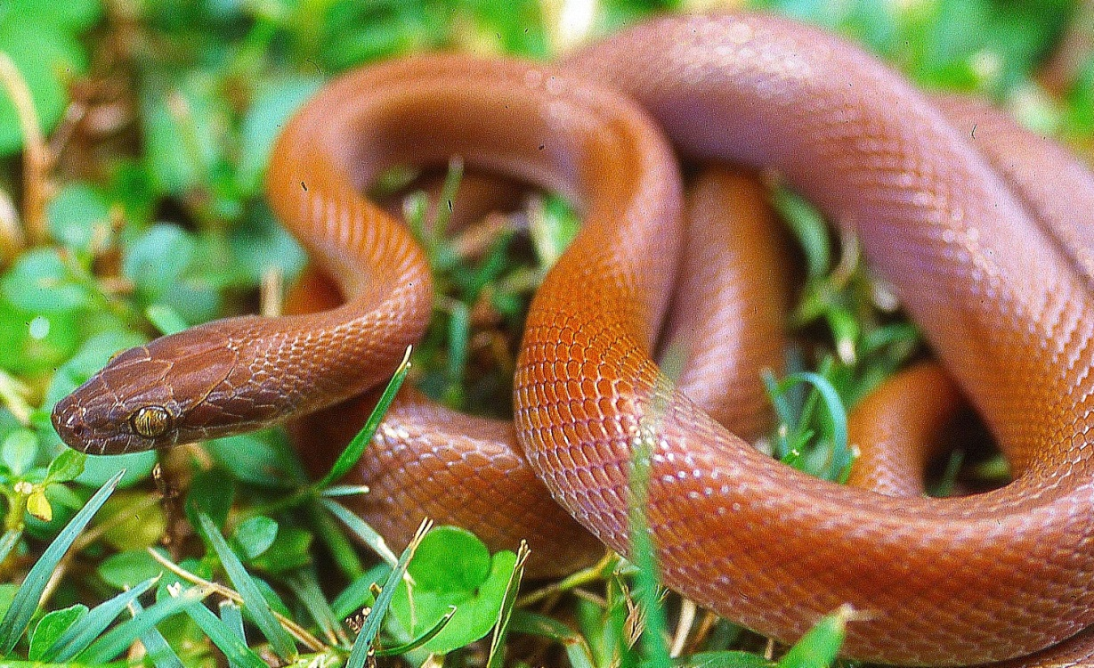

Brown house snake, Nyoka wa nyumbani, Lamprophis fuliginosus. Widespread all over Kenya but rare in the dry north. Harmless.

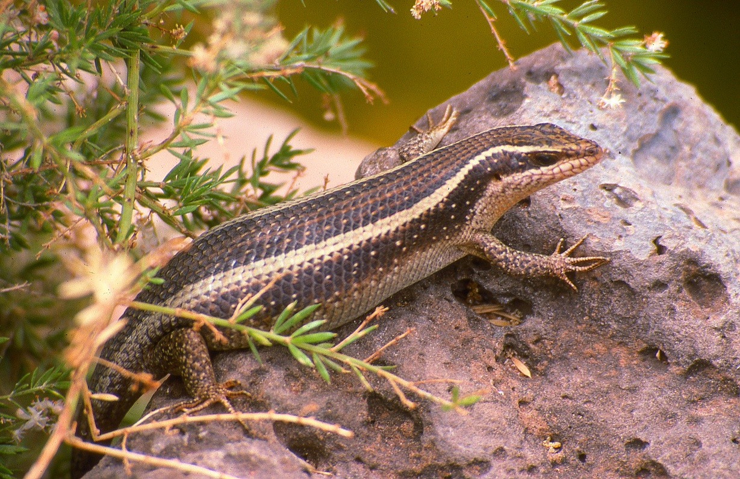
Striped skink, mjusi, Trachylepis striata. Widespread in Kenya, although rare in the dry northeast.

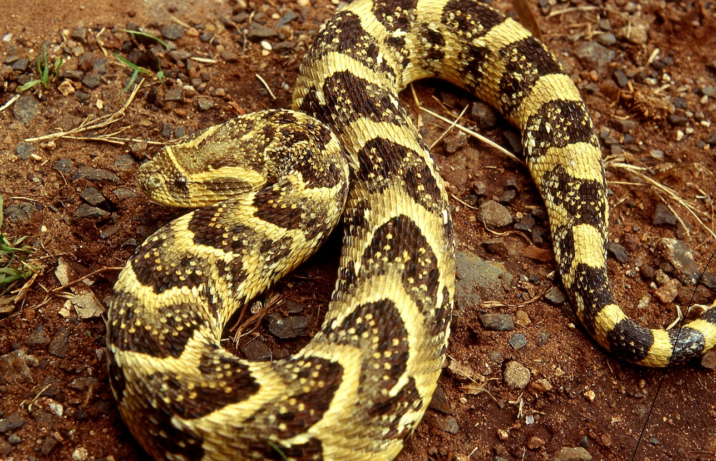
Puff adder, Kifutu au Bafe, Bitis arietans. Widespread in Kenya in savannah and semi-desert, rare above 2 000 m altitude. Very dangerous. Hatari sana!!

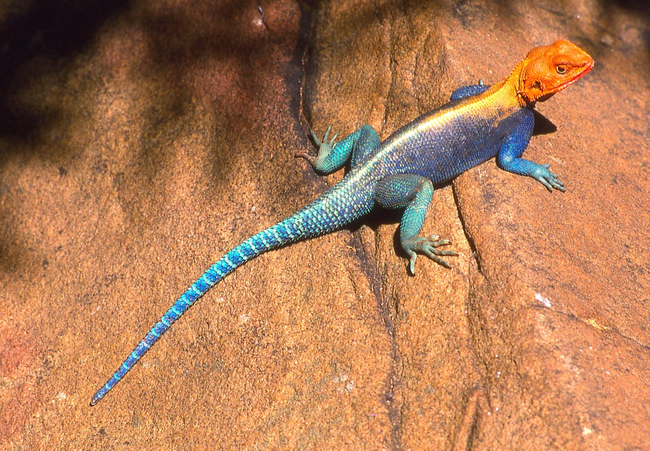
Red-headed rock agama, mjusi kaffiri, Agama (agama) lionotus. Widespread in the dry country of Kenya, where there are rocks and trees. This is a male.

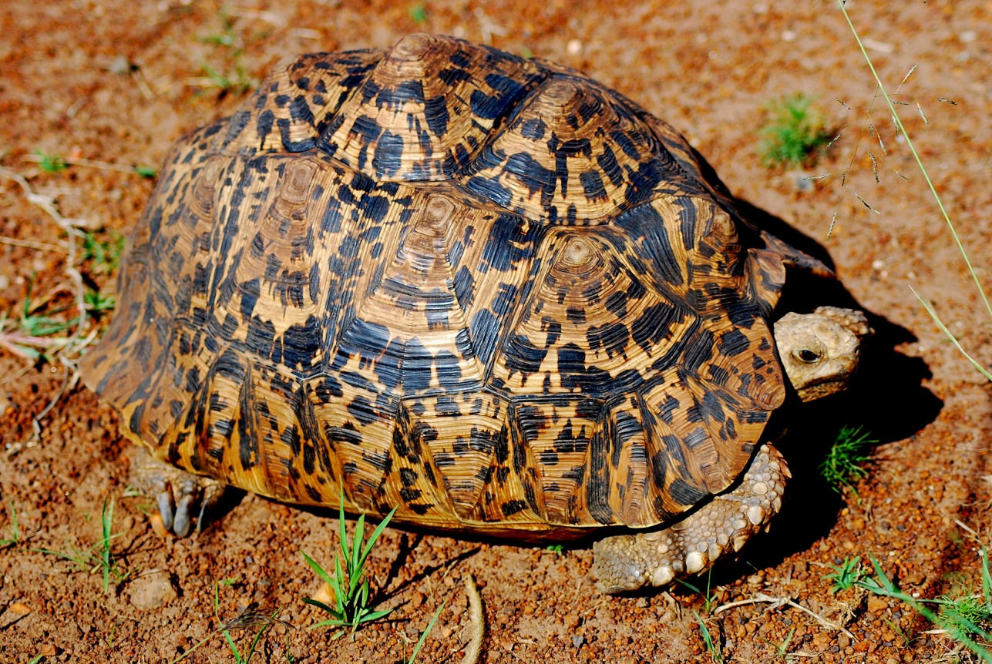
Leopard Tortoise, kobe. Stigmochelys (Geochelone) pardalis. Common in eastern Kenya and the coast, sporadic in northern Kenya. Not found above 1 600 m altitude.

