The Kenya Reptile Atlas
A free, downloadable atlas of Kenya’s reptiles. This is a free source of regularly updated information on Kenya’s Reptiles. Authors: Stephen Spawls, Beryl Bwong, Patrick Malonza, Vincent Muchai, Victor Wasonga
Obtainable under ‘downloads’ at Kenyareptileatlas.com
This project is funded by the Rufford Foundation under the auspices of the National Museums of Kenya; Department of Herpetology.

The Kenya Reptile Atlas offers you:
Pictures of Kenya’s reptiles
Distribution maps by quarter-degree-square
A description of the species
Click on any of the titles listed under the downloads tab to download for free. The various families will be added as the accounts are completed.
If you have any observations of Kenya’s reptiles, any distribution records, or any other data, or any digital pictures, we would like to receive them! Send them to Kenyareptileatlas@gmail.com
And if you live or travel in Kenya, and find any dead reptiles, please preserve them and take them to the Herpetology Section at the National Museum, Museum Hill, Nairobi.
The team thanks those who kindly commented upon the text of this section or generously loaned us pictures; including Susie Allan, Sanda Ashe, Rachael Barratt, Bill Branch, Anthony Childs, Bob Drewes, Harald Hinkel, Will Knocker, Vin Lawrence, Quentin Luke, the late Alex MacKay, Tomas Mazuch, David Modry, Thomas Price, Eduardo Razzetti, Steve Russell, Roberto Sindaco, Tim Spawls, Jan Stipala, Colin Tilbury and Lorenzo Vinciguerra. All uncredited photos by Stephen Spawls
Chameleons 2: Chameleons of the genus Trioceros, plus one introduced species and some undescribed species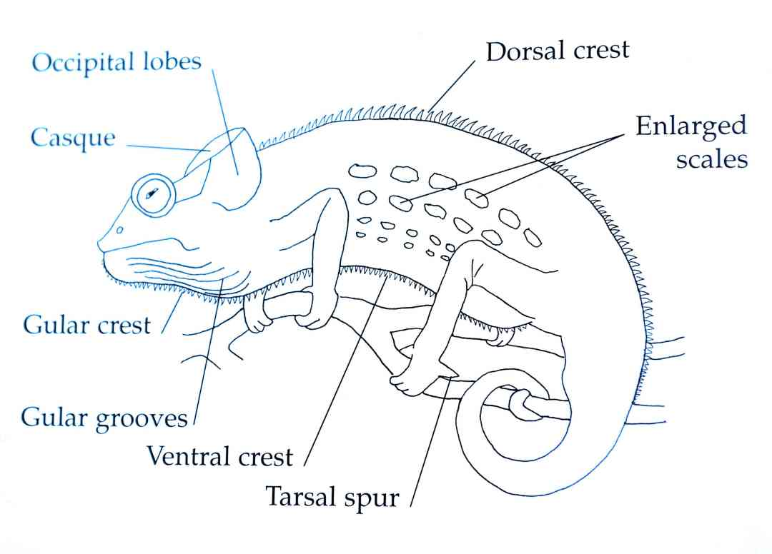
Some essential points of chameleon anatomy. (© Jonathan Spawls; after de Witte)
Some Taxonomic Notes: Some 13 species of chameleon of the genus Trioceros are recorded from Kenya, out of a total of 42 in Africa. Many of these, including several Kenyan forms, were originally regarded as subspecies of Chamaeleo bitaeniatus, the side-striped chameleon; others have an annulated bony horn. In 1963 the American herpetologist A. Stanley Rand revised the group. He elevated the four subspecies of Chamaeleo bitaeniatus then known from Kenya (C. b. bitaeniatus, C. b. ellioti, C. b. hoehnelii, C. b. schubotzi) to full species, based purely on the morphology of museum animals, a bold but ultimately correct move. In 2009, Colin Tilbury and Krystal Tolley suggested that the generic name Trioceros (coined in 1839 for the Congo species Trioceros grayii =T. oweni) be used for the clade that included all the side-striped chameleons of the bitaeniatus group and two Kenyan bony-horned species. The ‘bitaeniatus group’ or complex, are smallish chameleons, living mostly at high altitude, in shrubs and bushes in various types of savanna but rarely in forest. All East African members of the genus Trioceros have live young, and their populations appear to occasionally peak and crash, apparently as a result of predation. Seven of the thirteen Kenyan species live on isolated mountains and hills; some protected, some not. Like the chameleon genus Bradypodion in South Africa, they provide elegant proof of the evolutionary principle that isolation (in their case, resulting from climatic and tectonic changes) causes speciation. An ancestral species occupied the highlands; some of those ancestors climbed the emerging mountains, some adapted to montane conditions. Climatic change, causing the retreat of forest or cool montane vegetation upwards has left them trapped in pockets of suitable habitat, isolated and speciating, and global warming leaves them nowhere to go but up. See our supplementary notes at the end of this account.
Side-striped Chameleon Trioceros bitaeniatus
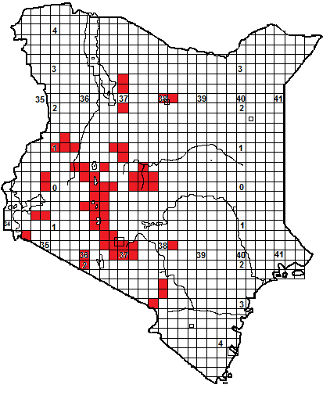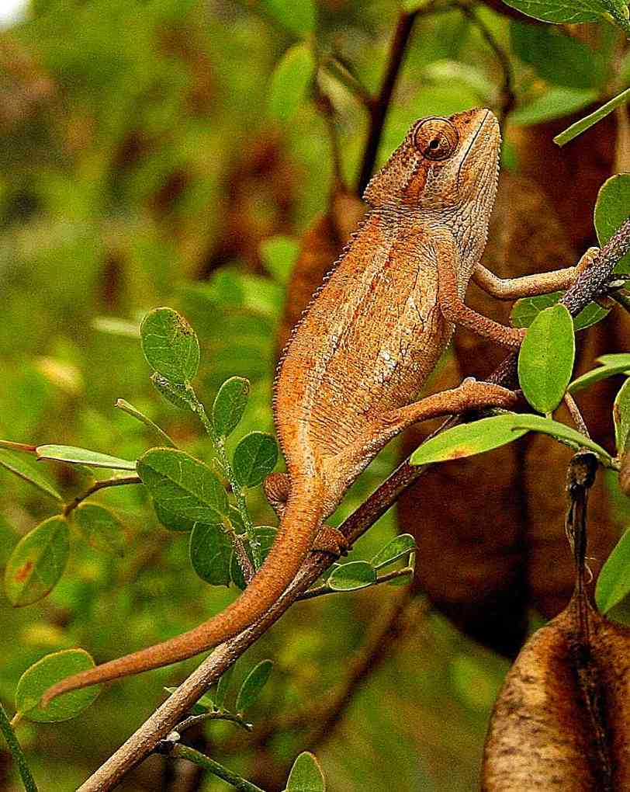
Local Names: Kinyonga (Swahili), Kimbu (Kikuyu), Nkototanki (Maasai); all generic.
Identification: A small brown or grey chameleon without horns but with a small gular crest or beard. Usually has two distinctive side-stripes, visible whatever the colour, and some enlarged scales on the flanks, particularly within the stripes. Average size 11 to 14 cm, maximum about 18 cm.
Distribution: A medium to high altitude savanna and grassland dweller, from 1 000 to 2 500 m, in northern Kenya may be in dry montane forest. Widely distributed in south-western Kenya, in savanna. In northern Kenya it is known from Mt Marsabit, Mt Nyiro and Kulal. The original type specimens were described by Gustav Fischer, who collected them at Lake Naivasha.
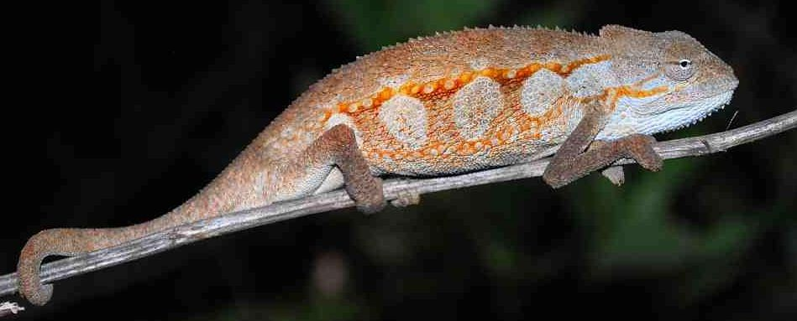

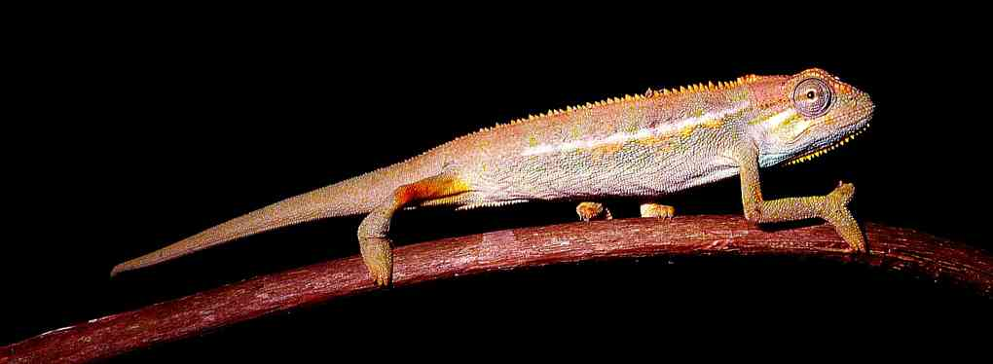
Natural History: Usually found in bush and thicket and rarely on big trees. May climb on stout grass, or Leonotus plants. Has been found in large numbers in and around Maasai manyattas. Sometimes abundant, but populations may peak and crash, this may be due to predation by birds like shrikes. They give live birth, usually 6 to 15, maximum 25 babies. Two broods of differing sizes have been recorded in the female oviducts, suggesting sperm retention, and females are known to eat their own young. Diet: small arthropods.
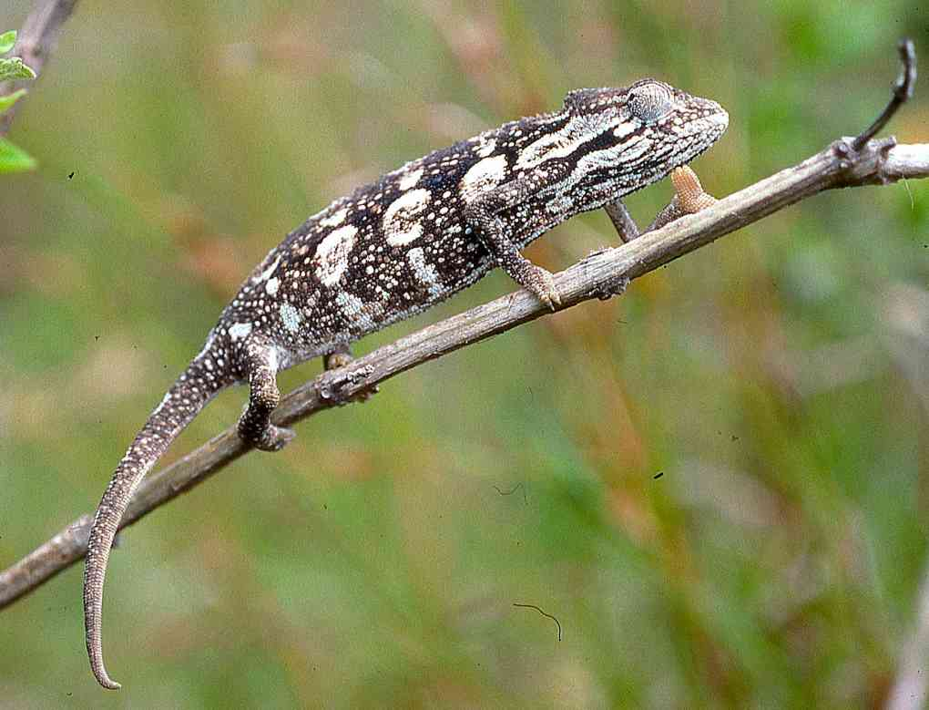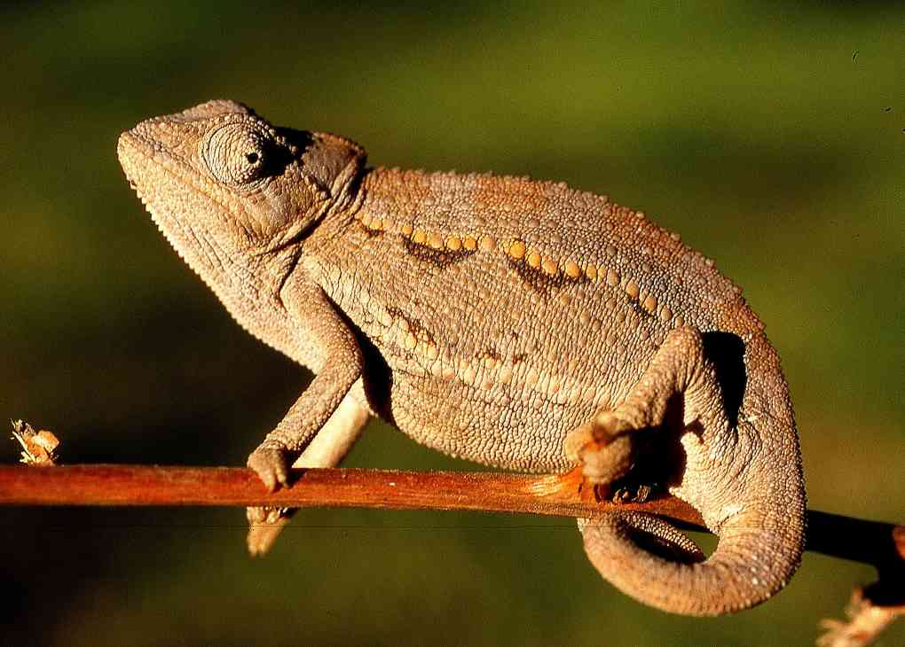
Conservation Significance: A widespread species, tolerates stock farming country of the rift valley and urban gardens, also occurs within Nairobi National park, Mt Longonot, Hell’s Gate and the Chyulu Hills, so unlikely to be under any threat. 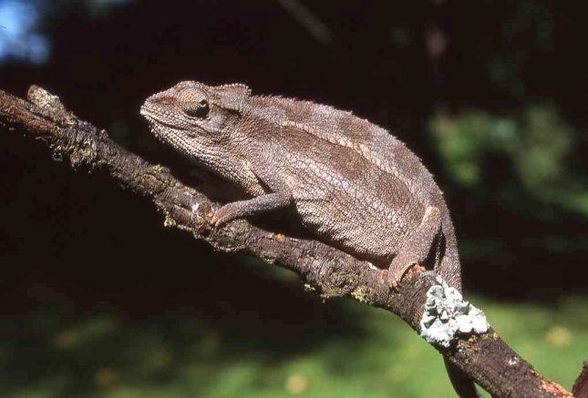
Illustrations: top Ngong,( © Susie Allan), upper middle Gilgil, lower middle and lower left Arusha (© Lorenzo Vinciguerra), lower right and bottom Naivasha.
Montane Side-striped Chameleon Trioceros ellioti
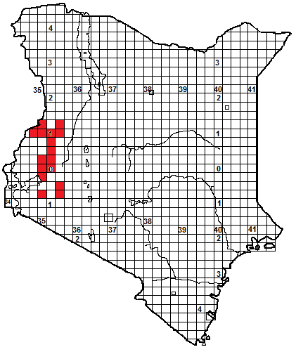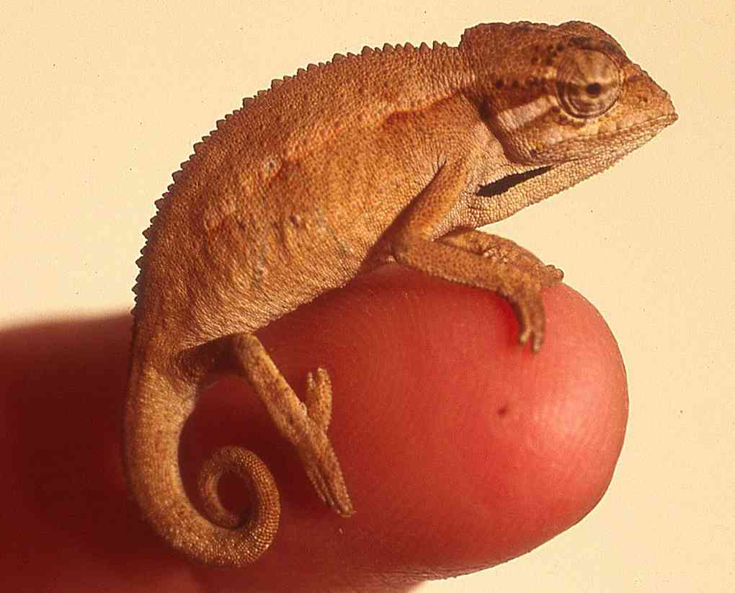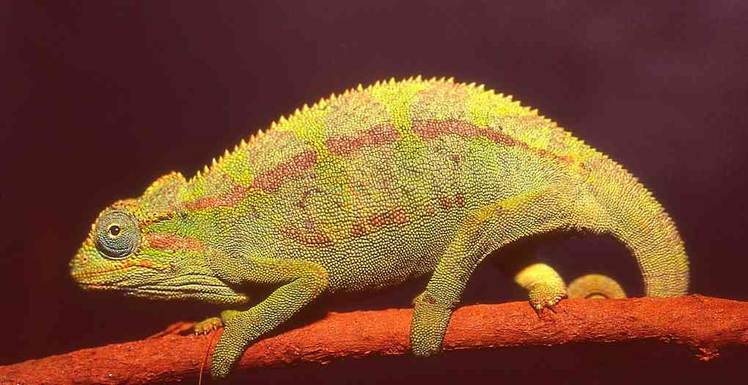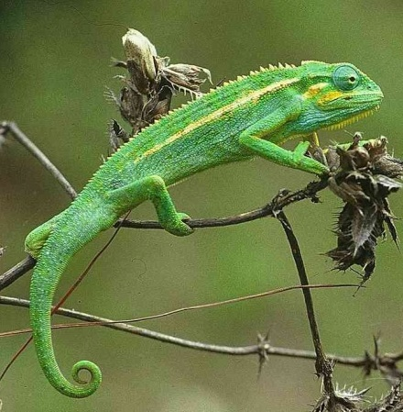

Local Names: Kinyonga (Swahili), Ong’ongruok (DhoLuo), Ekhaniafu (Luhya); all generic.
Identification: A small green or brown chameleon, often with a trace of blue, without horns but with a small gular crest or beard, the interstitial skin of the gular grooves is usually black (but sometimes unpigmented in high-altitude specimens). Has two side-stripes, the upper more prominent, with some slightly enlarged scales within. Average size 11 to 14 cm, maximum about 19 cm.
Distribution: Medium to high moist savanna, woodland and forest fringes, often around water sources, in high rainfall areas of western Kenya, at medium (1 400m ) to high (2 500 m) altitude, from Kisii, the western Mau and Kericho north through Kakamega area to the Cherangani Hills and the slopes of Mt Elgon.
Natural History: Usually in low trees, bushes, shrubs and tall grass, sometimes in reedbeds and sedge in swampy areas. Tolerates agriculture and urban gardens well, where it will live in hedges and ornamental trees. Often abundant in areas and, like the side-striped chameleon, its population may peak and crash. They give live birth, up to 28 babies at a time, and can retain viable sperm, as was demonstrated by a captive female who had five litters over 18 months without contact with a male. Hatchlings were found around Kakamega town in June and July. Diet arthropods. 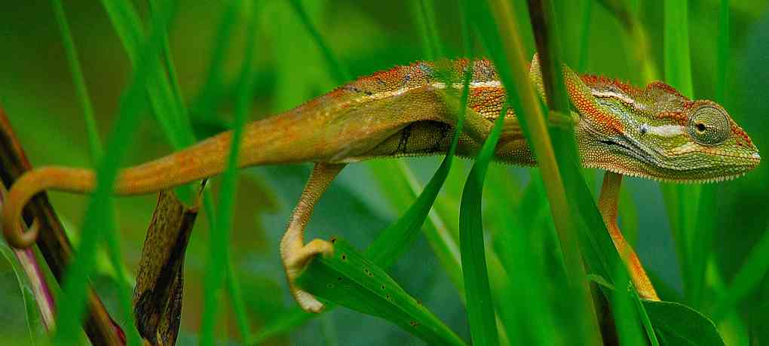Conservation Significance: A widespread species in Kenya, Uganda and the Albertine Rift; tolerates agriculture and urbanisation. Found in Mt Elgon National Park and Kakamega Forest, and in several protected forest areas, including the Nandi Forests.
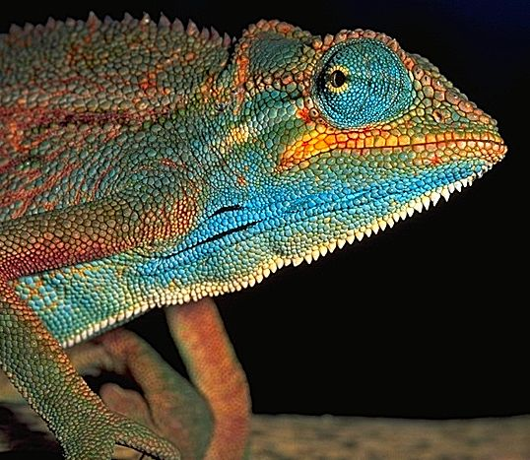 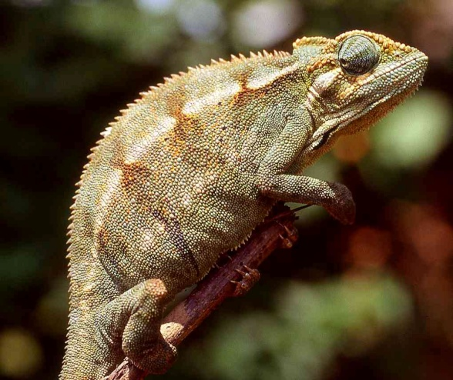I 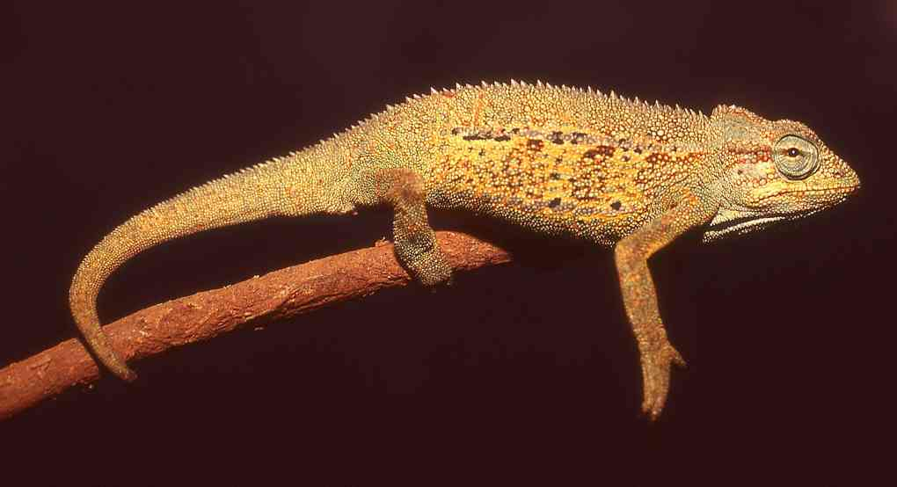
Illustrations: All Kakamega except middle, Kasese, Uganda, © Steve Russell, blue specimen , © Bob Drewes, Bwindi, Uganda, and lower top right, yellow-striped green, Rwanda, © Harald Hinkel.
Von Höhnel’s Chameleon Trioceros hoehnelii
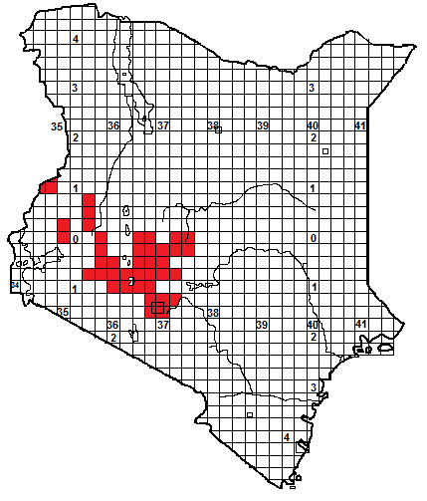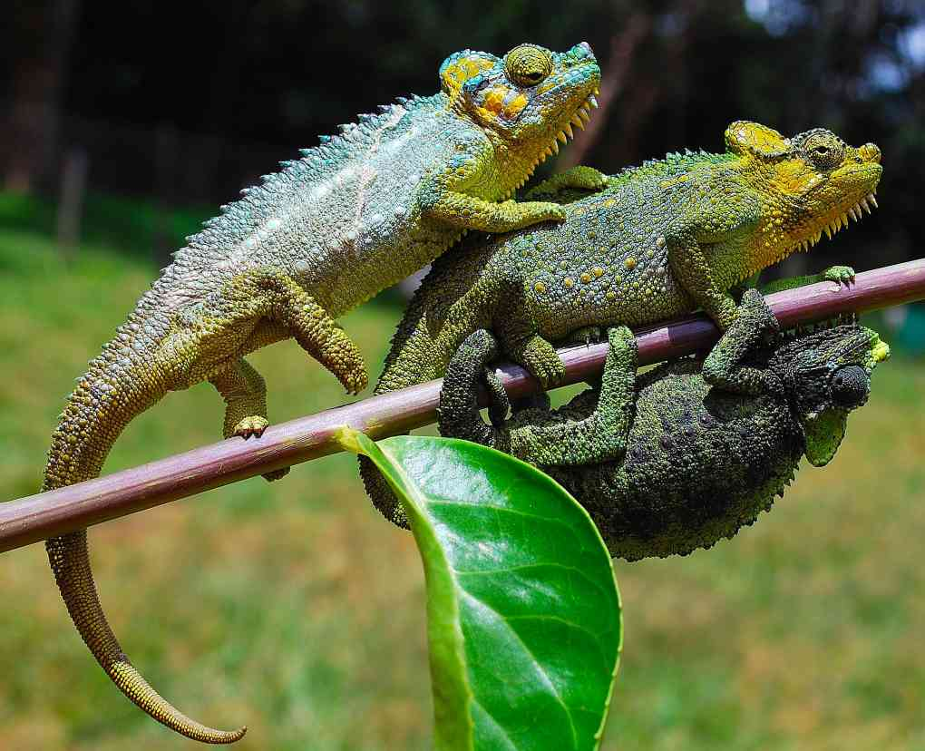

Local Names: Kinyonga (Swahili), Kimbu/Kembu (Kikuyu) Ong’ongruok (DhoLuo), Ekhaniafu (Luhya); all generic.
Identification: A small chameleon, colour very variable, with a blunt horn on the nose, a large raised helmet-like casque and a prominent ‘beard’ of enlarged gular tubercles under the chin. Has two prominent side-stripes with enlarged scales within. Size varies with locality; up to 23 cm on Mt Kenya, maximum 16 cm on Mt Elgon; Average size 12 to 15 cm.
Distribution: Medium to high savanna, grassland and moorland, from 1 500m to over 4000m altitude. Occurs north from Nairobi and the Ngong Hills to the Aberdares and Mt Kenya, where it is found at altitudes over 4 000m; thence westwards (although not recorded from the Rift Valley floor) to the Mau, north along the western wall of the Rift Valley, to the Cherangani Hills and Mt Elgon. In areas where the side-striped chameleon is found nearby, Von Höhnel’s chameleons seem to live higher up on the hillsides.
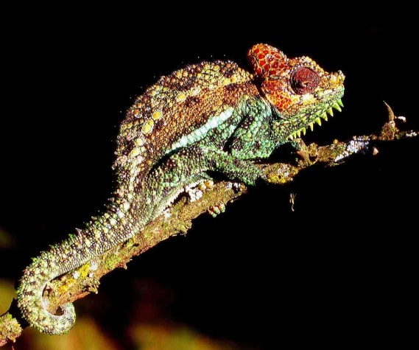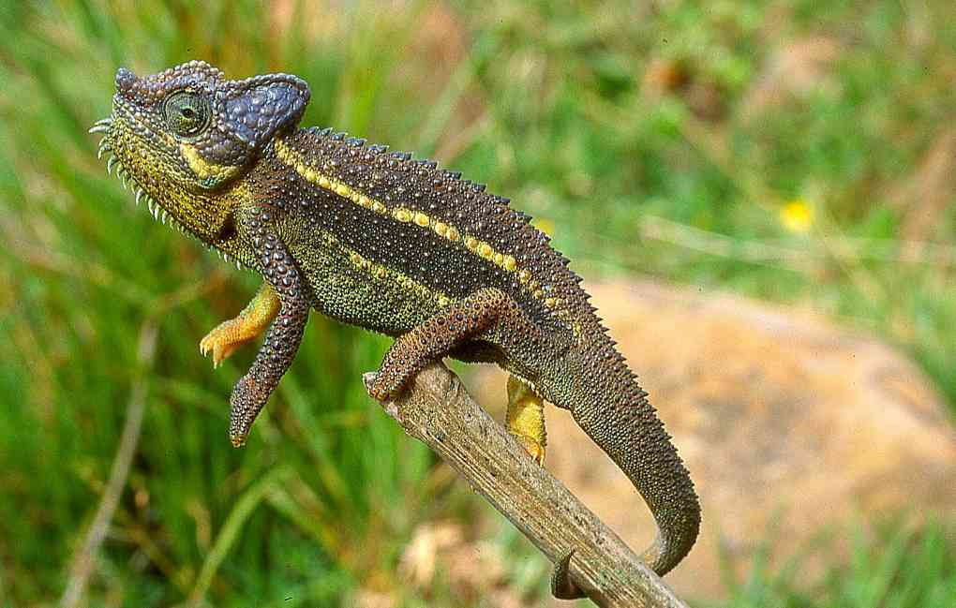
Natural History: Usually in low trees, bushes, shrubs, reeds, tall and tussock grass. Tolerates agriculture and urban gardens well, where it will live in hedges and ornamental trees. Often abundant in areas and, like the side-striped chameleon, its populations may peak and crash; in the Limuru area population densities of over 300 animals per hectare have been recorded. The males fight, circling, looking threatening and biting. They give live birth, 7-18 babies at a time. They can supercool, on the Aberdare moorlands they survive temperatures below minus 2ºC. Diet arthropods.
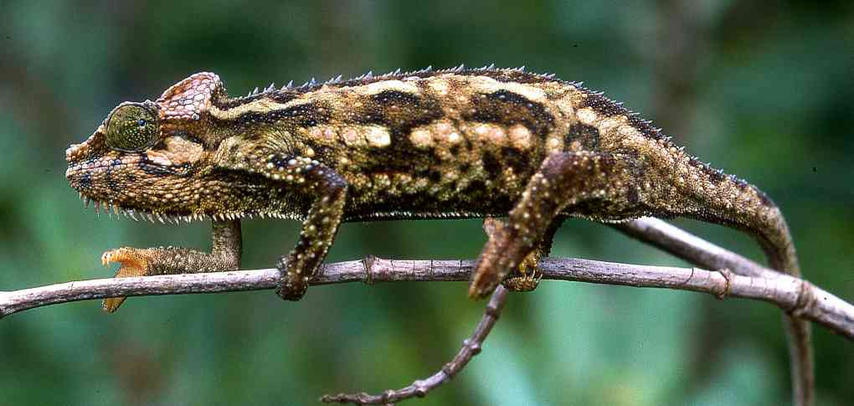
Conservation Significance: A widespread species in Kenya, and capable of thriving in agricultural areas, range protected in the Aberdare, Mt Kenya and Mt Elgon, so probably not under any threat.
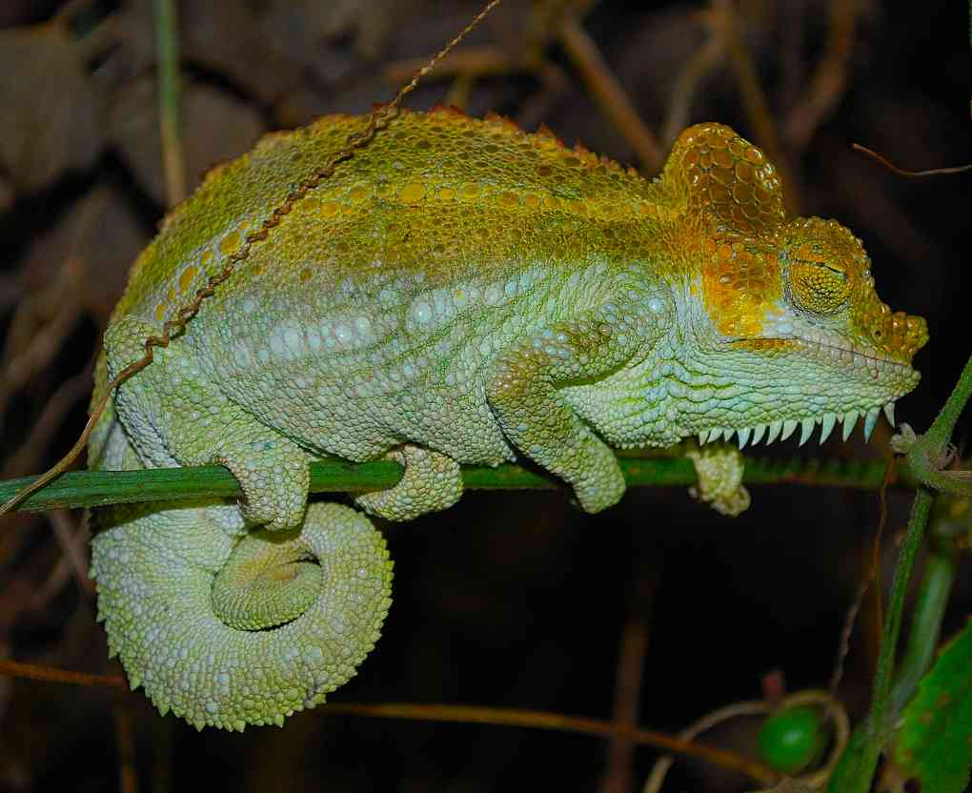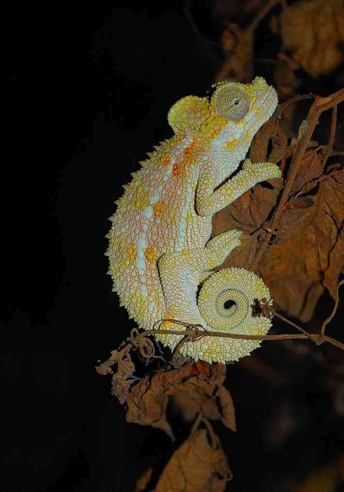
Illustrations Nyahururu (top), Mau Escarpment (ML),Aberdares, (MR), Uplands (lower middle), Kembu Camp, Njoro (both bottom).

Jackson’s Chameleon/Kikuyu Three-horned Chameleon Trioceros jacksonii
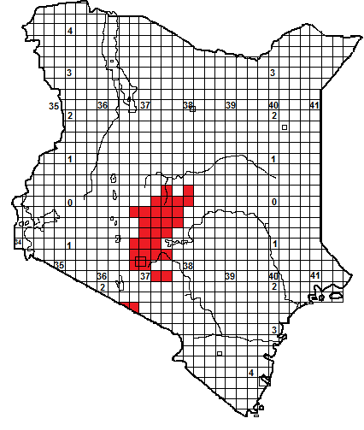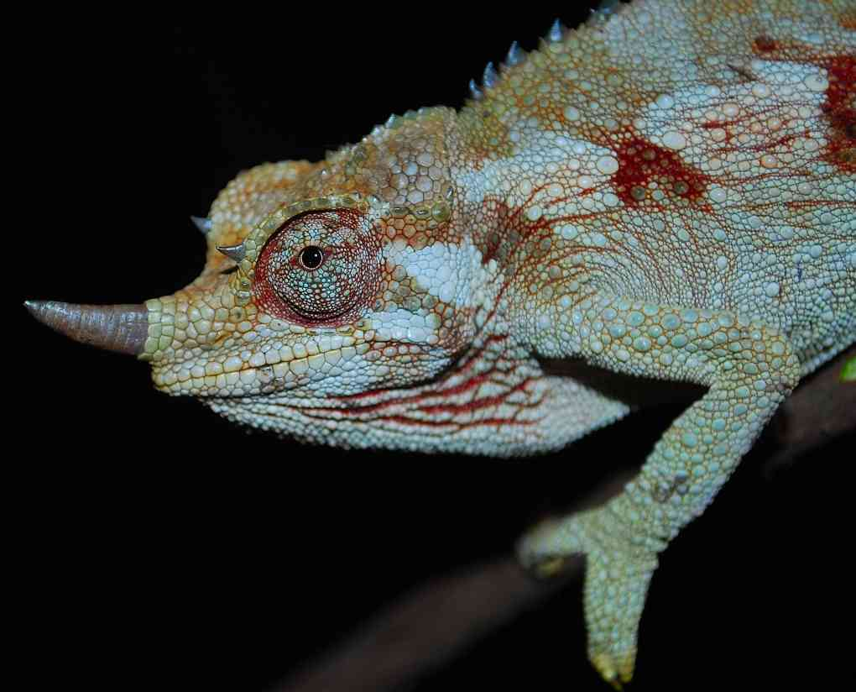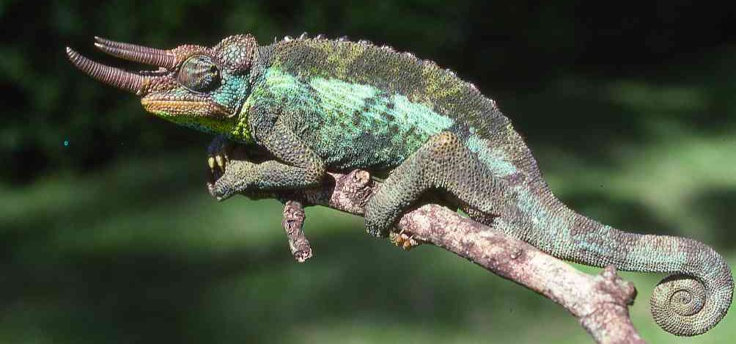
Local Names: Kinyonga wa pembe tatu(Swahili), Kimbu/Kembu/Muriiu (Kikuyu), Muriu (Embu); (last two generic).
Identification: A big chameleon, the males have three annular snout horns; the females may have one big and two little horns, a single horn or no horn. The casque is slightly raised, there is no beard. Males are usually some shade of green, females may be black and white, grey and white, greenish or some mixture of colours. Males (especially from eastern Mt Kenya) may reach 38 cm, but 20-25 cm is more usual.
Distribution: Mid-altitude woodland and forest of high central Kenya, east of the Rift Valley, between altitudes of 1 500 and 3 200 m. Occurs north from Nairobi northwest to Kijabe and the Kikuyu Escarpment forest, north through Thika, Muranga and Sagana to the Mt Kenya forest and the Nyambene Hills. Known from the eastern Aberdares and the northern and southern ends, but not the west. There are outlying populations on Ol Donyo Sabuk and the hills around Machakos, Ol Donyo Orok and on Mt Meru in Tanzania (named as the sub-species T. j. merumontanus, males with a bright yellow forehead).
Natural History: Occurs in forest (both moist and dry) and woodland, where it ascends up to 10 m or more in forest trees, but is equally fond of thicket, bushes and shrubbery. It tolerates agriculture, coffee farms and urban gardens well, (common in the suburbs of Nairobi, Embu and Meru) where it will live in hedges and ornamental trees. The males fight, circling, looking threatening, locking horns and biting; one has been seen to stab its rival through the leg. If threatened, they will sometimes jump from their perch. They give live birth, 7-30 babies at a time (although a scarcely credible maximum of 52 in a captive female is reported!). Diet arthropods.
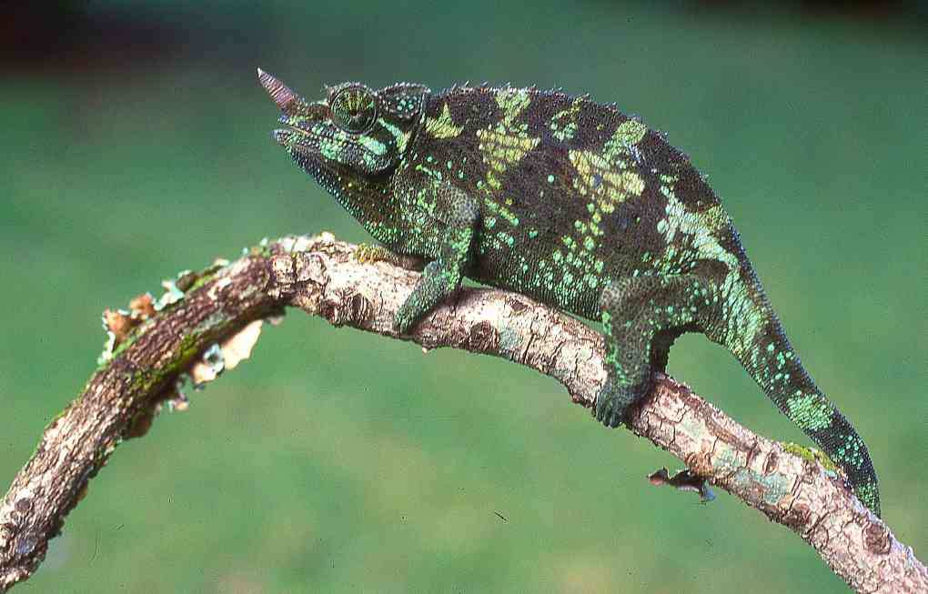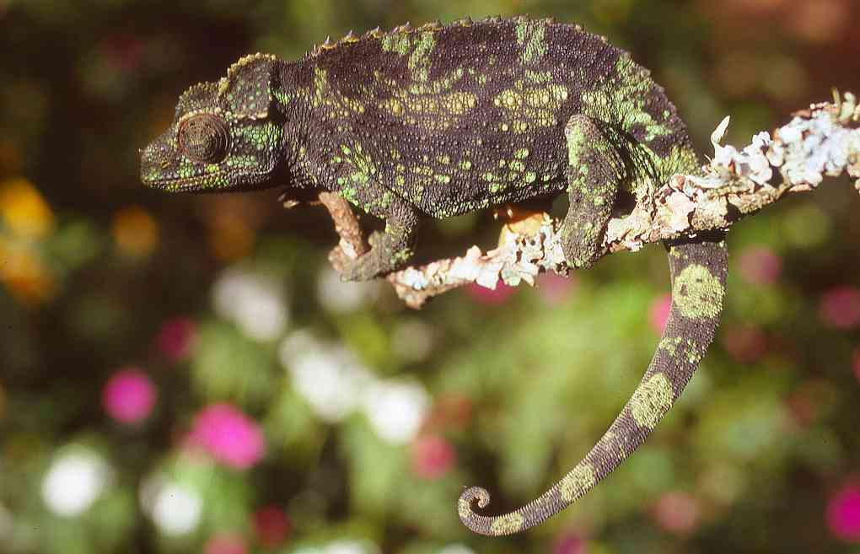
Conservation Significance: Two subspecies recognised in Kenya: C. j. jacksonii is protected in Nairobi National Park, Ol Donyo Sabuk and the eastern Aberdares, C. j. xantholophus is protected in the Mt Kenya National Park and the attendant forest reserves. Their ability to cope with agriculture and urbanisation means they are probably under no threat, but they are utilised and popular in the pet trade.
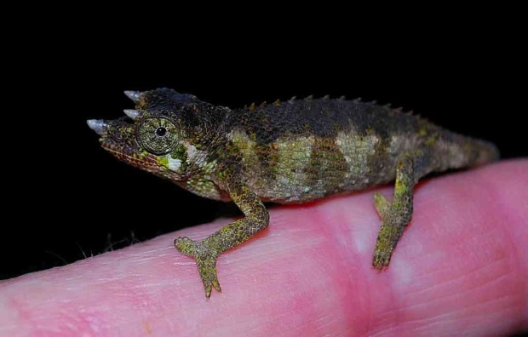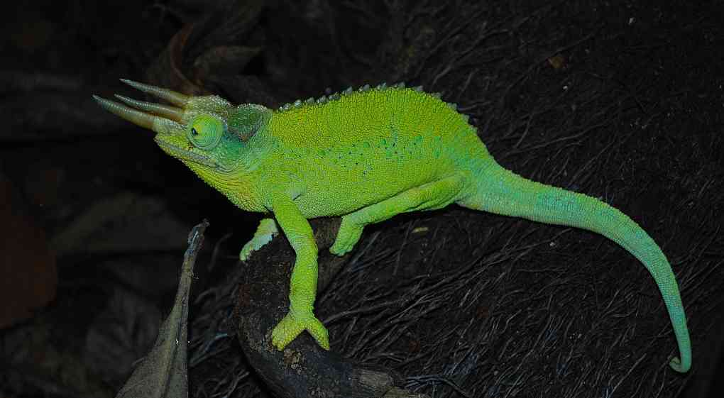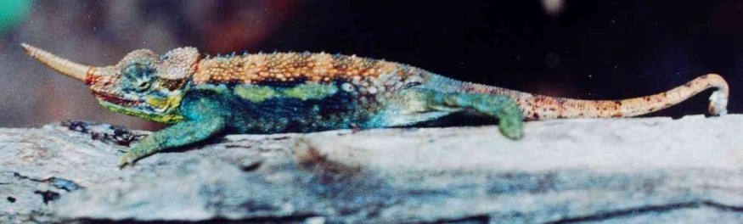
Illustrations: top; male (L) female (R) Nairobi, centre female Nairobi (L), female Embu (R), upper bottom juvenile male Naro Moru (L), male Meru (R), lower bottom Ol Donyo Orok (© Alex MacKay)
Mount Kinangop Alpine Chameleon/Aberdare Chameleon Trioceros kinangopensis
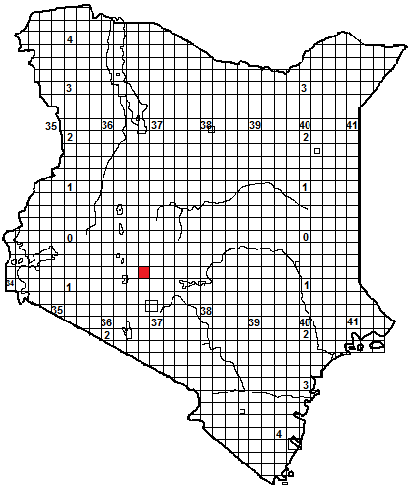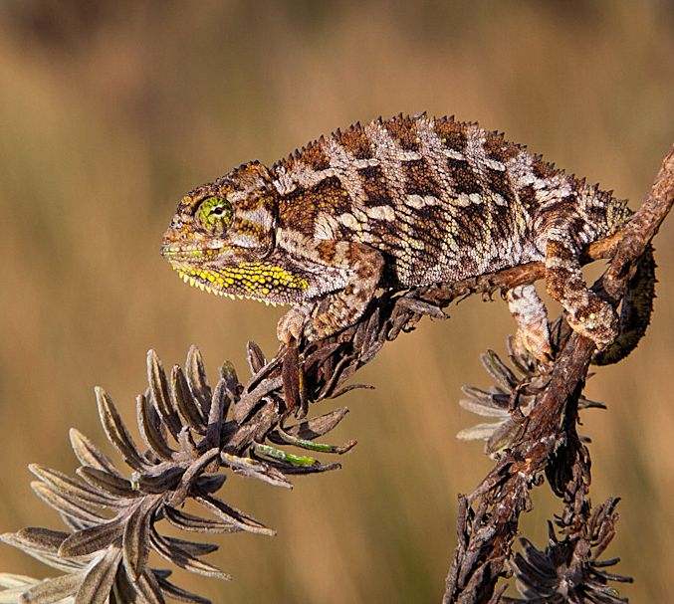
Identification: A squat little chameleon with a flat casque, a small gular crest, no horns or rostral processes. The tail is slightly less than half the total length. There are two stripes on the flanks, and enlarged scales on the flanks, and within the side-stripes. Males appear to be some combination of green and black or brown, with an orange gular crest, females yellow, grey and brown, with a yellow-orange gular crest. Maximum size about 12 cm. This species closely resembles T. schubotzi (which is why T. schubotzi has been erroneously reported from the Aberdares).
Distribution: Known only from the vicinity of Mt Kinangop, a cluster of peaks at the southern end of the Aberdare Mountains. Twelve specimens were collected in 2007, basking on ericaceous shrubs in a tussock grass area in the alpine zone at 3 500 m altitude. Described in 2012, by Jan Stipala and members of the team that found the first (and so far only) specimens.
Natural History: Active by day, eats small arthropods. Presumably gives live birth.
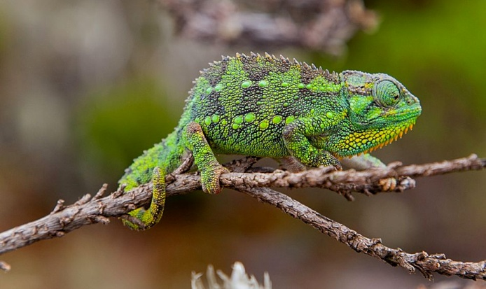Left male, above female: © Jan Stipala.
Conservation significance. At present, known only from a tiny high-altitude area inside the Aberdare National Park, so habitat fully protected, but possibly at risk from global warming, as it cannot move much further up. Might occur on the northern Aberdare peaks around Ol Donyo Lesatima.
Mount Marsabit Chameleon Trioceros marsabitensis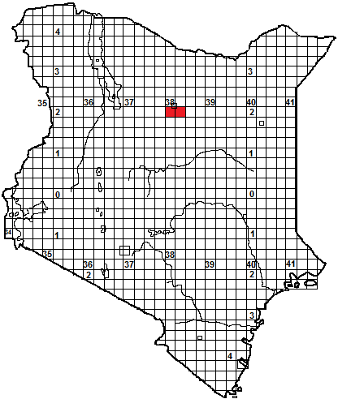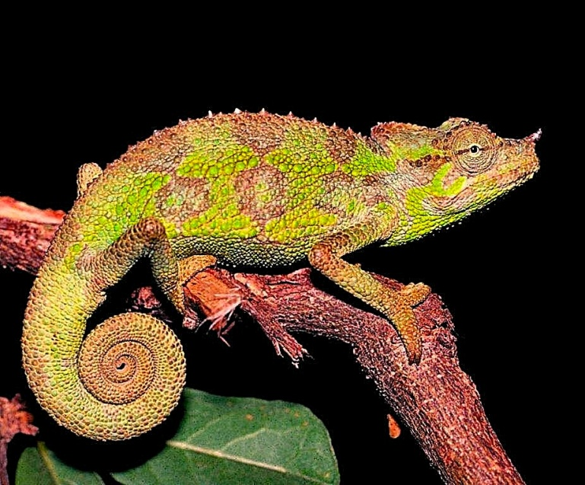
Local Names; Garrara (KiBoran).
Identification: A small green and brown chameleon with a slightly raised casque and no gular crest. Males have a single small annulated nose horn, females have a small nose tubercle. The tail is about half the total length. Enlarged scales on the flanks, suggesting an upper flank stripe. Maximum size about 18-19 cm.
Distribution: Known only from the forest of Mt Marsabit, at an altitude around 1 250 m, where it was first collected by Dr Colin Tilbury in 1988 and described in1991.
Natural History: In trees and bushes in the forest, recorded ascending to heights of 6 m, juveniles were found in bushes. Active by day, eats small arthropods. The males probably fight with their horns. Presumably gives live birth, 45 mm hatchlings were collected in May.
Conservation significance. Known only from the forest south of Marsabit town, within the Marsabit National Park; thus its entire known habitat is protected.
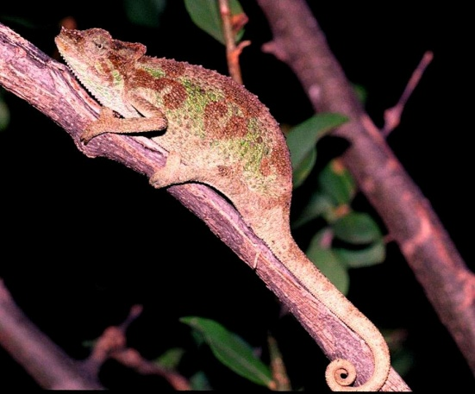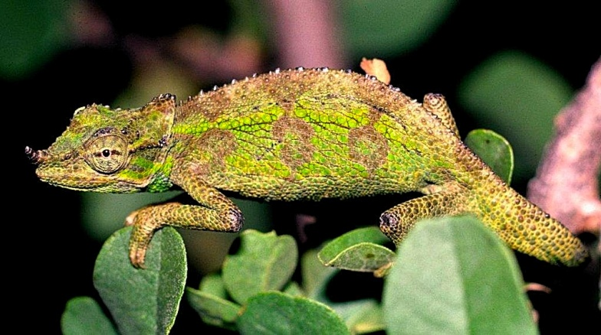
All illustrations; © Colin Tilbury; male top and bottom right, female bottom left.
Mount Kulal stump-nosed Chameleon Trioceros narraioca

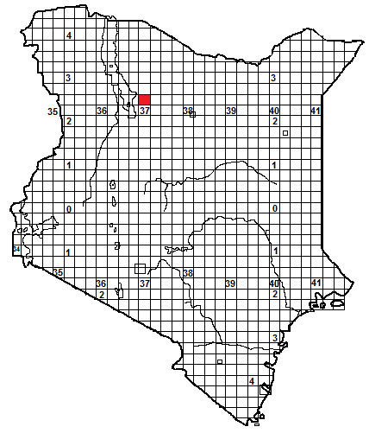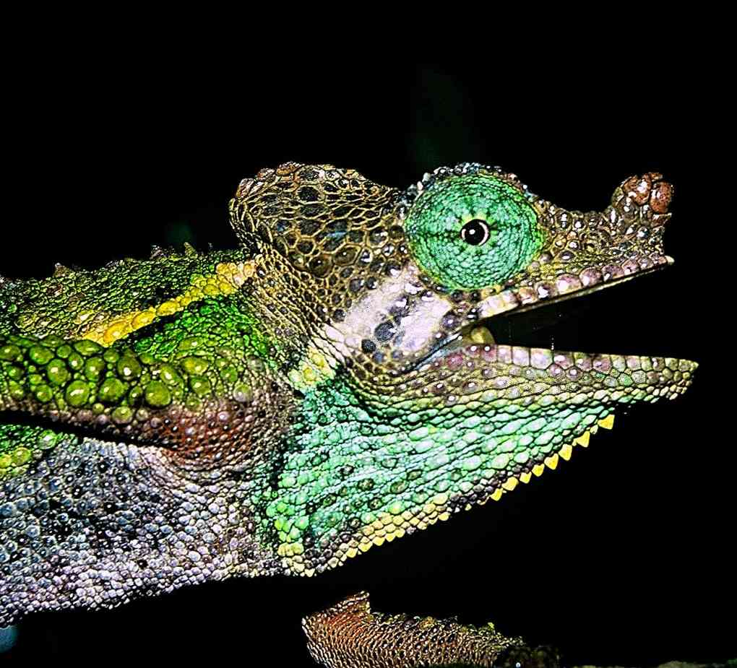
Local Names: Narrayioca (Samburu)
Identification: A small chameleon, similar in appearance to Von Höhnel’s chameleon, may be various patterns and shades of green, brown, yellow or grey, with a fairly tall casque and a small gular crest. It has a distinctive knob-like rostral process or horn; the males’ horn is slightly larger on average than the females’. The tail is about half the total length. The scales are markedly heterogeneous, with the head and casque covered by plate-like scales, and two distinctive rows of enlarged tubercles along the flanks. Maximum size about 17 cm.
Distribution: Known only from the montane forest belt at 1 700 to 1 800 m altitude on Mt Kulal, an extinct volcano east of the south-eastern shore of Lake Turkana.
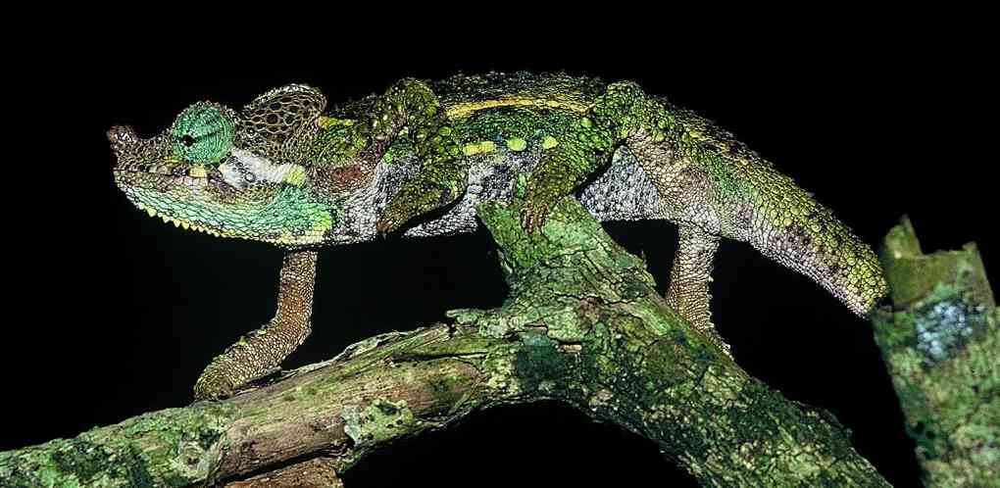
Natural History: In trees in the forest, but on the forest margins occurs in hedges, peri-urban vegetation and agriculture. Active by day, eats small arthropods. . Presumably gives live birth.
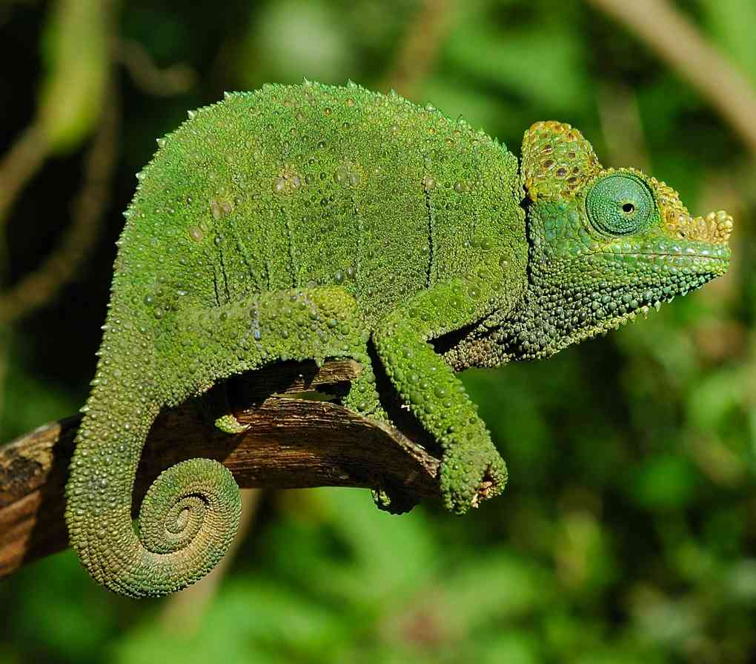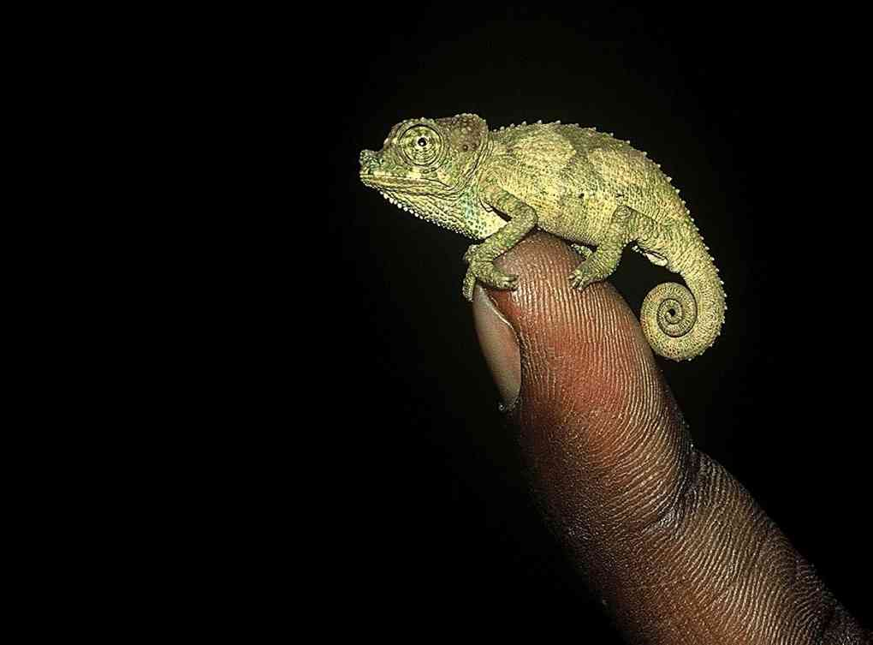

Conservation significance. Known only from the forest on Mt Kulal, which is officially declared a biosphere reserve but in practice doesn’t receive much protection.
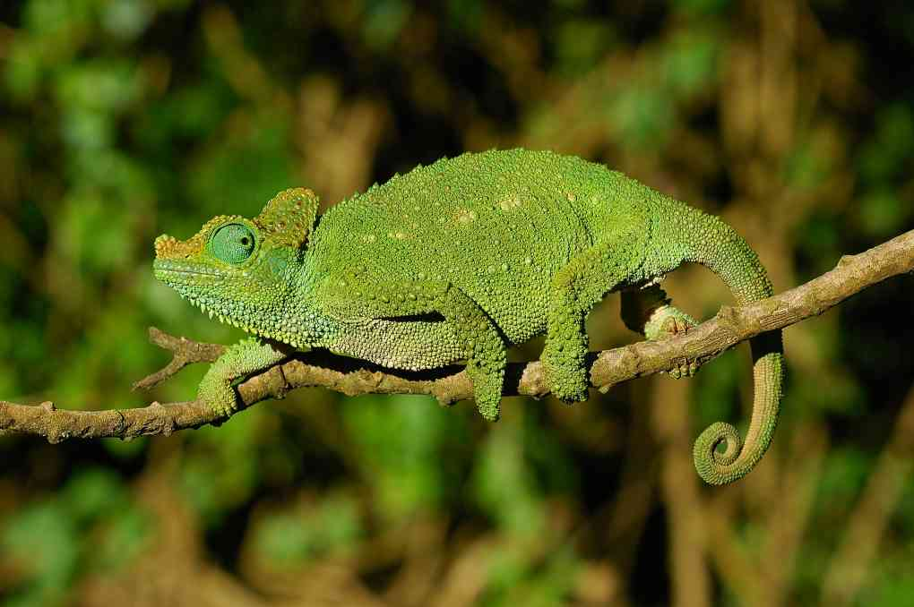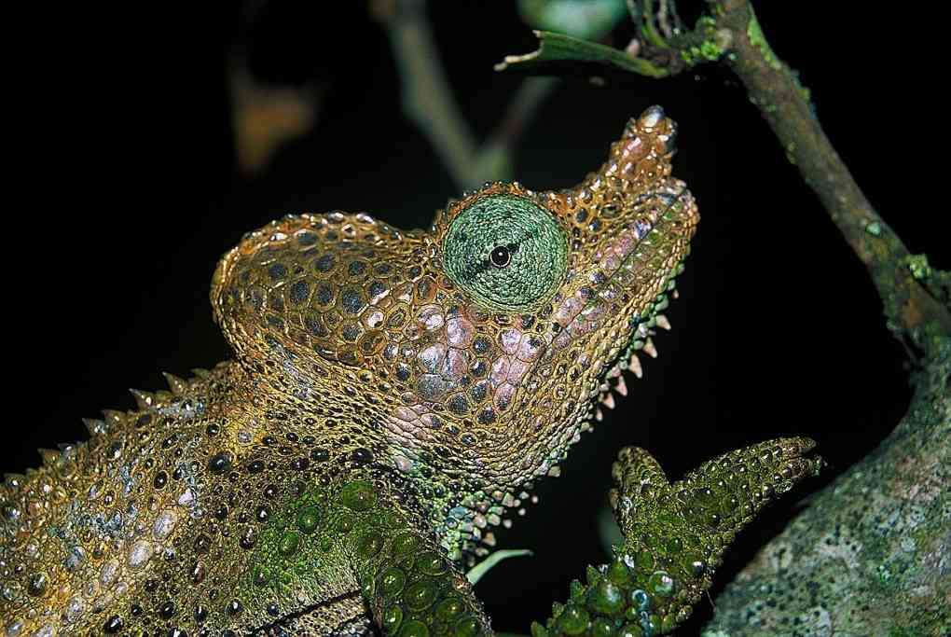
Illustrations: All © Tomas Mazuch, except green individual, © Eduardo Razzetti
Mount Nyiro Montane Chameleon Trioceros ntunte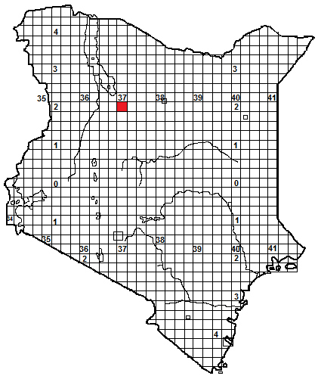 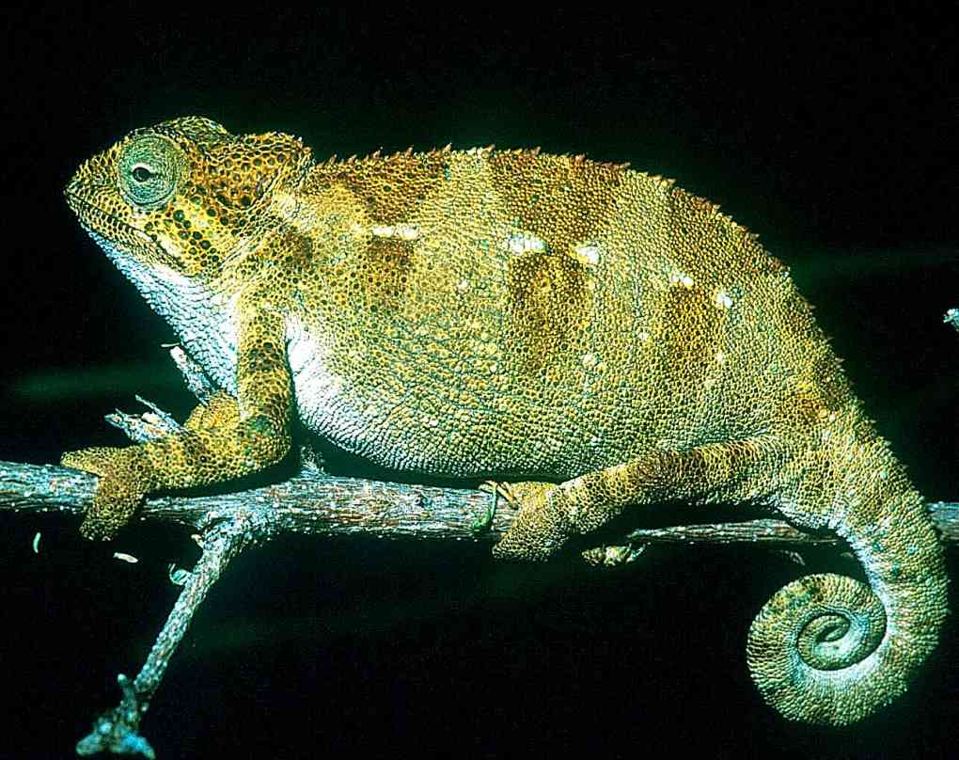
Local Names: N’tunte’ (Samburu), which loosely translates as ‘fat belly’!
Identification: A small stout chameleon with a slightly raised casque and a weak or non-existent gular crest. Overall colour brownish or greenish. The tail is slightly less than half the total length. Enlarged scales on the flanks, following a prominent upper stripe, lower stripe indistinct. Maximum size about 15 cm.
Distribution: Known only from Mt Nyiro, south of the southern end of Lake Turkana, at an altitude of 2 500 to 2 700 m, west of the town of South Horr.
Natural History: In bushes and small trees on moorland, at the edge of the bamboo forest. A slow-moving and apparently placid species. . Active by day, eats small arthropods. Gives live birth, nine to eleven young recorded, born in March.
Conservation significance. Known only from the moorland on Mt Nyiro. Another species of endemic chameleon, Kinyongia asheorum, is confined to this mountain, at a lower altitude. Mt Nyiro is a 450 km² gazetted forest, so nominally protected.
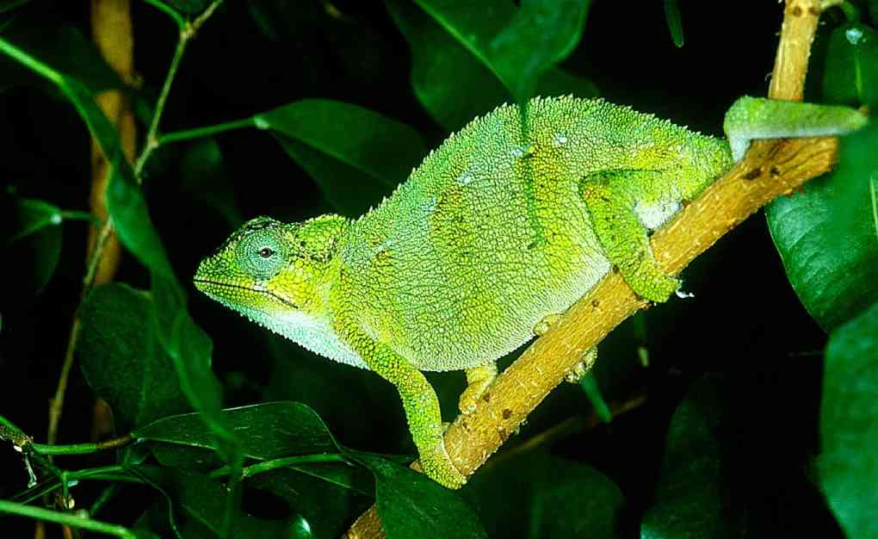Pictures © David Modry
Pokot Chameleon Trioceros nyirit
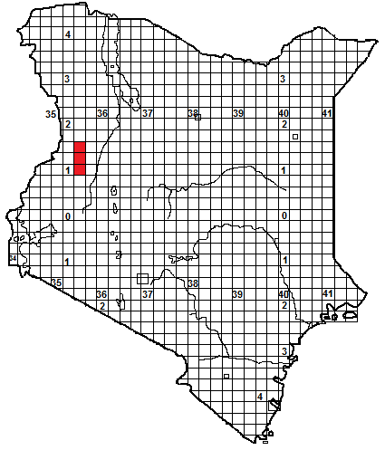 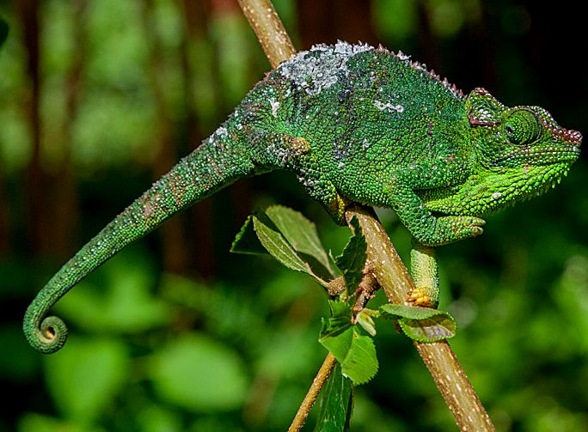Local Names: Nyirit (Pokot), meaning ‘chameleon’.
Identification: A small stout chameleon, rather similar to Von Höhnel’s chameleon, with a slightly raised casque and a gular crest that may be short or long. Overall colour brownish or greenish. The tail is slightly less than half the total length. Body scales are heterogeneous, with enlarged scales on the flanks, following the upper and lower flank stripes. Maximum size about 19 cm (males), 16 cm (females).
Distribution: Cherangani Hills, between altitudes of 2 900 and 3 150 m, (probably also at lower altitudes) and also on the Mtelo (or Sekerr) Massif, north of the Cheranganis across the Marich Pass, between 2 200 and 3 200 m altitude.
Natural History: On shrubs and small trees, at the edges of forest and in ericaceous shrubs above the treeline, also in hedges, roadside vegetation and shambas in the Cherangani Hills. The males fight, circling and biting. Diurnal, presumably give lives birth and eats insects and other arthropods.
Conservation significance. Sekerr is a non-gazetted forest reserve; but there are several forest reserves in the Cherangani Hills, and the existence of this species in agricultural lands bodes well for its survival.
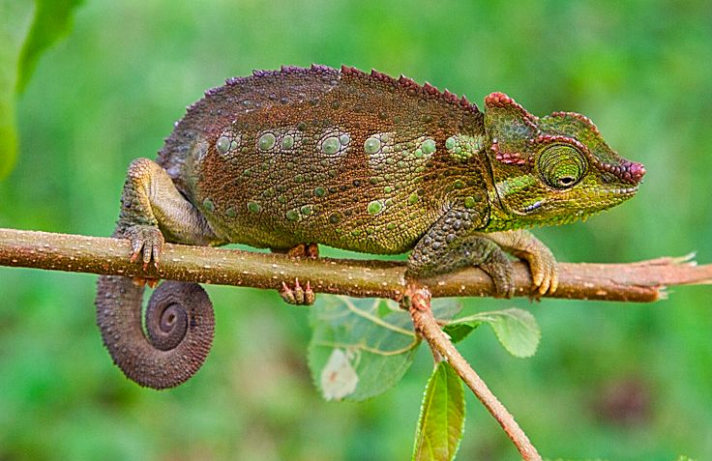All pictures: © Jan Stipala
Mt Kenya Side-striped Chameleon Trioceros schubotzi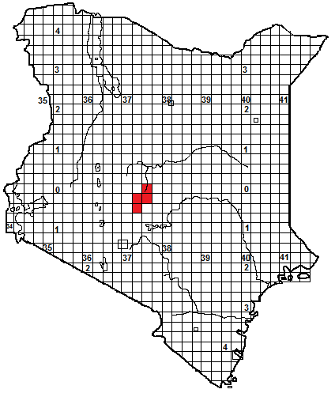 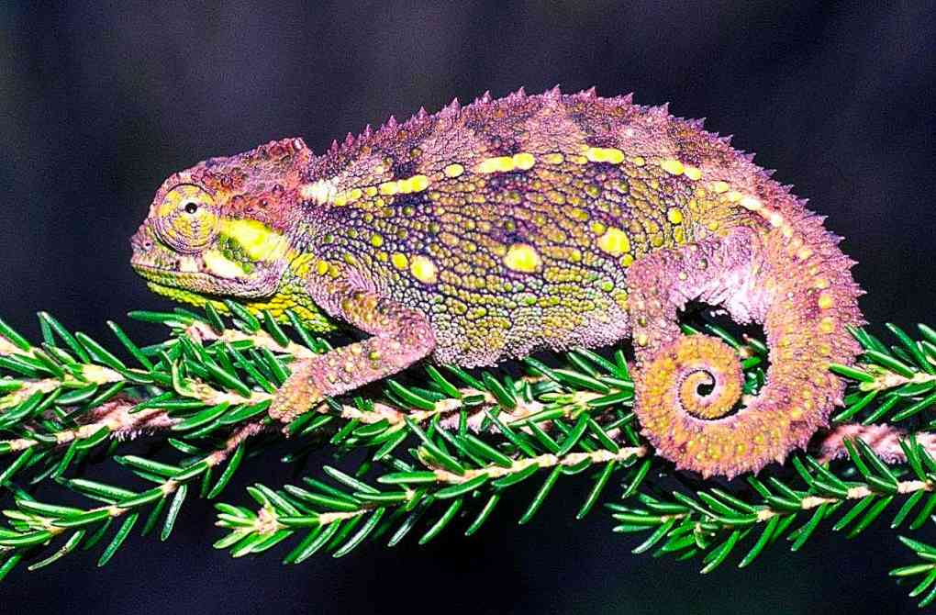
Identification: A small squat chameleon, with a gular crest that may be short or long. Overall colour grey, grey-green or brownish; the body scales are heterogeneous, with enlarged scales on the flanks, those following the prominent upper and lower flank stripes often big and sub-circular. Tail half or less than half total length. Maximum size about 15 cm.
Distribution: Endemic to Kenya and found only in the alpine zone of Mt Kenya, from 3 000 m upwards to 4 200m.
Natural History: Lives in ericaceous shrubs, small trees and tussock grass. Diurnal, it can forage at very low temperatures. Sleeps at night inside bushes. It can supercool, and thus tolerate temperatures below 0ºC. Gives live birth, 7-10 young, there seems to be no definite breeding season. Eats insects and other arthropods.
Conservation significance. A Kenyan endemic with a very restricted range, fortunately it all lies within the Mt Kenya National Park. It might be at risk from fires, and also global warming.
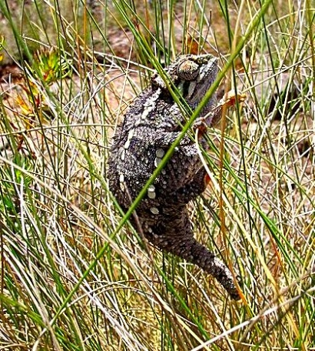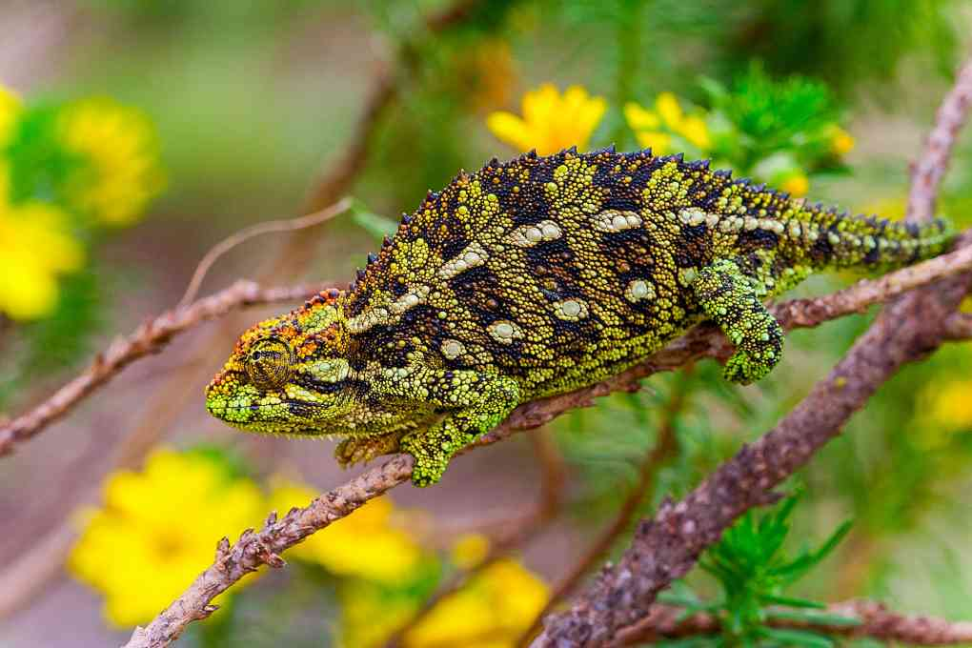
Illustrations: Will Knocker (BL), Colin Tilbury (T), Jan Stipala (BR)
Tanzanian Montane Dwarf Chameleon Trioceros sternfeldi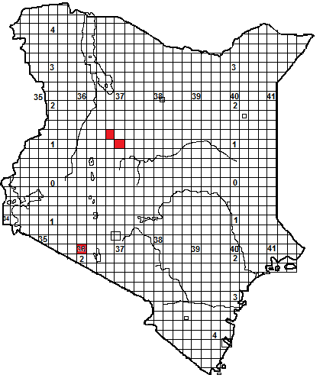 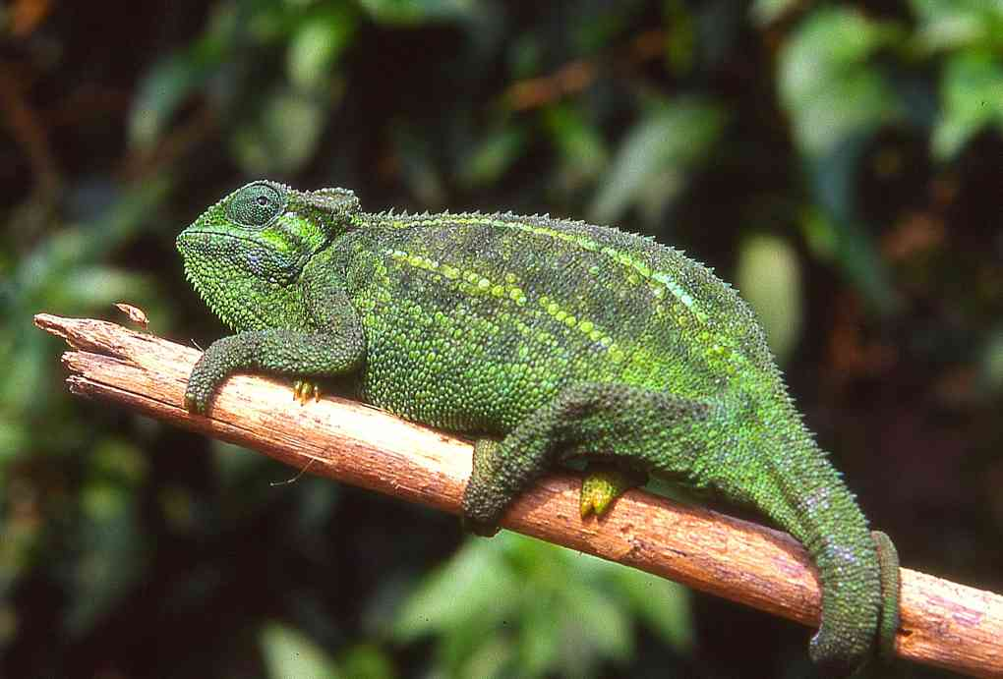
Identification: A small squat chameleon, with a short gular crest. Usually some shade of green. The body scales are heterogeneous, with enlarged scales on the flanks, those following the prominent upper and lower flank stripes often big and sub-circular. Tail slightly more than half total length. Maximum size about 17 cm.
Distribution: Originally thought to be a northern Tanzanian endemic, two Kenya populations have recently been found; in the Loita Hills, west of the Nguruman Escarpment, and on the Karisia and Samburu Hills north and east of Maralal (strictly, the Saanta Hills, not the Samburu Hills near Baragoi).
Natural History: Lives in trees and shrubs on the edge of dry montane forest, at altitudes between 2 400 and 2 600 m (in Tanzania it occupies moister areas at a wider range of altitude). Diurnal, gives live birth, 4-15 young. Eats arthropods.
Conservation significance. Little is known, both areas are farming regions with degradation of habitat and deforestation. Jan Stipala, who recently discovered both populations, noted that the Loita Hills populations happily lived on cattle bomas.
Taxonomic Note: Originally regarded as a subspecies of Trioceros rudis, elevated to a full species in 2009, the Kenyan populations may warrant recognition as separate species or subspecies; particularly those from the Samburu Hills .
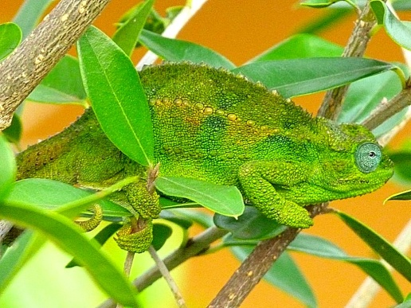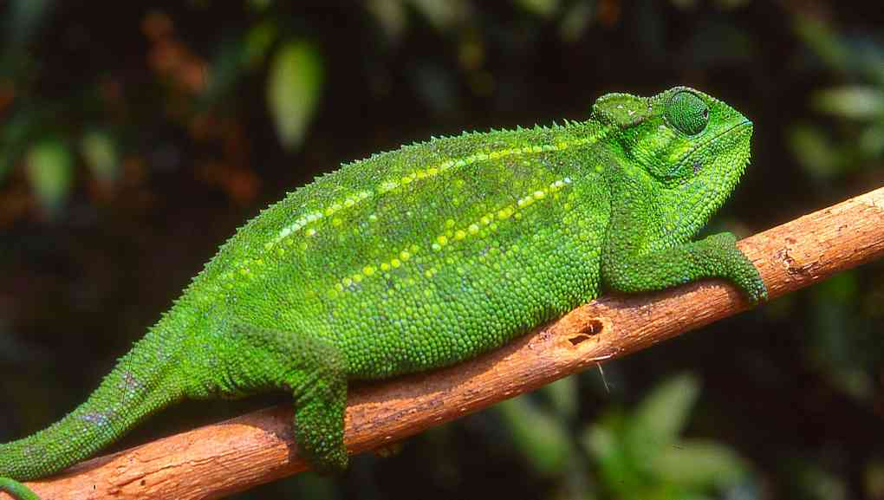
Illustrations: All northern Tanzania; BL © Vin Lawrence
Sudanese Unicorn Chameleon Trioceros conirostratus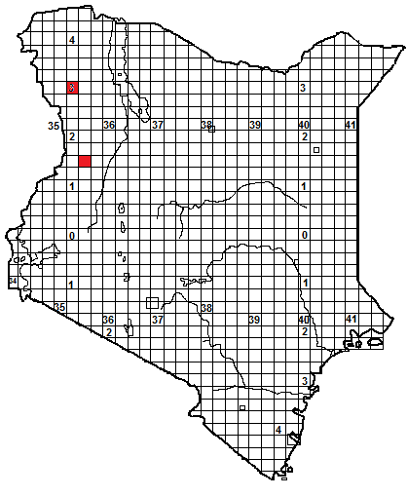 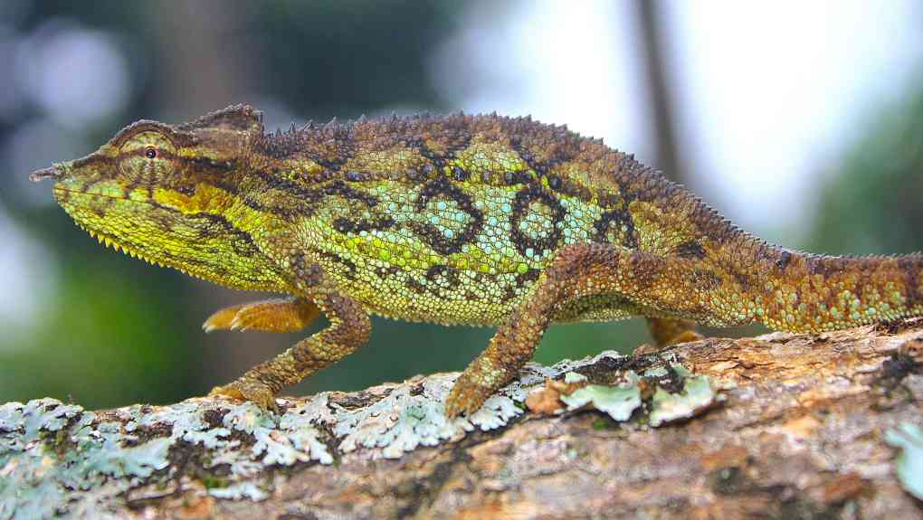
Identification: A small squat chameleon, with a short gular crest. Usually some shade of brown in Kenya, with orange tints, but green and brown in Uganda. Very similar to the side-striped chameleon, T. bitaeniatus, but males have a single, long cone-shaped scale on the tip of the snout. The body scales are heterogeneous, with enlarged scales on the flanks, particularly those within the flank stripes. Tail slightly less than half total length. Maximum size about 18 cm.
Distribution: Described by Colin Tilbury in 1998 from a single specimen from the Imatong Mountains in South Sudan, recently discovered in Kenya on the Mtelo Massif (Sekerr Range), at an altitude of 1 900 to 2 300 m, and the Loima Hills, (Murua Ngithigerr) at an altitude of 1 400m, 80 km west of Lodwar, northwest Kenya. Also recorded in northern Uganda.
Natural History: The Mtelo specimens were found in shrubs bordering fields in an agricultural landscape on a plateau which was originally covered with Acacia-Commiphora woodland.
Conservation significance. Difficult to evaluate, but its distribution in arid areas of northwest Kenya, northern Uganda and Sudan means it is probably not threatened. 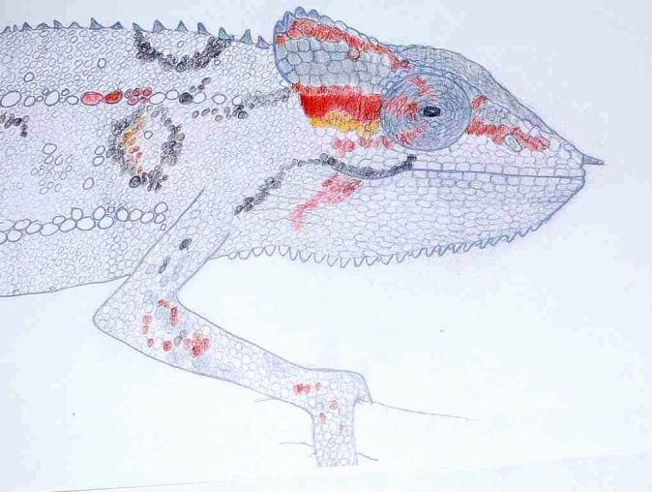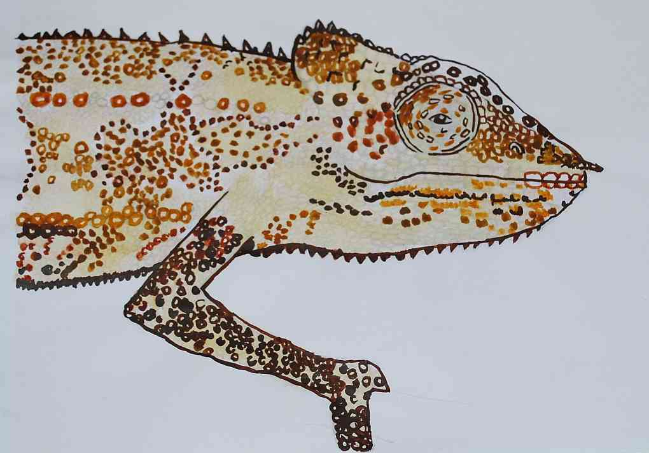
Illustrations: Thomas Price (T), (Uganda), Rachael Barratt (BL), Tim Spawls (BR)
Eldama Ravine Chameleon Trioceros tremperi
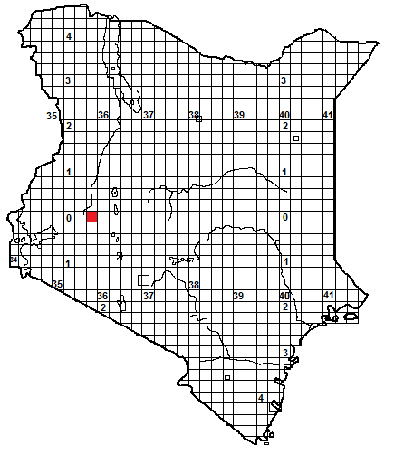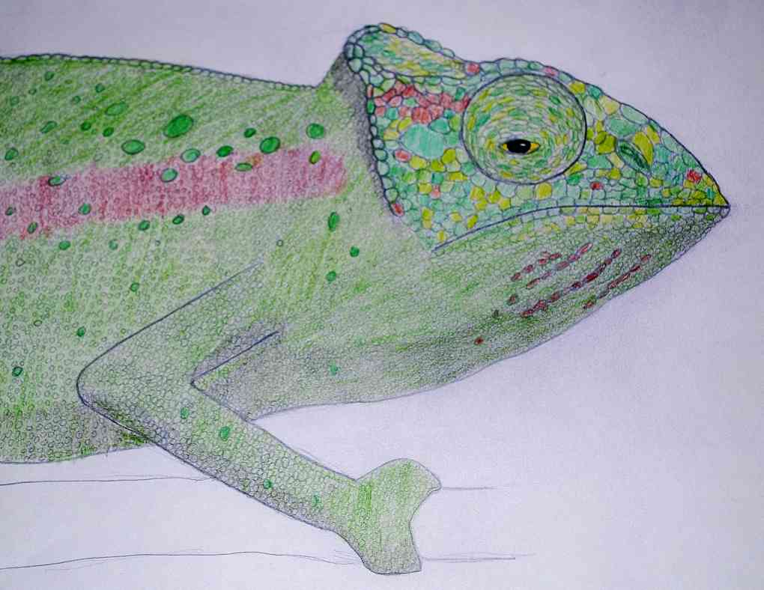

Identification: This species was described by Petr Necas in 1997, from preserved specimens in the Museum of Natural History in Vienna. The casque is moderately raised at the back. It has no gular crest. Tail about 50% of total length. The body scales are heterogeneous, with a scattering of enlarged scales on the flanks. Largest specimen about 14 cm length.
Distribution: The specimens in the museum are labelled ‘Eldama Ravine Station’ (0.00N 35.41E); this is Maji Mazuri (‘good water’) station on the Kenya-Uganda railway, in high woodland of the western rift valley wall at 2 400 m. Further work in the area has failed to locate any living examples of this species. The types were collected in 1904. At that time, the railway was just established, and the specimens might have come from a forest in the vicinity of the railhead, along with timber for the train. Maji Mazuri lies between three major forests; Mt Londiani, Lembus and Tinderet, parts of all are still extant.
Natural History: Totally unknown. No-one alive has seen a living example, yet. The African chameleon expert Dr Colin Tilbury suggests that the type specimens of T. tremperi have in fact been mis-labelled and are actually the Ituri Forest chameleon, T. iturienesis, a decision based on the fact that he could find no difference between T. tremperi and T. iturienesis. However, we prefer to leave open the possibility that this is a genuine Kenyan species, in the hope that it will stimulate collecting efforts in areas where this species might occur.
Illustration: Tim Spawls; based on a drawing in Necas’ original description, by Vladimir Trailin. The colours are speculative.
Other Chameleons in Kenya.
One introduced species of chameleon has been recorded in Kenya. In 1951, Arthur Loveridge reported that a single large specimen of a Madagascan chameleon, the Malagasy Giant Chameleon, Furcifer oustaleti, had been captured in the Ngong Forest in 1951; the specimen is lodged in the National Museum collection. In 1974, a second specimen, from Rowallan Camp, on the edge of the forest, was brought to the snake park in Nairobi but not apparently preserved. No further specimens have been found; but is possible that it survives. Inhabitants of the area are urged to keep an eye out for the species (illustrated below; © John Tashjian). 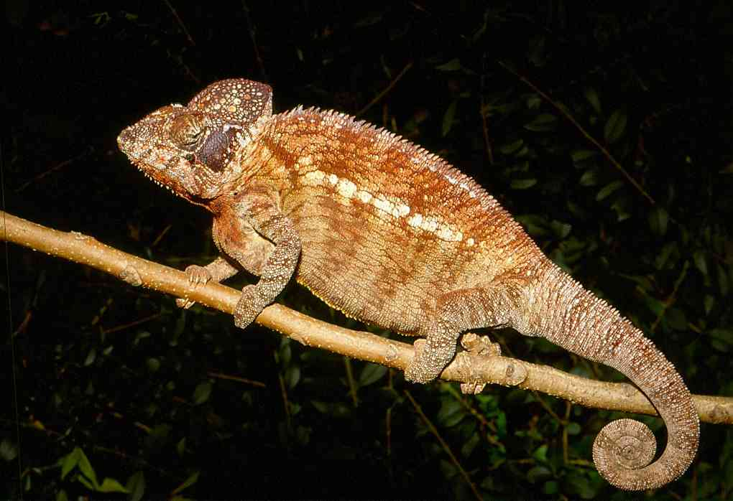
However, it is certain that Kenya has undiscovered species of chameleon; the
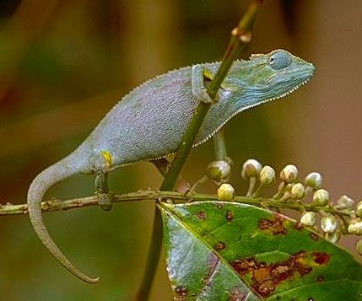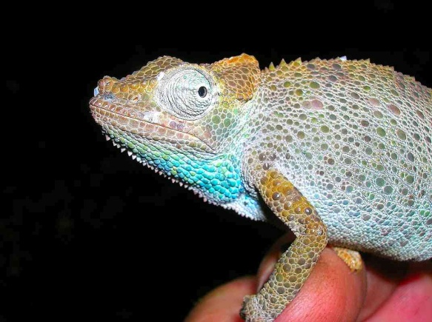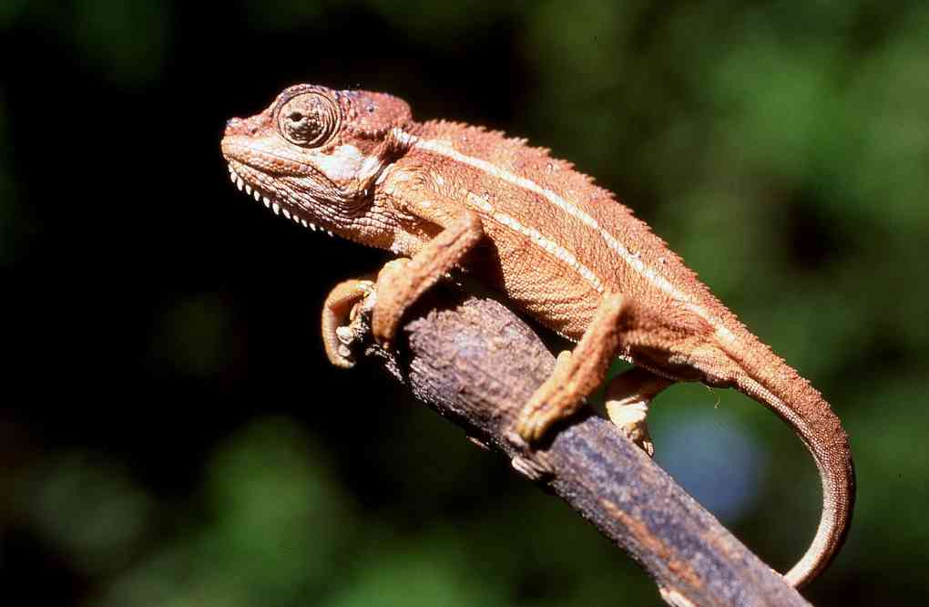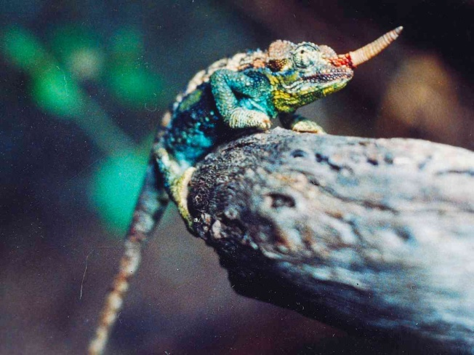
Illustrations here show some unusual animals. The blue chameleon (top left) from near Tarime in Tanzania (south of the Mara) appears to be intermediate between T. bitaeniatus and T. ellioti, (picture © Lorenzo Vinciguerra). Top right is an undescribed species from the Mathews Range (picture © Quentin Luke). The lower left picture shows an apparent intermediate between T. hoehnelii and T. bitaeniatus from northern Kedong; the lower right picture shows a curious T. jacksonii from an isolated population on Ol Donyo Orok, near Namanga (picture by Alex MacKay).
Why does Kenya have such a variety of chameleons? Only Tanzania, in all of mainland Africa, has more species. It is largely a result of the unusual Kenyan landscape, with a mixture of high and low altitude areas. There have been two major chameleon speciation events in eastern and southeastern Africa; both affecting Kenya. Firstly populations of pygmy chameleons have been isolated on the ancient crystalline mountains of southeastern Africa, as the rainforest shrunk, around 20 million years ago. Secondly, the growth of volcanic hills and mountains along the rift valley, coupled with increasing aridity has caused isolation of populations of chameleons of the genus Trioceros in the higher, better watered areas during roughly the last five million years. In both these scenarios, isolation has lead to speciation, with discrete populations accumulating changes.
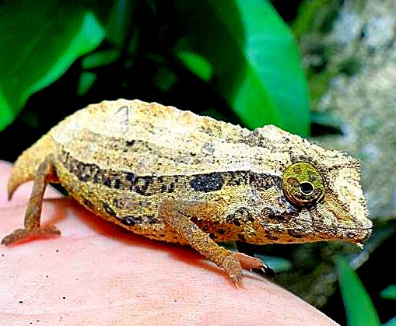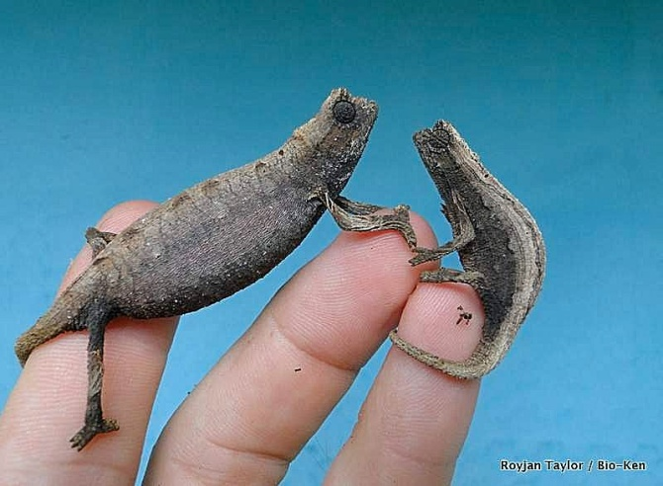
In the last 20 years, expeditions to the ancient crystalline mountains and the new volcanic ones have uncovered serval new species. No doubt more are yet to be discovered; not all the high land has been surveyed. In the National Museum collection in Nairobi there is an undescribed species of Rhampholeon from the Shimba Hills, which resembles Rhampholeon temporalis of Tanzania; and searches have failed to find further specimens. Survey work is needed.
Illustrations above: Rhampholeon brevicaudatus (left) , R. kersteni, (right) © Royjan Taylor/Bio-Ken.

