The Kenya Reptile Atlas
A free, downloadable atlas of Kenya’s reptiles. This is a free source of regularly updated information on Kenya’s Reptiles. Authors: Stephen Spawls, Beryl Bwong, Patrick Malonza, Vincent Muchai, Victor Wasonga
Obtainable under ‘downloads’ at Kenyareptileatlas.com; This project is funded by the Rufford Foundation under the auspices of the National Museums of Kenya; Department of Herpetology.

A New Checklist of the Reptiles of Kenya: Part 2; Snakes
Since the publication of the comprehensive Field Guide to the Reptiles of East Africa, by Spawls, Howell, Drewes and Ashe, in 2002, (known for short as the FGREA) the taxonomy of snakes has changed, as have a number of names. In addition, several species have been recorded in Kenya for the first time. So here is a current list of the snakes known to occur in Kenya at present; and we will update this from time to time. All other reptiles are in part 1. We’re using the nomenclature of the Reptile Database (www.reptile-database.org), which is also regularly updated and an excellent source of information.
The names are given thus: new scientific name, old scientific name in brackets (if different, if not then no second name), common name, old common name in brackets (if different). Species new to Kenya since the publication of the FGREA (newly described, or recorded for the first time, or elevated from the synonymy of another species) are indicated by an asterisk *. Where a photograph is shown, it is of the species directly above the picture (i.e. the picture is below the name).
Readers should be aware that the reptile taxonomy has undergone significant changes during the last 20 years. This stems from relationships revealed by analysis of various biochemicals, in particular the sequence of bases in nucleic acids such as DNA. Nowadays, snakes are believed to be a clade of legless lizards. Anyone wanting to familiarise themselves with the current situation should read the papers of Robert Alexander Pyron and his co-workers. The old ideas, such as that worm snakes are the most ‘primitive’ and vipers the most ‘advanced’ snakes have been superseded by a new relationship. For example, it is believed that colubrid snakes (what you might call ‘regular’ snakes) are the most recently evolved. We have used, as far as possible, the most up-to-date taxonomy, and also tried to follow the order of the FGREA, but changes mean that this isn’t always possible. So if the species you want doesn’t seem to be in order, scan up and down.
Our grateful thanks are extended to those who had a critical look at this list and made helpful comments and suggestions, and those who allowed us to use their photographs, including the Bio-Ken team (Sanda Ashe, Royjan Taylor, Anton Childs), Bill Branch and Tomas Mazuch.

Order Squamata; Snakes Sub-order Ophidia (also Serpentes)

Superfamily Typhlopoidea (Scolecophidia) Family Typhlopidae Subfamily Afrotyphlopinae African Blind Snakes

NB: Readers should be aware that the taxonomy of the blind snakes is in a state of flux. Recent work by Robert Alexander Pyron, Don Broadley, Van Wallach, S Blair Hedges and associated zoologists has produced conflicting evidence as to which genera are valid. Some names have changed twice inside two years. We use here the names from the reptile database, accessed in August 2014.

Afrotyphlops angolensis (Typhlops angolensis) Angola blind snake

Afrotyphlops brevis (Rhinotyphlops brevis) Angle-snouted blind snake

Afrotyphlops calabresii (Typhlops cuneirostris) Wedge-snouted blind snake

* Afrotyphlops kaimosae Kakamega blind snake

Afrotyphlops lineolatus (Typhlops lineolatus) Lineolate blind snake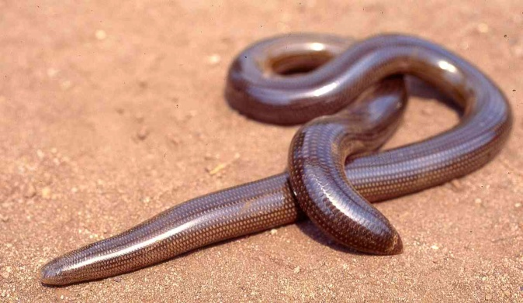

* Afrotyphlops nanus Kenyan dwarf blind snake

Afrotyphlops mucruso (Rhinotyphlops mucruso) Zambezi blind snake

Rhinotyphlops ataeniatus Somali blind snake

Rhinotyphlops unitaeniatus Yellow-striped blind snake/stripe-backed blind snake

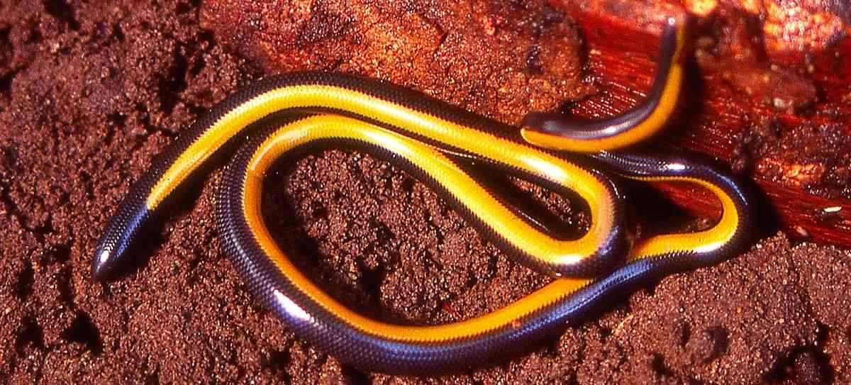(picture © James Ashe)

* Letheobia swahilica Swahili gracile blind snake/coastal blind snake (elevated from the synonymy of Rhinotyphlops pallidus, now Letheobia pallida and confined to Zanzibar)

Letheobia lumbriciformis (Rhinotyphlops lumbriciformis) Worm-like blind snake

Indotyphlops braminus (Ramphotyphlops braminus) Flower-pot blind snake

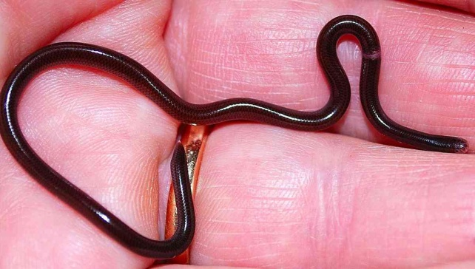
Superfamily Typhlopoidea (Scolecophidia) Family Leptotyphlopidae (Slender Blind Snakes) Subfamily Leptotyphlopinae worm snakes
Epacrophis boulengeri (Leptotyphlops boulengeri) Lamu worm snake
Epacrophis drewesi (Leptotyphlops drewesi) Drewes’ worm snake
* Leptotyphlops aethiopicus Ethiopian worm snake
* Leptotyphlops howelli Kim Howell’s worm snake
* Leptotyphlops keniensis Mt Kenya worm snake
Leptotyphlops macrops Large-eyed worm snake
* Leptotyphlops nigroterminus Black-tipped worm snake
Leptotyphlops scutifrons Peters’ worm snake (two subspecies L. s. merkeri in the southeast and L. s. pitmani in the far west) 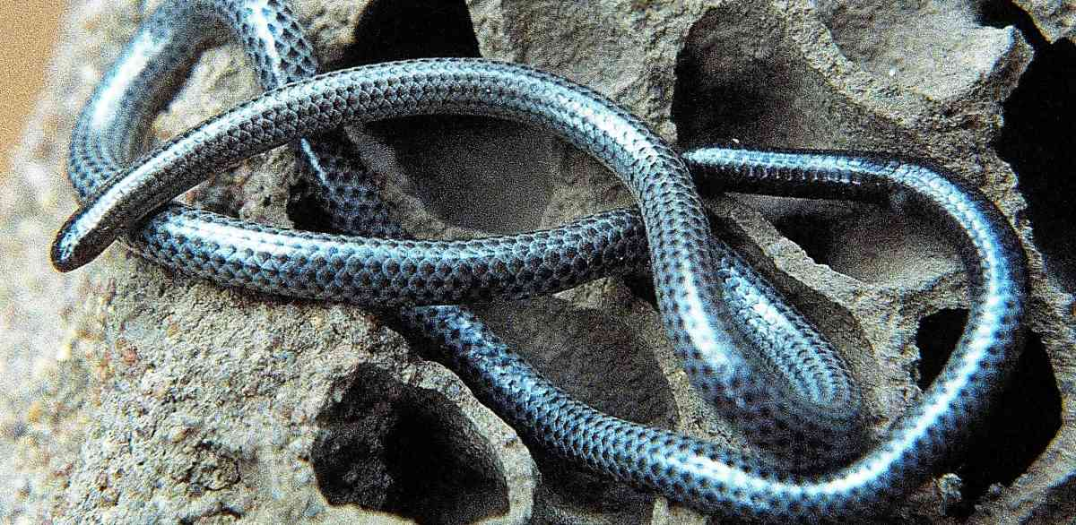
* Myriopholis braccianii (Leptotyphlops braccianii) Scortecci’s worm snake
* Myriopholis tanae (Leptotyphlops tanae) Tana Delta worm snake
Myriopholis macrorhyncha (Leptotyphlops macrorhynchus) Hook-snouted worm snake
Superfamily Pythonoidea (Pythons and relatives) Family Pythonidae Pythons
Python natalensis Southern African rock python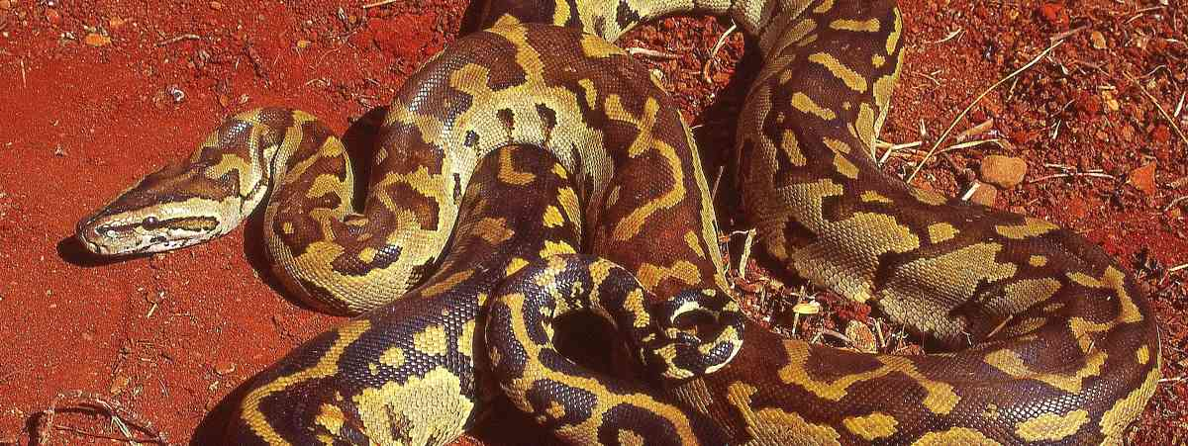
Python sebae Central African rock python
Superfamily Booidea Family Boidae (Boas) Family Erycidae Sand boas
Eryx colubrinus Kenya sand boa
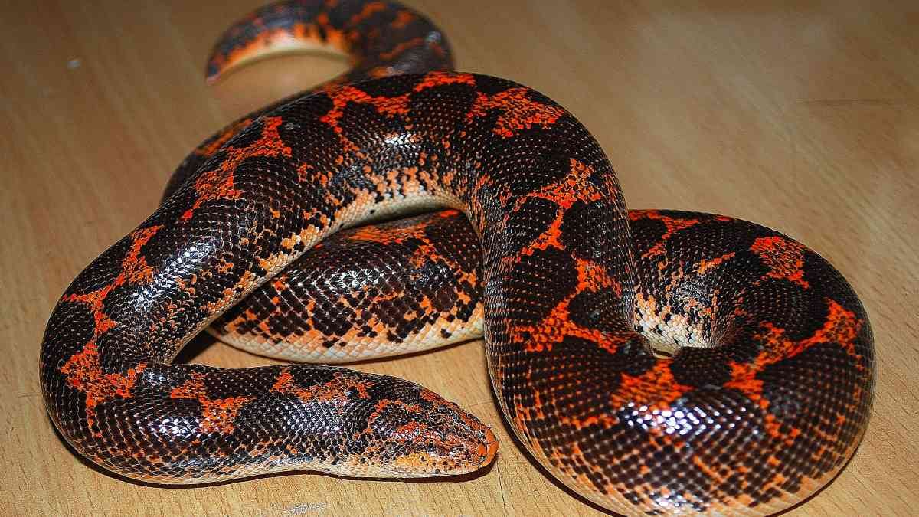
Superfamily Colubroidea Family Lamprophiidae Subfamily Lamprophiinae African House
snakes, wolf snakes and allies
Boaedon fuliginosus (Lamprophis fuliginosus) Brown house snake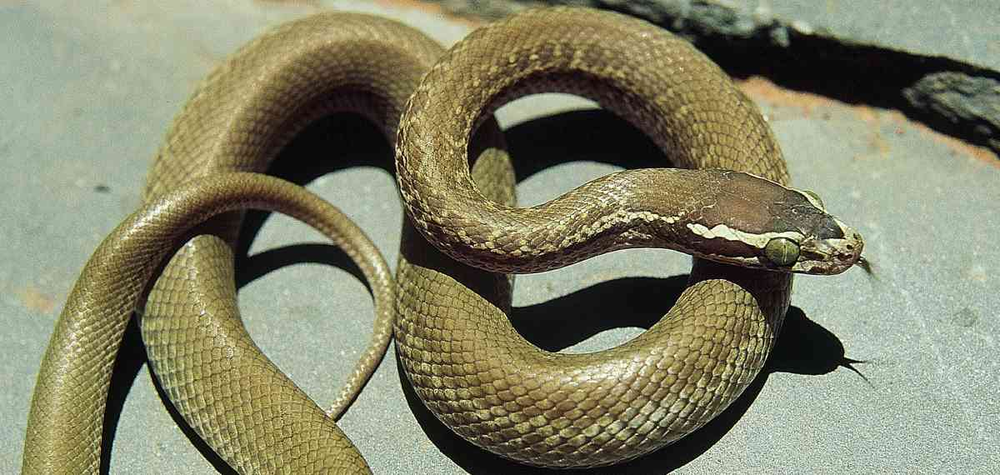
* Boaedon olivaceus (Lamprophis olivaceus) Olive house snake
Lycophidion capense Cape Wolf snake
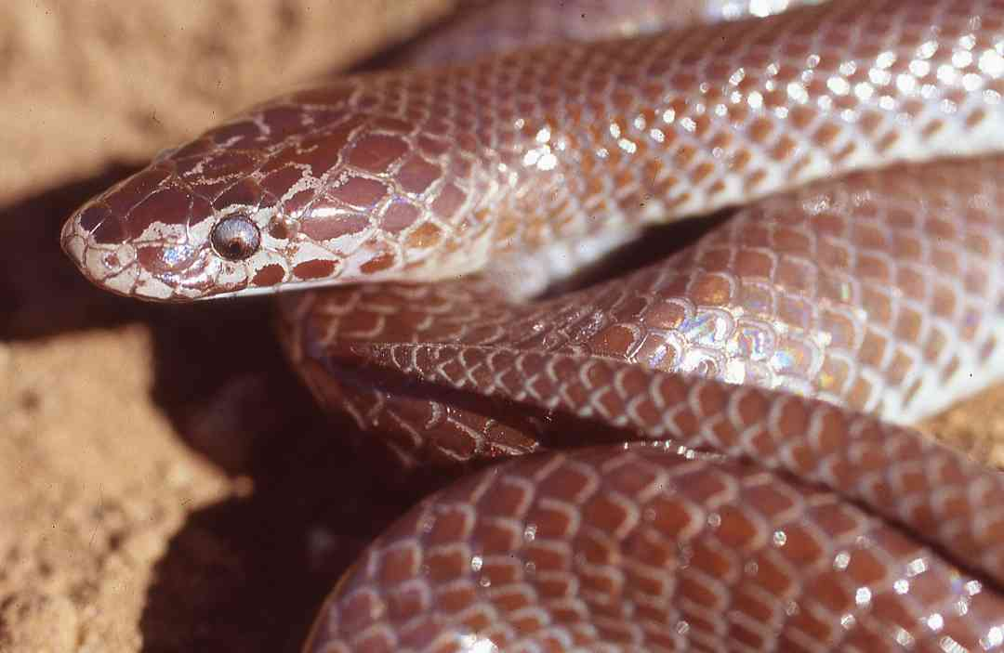
Lycophidion depressirostre Flat-snouted wolf snake
Lycophidion ornatum Forest wolf snake
Lycophidion taylori Taylor’s wolf snake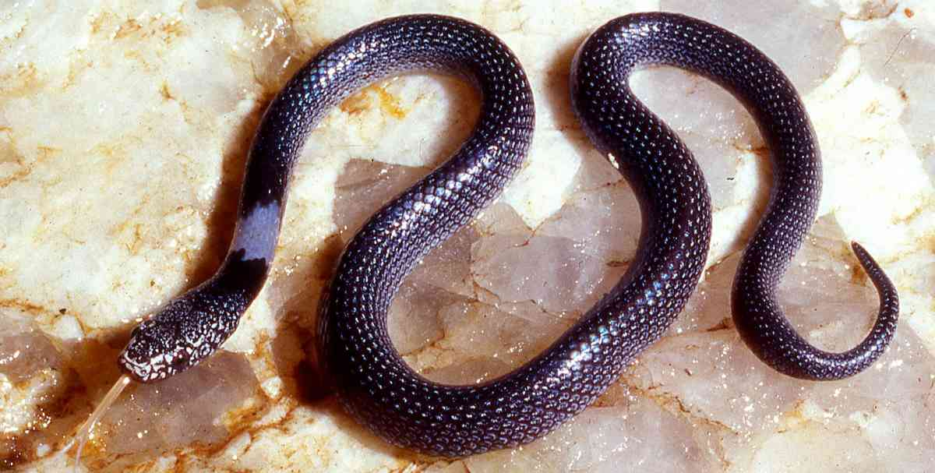(picture ©Lorenzo Vinciguerra)
Hormonotus modestus Yellow forest snake
Gonionotophis chanleri (Mehelya capensis, eastern ‘unicolor’ populations) Chanler’s file snake (Cape file snake)
Gonionotophis savorgnani (Mehelya capensis, western populations) ) De Brazza’s file snake/Congo file snake (Cape file snake)
Gonionotophis nyassae (Mehelya nyassae) Dwarf file snake/black file snake
Superfamily Colubroidea Family Lamprophiidae Subfamily Pseudaspidinae mole snakes
Pseudaspis cana Mole snake 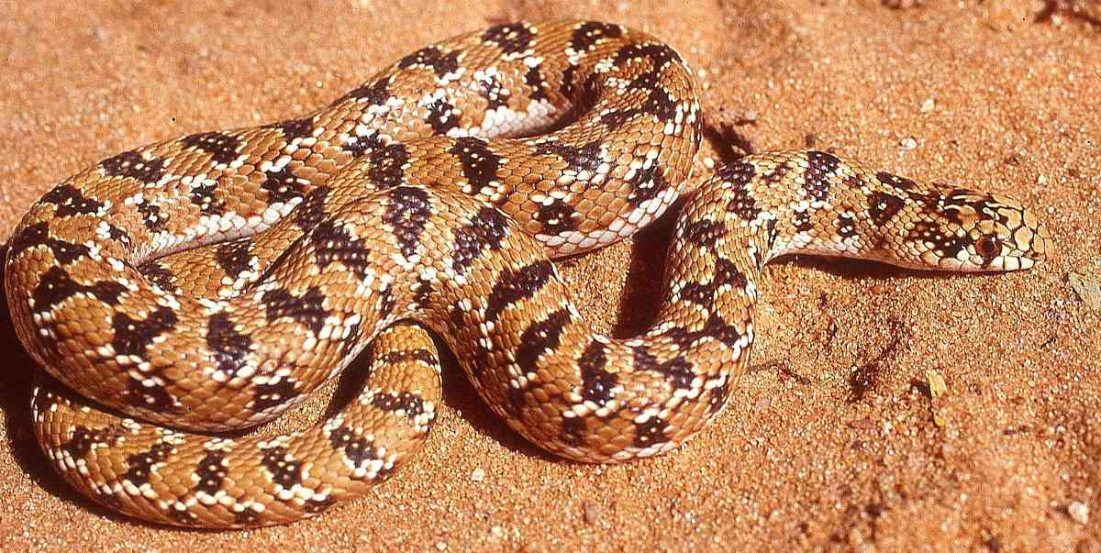
Superfamily Colubroidea Family Lamprophiidae Subfamily Pseudoxyrhophiinae Malagasy colubroids
Duberria lutrix East African slug-eater (slug eater)
Superfamily Colubroidea Family Lamprophiidae Subfamily Psammophiinae Sand snakes, bark snakes, skaapstekers and beaked snakes
Hemirhagerrhis kelleri Striped bark snake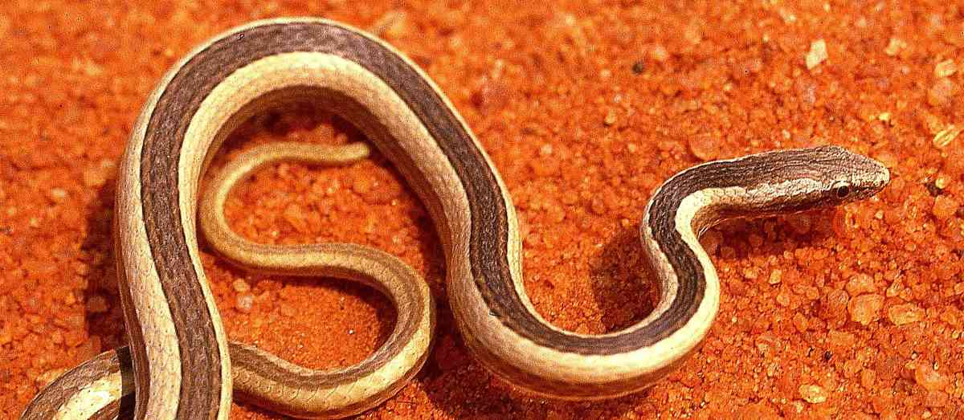
Hemirhagerrhis nototaenia Southern bark snake (bark snake)
* Hemirhagerrhis hildebrandtii Kenyan bark snake 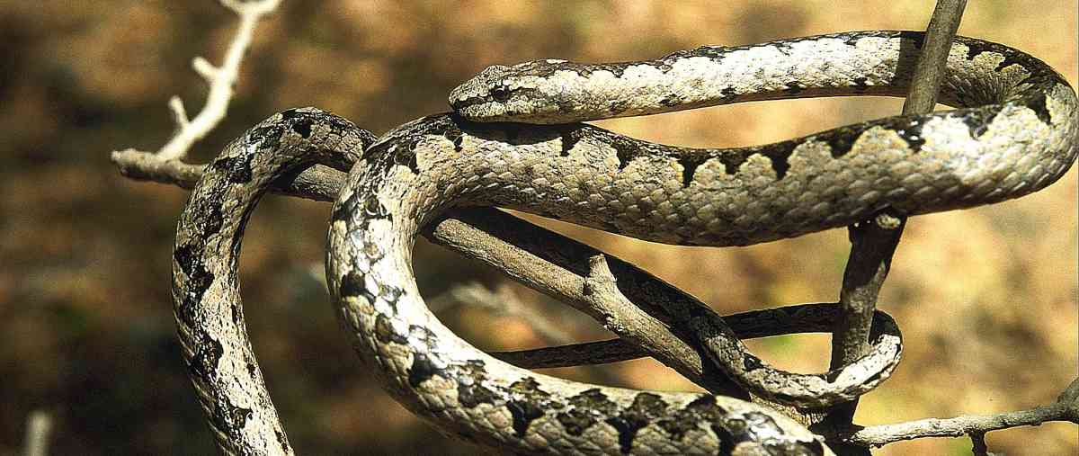
Psammophylax multisquamis Kenyan striped skaapsteker
Rhamphiophis rostratus Rufous beaked snake
Rhamphiophis rubropunctatus Red-spotted beaked snake
Psammophis lineatus (Dromophis lineatus) Striped olympic snake
Psammophis pulcher Beautiful sand snake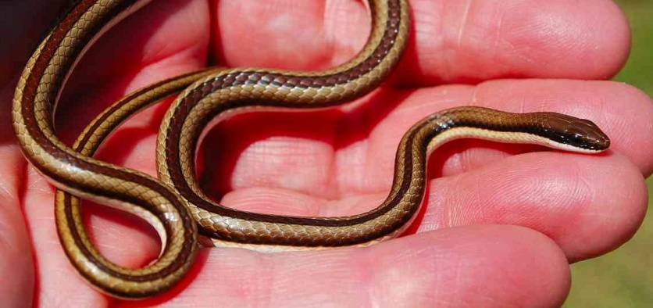
Psammophis mossambicus Olive sand snake/Hissing sand snake
Psammophis orientalis Eastern stripe-bellied sand snake
Psammophis rukwae Lake Rukwa sand snake
Psammophis sudanensis Northern stripe-bellied sand snake
Psammophis punctulatus Speckled sand snake
Psammophis biseriatus Link-marked sand snake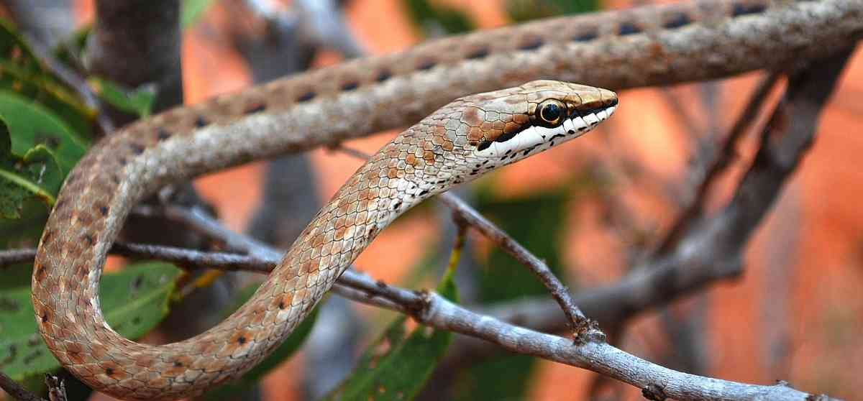
Psammophis tanganicus Tanganyika sand snake
Superfamily Colubroidea Family Lamprophiidae Subfamily Prosymninae Shovel-snouts
Prosymna ambigua Angolan shovel-snout
Prosymna ruspolii Prince Ruspoli’s shovel-snout
Prosymna stuhlmanni East African shovel-snout
Superfamily Colubroidea Family Lamprophiidae Subfamily Aparallactinae burrowing snakes
Aparallactus guentheri Black centipede-eater
Aparallactus jacksoni Jackson’s centipede-eater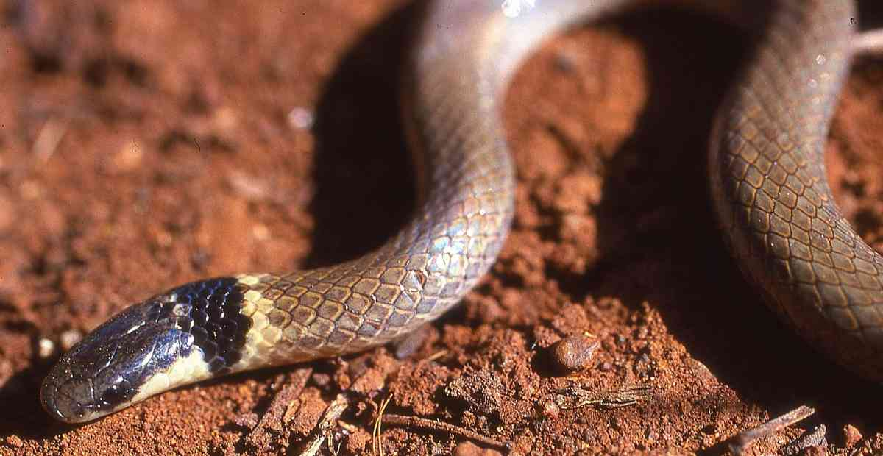
Aparallactus lunulatus Plumbeous centipede-eater
Aparallactus turneri Malindi centipede-eater
Polemon christyi Christy’s snake-eater
Amblyodipsas polylepis Common purple-glossed snake
Amblyodipsas teitana Taita Hills purple-glossed snake
Amblyodipsas unicolor Western purple-glossed snake
Micrelaps bicoloratus Two-coloured snake
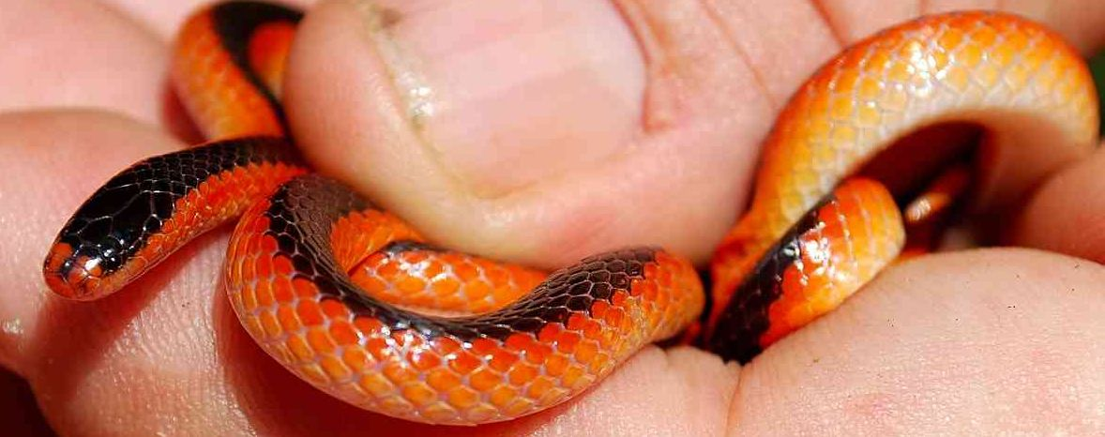
Micrelaps vaillanti (Micrelaps boettgeri) Desert black-headed snake
Superfamily Colubroidea Family Lamprophiidae Subfamily Atractaspidinae burrowing asps/stiletto snakes/Mole Vipers
Atractaspis bibronii Bibron’s burrowing asp
Atractaspis engdahli Engdahl’s burrowing asp
Atractaspis irregularis Variable burrowing asp
Atractaspis microlepidota Small-scaled burrowing asp 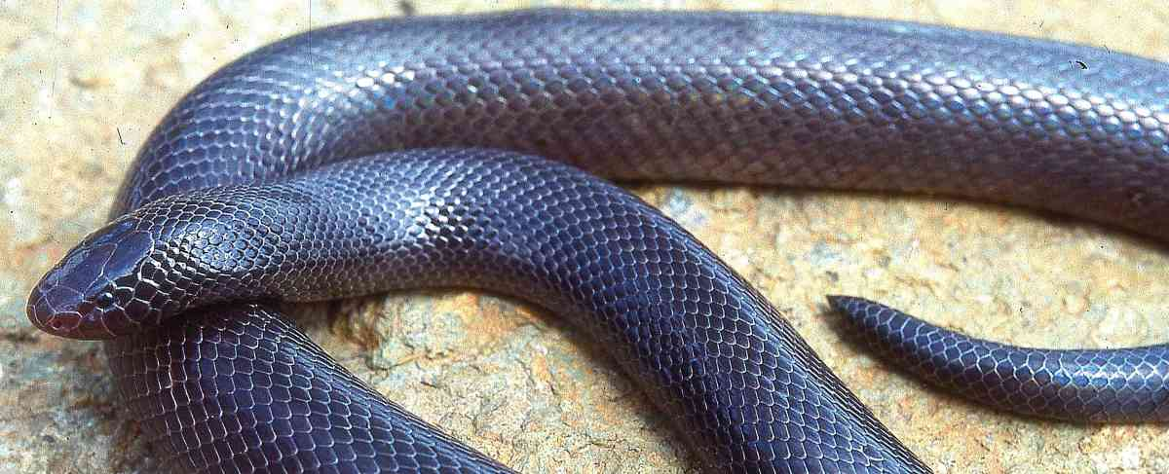
Superfamily Colubroidea Family Colubridae Subfamily Colubrinae regular snakes
Platyceps florulentus (Coluber florulentus) Flowered racer
Platyceps brevis (Coluber smithii) Smith’s racer
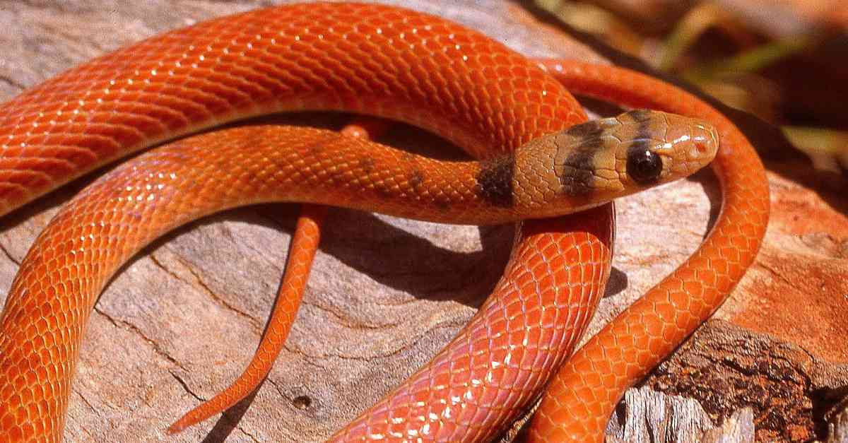
Meizodon krameri Tana Delta smooth snake
Meizodon plumbiceps Black-headed smooth snake
Meizodon regularis Eastern crowned snake
Meizodon semiornatus Semi-ornate snake
Philothamnus battersbyi Battersby’s green-snake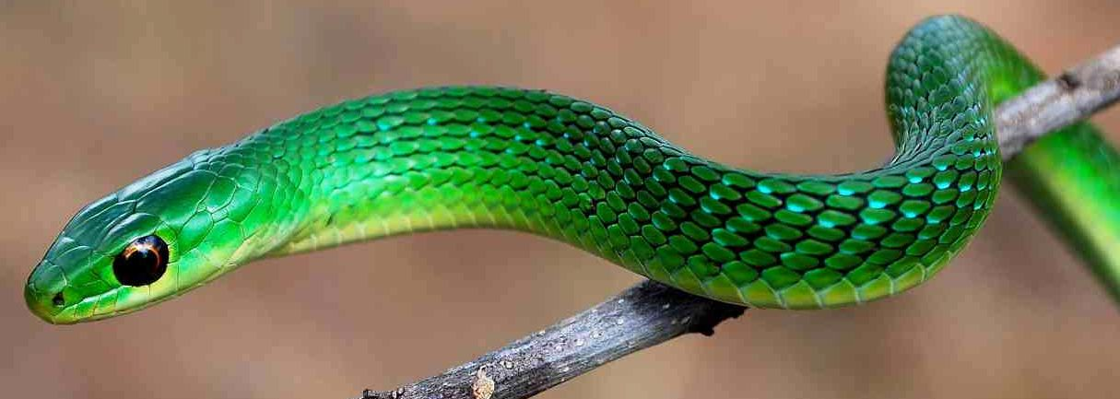
Philothamnus carinatus Thirteen-scaled green-snake
Philothamnus heterolepidotus Slender green-snake
Philothamnus hoplogaster South-eastern green-snake/green water snake
* Philothamnus macrops Usambara green-snake
Philothamnus nitidus Loveridge’s green-snake
Philothamnus punctatus Speckled green-snake
Philothamnus semivariegatus Spotted bush snake/spotted wood snake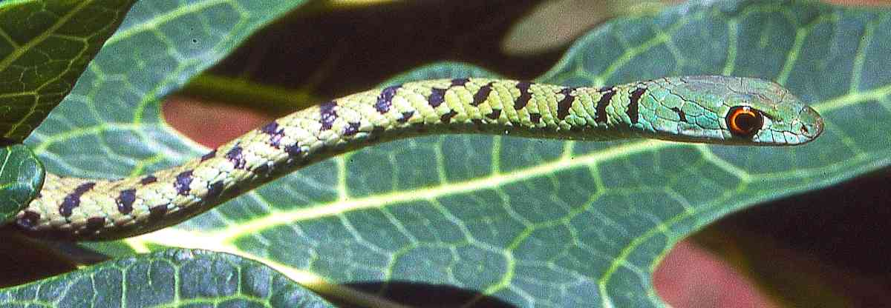
Hapsidophrys lineata Black-lined green snake
Thrasops jacksoni Jackson’s tree snake
*Thrasops schmidti Schmidt’s black tree snake
Rhamnophis aethiopissa Large-eyed green tree snake
Scaphiophis albopunctatus Hook-nosed snake
Scaphiophis raffreyi Ethiopian hook-nosed snake
Boiga blandingii Blanding’s tree snake (some authorities use the name Toxicodryas for African Boiga, although research indicates there are no significant differences between the African and Asian forms)
Boiga pulverulenta Powdered tree snake
Telescopus dhara Large-eyed snake
Telescopus semiannulatus Tiger snake
Crotaphopeltis braestrupi Tana herald snake
Crotaphopeltis degeni Degen’s water snake/yellow-flanked snake
Crotaphopeltis hotamboeia White-lipped snake/white lip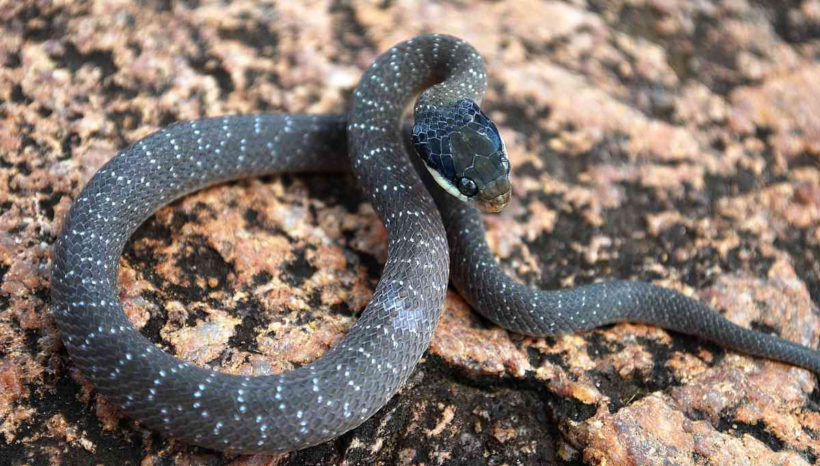
Dipsadoboa flavida Cross-barred tree snake
Dispholidus typus Boomslang
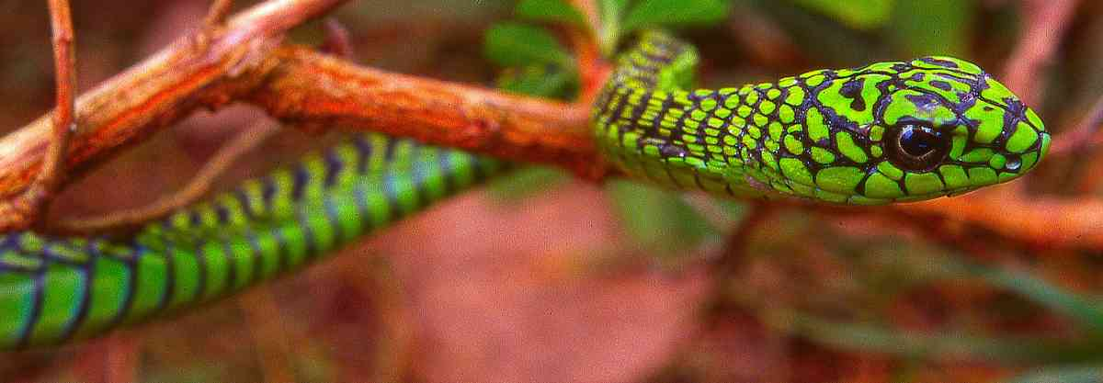
Thelotornis mossambicanus (Thelotornis capensis) Savanna vine snake
* Thelotornis usambaricus Usambara vine snake (of doubtful validity)
Dasypeltis atra Montane egg-eater
Dasypeltis medici Rufous egg-eater/East African egg-eater
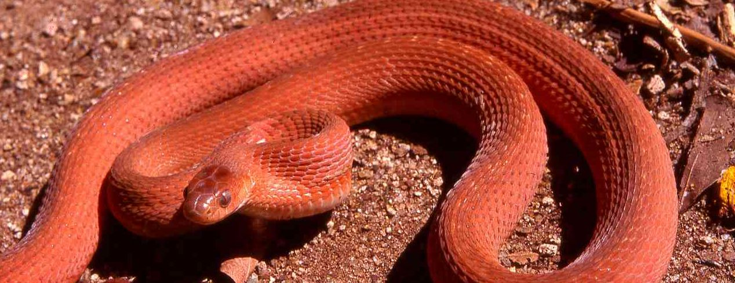
Dasypeltis scabra Common egg-eater/rhombic egg-eater
Superfamily Colubroidea Family Colubridae Subfamily Grayiinae Central African water snakes
Grayia smythii Smith’s water snake
Grayia tholloni Thollon’s water snake
Superfamily Colubroidea Family Colubridae subfamily Natricidae Palaearctic/African water snakes
Natriciteres olivacea Olive marsh snake
Superfamily Colubroidea Family Elapidae cobras, mambas and allies
Elapsoidea loveridgei East African garter snake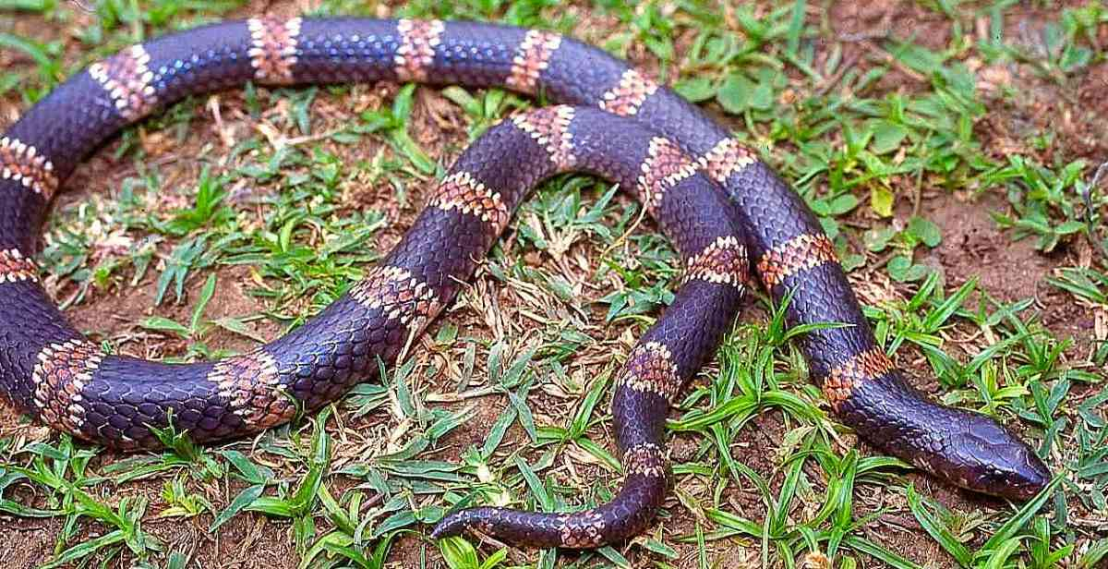
* Elapsoidea nigra Usambara garter snake
* Naja ashei Ashe’s Spitting Cobra/Large Brown Spitting Cobra 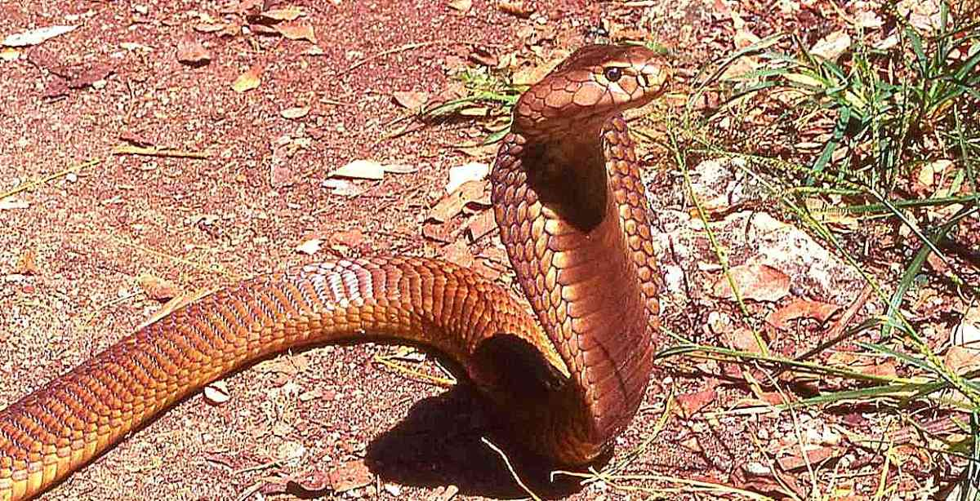
Naja haje Egyptian cobra
Naja melanoleuca Forest cobra
Naja nigricollis Black-necked spitting cobra
Naja pallida Red spitting cobra
Pseudohaje goldii Gold’s tree cobra
Dendroaspis angusticeps Green mamba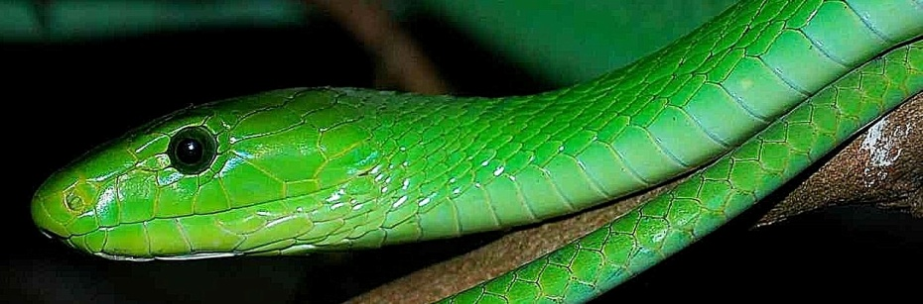
Dendroaspis jamesoni Jameson’s mamba
Dendroaspis polylepis Black mamba
Hydrophis platurus (Pelamis platurus) Yellow-bellied sea snake
Superfamily Colubroidea Family Viperidae Subfamily Viperinae Old World vipers
Causus defilippii Snouted night adder
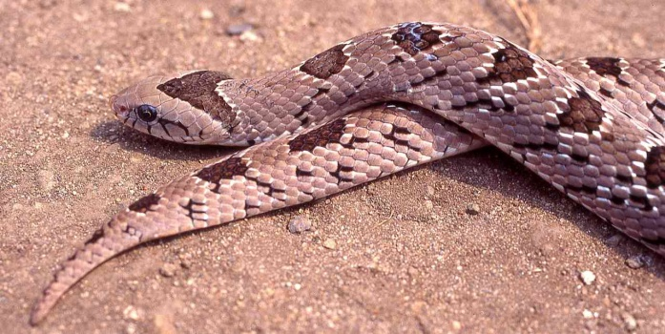
Causus lichtensteini Forest night adder
Causus resimus Velvety-green night adder
Causus rhombeatus Rhombic night adder
Bitis arietans Puff adder
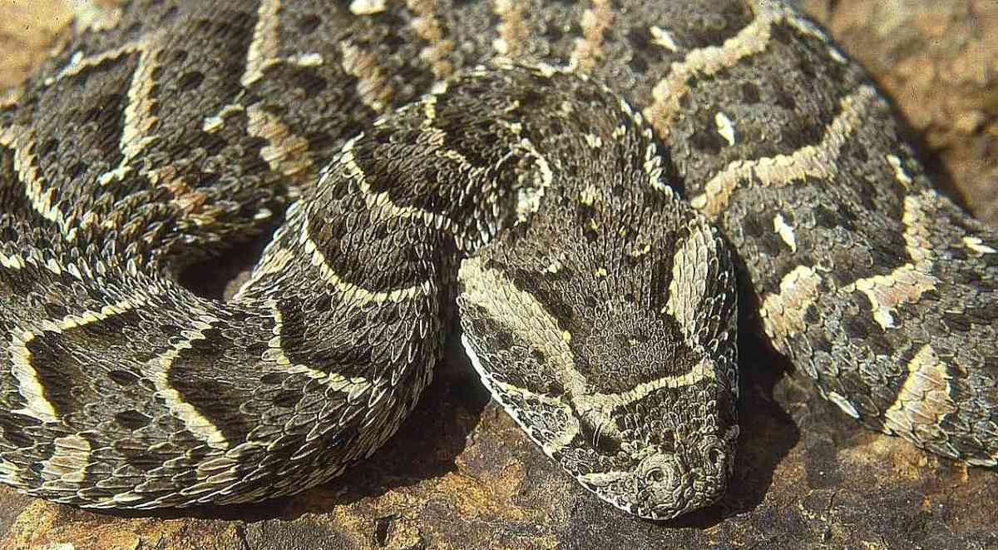
Bitis gabonica Gaboon viper
Bitis nasicornis Rhinoceros viper/Nose-horned viper
Bitis worthingtoni Kenya horned viper
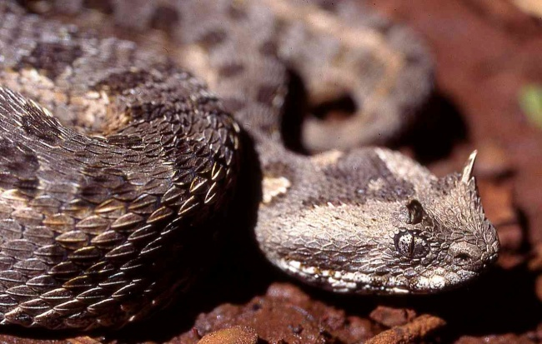
Echis pyramidum North-east African carpet viper/saw-scaled viper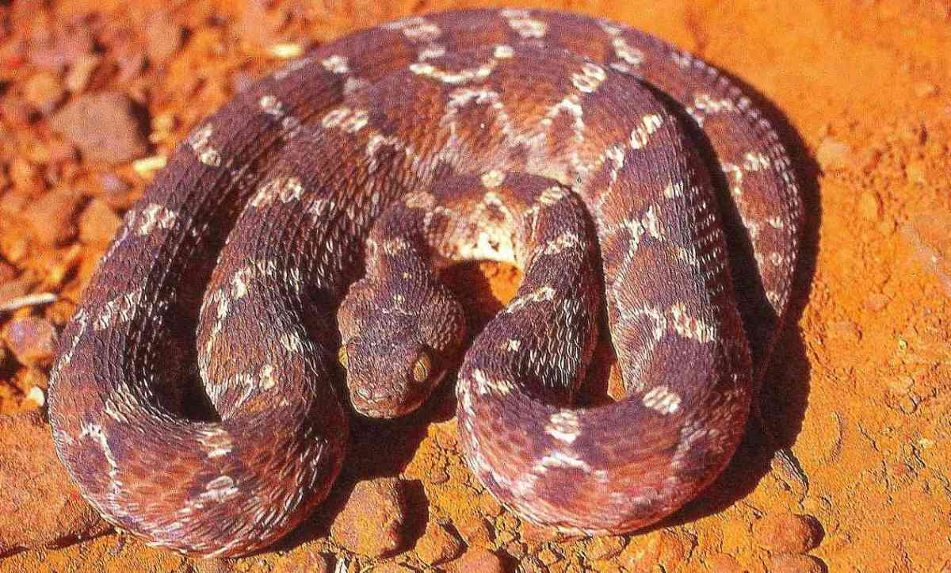
Atheris desaixi Mt Kenya bush viper
Atheris hispida Rough-scaled bush viper
Atheris squamiger Green bush viper 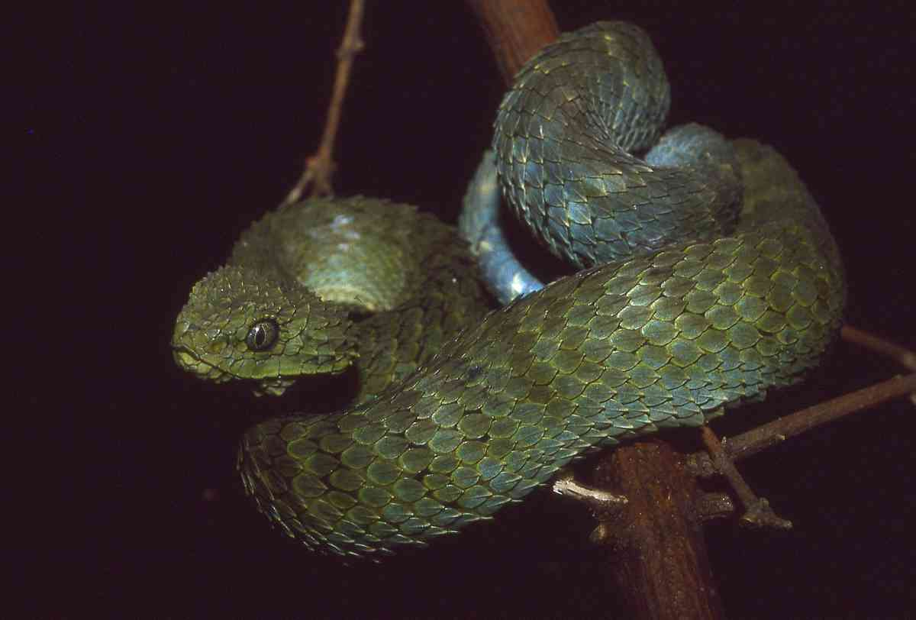
Montatheris hindii Kenya montane viper 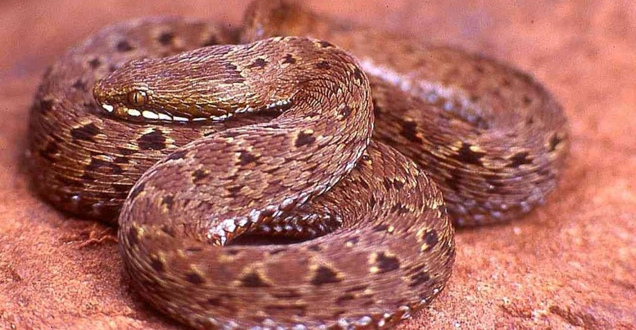 (photo © Alex Duff-Mackay)

