The Kenya Reptile Atlas
A free, downloadable atlas of Kenya’s reptiles. This is a free source of regularly updated information on Kenya’s Reptiles. Authors: Stephen Spawls, Beryl Bwong, Patrick Malonza, Vincent Muchai, Victor Wasonga
Obtainable under ‘downloads’ at Kenyareptileatlas.com
This project is funded by the Rufford Foundation under the auspices of the National Museums of Kenya; Department of Herpetology.

A New Checklist of the Reptiles of Kenya: Part 1;
Turtles, tortoises, lizards, worm lizards and crocodiles.
Since the publication of ‘A Field Guide to the Reptiles of East Africa’, by Spawls, Howell, Drewes and Ashe, in 2002, (known for short as FGREA) a number of names have changed, and a number of species have been recorded in Kenya for the first time. So here is a current list of the chelonians, lizards, amphisbaenians and crocodiles known to occur in Kenya at present; and we will update this from time to time. Snakes will be in part 2. We’re using the nomenclature of the Reptile Database (www.reptile-database.org) , which is also regularly updated and an excellent source of information.
The names are given thus: new scientific name, old scientific name in brackets (if different, if not then no second name), common name, old common name in brackets (if different). Species new to Kenya since the publication of the FGREA (both newly described, or recorded for the first time, or elevated from the synonymy of another species) are indicated by an asterisk *. We have tried to stick to the original order of the FGREA, but some changes in taxonomic groups means this is not always possible (for example, in the rearrangement of the skink families). Where a photograph is shown, it is of the species directly above the picture. Users should be aware that major taxonomic changes will take place over the next few years, particularly with complex groups like the small geckoes (Lygodactylus, Cnemaspis) and burrowing skinks.
Our grateful thanks are extended to those who had a critical look at this list and made helpful comments and suggestions, and those who allowed us use of their photographs; including the Bio-Ken team (Sanda Ashe, Royjan Taylor, Anton Childs), Mike Roberts and Tomas Mazuch.

Turtles and Tortoises; order Testudines.
Superfamily Testudinoidea, Family Testudinidae. Terrestrial tortoises.
Stigmochelys pardalis (Geochelone pardalis) Leopard tortoise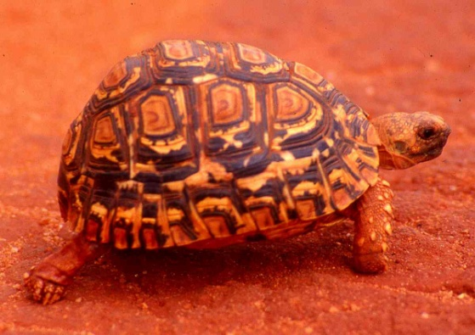
Kinixys belliana Bell’s hinged tortoise
Kinixys spekii Speke’s hinged tortoise 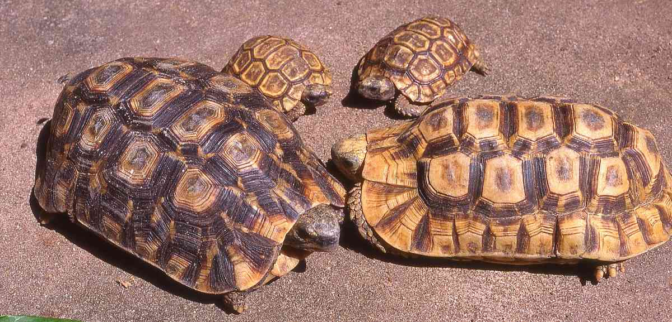
Malacochersus tornieri Pancake tortoise
Superfamily Trionychoidea, Family Trionychidae Soft-shelled Turtles
Trionyx triunguis Nile soft-shelled turtle
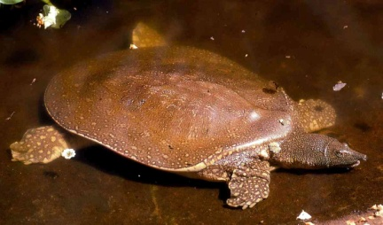
Superfamily Chelonioidea, Family Cheloniidae Sea Turtles
Lepidochelys olivacea Olive ridley turtle
Caretta caretta Loggerhead turtle
Eretmochelys imbricata Hawksbill turtle
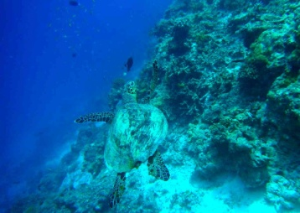
Chelonia mydas Green turtle
Superfamily Chelonioidea, Family Dermochelyidae Leatherback Turtles
Dermochelys coriacea Leatherback turtle

Superfamily. Pelomedusoidea Family Pelomedusidae Afro-American Side-necked Turtles

Pelomedusa neumanni (Pelomedusa subrufa) Neumann’s helmeted terrapin (Helmeted terrapin)

Pelusios broadleyi Lake Turkana hinged terrapin

Pelusios castanoides Yellow-bellied hinged terrapin

Pelusios sinuatus Serrated hinged terrapin

Pelusios williamsi Williams’ hinged terrapin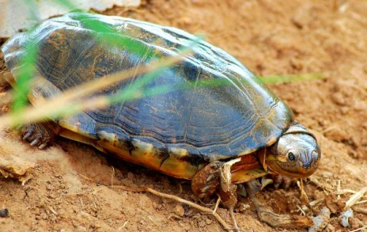

Order Squamata; Lizards Sub-order Sauria (also Lacertilia)

Infraorder Gekkota Family Eublepharidae Eyelid geckos

Holodactylus africanus Somali-Maasai clawed gecko

Infraorder Gekkota Family Gekkonidae Regular geckos

Stenodactylus sthenodactylus Elegant gecko

Cnemaspis africana Usambara forest gecko

Cnemaspis dickersonae (Cnemaspis dickersoni) Dickerson’s forest gecko

Cnemaspis elgonensis Elgon forest gecko

Hemidactylus angulatus (Hemidactylus brooki) Afro-tropical ground gecko (Brook’s gecko)

Hemidactylus barbouri Barbour’s gecko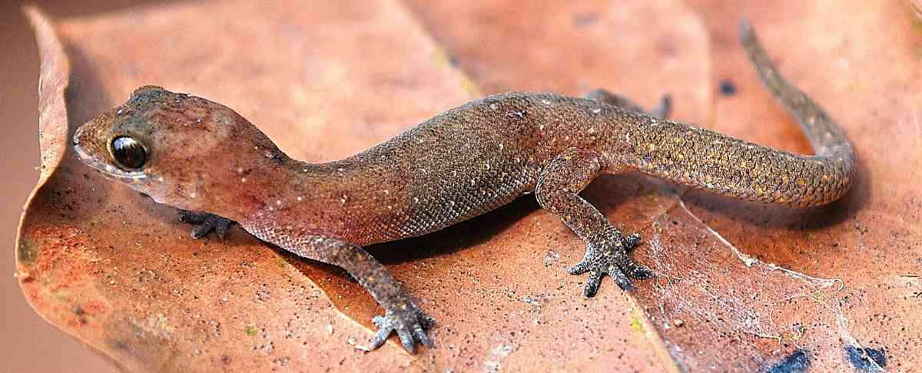

* Hemidactylus barbierii Lake Turkana gecko

Hemidactylus bavazzanoi Somali banded gecko

Hemidactylus frenatus Pacific gecko

Hemidactylus funaiolii Archer’s Post gecko

Hemidactylus isolepis Uniform-scaled gecko

Hemidactylus mabouia Tropical house gecko

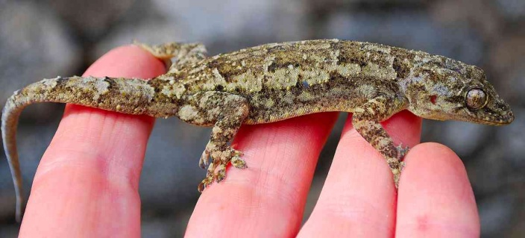

Hemidactylus macropholis Boulenger’s gecko

Hemidactylus modestus Tana River gecko

* Hemidactylus mrimaensis Kaya Mrima gecko

Hemidactylus platycephalus Tree gecko

Hemidactylus robustus Somali Plain gecko

Hemidactylus ruspolii Prince Ruspoli’s gecko

Hemidactylus squamulatus Nyika gecko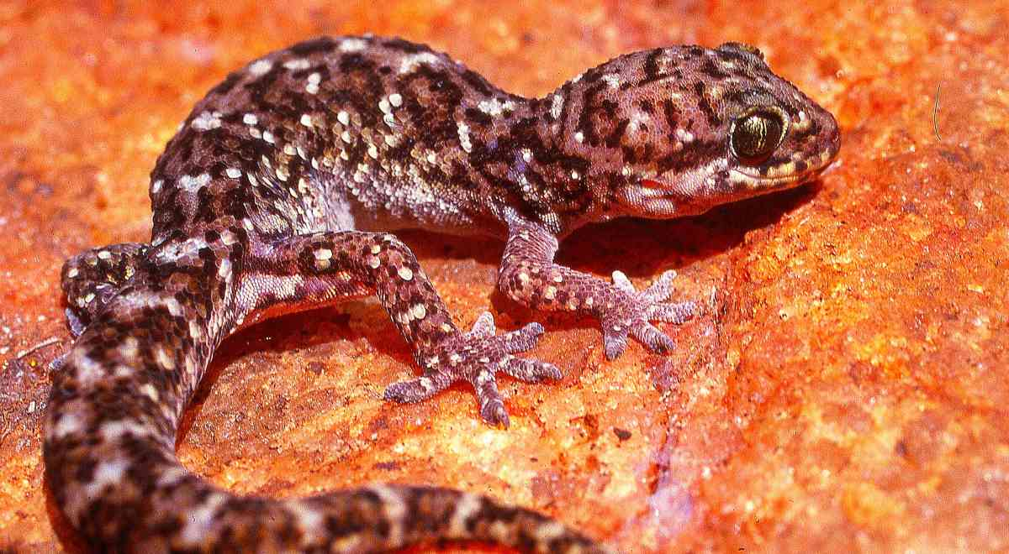

Hemidactylus tropidolepis Ogaden gecko

Lygodactylus angolensis Angolan dwarf gecko

Lygodactylus angularis Angulate dwarf gecko

Lygodactylus capensis Cape dwarf gecko

Lygodactylus grandisonae (Lygodactylus grandisoni) Bunty’s dwarf gecko

* Lygodactylus gutturalis Chevron-throated dwarf gecko/Forest dwarf gecko

Lygodactylus keniensis Kenya dwarf gecko

Lygodactylus laterimaculatus Side-spotted dwarf gecko

Lygodactylus luteopicturatus Yellow-headed dwarf gecko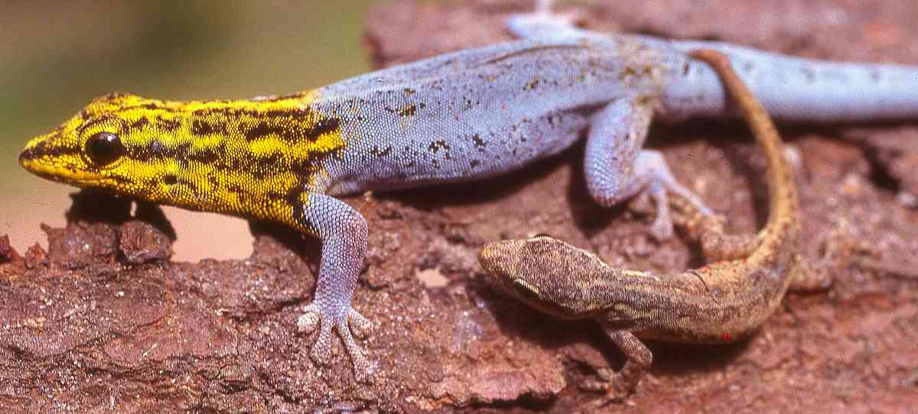

Lygodactylus manni Mann’s dwarf gecko

* Lygodactylus mombasicus Mombasa dwarf gecko (there is debate about the identity of this species, as well as L. picturatus and L. luteopicturatus; see papers by Beate Roll and co-workers. Lygodactylus mombasicus appears to be paraphyletic.)

Lygodactylus picturatus White-headed dwarf gecko

Lygodactylus scheffleri Scheffler’s dwarf gecko

Lygodactylus scorteccii Scortecci’s dwarf gecko

Lygodactylus somalicus Somali dwarf gecko

Chondrodactylus turneri (Pachydactylus turneri) Turner’s thick-toed gecko 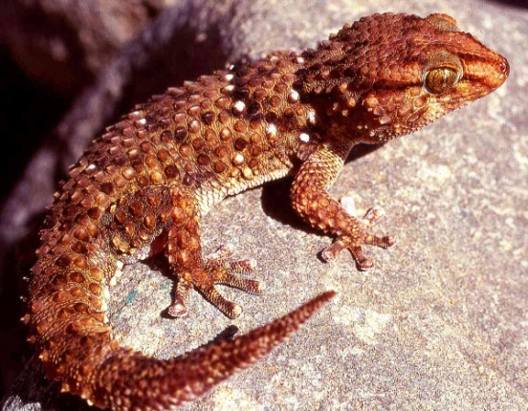

Phelsuma dubia Dull-green day gecko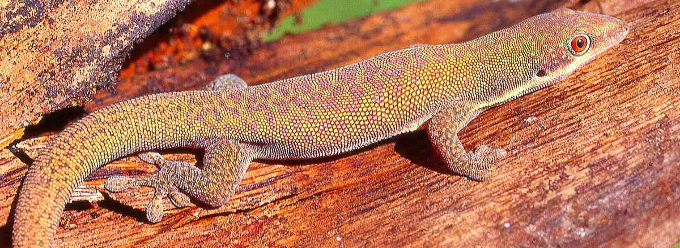

Homopholis fasciata Banded velvet gecko

Infraorder Gekkota Family Sphaerodactylidae Ball geckos

Pristurus crucifer Cross-marked sand gecko

Infraorder Scincomorpha Family Scincidae Subfamily Acontinae Limbless skinks

Acontias percivali Percival’s legless skink

Infraorder Scincomorpha Family Scincidae Subfamily Mabuyinae skinks

Eumecia anchietae Western serpentiform skink

Trachylepis bayoni (Mabuya bayoni) Bayon’s skink

Trachylepis brevicollis (Mabuya brevicollis) Short-necked skink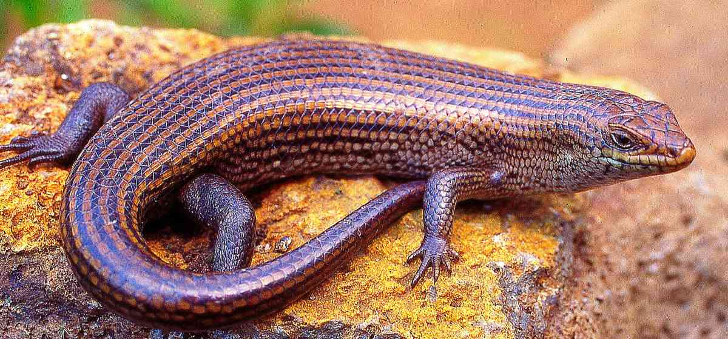

* Trachylepis dichroma Two-coloured skink

Trachylepis irregularis (Mabuya irregularis) Alpine-meadow skink

Trachylepis maculilabris (Mabuya maculilabris) Speckle-lipped skink

Trachylepis margaritifer (Mabuya margaritifer) Rainbow skink

Trachylepis megalura (Mabuya megalura) Grass top skink/long-tailed skink

Trachylepis planifrons (Mabuya planifrons) Tree skink

Trachylepis quinquetaeniata (Mabuya quinquetaeniata) Five-lined skink

Trachylepis striata (Mabuya striata) Striped skink

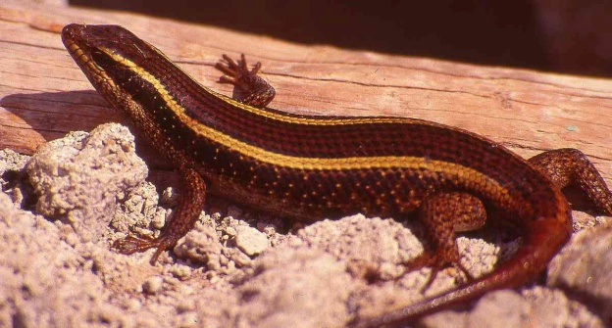

Trachylepis varia (Mabuya varia) Variable skink

Infraorder Scincomorpha Family Scincidae Subfamily Lygosominae Lygosomid/burrowing skinks

Lygosoma pembanum Pemba Island writhing skink

Mochlus afer (Lygosoma afrum) Peters’ writhing skink

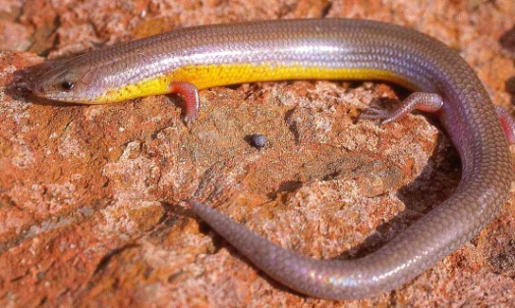

Mochlus mabuiiforme (Lygosoma mabuiiformis) Mabuya-like writhing skink

Mochlus somalicum (Lygosoma somalicum) Somali writhing skink

Mochlus sundevalli (Lygosoma sundevalli) Sundevall’s writhing skink

Mochlus tanae (Lygosoma tanae) Tana River writhing skink

Lepidothyris hinkeli (Lygosoma fernandi) Hinkel’s red-flanked skink (Red-flanked skink)

Infraorder Scincomorpha Family Scincidae Subfamily Eugongylinae Eugongylid skinks

Leptosiaphos kilimensis Kilimanjaro five-toed skink

Afroablepharus wahlbergii (Panaspis wahlbergii) Wahlberg’s snake-eyed skink

Cryptoblepharus africanus (Cryptoblepharus boutonii) Coral rag skink

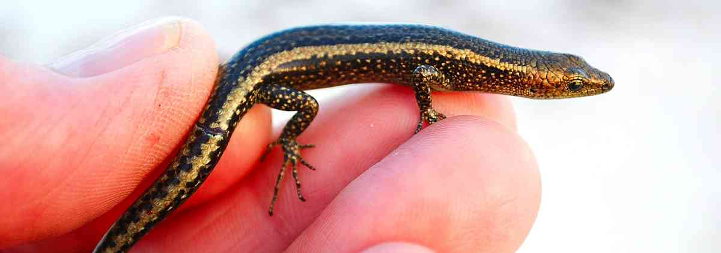

Infraorder Scincomorpha Family Scincidae Subfamily Scincinae Typical skinks

Chalcides bottegi (Chalcides ocellatus) Ocellated skink

* Feylinia currori Western forest limbless skink

* Melanoseps loveridgei Loveridge’s limbless skink

* Melanoseps pygmaeus Pygmy limbless skink

Infraorder Scincomorpha Family Lacertidae Lacertids, Wall Lizards

Gastropholis prasina Green keel-bellied lizard

Gastropholis vittata Striped keel-bellied lizard

* Holaspis laevis Blue-tailed gliding lizard

Philochortus rudolfensis Turkana shield-backed ground lizard 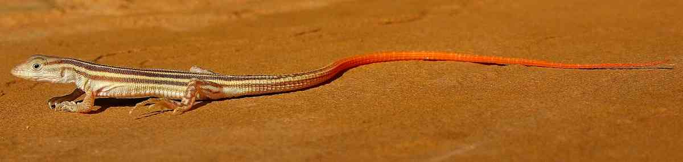

(© Mike Roberts)

* Adolfus africanus Multi-scaled forest lizard

Adolfus alleni Mt Kenya Alpine-meadow lizard (Alpine meadow-lizard)

* Adolfus masavaensis (elevated from within A. alleni) Mt Elgon Alpine-meadow lizard (also on Aberdares)

Adolfus jacksoni Jackson’s forest lizard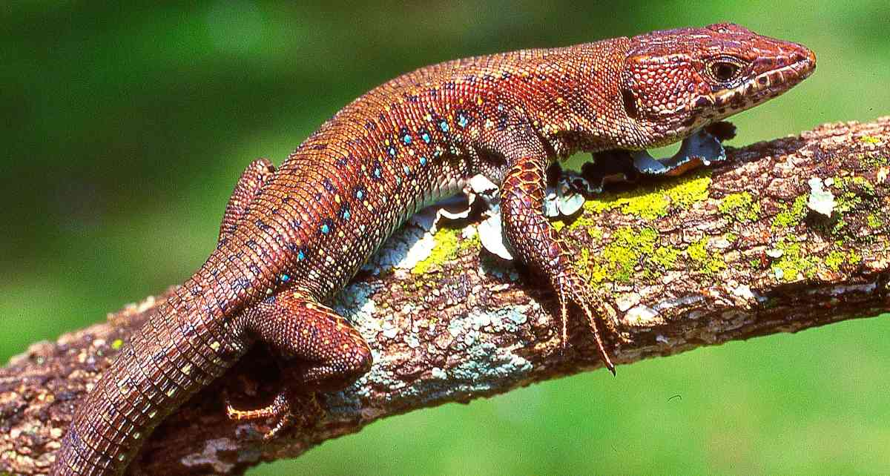

Nucras boulengeri Boulenger’s scrub lizard

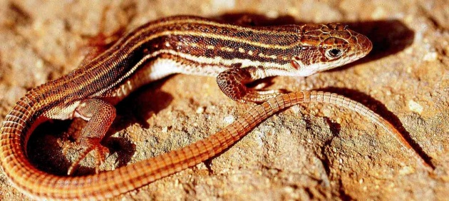

Heliobolus neumanni Neumann’s sand lizard

Heliobolus spekii Speke’s sand lizard

Pseuderemias striatus (Pseuderemias striata) Peters’ sand lizard

Pseuderemias smithii Smith’s sand lizard

Latastia longicaudata Southern long-tailed lizard

Infraorder Scincomorpha Family Cordylidae Girdled and grass lizards

Cordylus tropidosternum Tropical girdled lizard

Cordylus beraduccii Maasai girdled lizard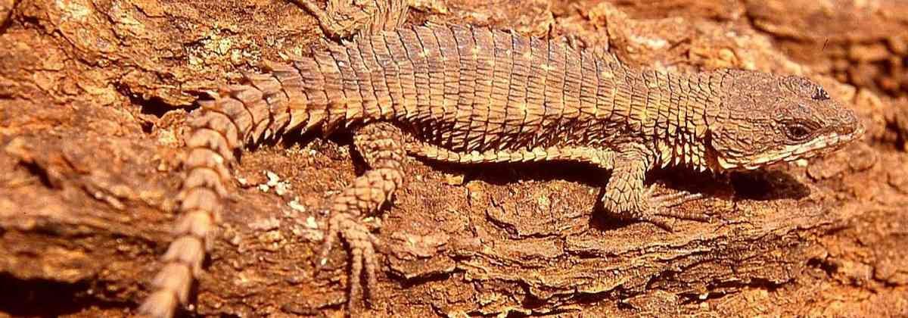

Chamaesaura tenuior (Chamaesaura anguina) Highland grass lizard

Infraorder Scincomorpha Family Gerrhosauridae Plated Lizards

Gerrhosaurus flavigularis Yellow-throated plated lizard

Gerrhosaurus nigrolineatus Black-lined plated lizard

Broadleysaurus major (Gerrhosaurus major) Great plated lizard

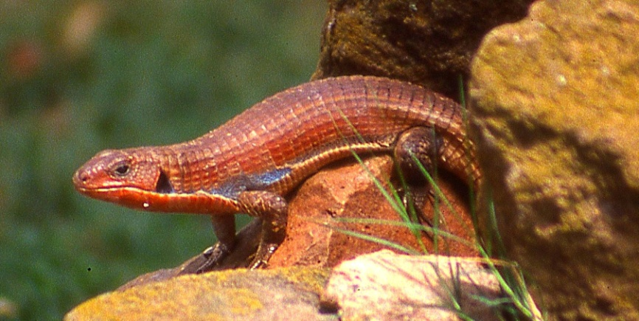

Infraorder Iguania Family Agamidae Agamas

Acanthocercus annectans Eritrean rock agama

Acanthocercus atricollis Blue-headed tree agama

Agama lionotus (Agama agama) Red-headed rock agama

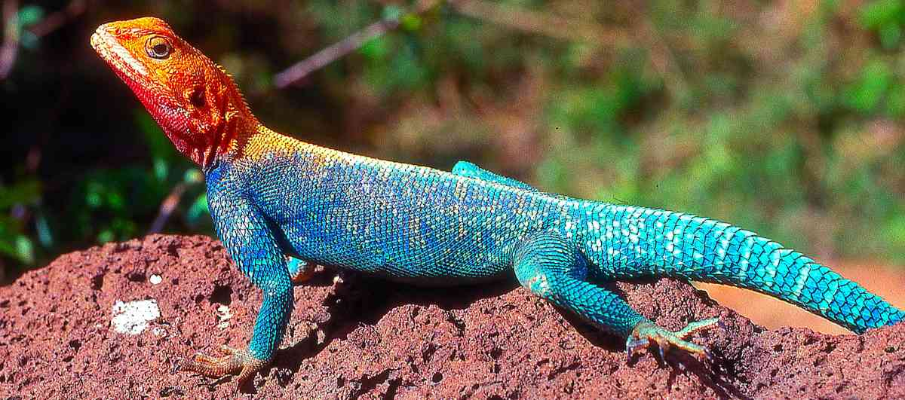

Agama armata Tropical spiny agama

Agama caudospinosa (Agama caudospina) Elmenteita rock agama

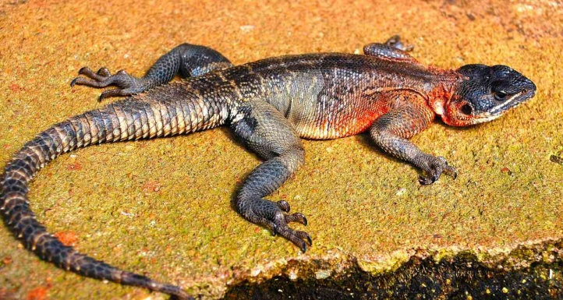

* Agama finchi Malaba rock agama/Brian Finch’s rock agama

* Agama kaimosae Kaimosi agama

Agama mwanzae Mwanza flat-headed agama

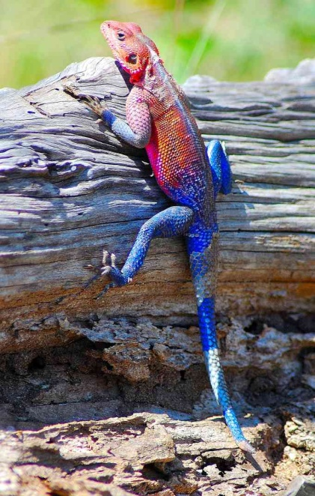

Agama persimilis Somali painted agama

Agama rueppelli Rüppell’s agama

Infraorder Iguania Family Chamaeleonidae Chameleons
* Kinyongia asheorum Mt Nyiro bearded chameleon
* Kinyongia boehmei (elevated from within Chamaeleo tavetanus) Taita Hills blade-horned chameleon
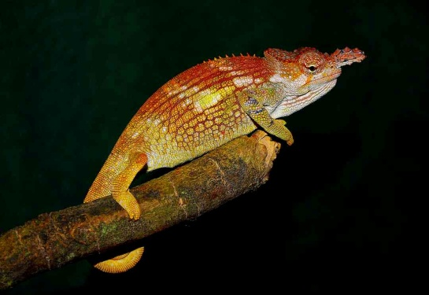
Kinyongia excubitor (Chamaeleo excubitor) Mt Kenya hornless chameleon
Kinyongia tavetana (Chamaeleo tavetanus) Mt Kilimanjaro two-horned chameleon
Kinyongia tenuis (Chamaeleo tenue) Usambara soft-horned chameleon.
Chamaeleo dilepis Flap-necked chameleon
Chamaeleo gracilis Slender chameleon, graceful chameleon
Chamaeleo laevigatus Smooth chameleon
Trioceros bitaeniatus (Chamaeleo bitaeniatus) Side-striped chameleon
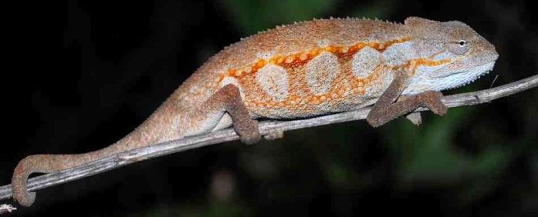
* Trioceros conirostratus Sudanese unicorn chameleon
Trioceros ellioti (Chamaeleo ellioti) Montane side-striped chameleon
Trioceros hoehnelii (Chamaeleo hoehnelii) Von Höhnel’s chameleon
Trioceros jacksonii (Chamaeleo jacksonii) Jackson’s chameleon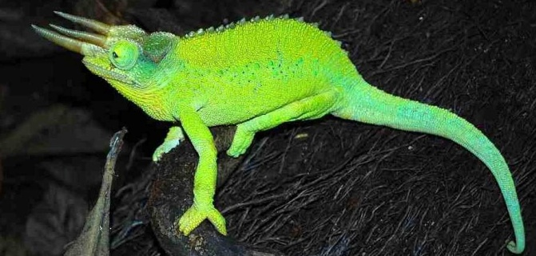
* Trioceros kinangopensis Mt Kinangop alpine chameleon, Aberdare chameleon
Trioceros marsabitensis (Chamaeleo marsabitensis) Mount Marsabit chameleon
* Trioceros narraioca Mt Kulal stump-nosed chameleon
* Trioceros ntunte Mt Nyiro montane chameleon
* Trioceros nyirit Pokot chameleon
Trioceros schubotzi (Chamaeleo schubotzi) Mt Kenya side-striped chameleon
Trioceros sternfeldi (Chamaeleo rudis) Tanzanian montane dwarf chameleon (Ruwenzori side-striped chameleon)
Trioceros tremperi (Chamaeleo tremperi) Eldama Ravine chameleon
Furcifer oustaleti (Chamaeleo oustaleti) Malagasy giant chameleon (introduced, probably extinct in Kenya)
Rhampholeon boulengeri Boulenger’s pygmy-chameleon
Rieppeleon brevicaudatus (Rhampholeon brevicaudatus) Bearded pygmy-chameleon
Rieppeleon kersteni (Rhampholeon kersteni) Kenya pygmy-chameleon 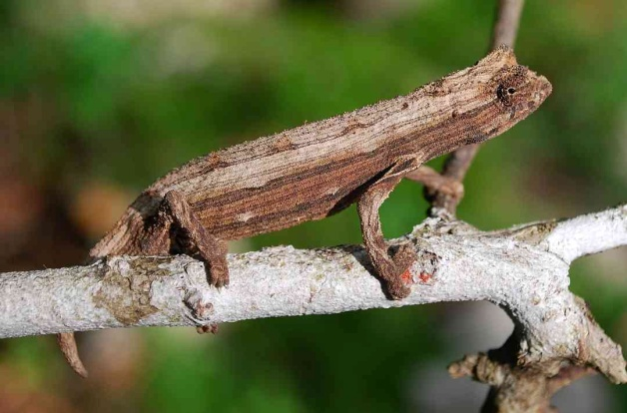
Infraorder Platynota (Varanoidea) Family Varanidae Monitor Lizards
Varanus albigularis White-throated savanna monitor 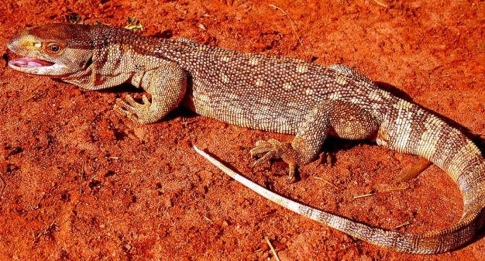
Varanus niloticus Nile monitor
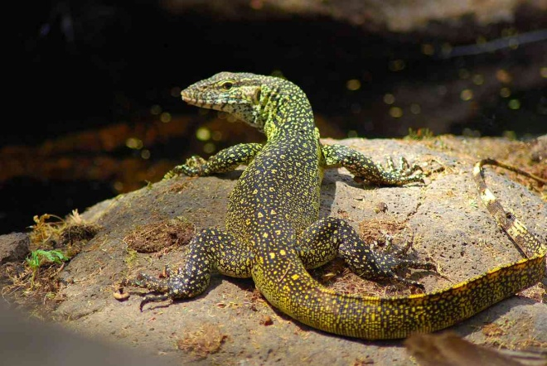
Amphisbaenians or Worm Lizards Sub-order Amphisbaenia
Sub-order Amphisbaenia Family Amphisbaenidae Wedge-snouted worm lizards
Geocalamus acutus Voi wedge-snouted worm lizard
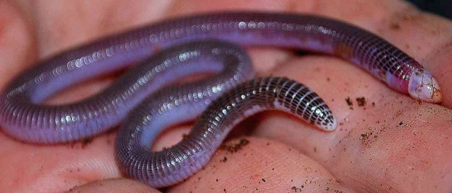
Crocodiles; Order Crocodylia

Suborder Eusuchia Family Crocodylidae Crocodylians

Crocodylus niloticus Nile crocodile
