The Kenya Reptile Atlas
A free, downloadable atlas of Kenya’s reptiles. This is a free source of regularly updated information on Kenya’s Reptiles. Authors: Stephen Spawls, Beryl Bwong, Patrick Malonza, Vincent Muchai, Victor Wasonga
Obtainable under ‘downloads’ at Kenyareptileatlas.com
This project is funded by the Rufford Foundation under the auspices of the National Museums of Kenya; Department of Herpetology.

The Kenya Reptile Atlas offers you:
Pictures of Kenya’s reptiles
Distribution maps by quarter-degree-square
A description of the species
Click on any of the titles listed under the downloads tab to download for free. The various families will be added as the accounts are completed.
If you have any observations of Kenya’s reptiles, any distribution records, or any other data, or any digital pictures, we would like to receive them! Send them to Kenyareptileatlas@gmail.com
And if you live or travel in Kenya, and find any dead reptiles, please preserve them and take them to the Herpetology Section at the National Museum, Museum Hill, Nairobi.
The team thanks those who kindly commented upon the text of this section or generously loaned us pictures; including the herpetological team at Bio-Ken (Sanda Ashe, Anthony Childs and Royjan Taylor), Tomas Mazuch, Don Broadley and Lorenzo Vinciguerra. All uncredited photos by Stephen Spawls.
Burrowing Snakes

Burrowing Snakes: Family Lamprophiidae, subfamilies Aparallactinae and Atractaspidinae. Kenyan representatives of these two subfamilies are mostly small nocturnal snakes that hide underground or in leaf litter, and are only likely to be found on the surface at night, especially after rain. Ten species of the subfamily Aparallactinae are known from Kenya at present; that is four centipede-eaters (Aparallactus), three purple-glossed snakes (Amblyodipsas), two Micrelaps (no common name for the group) and one snake-eater (Polemon). None are dangerous.
However, four dangerous members of the subfamily Atractaspidinae are known from Kenya, all of the genus Atractaspis. Originally called mole vipers, taxonomic work shows they are not vipers, but specialised colubrids. Suggested names for the snakes of this genus are burrowing asps (our preferred term), stiletto snakes and side-stabbing snakes. All are dangerously venomous, although their bites rarely (but occasionally) cause fatalities. However, they are a major medical hazard in some areas, particularly where poor people sleep on the ground, as they often slide into dwellings at night.
It is often suggested that these burrowing snakes are very hard to identify, and quite a number of snake handlers have been bitten by burrowing asps, having mistaken them for another species. However, with a little knowledge, these snakes can often be identified to the genus, even if not to the species. The centipede-eaters are slim; they have a long thin tail, and often have distinctive head and neck markings. The Kenyan burrowing asps are usually one colour; brown or grey or black, with a short head and a short tail that ends in a spike. In Kenya, their locality gives clues as to their identity. The Micrelaps have unusual markings. Christy’s snake-eater is very rare, only likely to be encountered in the forests of the west. The difficult group is the purple-glossed snakes, which are very similar to burrowing asps in head and tail shape, colour, and they even show similar (although not identical) neck-arching behaviour. We would advise never handling purple-glossed snakes.
As always, we make a plea; these snakes are under-represented in Kenya’s museums, and without museum specimens, we cannot do conservation or taxonomic work. It is almost certain that cryptic species are concealed within the various species as we know them. Please consider donating specimens. You don’t have to kill them. These little burrowing snakes are often found dead on the road or on paths; if you find one, preserve it (in methylated spirit, or alcohol such as gin or vodka, if no formalin or ethanol is available) and take it to the Nairobi Museum. A live specimen – if it can be transported safely - is useful for educative displays, and can be preserved in the museum collection if it dies.
Black centipede-eater Aparallactus guentheri 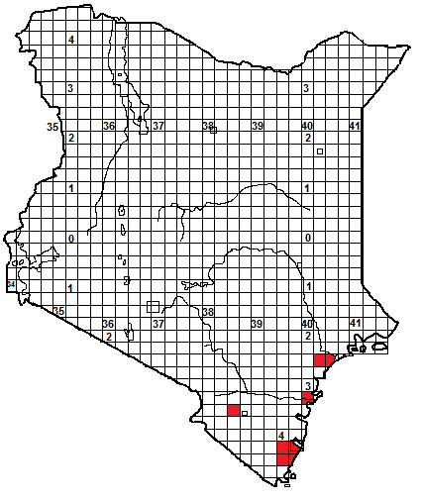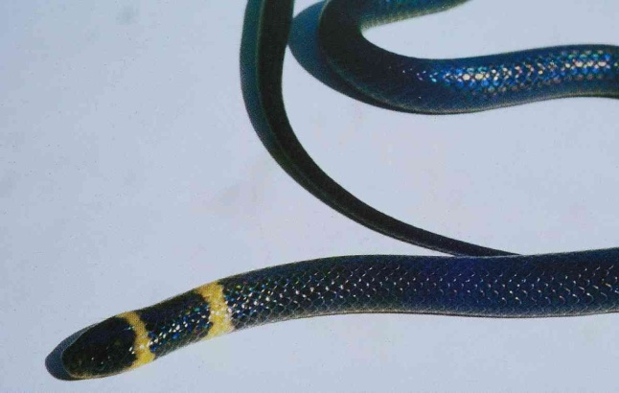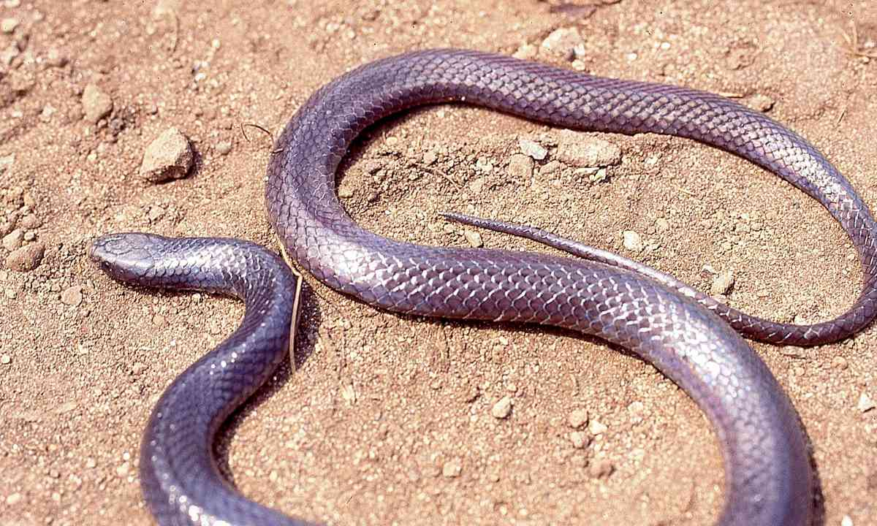
Identification: A harmless, small, fairly slim, dark snake with a rounded head and a long tail. Maximum size about 50 cm, average 30-45 cm. Adults uniform shiny grey or black, paler below, juveniles have two distinct light crossbars on the back of the head and the neck. Occasional individuals with a reticulate pattern are known.
Distribution: Coastal bush moist savanna and evergreen hill forest. A rare species in Kenya, known from a few coastal localities (Tana Delta, Arabuko-Sokoke Forest, Mombasa, Tiwi, Shimba Hills) and the Taita Hills; more widespread in eastern Tanzania.
Natural History: Poorly known. Lives underground, in holes, emerges onto surface on wet nights. Lays eggs; eats centipedes.
Illustrations: Juvenile Zimbabwe, © Don Broadley. Adult N Tanzania.
Jackson’s Centipede-eater Aparallactus jacksoni
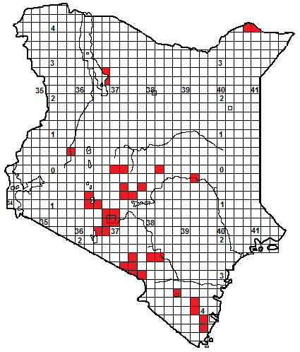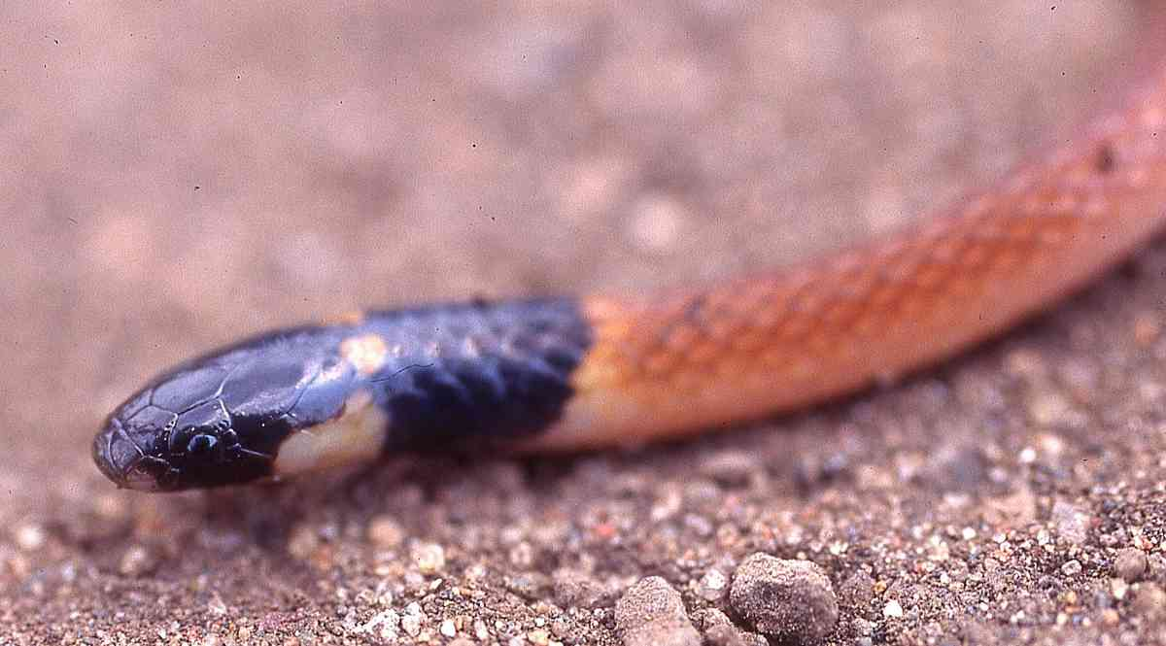
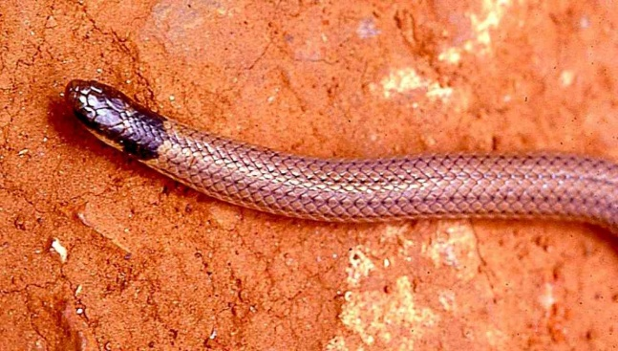
Identification: A harmless, very small, slim, brown snake with a black head. Maximum size about 25-28 cm, average 20-25 cm, hatchlings 10-11 cm. Usually pink, rufous or brown above, sometimes with fine dark dorsal lines. The size and position of the yellow collar varies. Yellow, cream or pinkish below.
Distribution: Moist and dry savanna, woodland and high grassland, from sea level (in Tanzania) to 2 200 m altitude. There are sporadic records in eastern Kenya (Shimba Hills, Voi, Taru, Kibwezi and the northern loop of the Tana), around Kilimanjaro and the Amboseli area, Nairobi and Naivasha, Laikipia and the Kerio Valley. Also at Malka Murri on the northern border and the east shore of Lake Turkana (although few records from the dry north).
Natural History: A burrowing snake, hides in holes, under rocks, logs and in soft soil and sand, may emerge and hunt on the surface on wet nights. Rare in some places, but quite common in others, seven were found one evening in Amboseli following a rainstorm. Unusually, it gives live birth to 2 or 3 young. Eats centipedes.
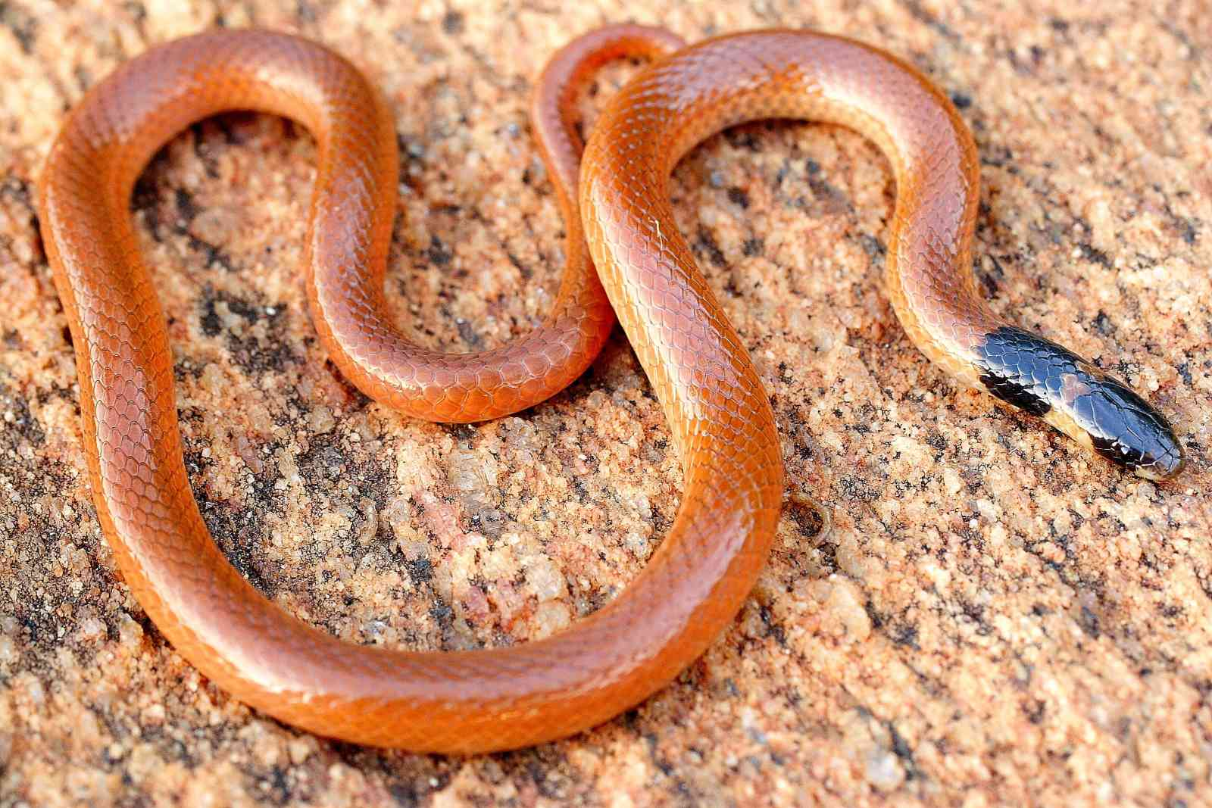
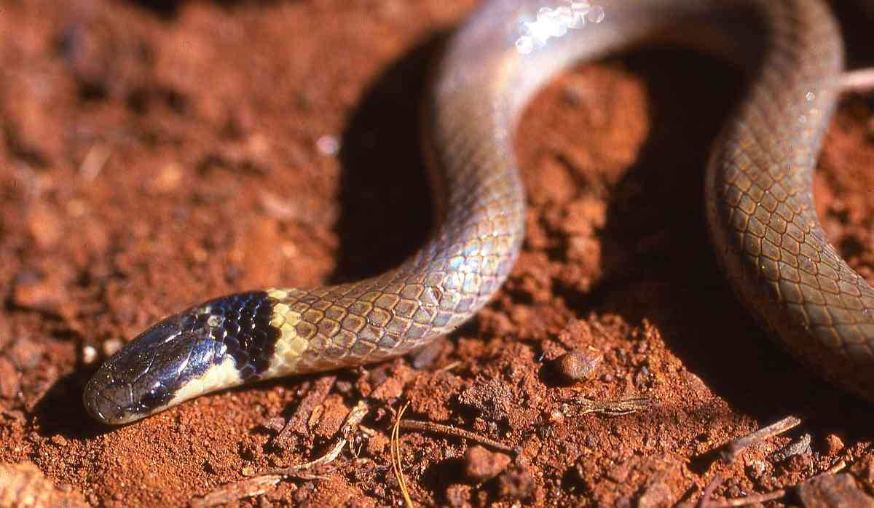
Illustrations: Longido (top) Voi (middle), Elsa’s Kopje (Meru National Park; © Anton Childs) upper bottom, Hell’s Gate (lower bottom).

Plumbeous centipede-eater Aparallactus lunulatus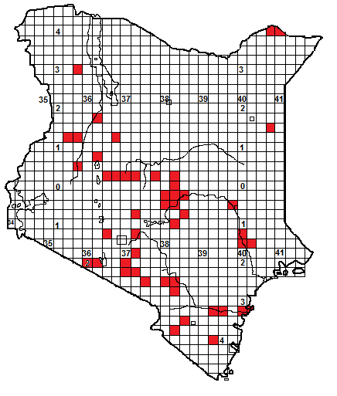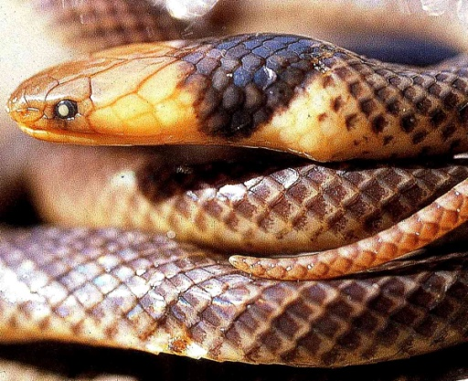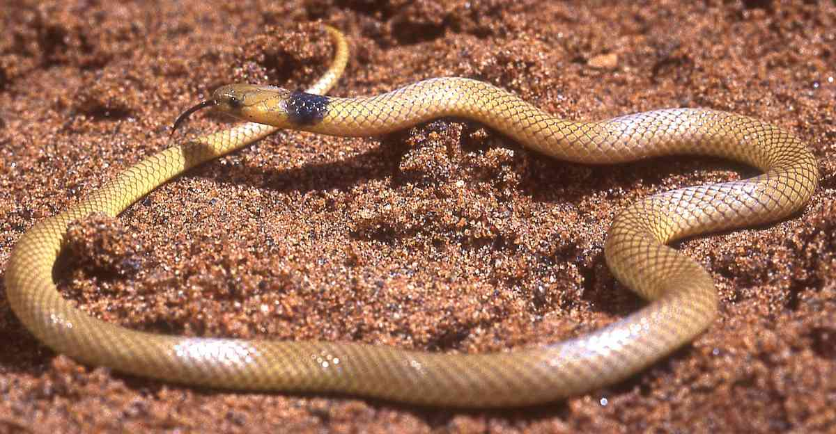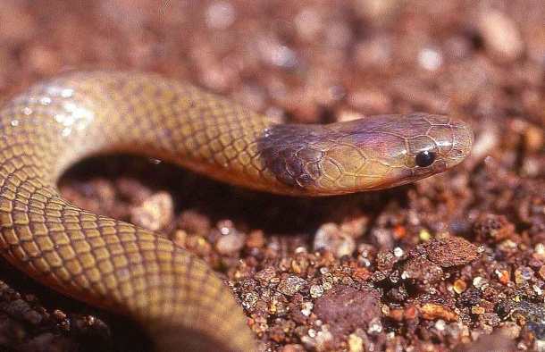
Identification: A harmless small, slim snake. Maximum size about 50 cm, average 30-40 cm, hatchlings 12-15 cm. Colour very variable, in Kenya some individuals are uniform grey or black, others are grey with dorsal scales white edged, with a yellow head and black collar, others are fawn, brown or yellow, with a black collar, sometimes each dorsal scale has black edging, giving a reticulate effect. Juvenile specimens from southern Africa have a series of narrowing bars on the neck. It is possible that more than one species is involved.
Distribution: Coastal bush, moist and dry savanna, woodland and semi-desert, from sea level to 2 200 m altitude. Widely recorded from dry eastern and north-western Kenya, and the southern Rift Valley south of Suswa, no records from the coastal strip and few from the dry northeast save Wajir Bor and Malka Murri.
Natural History: A burrowing snake, hides in holes, under rocks and in soft soil and sand, although it doesn’t seem to live in pure sandy country, preferring areas with some rocks. May emerge and hunt on the surface on wet nights. Some specimens bite fiercely when handled, although its tiny fangs mean it is not dangerous. Lays 2-4 eggs. Eats centipedes; one South African specimen ate a scorpion.
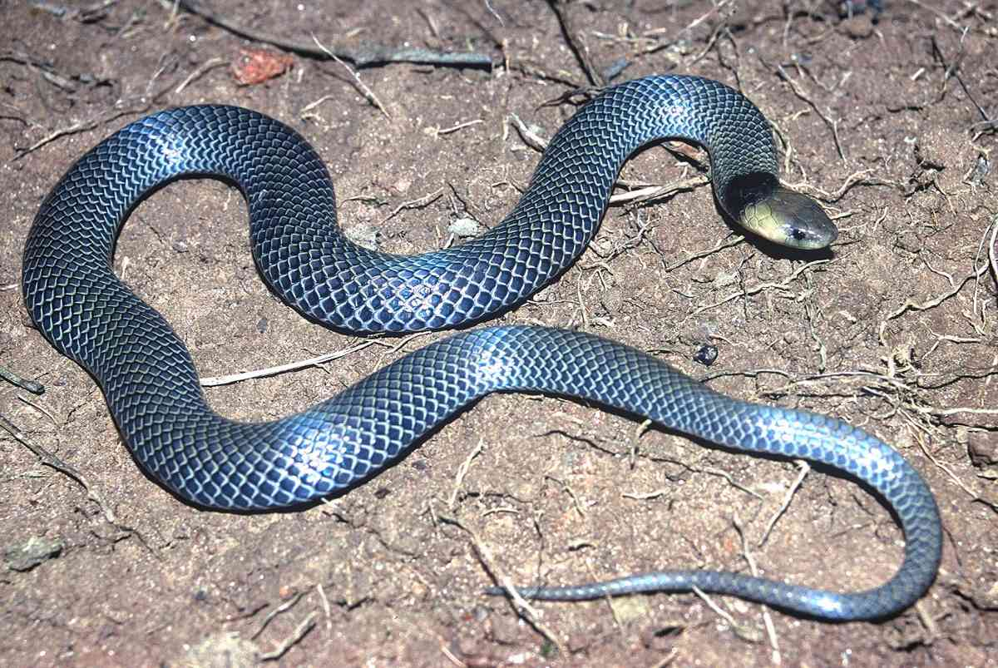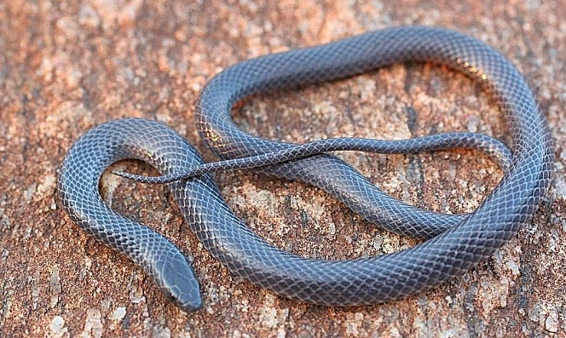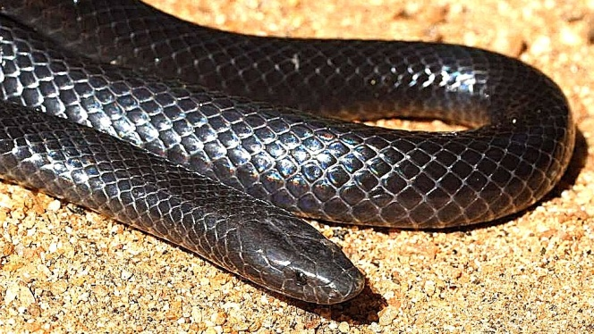
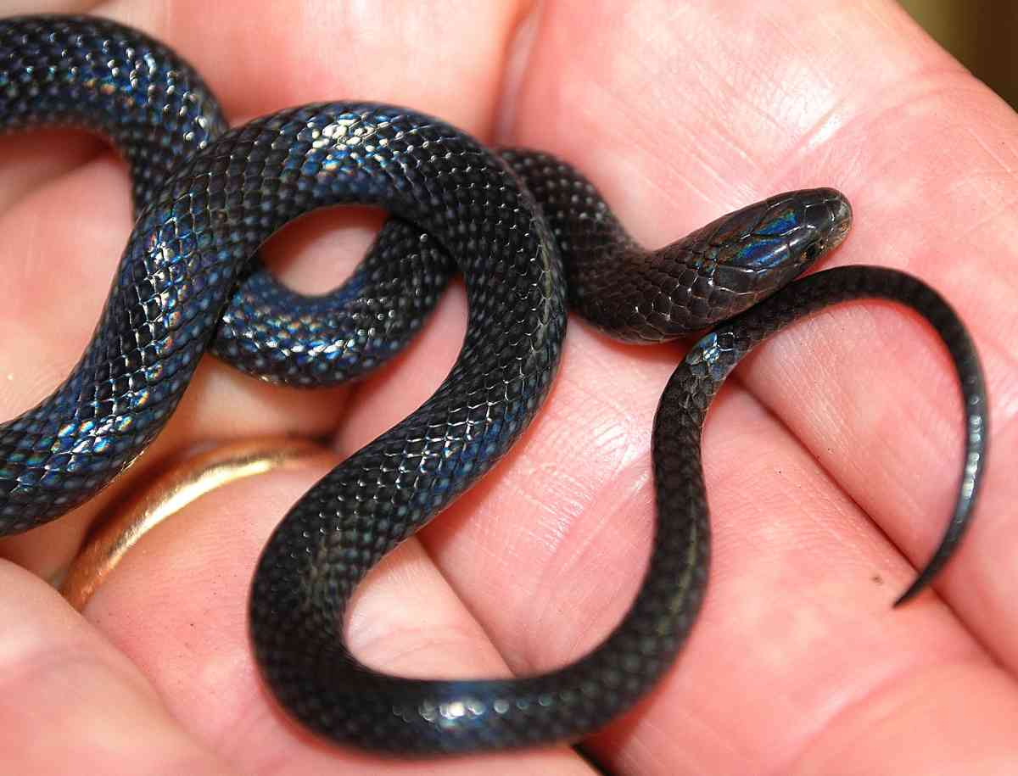
Illustrations: Rumuruti (preserved specimen upper top), Longido (lower top left, © Lorenzo Vinciguerra), Nazret, Ethiopia (lower top right), Samburu Hills (large centre, © Tomas Mazuch), Meru National Park (lower centre left and right, © Anton Childs), Watamu (bottom).
Malindi centipede-eater Aparallactus turneri
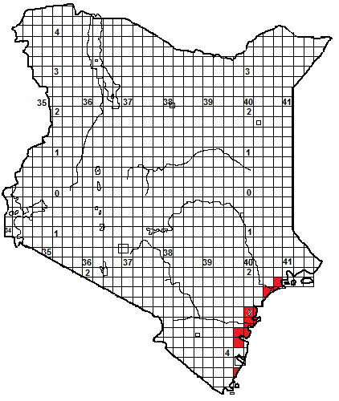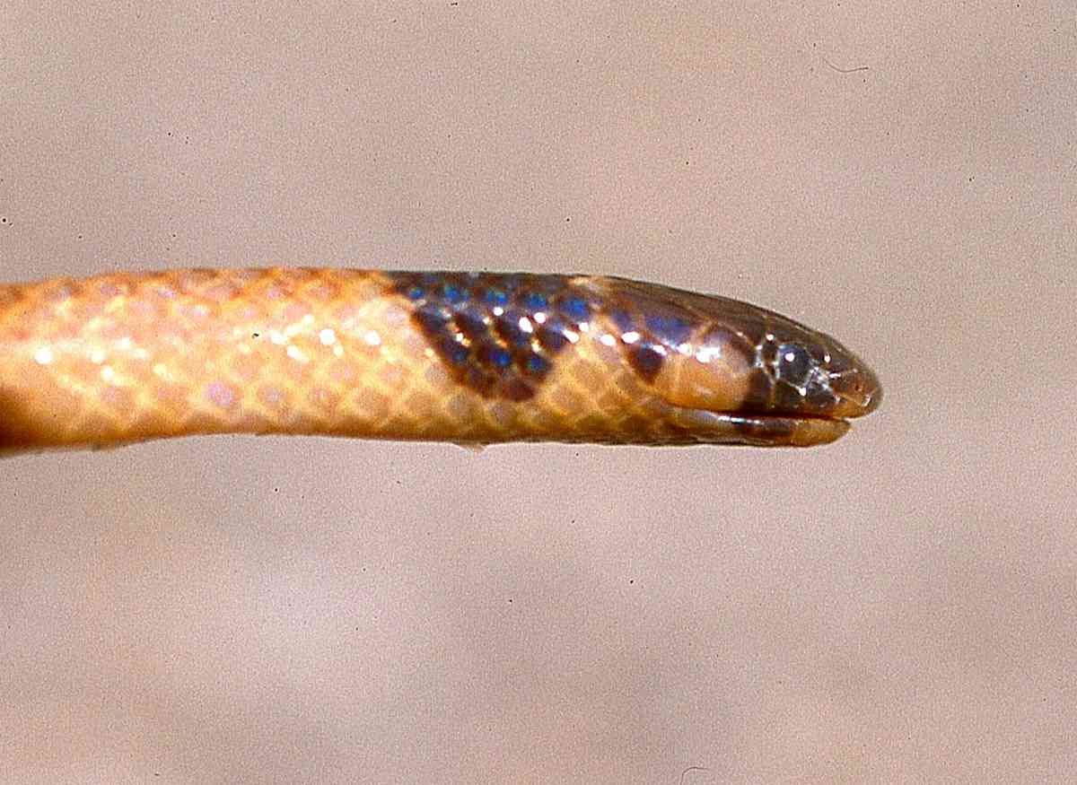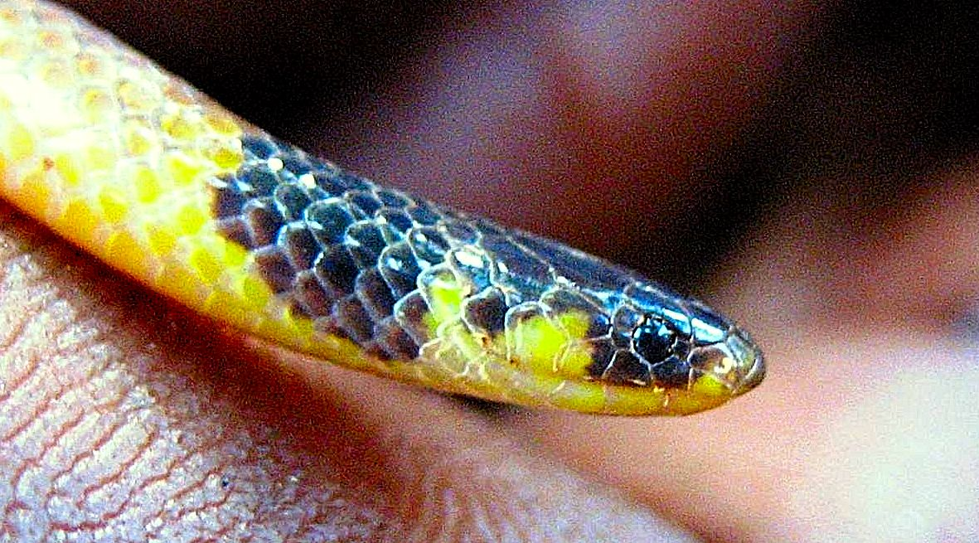
Identification: A harmless, very small, slim snake. Maximum size about 20 cm, average 15-18 cm. Brown or yellow-brown in colour, top of head black, the black extending down onto the throat, also to just behind the mouth and through the eyes. Ventrals yellow or cream. A narrow light collar may be present, and occasionally a fine dark vertebral line.
Distribution: Endemic to the woodland, thicket and savanna of the Kenya coast, recorded sporadically from the mainland opposite Lamu Island south to Mombasa, with a single record south of Mombasa at Tiwi Beach.
Natural History: Poorly known but probably similar to other centipede-eaters; i.e. a burrowing snake, hides in holes, under rocks and in soft soil and sand, may emerge and hunt on the surface on wet nights. Eats centipedes. Presumably lays eggs.
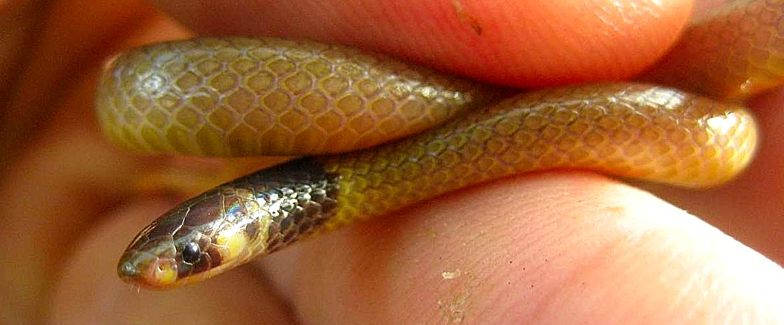

Illustrations: Malindi (top), preserved specimen, all others Arabuko-Sokoke Forest; (© Royjan Taylor, Bio-Ken)

Christy’s snake-eater Polemon christyi
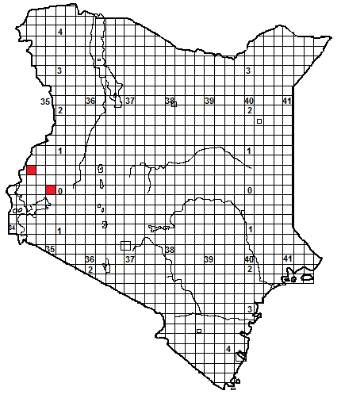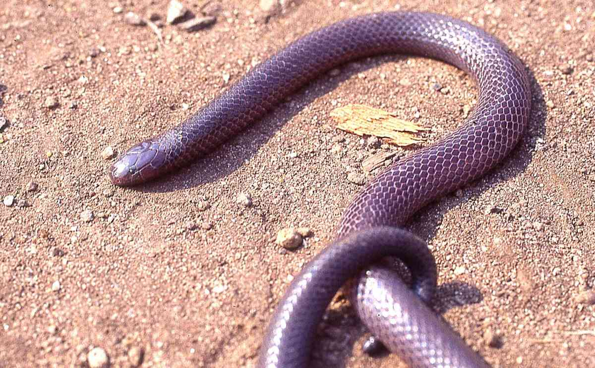
Identification: A harmless, small dark burrowing snake, with a short blunt head, tiny eye, cylindrical body and a very short tail, 3-9% of total length. Maximum length about 80 cm, average 40-70 cm. Colour; iridescent blue-black, grey or purplish-grey above, the underside is black, or black with white edging. Closely resembles several other small burrowing snakes (purple-glossed snakes, burrowing asps), so should not be handled.
Distribution: Forest, thick woodland, well-wooded savanna and recently deforested areas. There are only two records from Kenya; both from the far west, Netima near Mt Elgon and Kakamega.
Natural History: Poorly known. A burrowing snake, hides in holes, living under ground cover, and in soft soil and leaf litter, may emerge and hunt on the surface on wet nights. Slow moving and inoffensive. Presumably lays eggs. Diet; other snakes (including its own species), recorded eating blind snakes, worm snakes and white-lips.
Illustration: Eastern Congo; (© Michael McLaren)
Common Purple-glossed snake Amblyodipsas polylepis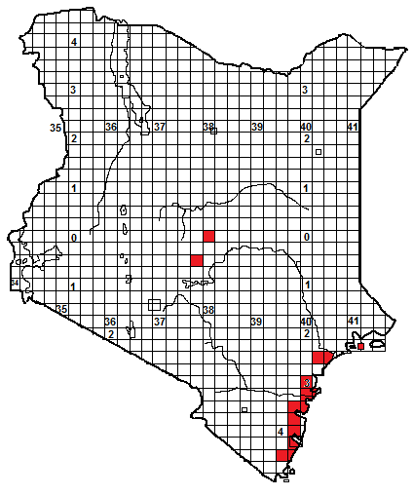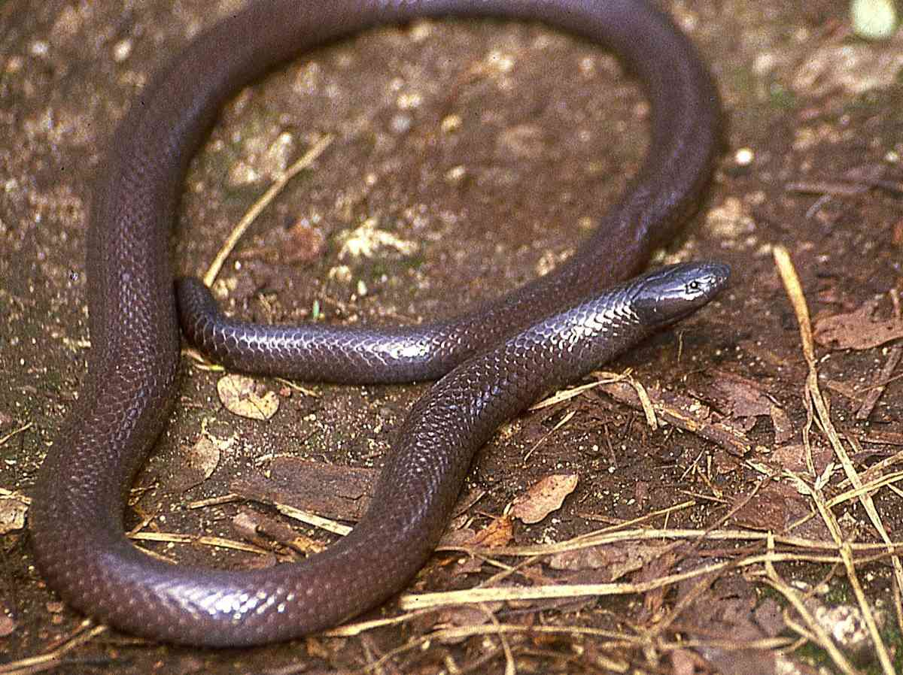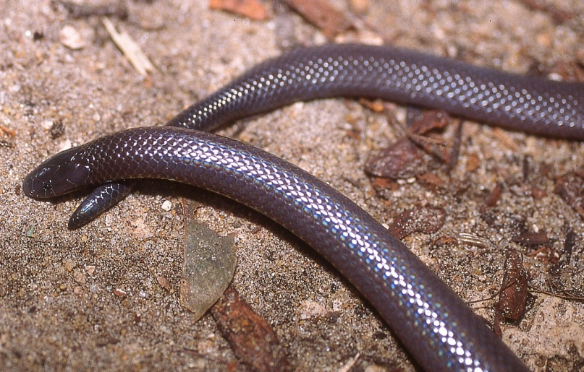
Identification: A rear-fanged, small dark burrowing snake, with a short blunt head, small eye, cylindrical body and short tail. Maximum length about 70 cm, average 40-60 cm. Colour purplish or pinkish brown, sometimes grey, often with a distinct purple bloom on the scales (hence the common name), especially if freshly sloughed. Closely resembles burrowing asps so should not be handled.
Distribution: Coastal woodland and thicket, moist savanna and evergreen hill forest, from sea level to about 1 500 m. Sporadically recorded along the Kenya coast, from Manda Island and the Tana delta south to Mombasa, Diani-Kinondo, also known from the moist forests of eastern Mt Kenya (at Chuka) and the Nyambene Hills.
Natural History: Poorly known. A burrowing snake, hides in holes, living under ground cover, and in soft soil and leaf litter, may emerge and hunt on the surface on wet nights. It is nervous and quick moving, if picked up some individuals will turn and bite furiously and tenaciously. When molested, it may arch the neck in the manner of a burrowing asp (although not as steeply, compare the lower picture above with the Bibron’s burrowing asp). Presumably lays eggs. Diet; other snakes, smooth-bodied skinks and caecilians.
Medical Significance: The venom is unstudied, no bite cases resulting in any sort of symptoms are known, but its habit of biting when handled (and its resemblance to burrowing asps) indicates that it should not be picked up.
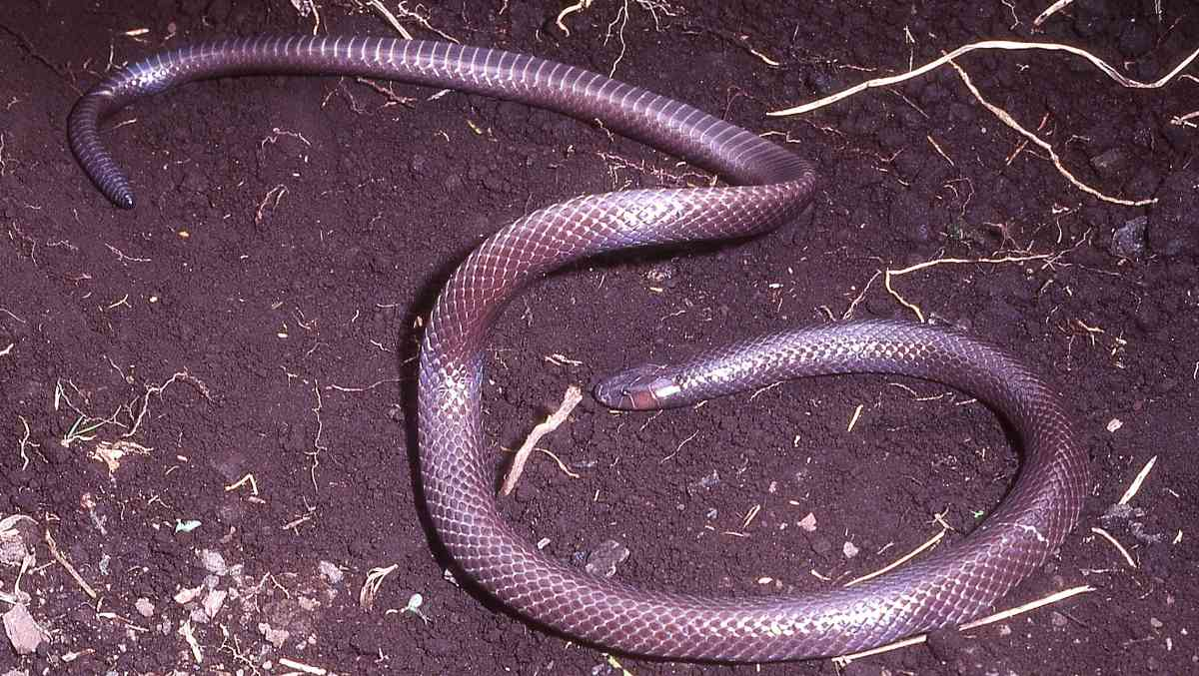
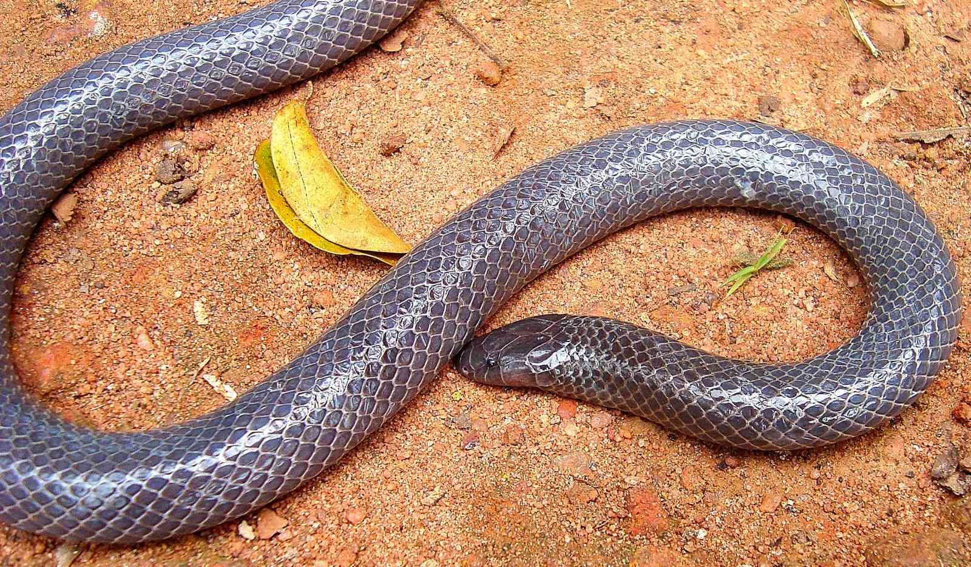
Illustrations: Top two Watamu (TR © James Ashe), middle Arusha (© Lorenzo Vinciguerra, bottom Shimba Hills (© Victor Wasonga)

Taita Hills Purple-glossed snake Amblyodipsas teitana
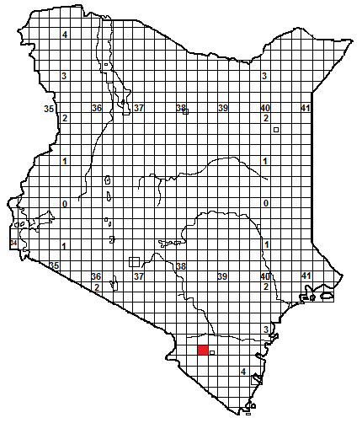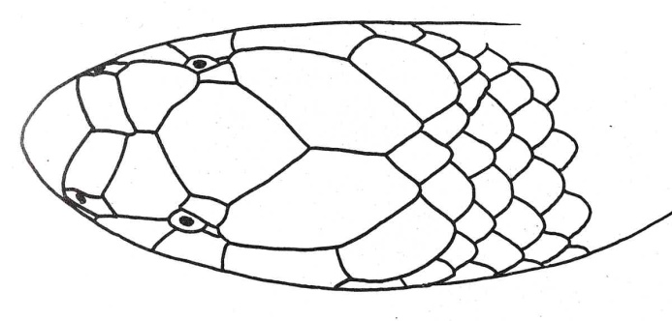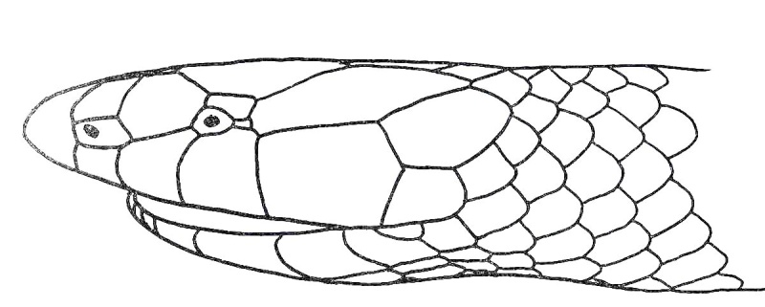
Identification: This snake is endemic to Kenya and is known from a single female specimen collected in 1934; since then no further specimens have been found. The head is fairly short, but – unlike Kenya’s two other species of Amblyodipsas – the snout is quite pointed. The specimen, collected by Arthur Loveridge, is 43.4 cm long, black above and below, except for a white patch at the front of the chin.
Distribution: Collected at an altitude of roughly 1150 m, on the slopes of Mt Mbololo, Taita Hills, possibly above Ndome town. The habitat is shown below; it is outside of the forest proper, but above the surrounding Tsavo plains. 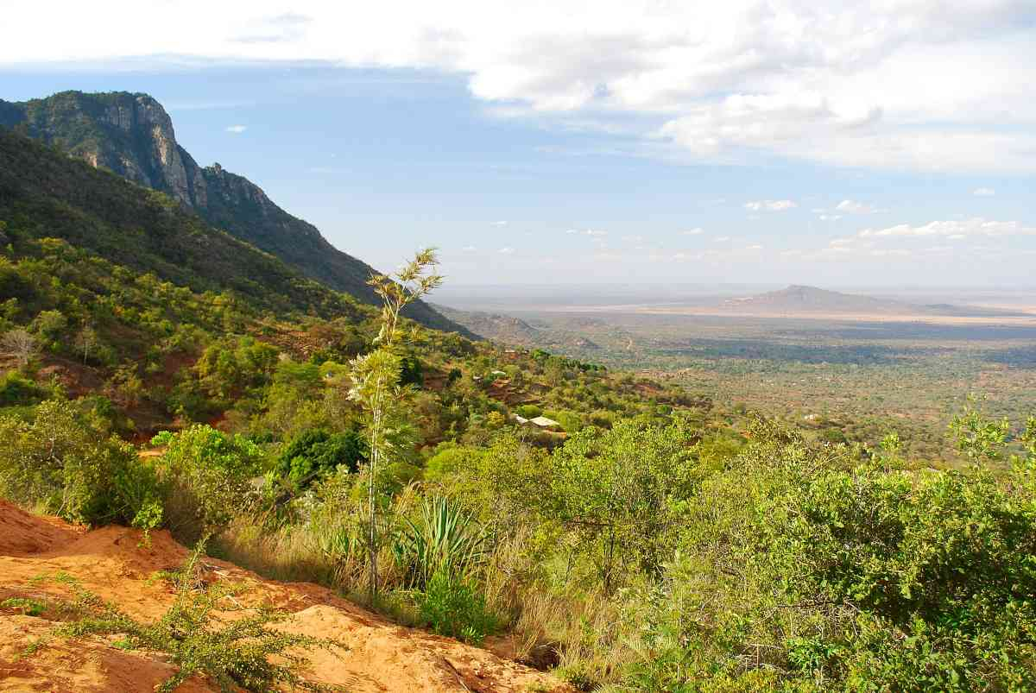
Natural History: Totally unknown, but presumably similar to other purple-glossed snakes; i.e. burrowing, emerges on wet nights, eats snakes and lizards.
Illustration: The head drawings above are used with permission from Don Broadley’s paper; ‘A revision of the African snake genera Amblyodipsas and Xenocalamus’ (1971 Occasional Papers of the National Museums of Rhodesia; Volume 4 # 33B; pp 629-697). The elongate snout indicates that this species might be similar to a long-snouted Tanzanian form, Ionides’ purple-glossed snake, Amblyodipsas katangensis ionidesi, which occurs in moist savanna; the head of a specimen of that species is shown below.
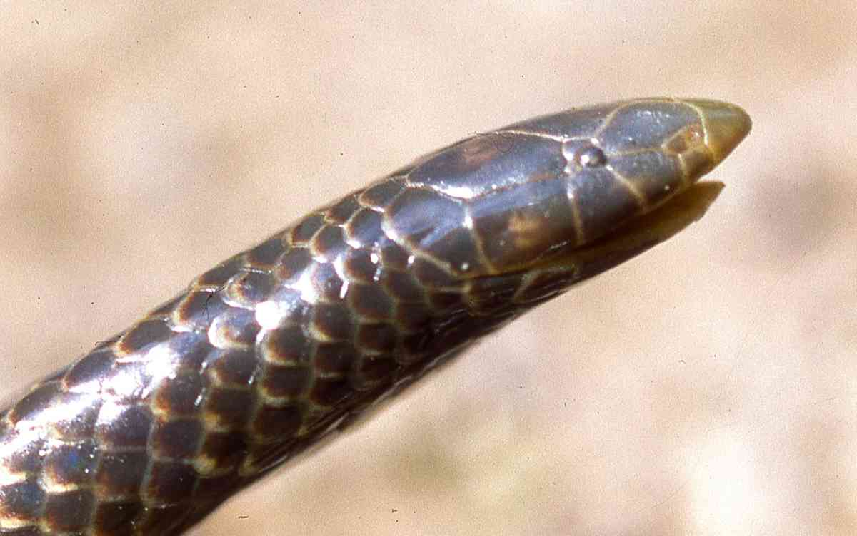
Western Purple-glossed snake Amblyodipsas unicolor
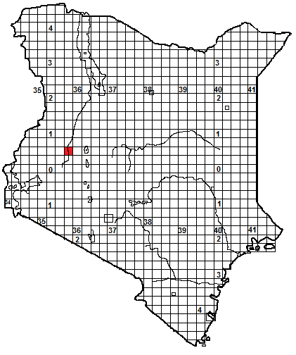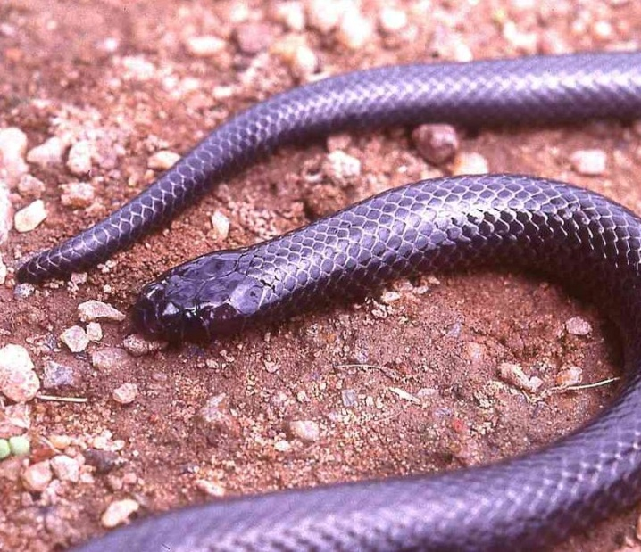

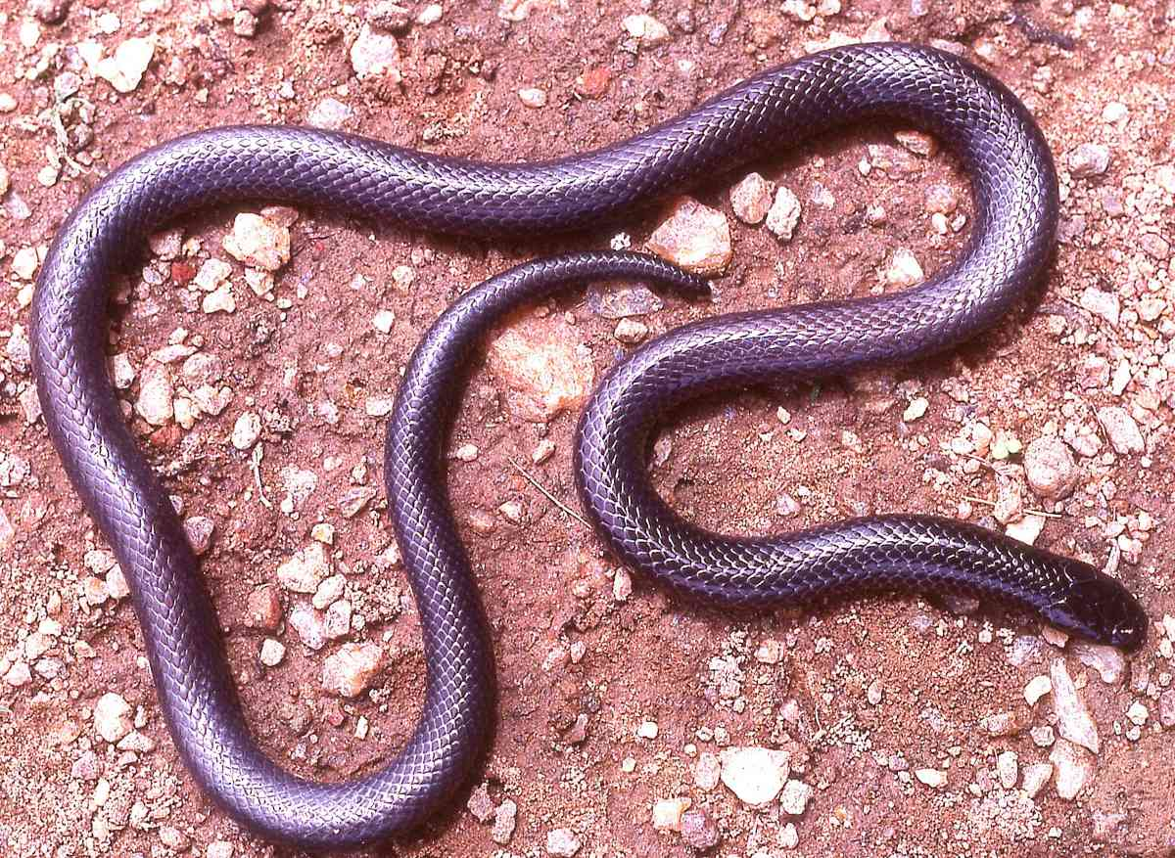
Identification: A rear-fanged, dark burrowing snake, with a short blunt head, small eye, cylindrical body and short tail. Maximum length about 110 cm, average 50-80 cm. Colour dark grey, purple-grey or black above and below, often with a distinct purple bloom on the scales (hence the common name), especially if freshly sloughed. Closely resembles burrowing asps so should not be handled.
Distribution: Dry and moist savanna, woodland and forest. Widespread from Kenya across the savanna to West Africa, but the only Kenyan record is from the Kerio Valley.
Natural History: Poorly known. A burrowing snake, hides in holes, living under ground cover, and in soft soil and leaf litter, may emerge and hunt on the surface on wet nights. It is nervous and quick moving, if handled it may bite tenaciously and furiously When molested, it may arch the neck in the manner of a burrowing asp. Presumably lays eggs. Diet; similar to other purple-glossed snakes; including other snakes, smooth-bodied skinks and caecilians.
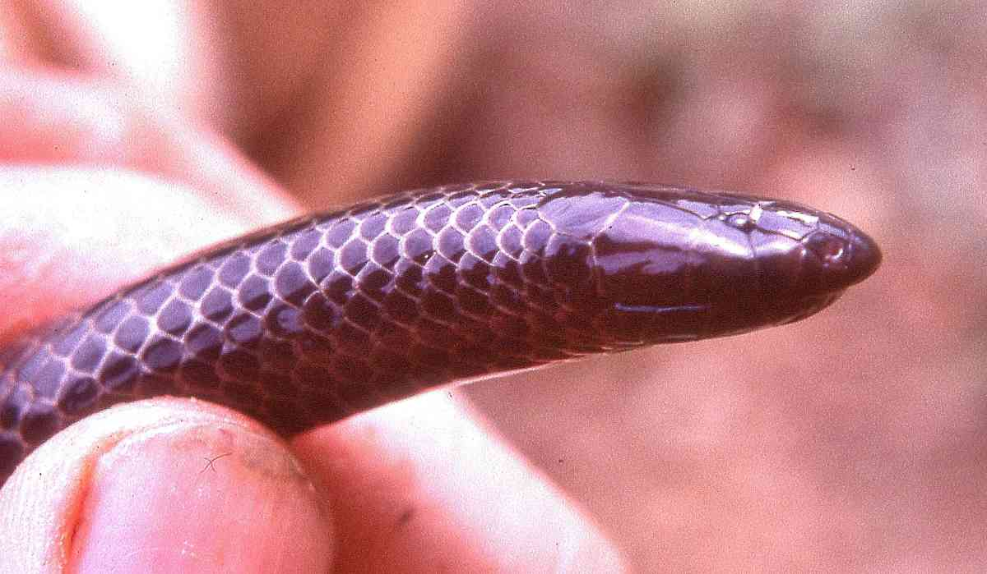
Medical Significance: The venom is unstudied, no bite cases resulting in any sort of symptoms are known, but its habit of biting when handled (and its resemblance to burrowing asps) indicate that it should not be picked up.
Illustrations: Specimen from Ghana, West Africa.

Two-coloured snake Micrelaps bicoloratus
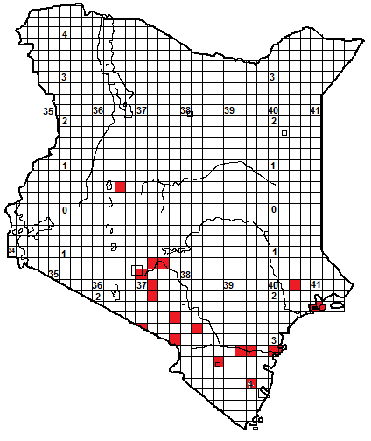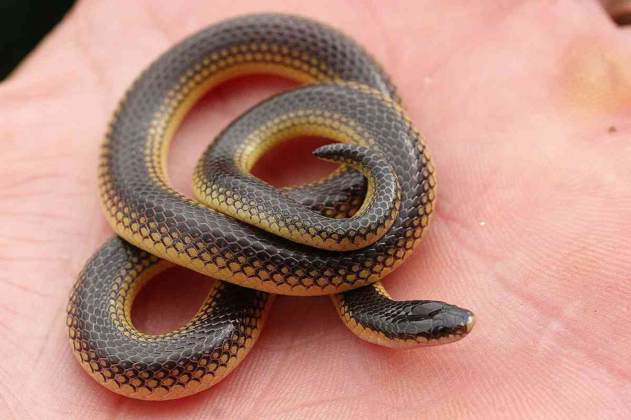
Identification: A harmless small striped burrowing snake, with a short stubby tail. Maximum length about 33 cm, average 15-25 cm. There are several colour phases; (a) a broad brown vertebral stripe, 4-7 scales wide, lower dorsal scales and ventrals orange, cream or white, (b) similar to (a) but dorsal scales below vertebral stripe heavily and then lightly black edged, (c) vertebral stripe deep brown or black, lower dorsal scales and ventrals rich orangey-red, (d) vertebral stripe yellow or cream, below that a brown dorsal stripe, lowest dorsals and ventrals cream or white; this last colour phase has been named as a subspecies, Micrelaps bicoloratus moyeri, and in Kenya is known only from the Namanga area.
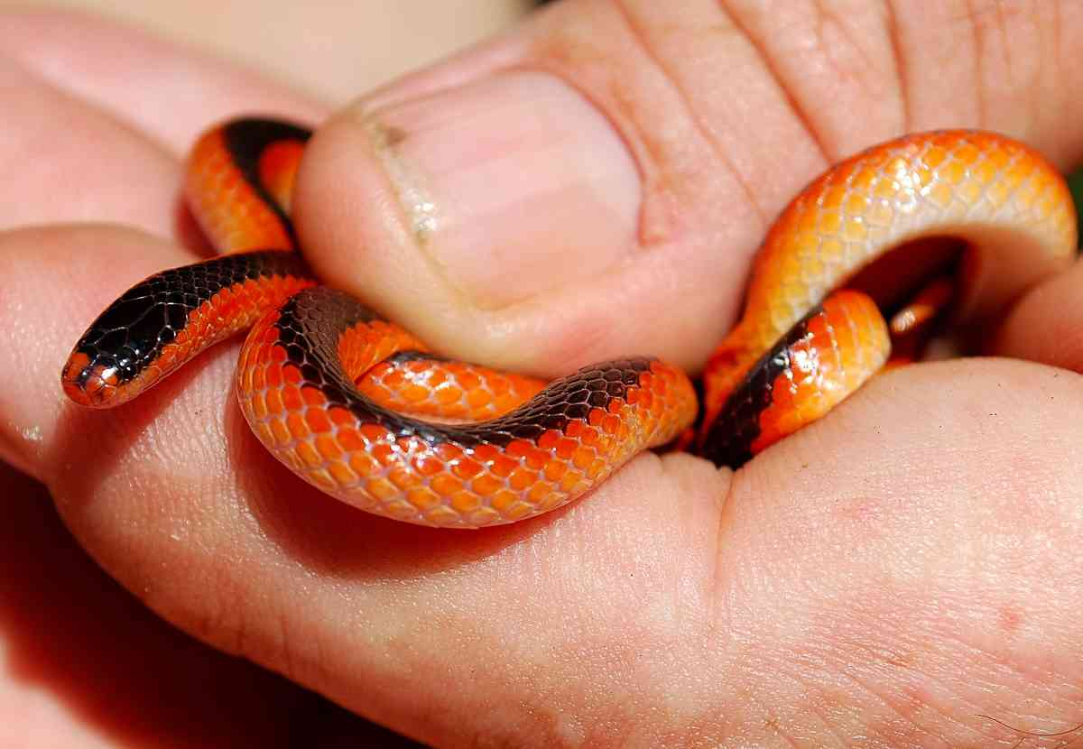
Distribution: Coastal bush, dry and moist savanna and high grassland, from sea level to about 2000 m. An East African endemic, with most records from the southeastern corner of Kenya, known localities including Nairobi Falls near Thika, Kitengela, Konza, Namanga, Loitokitok, Ijara, Watamu and Manda Island. The only Kenyan record north of Nairobi and west of the Rift Valley was Ol Ari Nyiro ranch, near Rumuruti.
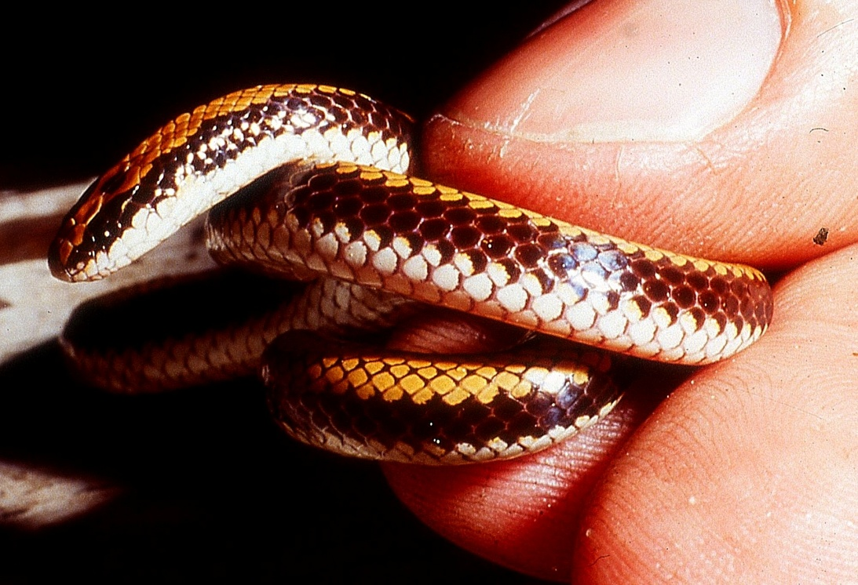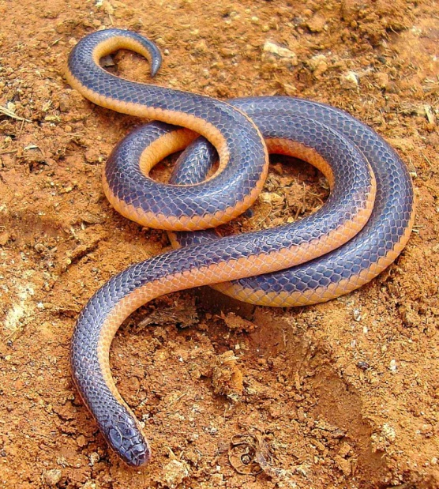

Natural History: Poorly known. A burrowing snake, hides in holes, living under ground cover, and in sand, may emerge and hunt on the surface on wet nights. Specimens have been captured on roads at night in the rainy season, Tanzanian specimens were found during ploughing; the Ol Ari Nyiro specimen was under a collapsed fence post in a dry gulley. Diet unknown but other Micrelaps eat snakes. Presumably lays eggs.
Illustrations: Top: Kitengela, © Anton Childs/Bio-Ken, middle Watamu, bottom left Micrelaps bicoloratus moyeri, Ol Donyo Sambu (northern Tanzania, © Lorenzo Vinciguerra), bottom right Ol Ari Nyiro ( © Victor Wasonga).

Desert black-headed snake Micrelaps vaillanti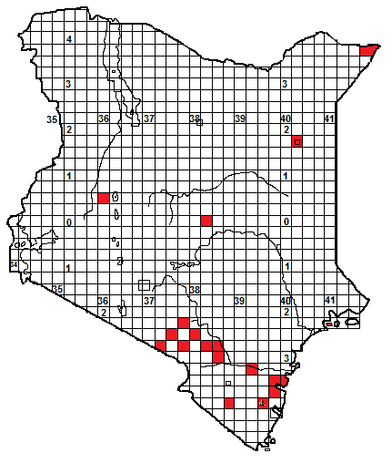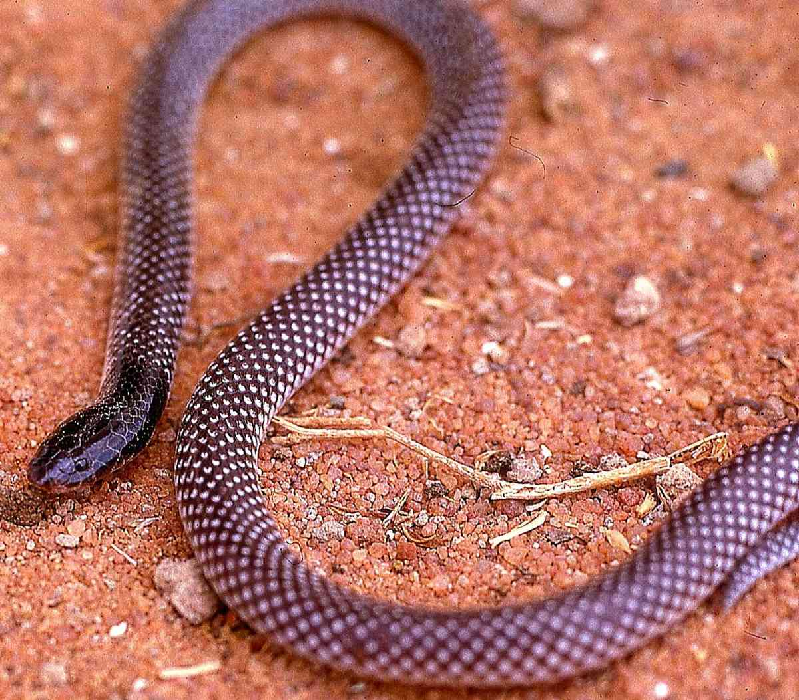
Identification: A small grey burrowing snake, usually with a black head, and a short stubby tail. Maximum size about 50 cm, average 30-40 cm. Overall grey, the back of each dorsal scale is white-edged. Specimens from northern and eastern Kenya have an all-black head; those from southeastern Kenya have the top of the head black, lips and sides of head white. White or cream below. Some specimens are dark brown or purple-brown, and thus the black head is hard to see.
Habitat and Distribution: Coastal thicket, moist and dry savanna and semi-desert, from sea level to about 1 700 m altitude. Most Kenya records from the southeast, including Lamu, Kilifi, Kasigau and Makindu, the only Kenya records north of the equator are Kabartonjo in the Tugen Hills, Wajir and Mandera.
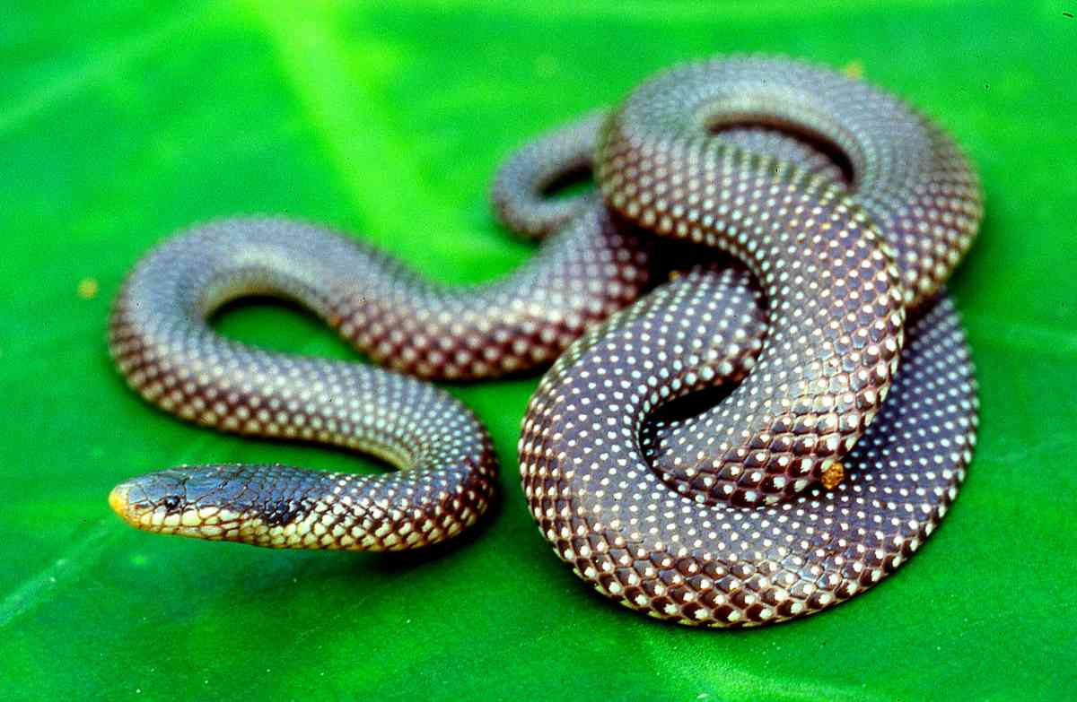
Natural History: Poorly known. A burrowing snake, hides in holes, living under ground cover, and in soft soil sand, may emerge and hunt on the surface on wet nights. Specimens have been captured on roads at night in the rainy season, and hiding under ground cover by day. A Somali female had 6 eggs in her oviducts in October. Diet includes small snakes and smooth-bodied skinks.
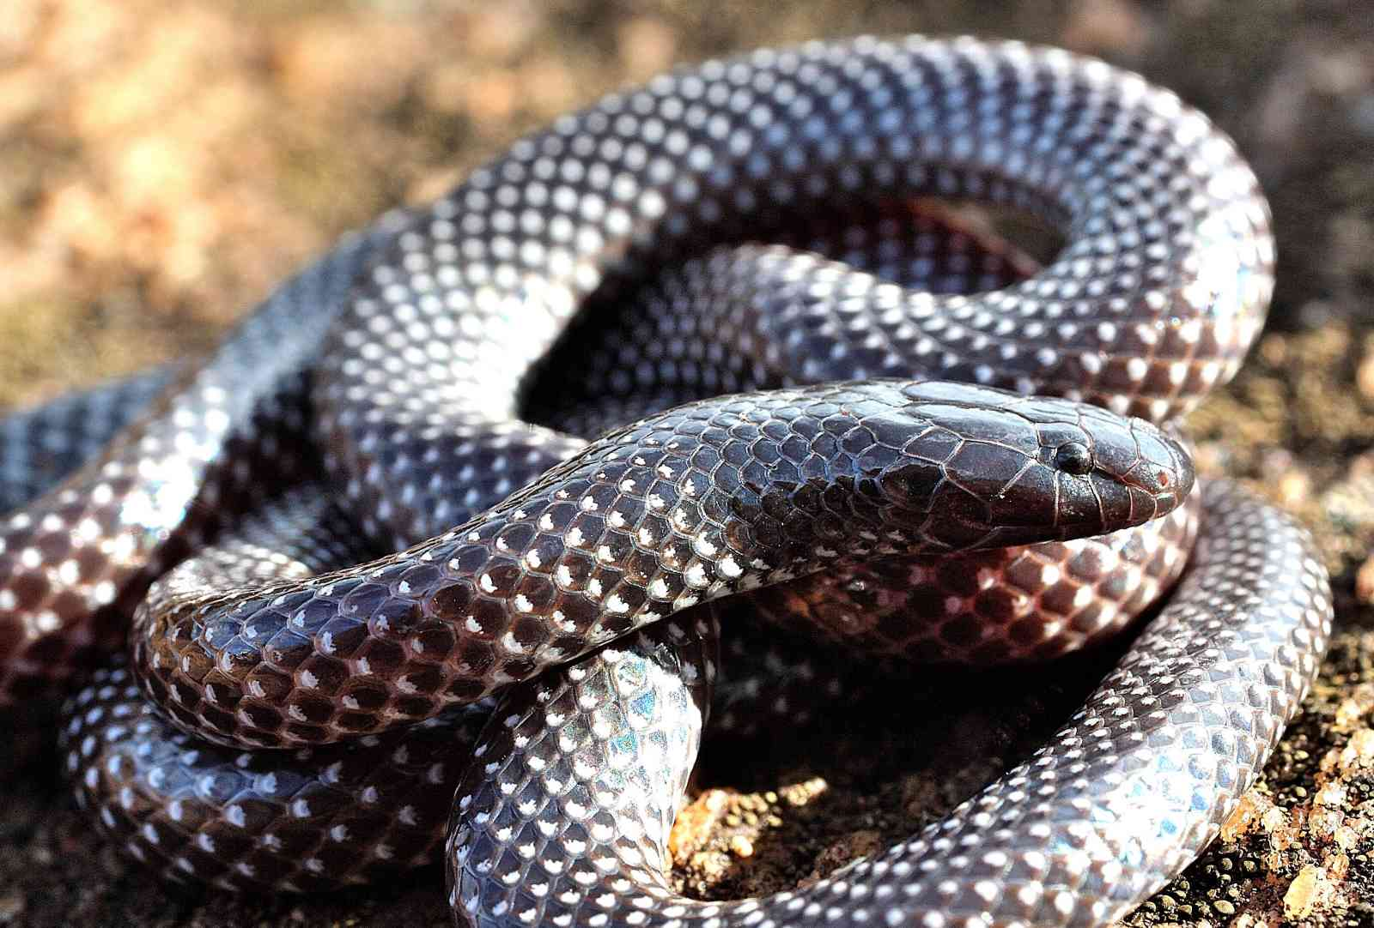

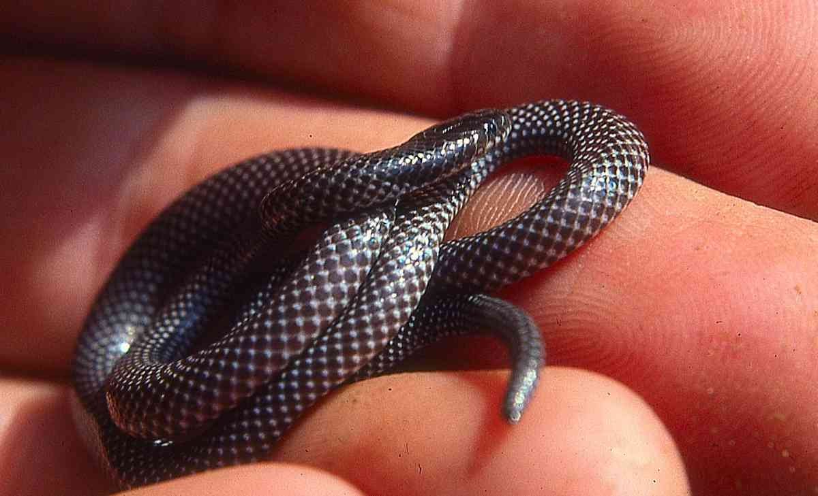
Illustrations: Top Wajir, middle Amboseli; bottom Elsa’s Kopje (Meru National Park: © Anton Childs), Makindu/Hunter’s Lodge.

Bibron’s burrowing asp Atractaspis bibronii
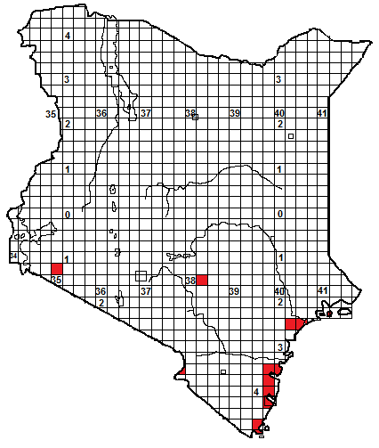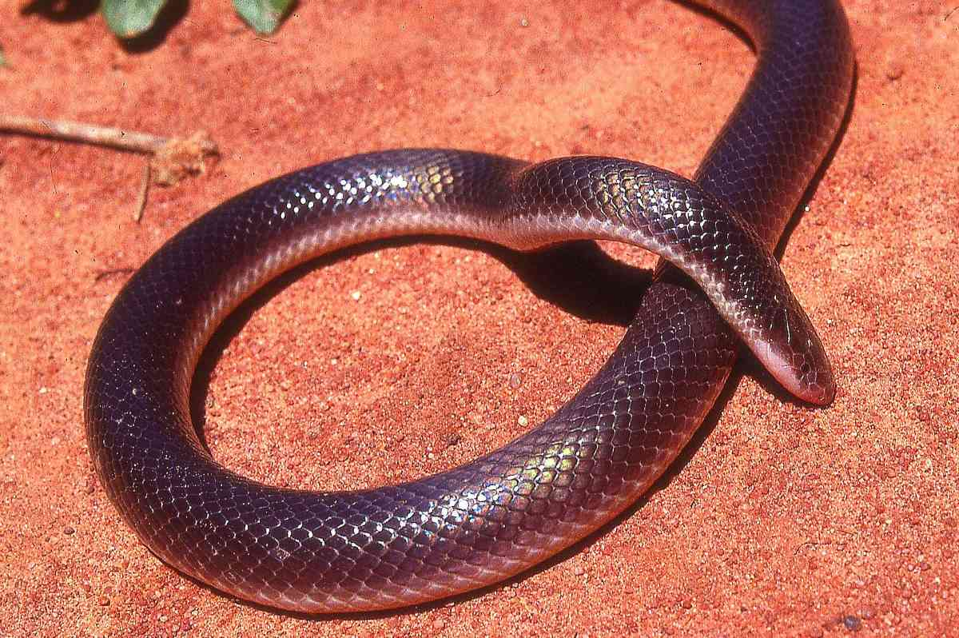
Identification: A dangerous, fairly small, slim dark snake with a prominent snout and a short blunt tail. Maximum size about 70 cm, average 40-60 cm. Usually grey, dark brown or blackish in colour, often with a purplish sheen on the scales. The lower dorsal scale rows and ventral scales are white or cream, but occasional belly scales may be dark, (see left hand photo below). Quite hard to identify, liable to be mistaken for purple-glossed snakes or wolf snakes.
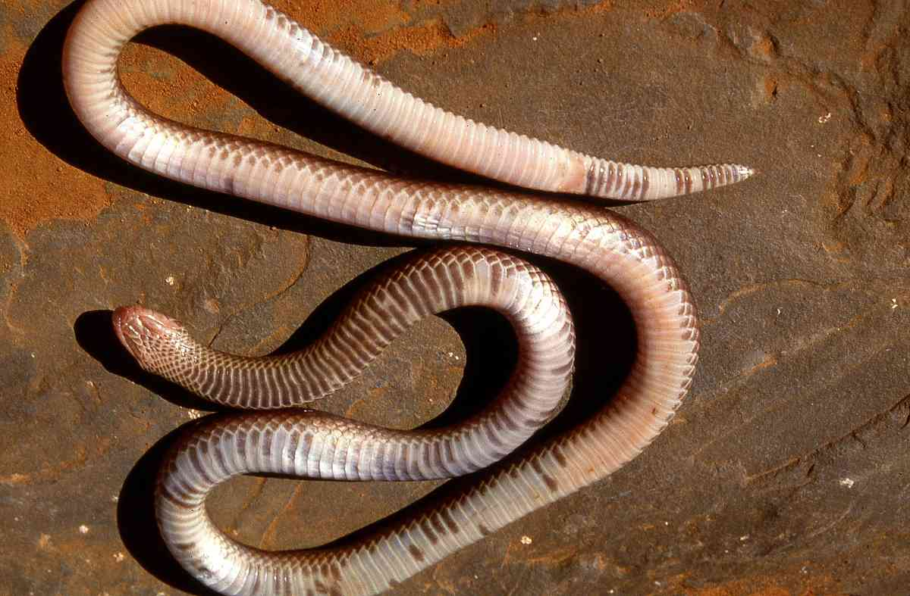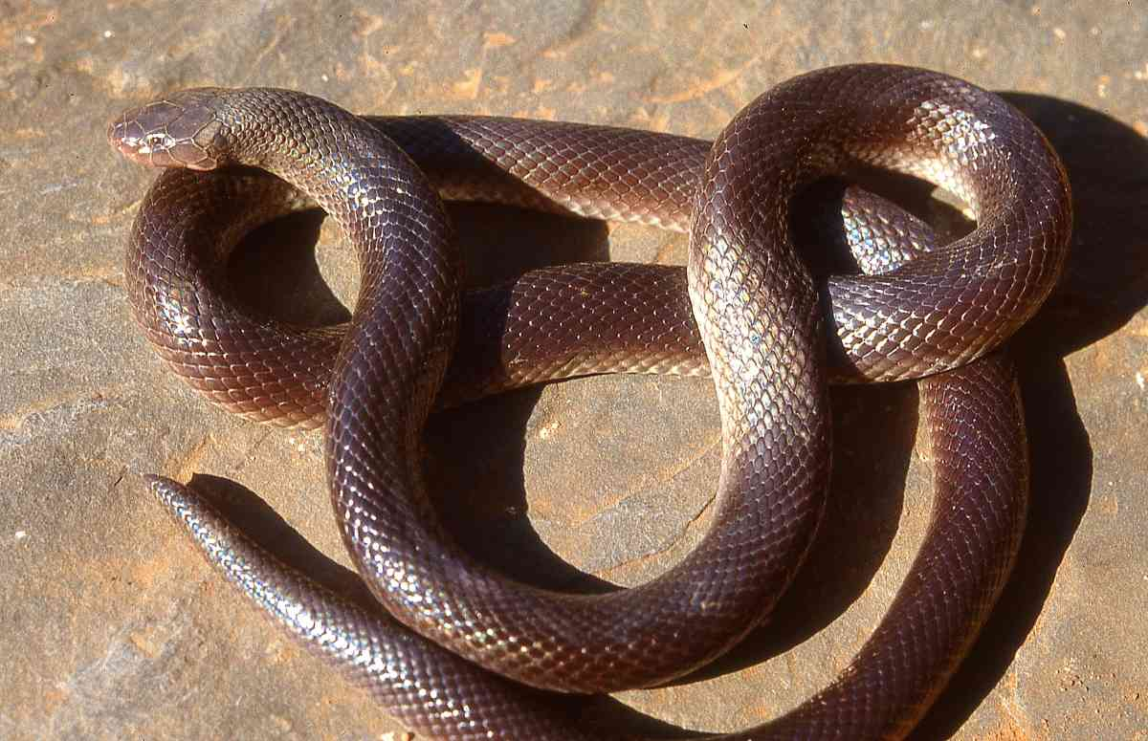
Distribution: Coastal thicket, woodland, moist and dry savanna, ranges from sea level to 1 600m. In Kenya, most records from the coastal strip, from Lamu south to Shimoni, the only inland records are Keekorok in the Maasai Mara, Kitobo Forest near Taveta and Kitui. Coastal herpetologists have found that this snake is much rarer than the small-scaled burrowing asp and is very rarely encountered.
Natural History: A fossorial (burrowing) species, living mostly underground, in holes, soft soil, sand or leaf litter, but will emerge on wet nights and prowl about on the surface. They can move relatively fast. If restrained or cornered, they have distinctive display, arching the neck and pointing the nose at the ground, looking like an inverted U. They may also release from the cloaca a distinctive smelling chemical, and if further disturbed they may wind the body into tight coils, turn the head and neck upside down, lash from side to side or jerk violently. They are unaggressive, but if restrained will try to bite. Burrowing asps can elevate the fangs independently and bite by then twisting the head and jabbing down, driving the fang into the victim. Their fangs are relatively large and thus they cannot safely be held by hand (see picture below, this is a dead specimen).
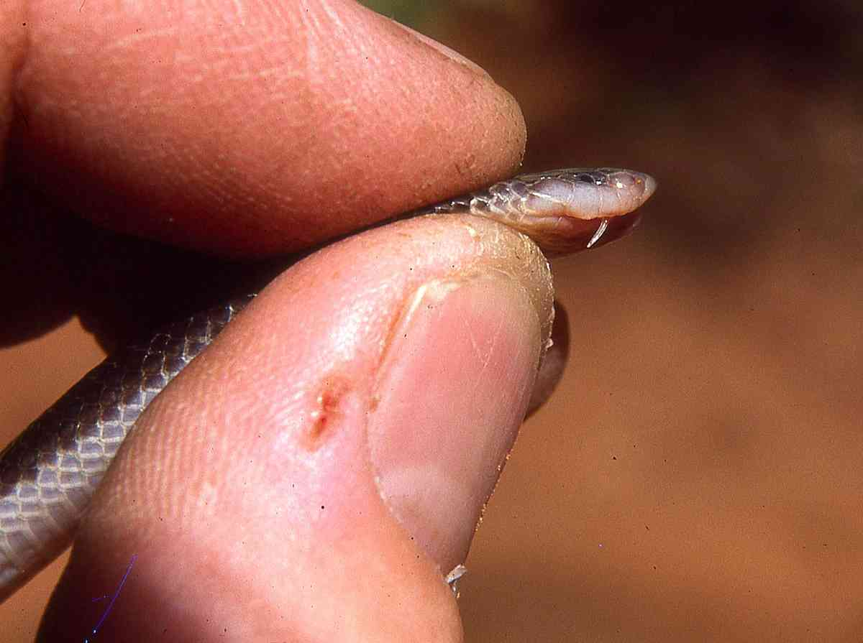
Diet: a range of prey, including other snakes, lizards, amphibians and small mammals. They lay from 4-7 eggs.
Medical Significance: The venom is toxic, causing pain (sometimes intense), swelling and local necrosis, although no fatalities are known. A lot of people have been bitten by burrowing asps on the East African coast, where the population density is high, the vegetation remains and these secretive snakes persist in semi-urban areas. Most bite cases result from someone either treading on the snake in darkness, or the snakes entering buildings at night.
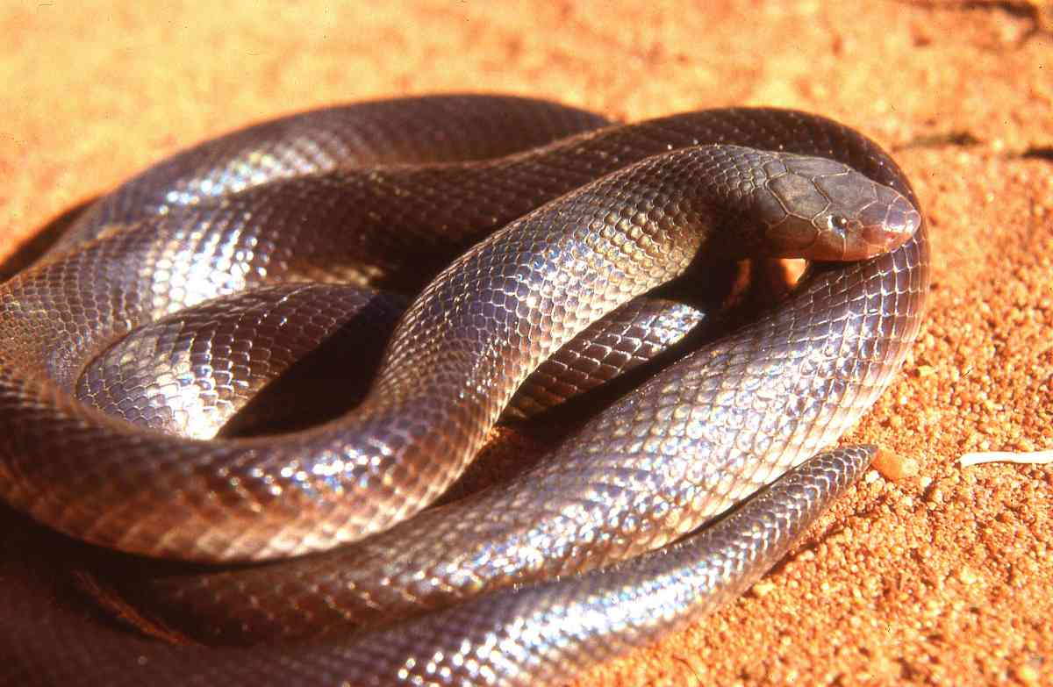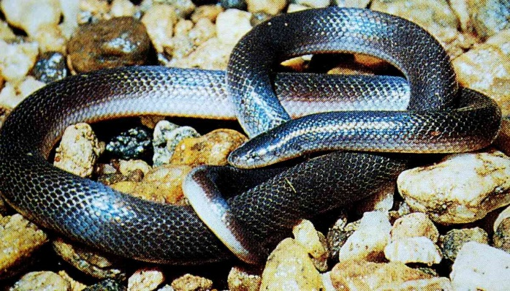
Illustrations: all specimens from Botswana, except bottom right, northern Tanzania, © Lorenzo Vinciguerra.

Engdahl’s burrowing asp Atractaspis engdahli
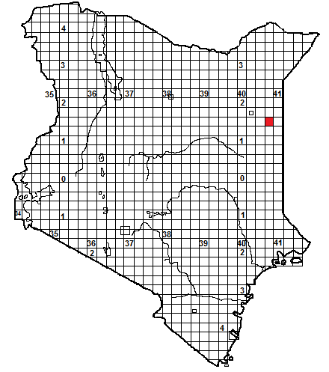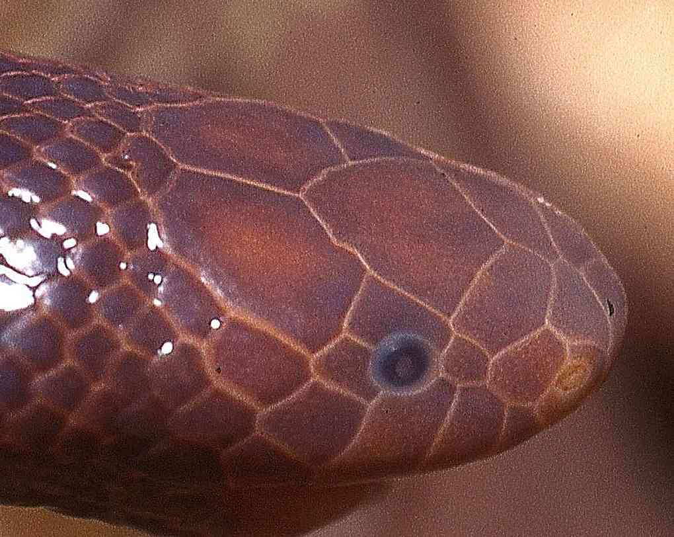
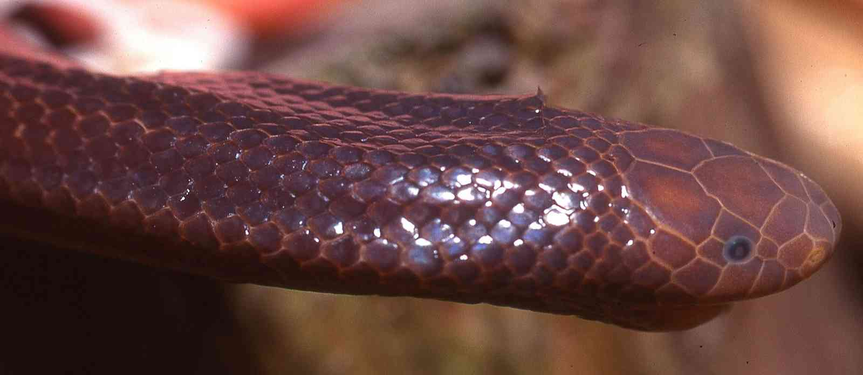
Identification: A dangerous small burrowing asp, with a rounded snout. Maximum size about 45 cm, average 25-40 cm. Black, brown or red-brown in colour.
Distribution: A Somali species, known from coastal thicket, grassland, dry savanna and semi-desert. In Kenya, it is known from a single specimen from the semi-desert of northeastern Kenya, at Wajir Bor, 50 km east of Wajir. Probably occurs in the dry country east of the lower Tana.
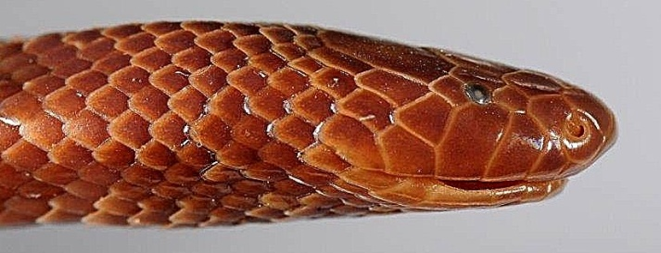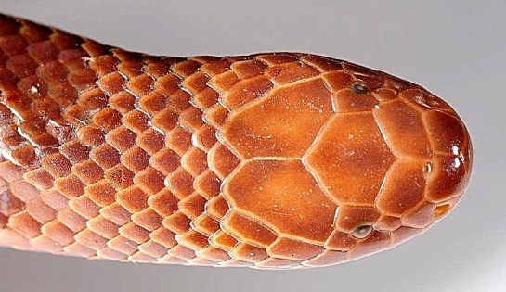
Natural History: Presumably similar to other Atractaspis i.e. burrowing, on the surface on moist nights, eats snakes and lizards. Somali specimens were found in termitaria, in holes and active at night; the Wajir Bor specimen was found in a dry well.
Medical Significance: Presumably similar to other burrowing asps.
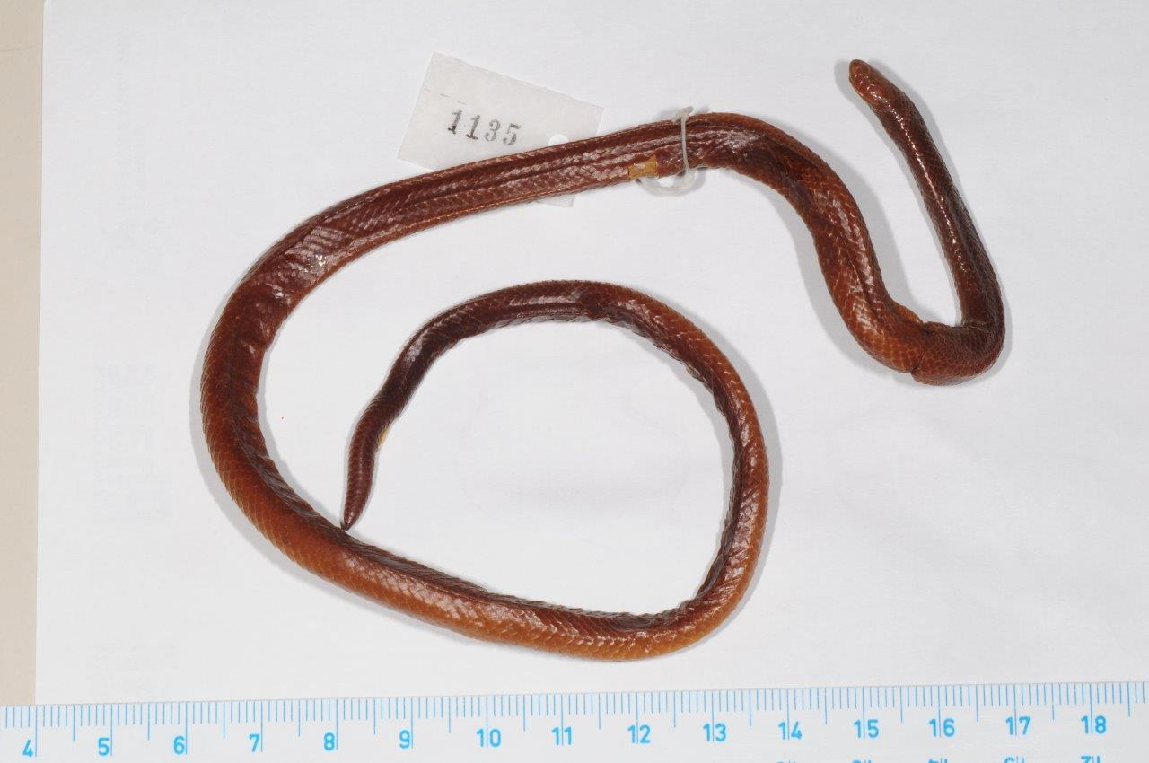
Illustrations: preserved specimens; top: Wajir Bor, © Dong Lin; California Academy of Sciences; middle and bottom; Afgoi, Somalia, © Tomas Mazuch.

Variable Burrowing Asp Atractaspis irregularis
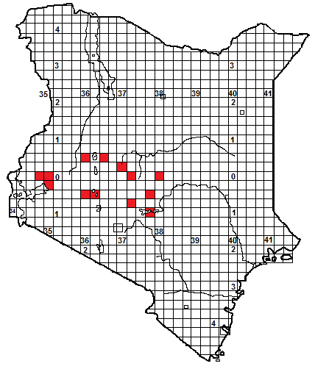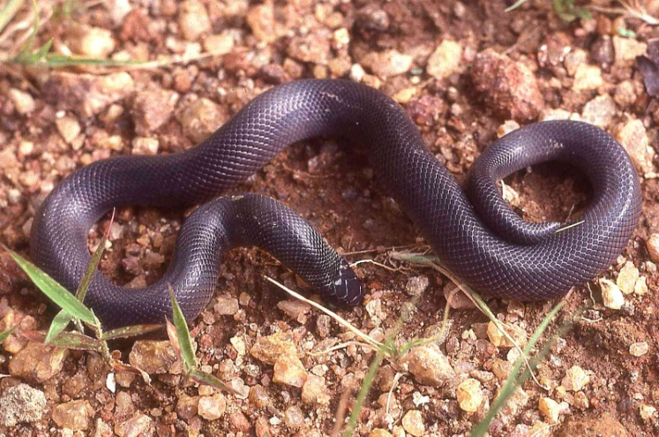
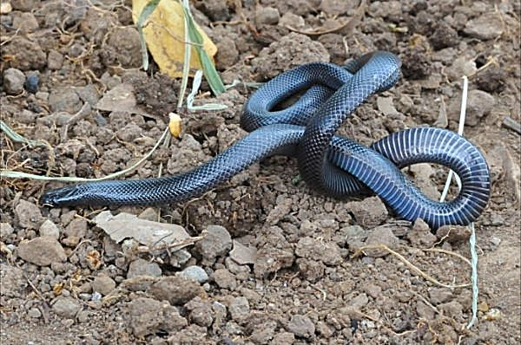
Identification: A dangerous, fairly small burrowing asp. Maximum size about 66 cm, average 30-50 cm. Black or blackish-grey in colour, ventrals also dark.
Distribution: Moist savanna, grassland, woodland and forest, in Kenya from 600 to around 2000 m altitude. In Kenya this is largely a snake of savannah and high grassland, but elsewhere it is a forest snake. It occurs from Muranga and Mwea National Park north to Chuka, Meru and the Nyambeni Hills, around the eastern and northern sides of Mt Kenya, across Laikipia to the west, known from the Tugen Hills, Ol Ari Nyiro, Kisumu and Kakamega.
Natural History: Similar to other burrowing asps, with a burrowing lifestyle, living in holes and soft soil, sometimes emerges by night onto the surface. They show the usual neck-arching display. Diet; snakes and lizards, also recorded eating rodents.
Medical Significance: Unusually, this species has been known to cause fatalities, one involved a man in Liberia who rolled on one in his sleep and was bitten eight timers, the other a ten-month old baby. No fatalities known in Kenya, but this snake occurs in intensively farmed areas with a dense population. Bite cases have involved swelling, lymphadenopathy and muscle pain. No antivenom is produced for burrowing asps.
Illustrations: top Ghana; bottom © Arnaud Germain, Greensteds, Nakuru.

Small-scaled burrowing asp Atractaspis microlepidota
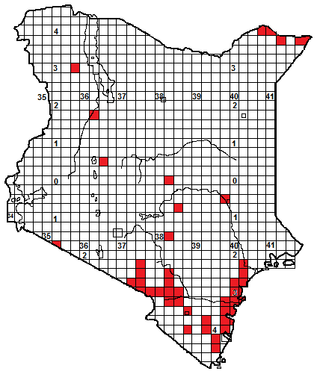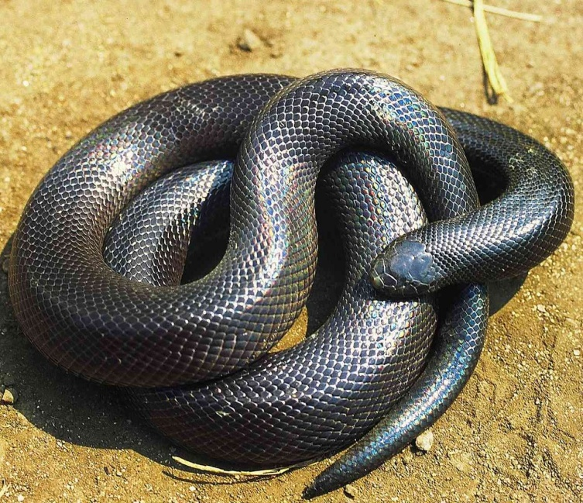
Local Names: Apris/Jilbris (Somali)
Identification: A dangerous, relatively large, often thick-bodied burrowing asp, with the usual short head and tail. Reaches a length of 1.1 m, average size 60 to 90 cm. Colour quite variable, black, grey, brown, Kenya coastal specimens sometimes purplish, darkening towards the head. Scales often iridescent. The belly is dark.
Distribution: Coastal bush and thicket, dry and moist savanna, grassland and semi-desert, from sea level to about 1 800 m, but usually below 1 300 m. Widespread and probably occurs throughout southeastern Kenya, recorded from Emali and Amboseli eastwards through Tsavo to the coast. Isolated records include Keekorok Lodge, Kitui, Garissa, Lokori, Lodwar, Laikipia Nature Conservancy and along the Daua River in northern Kenya, from Malka Murri to Mandera.
Natural History: Similar to other burrowing asps, i.e. lives underground, in soil, sand or in holes, emerging on damp nights. Occasional specimens have been found active in daylight, a risky undertaking for a black, fairly slow-moving snake in Africa. Said to be relatively common in parts of the north Kenya coast. Big adults are very hard to catch; they are strong, active and bite furiously if restrained. A clutch of eight eggs has been recorded. Eats other snakes, lizards, rodents and amphibians.
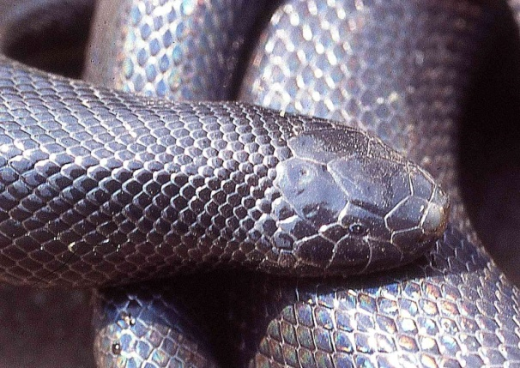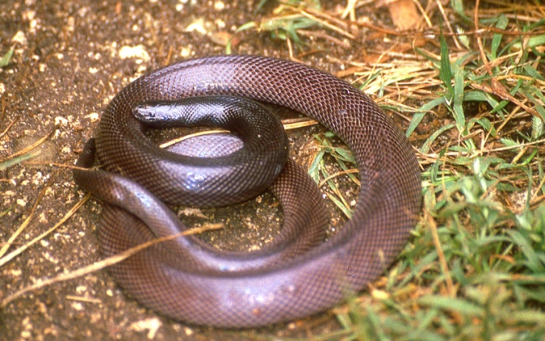
Medical Significance: This snake is large and has long venom glands; it is capable of injecting a dangerous dose of venom. Its relative abundance on the Kenya coast means it is a major snakebite hazard in some areas. Bites usually result in pain, swelling and necrosis. A few fatalities are known, a bite from a big example of this species is a major medical emergency, particularly since no antivenom is effective.
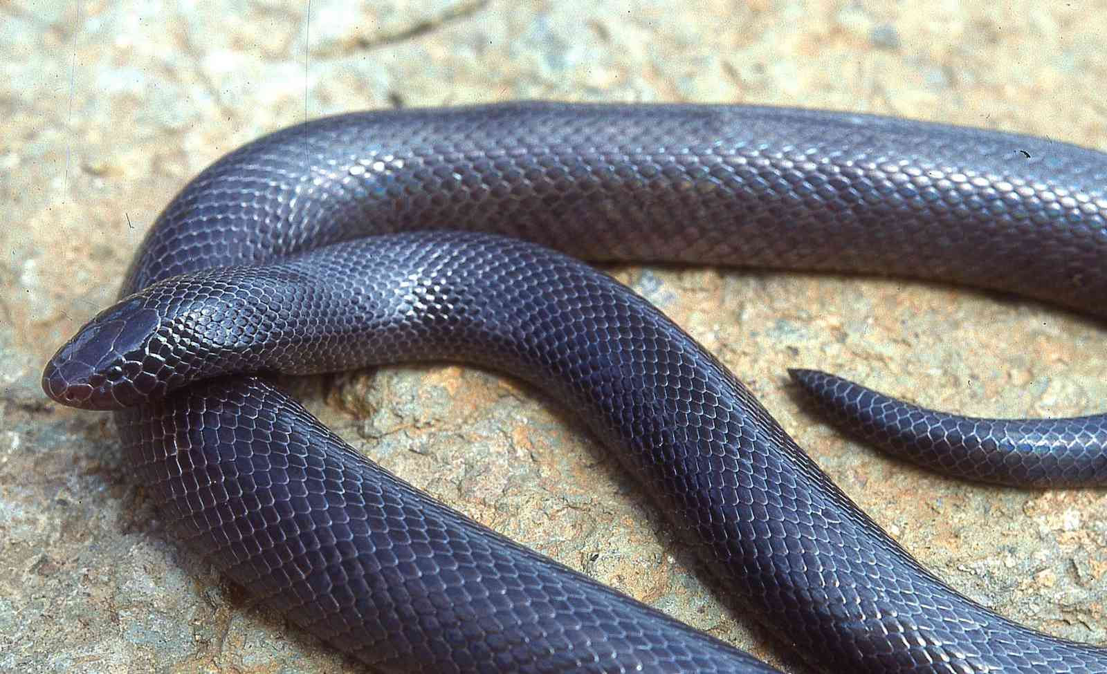
Taxonomic Note: Several subspecies have been described, some authorities believe they should be full species, in which case the Kenyan snake would be Atractaspis fallax, but we have retained the old name for the time being.
Illustrations: Mkomazi, Tanzania (T), Voi (ML); Watamu MR), Awash, Ethiopia (B)

