The Kenya Reptile Atlas
A free, downloadable atlas of Kenya’s reptiles. This is a free source of regularly updated information on Kenya’s Reptiles. Authors: Stephen Spawls, Beryl Bwong, Patrick Malonza, Vincent Muchai, Victor Wasonga
This project is funded by the Rufford Foundation under the auspices of the National Museums of Kenya; Department of Herpetology.

The Kenya Reptile Atlas offers you:
Pictures of Kenya’s reptiles
Distribution maps by quarter-degree-square
A description of the species

Click on any of the titles listed under the downloads tab to download for free. The various families will be added as the accounts are completed.

If you have any observations of Kenya’s reptiles, any distribution records, or any other data, or any digital pictures, we would like to receive them! Send them to Kenyareptileatlas@gmail.com
And if you live or travel in Kenya, and find any dead reptiles, please preserve them and take them to the Department of Herpetology, at the National Museum, Museum Hill, Nairobi.
The team thanks those who kindly commented upon the text or loaned us pictures; this includes Sanda Ashe and Royjan Taylor of Bio-Ken at Watamu, Jonathan Spawls and Lorenzo Vinciguerra.

The Kenya Reptile Atlas
The Elapids 1 – Mambas; sea snake, garter snakes.
The elapids are a family of dangerous snakes. African members of the family include the cobras, mambas, garter snakes and sea snakes. All elapids have relatively short, erect, immovable poison fangs at the front of the upper jaw. Eleven species of elapid occur on land in Kenya; two garter snakes, five cobras, three mambas and one tree cobra; one species of sea snake occurs off our coast. All (apart from the garter snakes) are highly venomous, and several (especially the spitting cobras) are major causes of snakebite in rural Kenya.
Black Mamba Koboko Dendroaspis polylepis
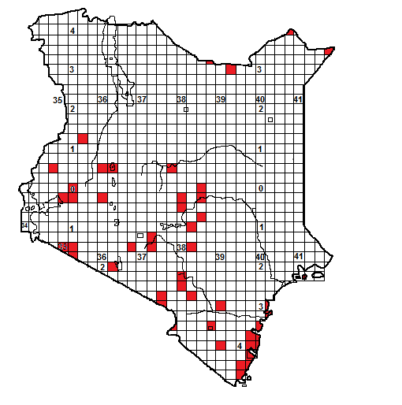
Illustrations below: top left Ngomeni adult, top right Malindi adult spreading hood, middle left head close-up, (specimen from Voi), middle right yellow phase adult, Baringo, bottom left heavily speckled tail of dry savanna specimen, bottom right fangs of Watamu specimen.

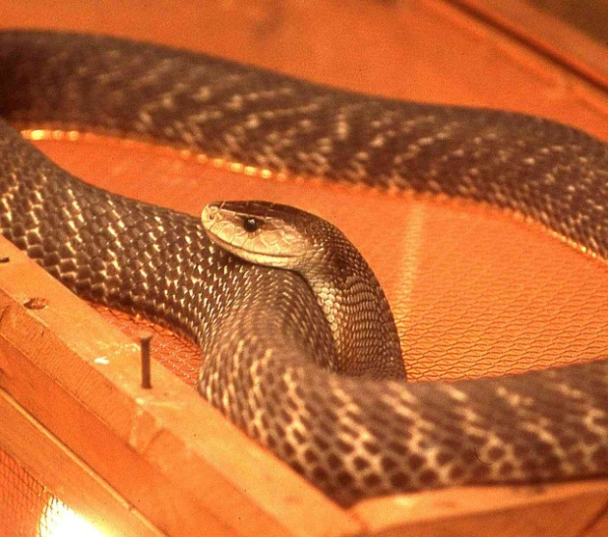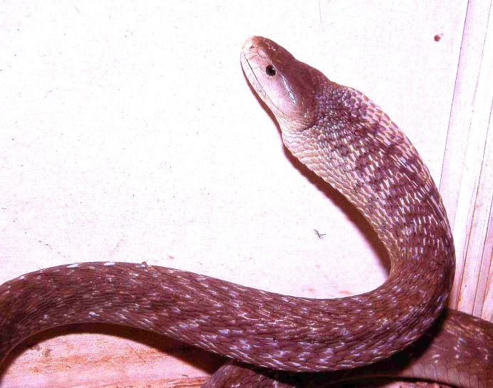
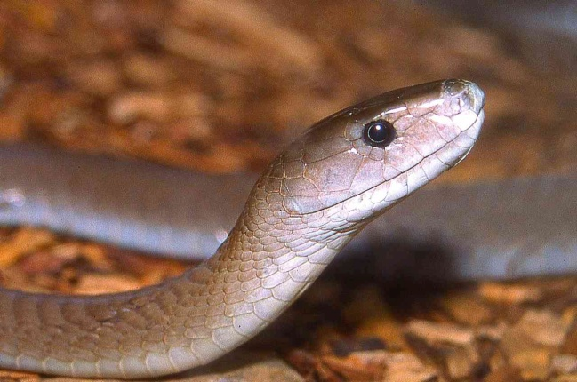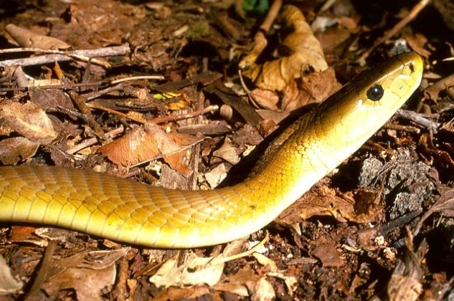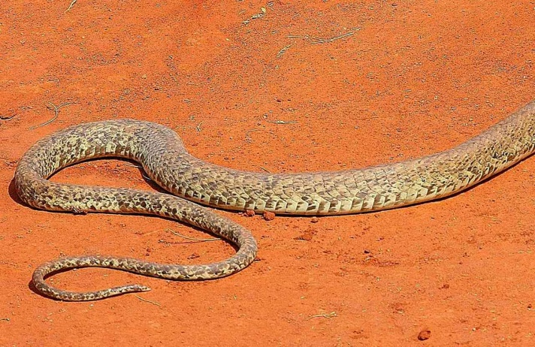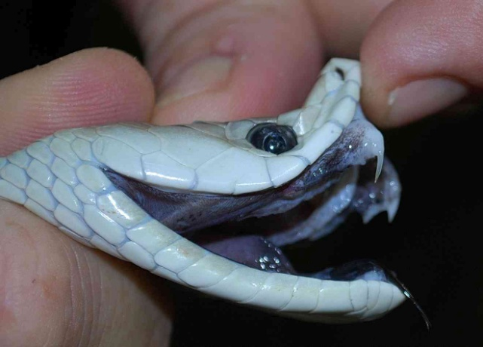

Local Names: Koboko (Swahili), Isembelei, Ikuuwa, Ivuu, Ivwau (Kikamba), Rai Ikombe (Dholuo), Kiplogoyon (Kalenjin), Matangi (Luhya), Kiria Munyore (Tharaka), Tsatsapala (Mijikenda) Cuthu (Kikuyu), Ilimanjiwu, Imilambimbi (Kitaita).
Identification: A very large snake, up to 3.2 m, usually 1.5 – 2.5 m, may be grey, almost white, olive, brown, or yellow brown; paler below. Head long. Body often barred, and dry country specimens often heavily speckled towards tail.
Distribution: Widespread in medium to low altitude savanna, woodland and coastal bush. Apparently absent from most of dry northern Kenya and the highlands of the southwest. Found near the following towns; Mombasa, Watamu, Malindi, Voi, Mtito Andei, Mwingi, Kisumu.
Natural History: Active by day (there is isolated records of night activity). Shelters in termite hills, holes, holes in trees, rock fissures and beehives. Fast moving, when disturbed can spread a narrow hood and opens mouth to show black interior. Eats mammals, birds. Lays 10-15 eggs.
Conservation Significance: Does not co-exist well with humans due to its size, but widespread and found in the following conservation areas: Amboseli, Tsavo, Shimba Hills, Gede, Maasai Mara, Samburu, Buffalo Springs, Meru.
Medical Significance: Not aggressive and bites unlikely, as it tends to move away from confrontation. However, venom is a strong neurotoxin and cardiotoxin, causing respiratory failure and death. A black mamba bite must be treated as a medical emergency. A polyvalent serum is available from South African Vaccine Producers.

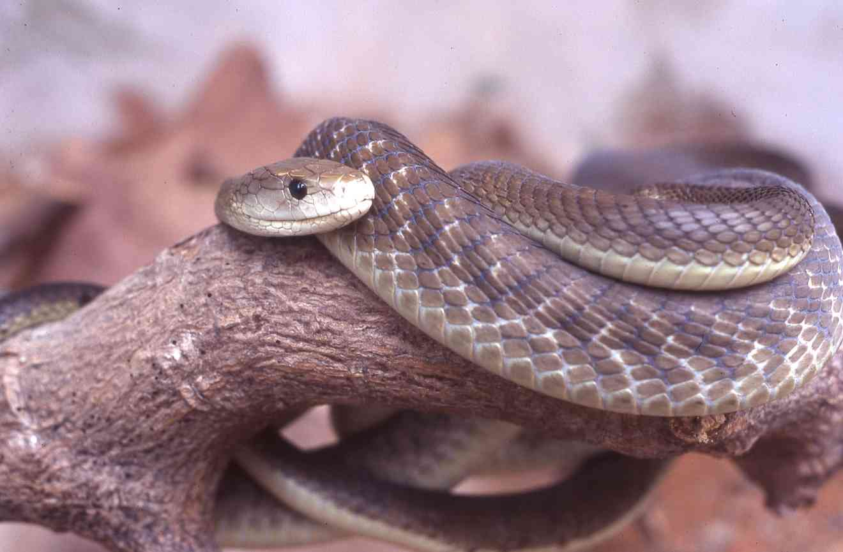
Northern Tanzanian specimen

Green Mamba Dendroaspis angusticeps
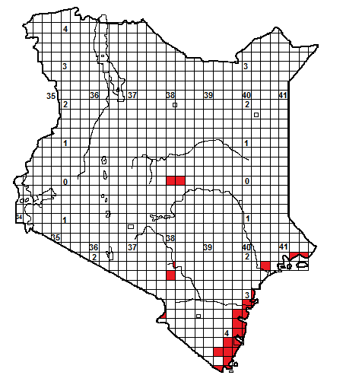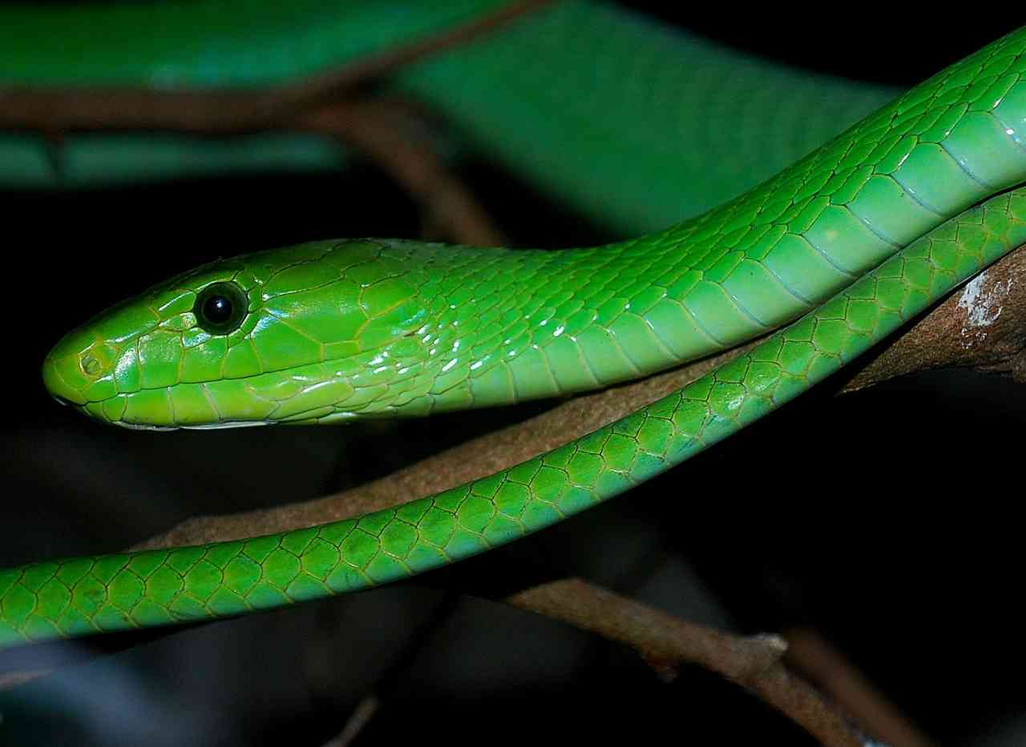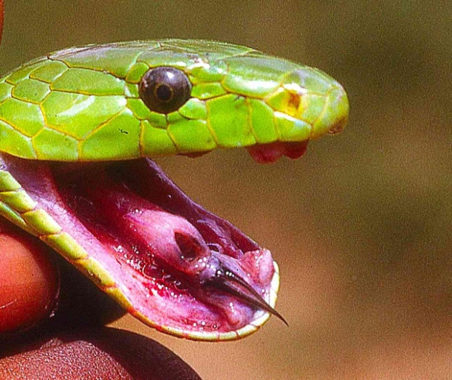
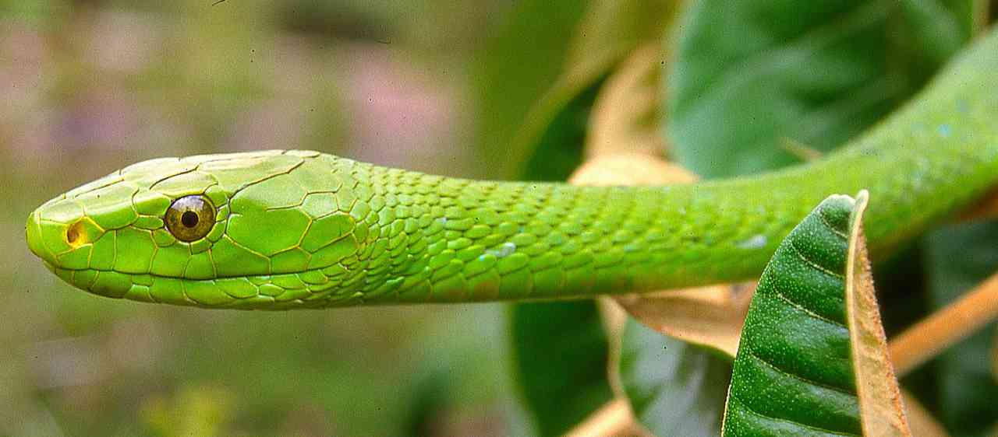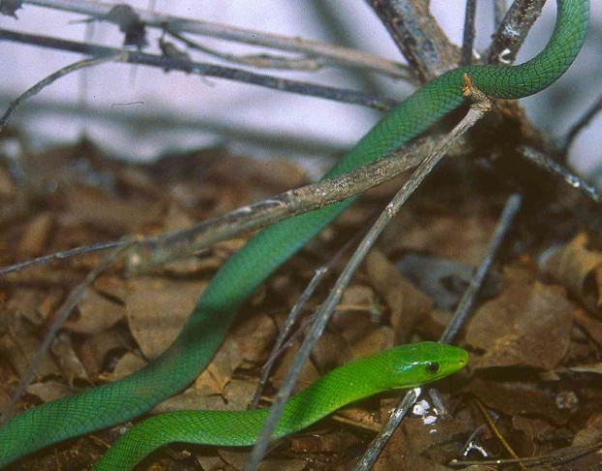
Illustrations: All from Gede/Watamu except largest picture, Arusha.
Local Names: Koboko kijani (Swahili), Vunzarere, Vunzaparere (Mijikenda)
Identification: A large snake, up to 2.3 m, usually 1.2 – 2 m, usually green, sometimes with a sprinkling of yellow scales, juveniles are bluish-green towards the tail (see bottom picture).
Distribution: Largely a coastal snake in Kenya; found in thicket, woodland and forest. Inland records: Kibwezi area, Chylul Hills, Kitobo Forest (Taveta), southern-eastern Nyambene Hills and Meru National Park. Found near the following towns; Mombasa, Watamu, Malindi.
Natural History: Active by day. Shelters in thickets and tree holes. Fast moving but secretive. Eats mammals, birds and arboreal lizards. Lays up to 17 eggs.
Conservation Significance: Does not co-exist well with humans due to its size, but its secretive nature and habit of living high in trees means it often persists in coastal farms. Found in the following conservation areas; Gede, Arabuko-Sokoke, Shimba Hills, and other protected coastal forests.
Medical Significance: Not aggressive, rarely bites, moves away from confrontation. However, venom is a strong neurotoxin so bites must be treated as a medical emergency. A polyvalent serum is available from South African Vaccine Producers.
Jameson’s Mamba Dendroaspis jamesoni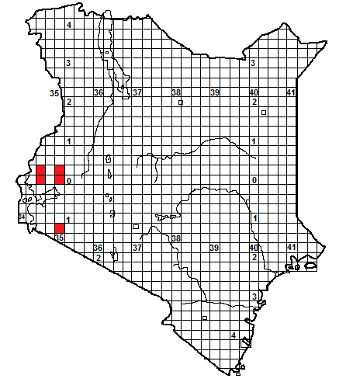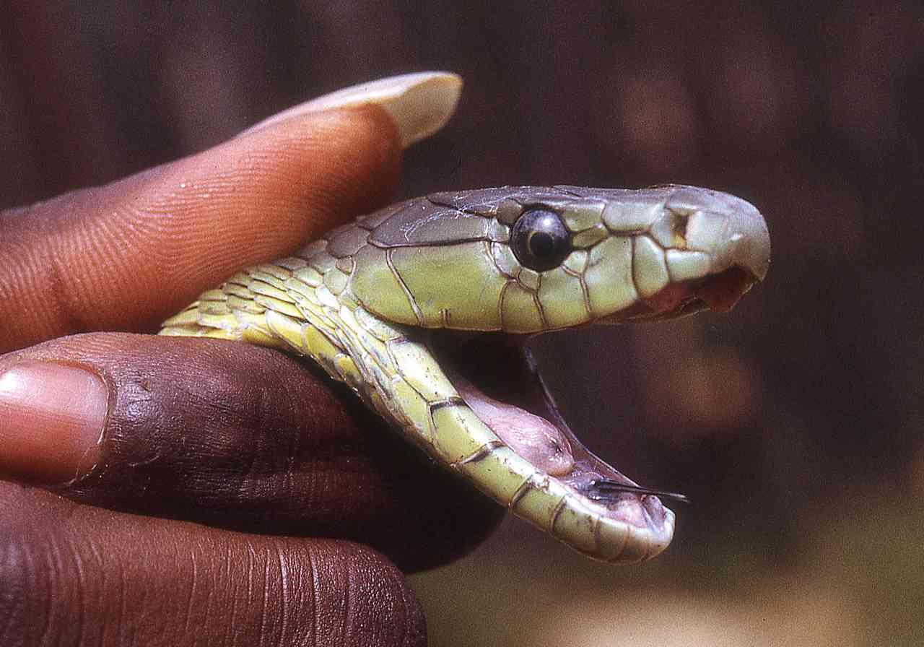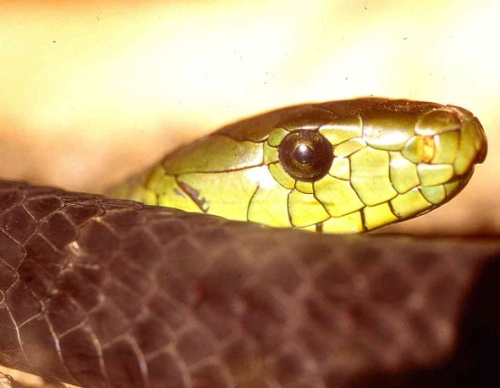

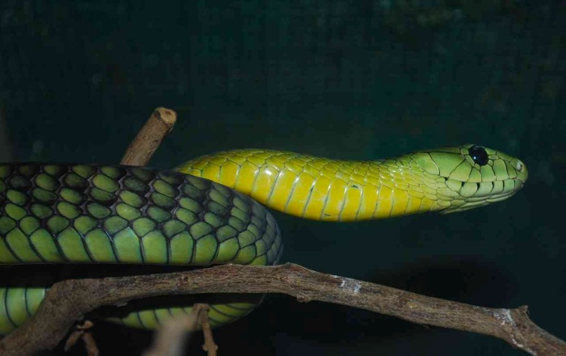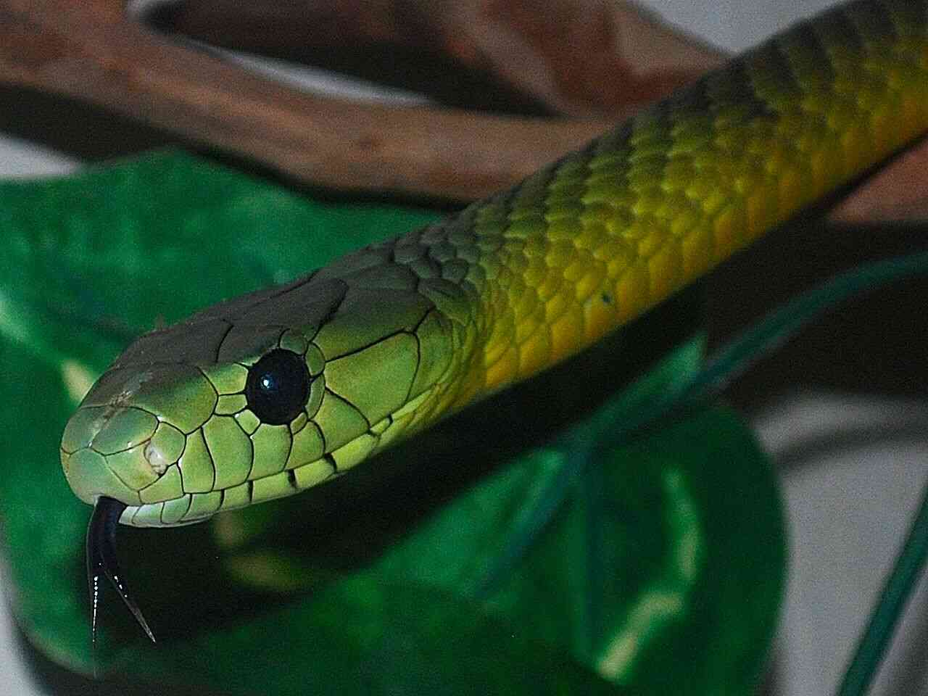
All illustrations Kakamega Forest specimens.
Identification: A large snake, up to 2.6 m, usually 1.5 – 2.2 m, usually dull green above, chin and throat often yellow, the head scales black-edged. Kenyan specimens have a black tail.
Distribution: A few forests in western Kenya; specifically Kakamega Forest, Yala River, around Mumias, Kaimosi and Butere. A sight record from Lolgorien, above the Mara escarpment. . Found near the following towns; Kakamega, Mumias, Butere.
Natural History: Active by day. Shelters in thickets and tree holes. Fast moving but secretive. Eats mammals, birds and arboreal lizards. Lays eggs.
Conservation Significance: Does not co-exist well with humans due to its size, but its secretive nature and habit of living high in trees means it often persists in urban areas, in Uganda persists in parks and well-wooded suburbs.
Medical Significance: Not aggressive. However, venom is probably a strong neurotoxin; several fatalities are recorded in Uganda. A polyvalent serum is available from South African Vaccine Producers.
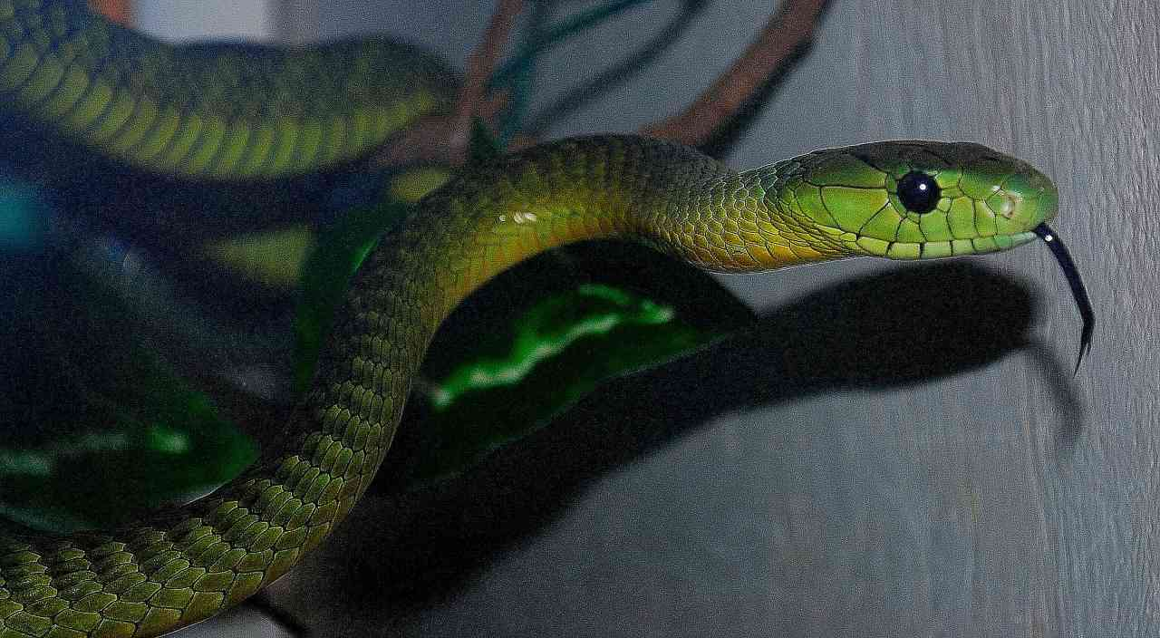
Yellow-bellied sea snake Pelamis platurus
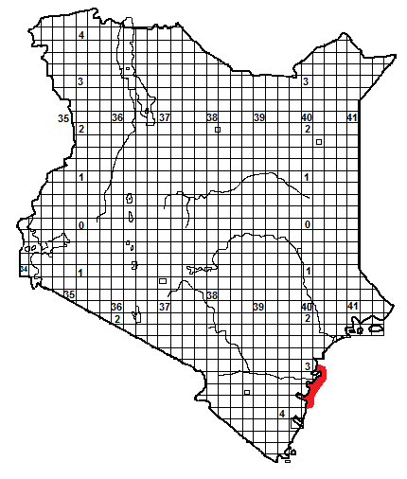
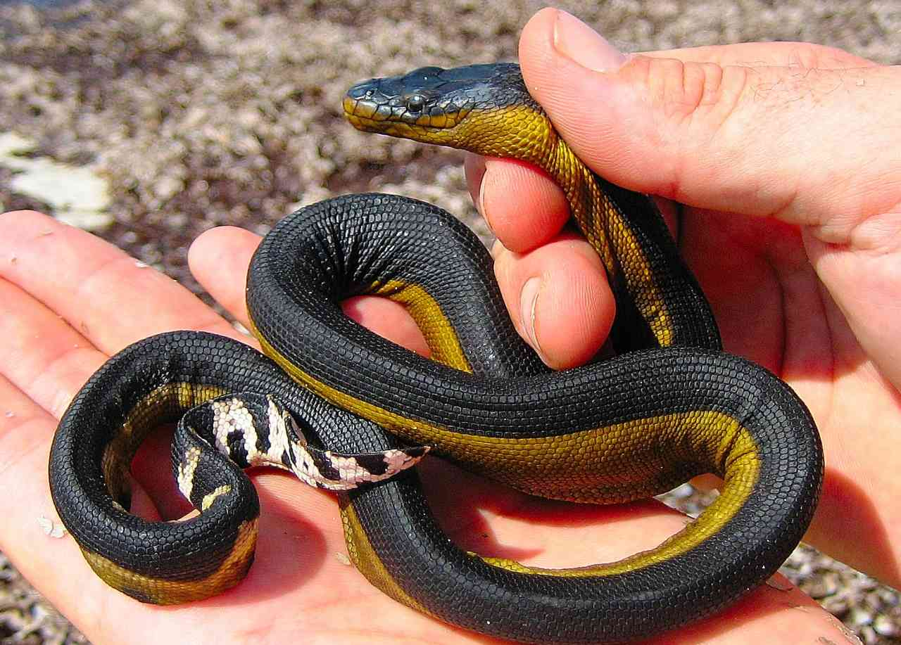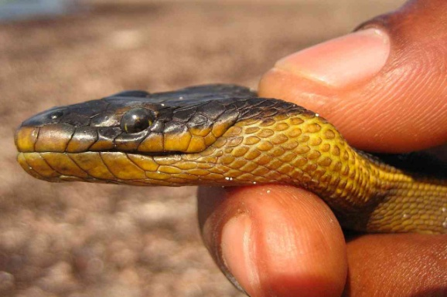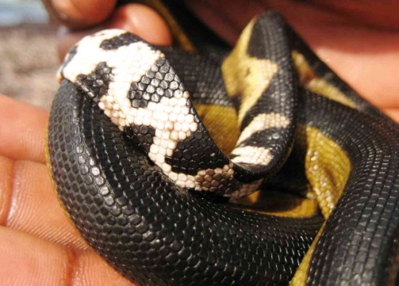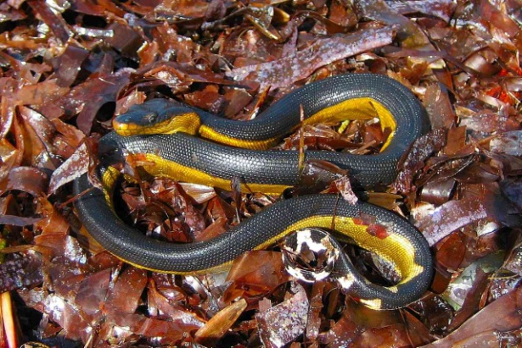
All photographs above: © Royjan Taylor/Bio-Ken snake farm; Watamu specimen.
Identification: A sea snake, black above, yellow below, the black and white tail flattened vertically. Occasional specimens have black saddles, or are all yellow. Nostrils on top of the long head. It is the only sea snake found on the Kenya coast. Snake eels (Ophichthidae, see picture below) are often mistaken for sea snakes.
Distribution: Widespread in the Pacific and Indian Oceans. In Kenya, only recorded from Kilifi, Watamu and Malindi, but could be found anywhere on the coast. Specimens found on reefs or the shore are usually weak or dying animals.
Natural History: Hunts mostly in open water, rarely round reefs. But usually within 300 km of land. A superb swimmer, swimming with side to side undulations, can swim backwards or forwards. Often found around sea slicks, where it hunts fish; there are anecdotal reports of huge concentrations of these snakes utilising surface currents. Nervous, usually moves away from humans. Gives live birth to 3-8 young.
Conservation Significance: Found over huge areas of warm oceans, so unlikely to be under threat.
Medical Significance: Not aggressive and bites virtually unknown. However, venom is toxic. Antivenom produced by the Commonwealth serum laboratories (Melbourne, Australia) for a different sea snake (Enhydrina schistosa) neutralises the venom of this snake.
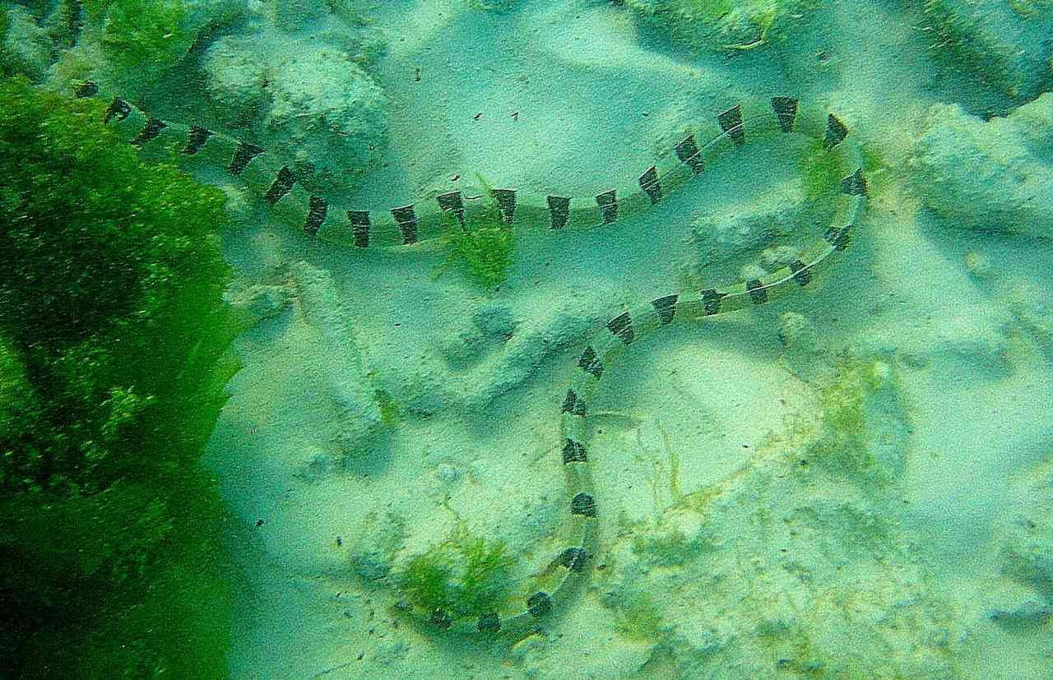
Snake eel (photo © Jonathan Spawls)

East African Garter Snake Elapsoidea loveridgei
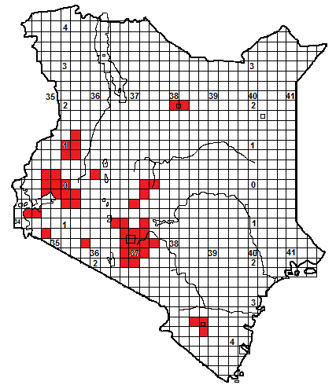
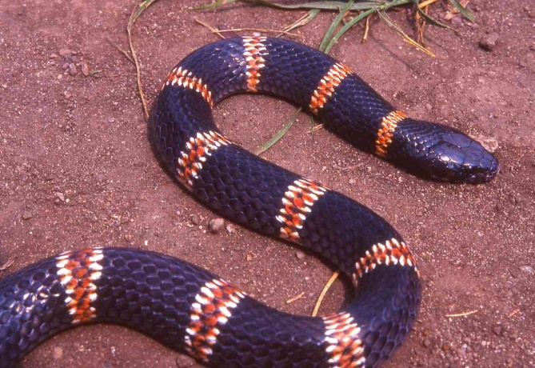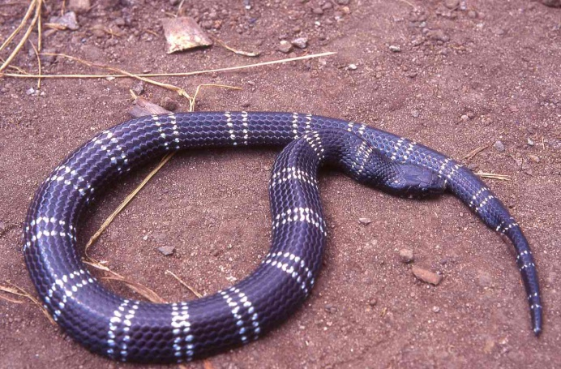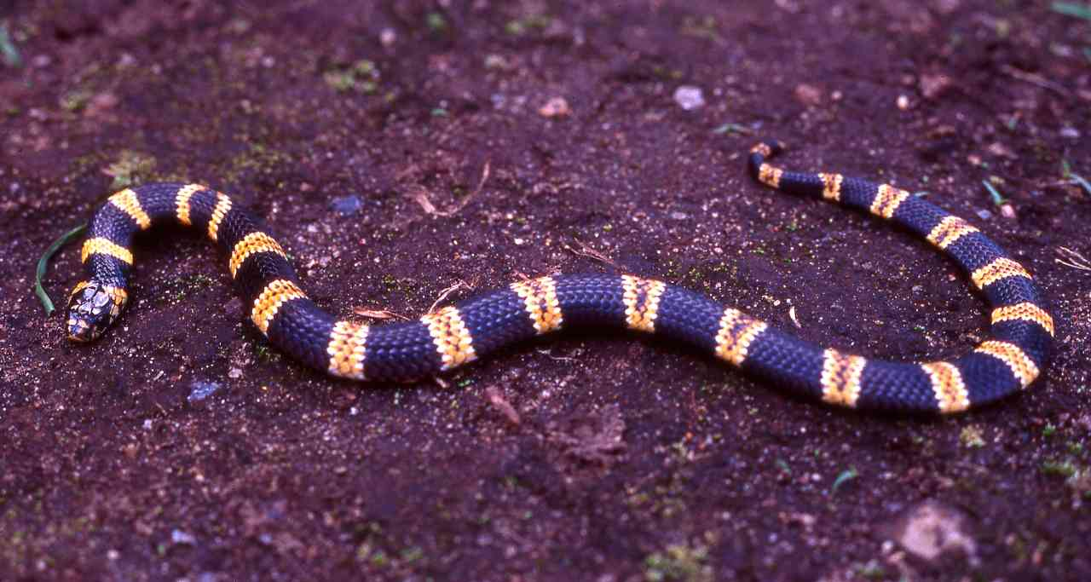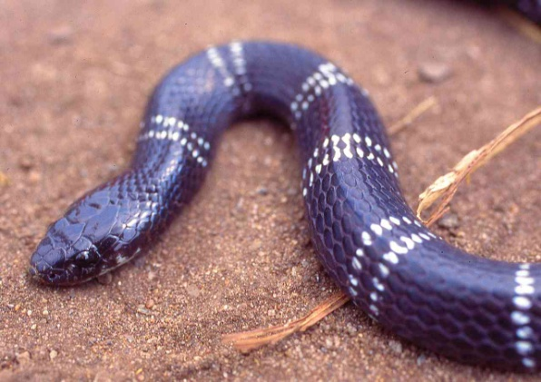
Illustrations: All adults; bottom left © Lorenzo Vinciguerra.
Identification: A small snake, up to about 65 cm, usually 30-50 cm in length, black with narrow pink, pink-white or white bands (very occasionally orangey-yellow). In most adults the bands persist throughout life, in others the centre of the band may fade, leaving two white rings, occasionally fades totally to leave a black snake.
Distribution: Medium to high savanna, grassland and woodland, on either side of the southern rift valley. Isolated populations on the Taita Hills, Mt Sagalla, Mt Mbololo and Mt Marsabit. Not known from the rift valley floor which appears to be the buffer zone between the eastern subspecies, with 16-20 body bands, and the western subspecies, with 23-34 bands. Found near the following towns; Wundanyi, Kajiado, Thika, Nairobi, Athi River-Lukenya, Kiambu, Kijabe, Bungoma, Kericho, Kakamega, Kisumu, Kitale. Might be much more widespread than the map indicates, as it is rarely seen.
Natural History: Secretive, terrestrial, slow-moving and nocturnal. In holes and under ground cover during the day, but will prowl on the surface after rain, specimens occasionally active during damp days. Inoffensive and unaggressive, rarely tries to bite even if handled. Lays eggs. Eats small snakes, lizards, frogs and occasionally small mammals.
Conservation Significance: Widespread and secretive so unlikely to be under any threat. Occurs in the following conservation areas; Nairobi National Park, Ol Donyo Sabuk, Ruma National Park, Kakamega Forest, Mt Marsabit National Park.
Medical Significance: Bites are very rare and no fatalities have been reported, no serum is produced for snakes of this genus. However, a small dog died quite rapidly after a garter snake bite and exhibited neurotoxic symptoms.
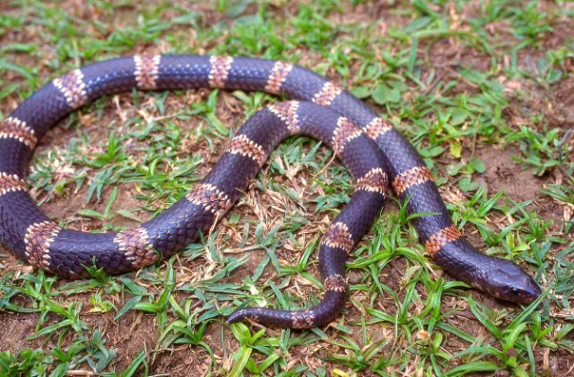
Usambara Garter Snake Elapsoidea nigra
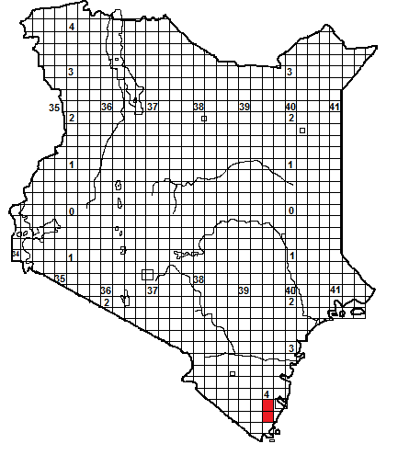
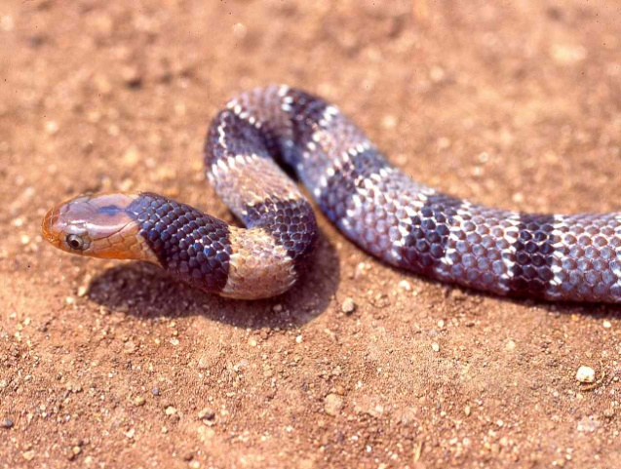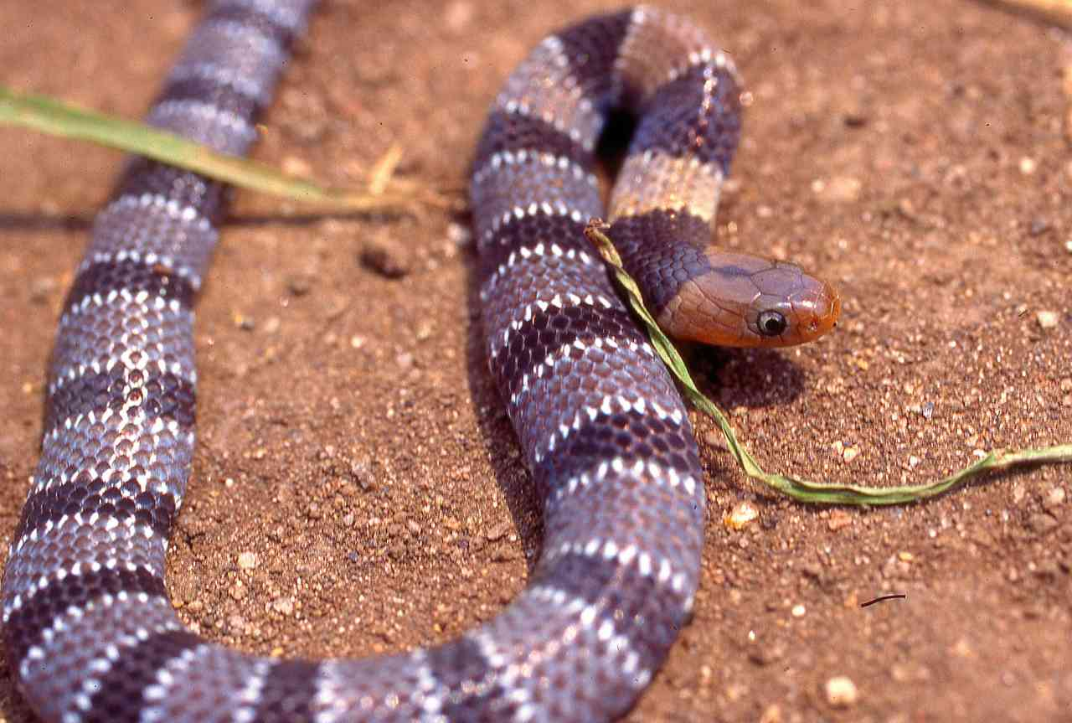
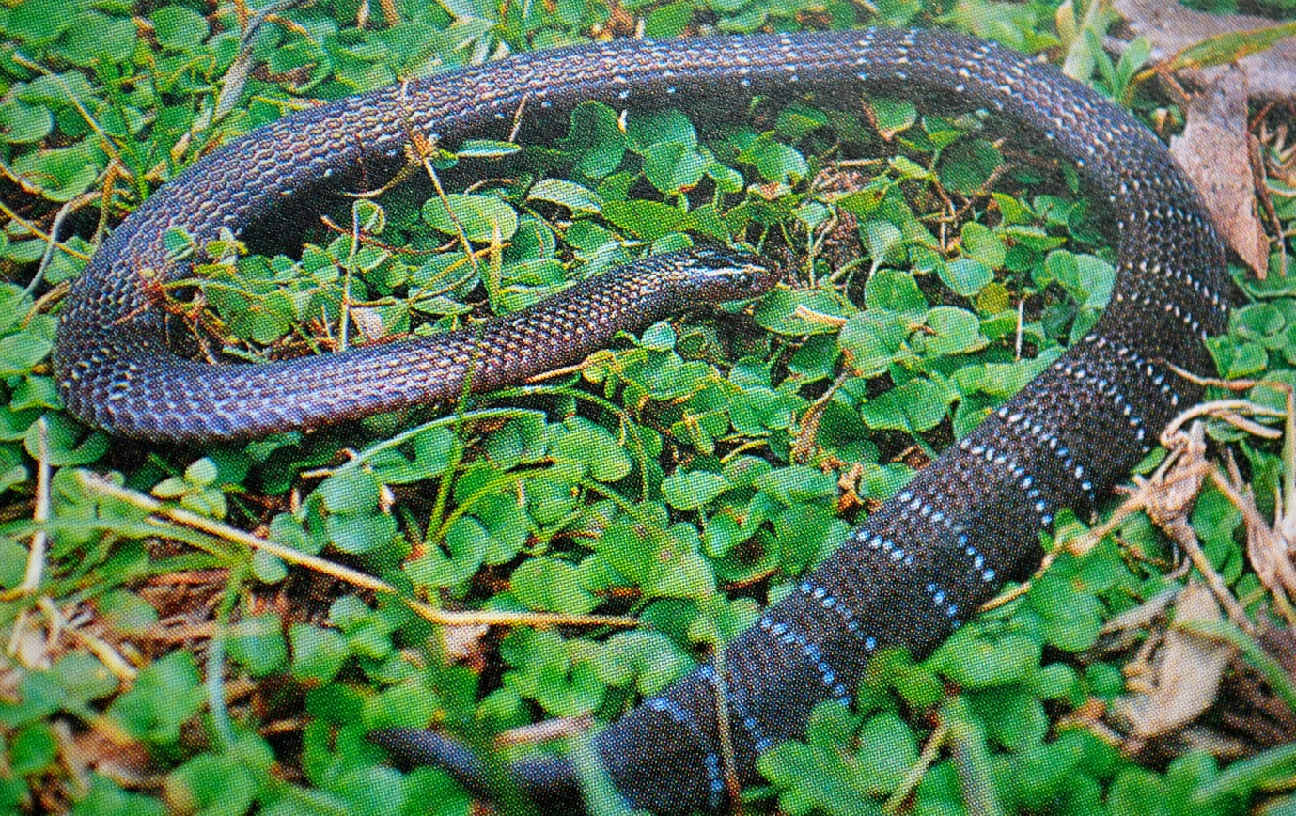
Photograph above: © Lorenzo Vinciguerra; Tanzanian specimen. Top pictures juveniles, lower picture adult.

Identification: A small snake, up to about 60 cm, usually 30-50 cm in length. Juveniles are distinctly marked with an orange head and a grey body with black, white-edged bands, in adults the bands fade to two fine white rings, occasionally the bands totally disappear.
Distribution: Eastern Arc Mountains of north and central Tanzania, recently recorded in the Shimba Hills in Kenya.
Natural History: Secretive, terrestrial, slow-moving and nocturnal. In holes and under ground cover during the day, but will prowl on the surface afer rain, specimens occasionally active during damp days. Inoffensive and unaggressive, rarely tries to bite even if handled. Lays eggs. Eats caecilians, might also eat small snakes and lizards.
Conservation Significance: In Kenya its known range is all within a national park, the Shimba Hills.
.Medical Significance: Bites unknown but no human fatalities are known for other members of the genus; no serum is produced for snakes of this genus.

